Project Report: Network Scanner Tool
Real-time Network Monitoring and Security Auditing System
Final Year Engineering Project

1. Project Overview
The Network Scanner Tool is a sophisticated security application designed for local area network (LAN) auditing. Its primary objective is to provide network administrators with a real-time view of active devices, open services (ports), and potential security vulnerabilities within a subnet.

1.1 Objectives
- Device Discovery: Automate the identification of all active hosts in a given IP range.
- Port Auditing: Identify open ports and the services running on them.
- Real-time Monitoring: Provide a dynamic dashboard that updates as devices join or leave the network.
- Reporting: Generate professional-grade audit reports for compliance and documentation.

2. Features
- LAN / IP Range Scanning: Supports CIDR notation (e.g., 192.168.1.0/24).
- Active Device Detection: IP Address, MAC Address, Hostname, and Vendor Detection.
- Port Scanning: Multi-threaded scanning of TCP ports.
- Interactive Dashboard: Premium Glassmorphism web UI.
- Mobile QR Scan: Dynamic QR code for mobile webscan access.
- Professional Reporting: Automated PDF generation.

3. Technology Stack
Component | Technology | Rationale
Backend | Python | Robust libraries for networking.
Networking | Scapy, Socket | Low-level packet manipulation & TCP.
Web Framework | Django | Secure & scalable management system.
Database | SQLite | Efficient storage of scan history.
Reporting | ReportLab | Professional PDF generation.

4. System Architecture
The system follows a modular architecture where the scanning engine is decoupled from the user interface.
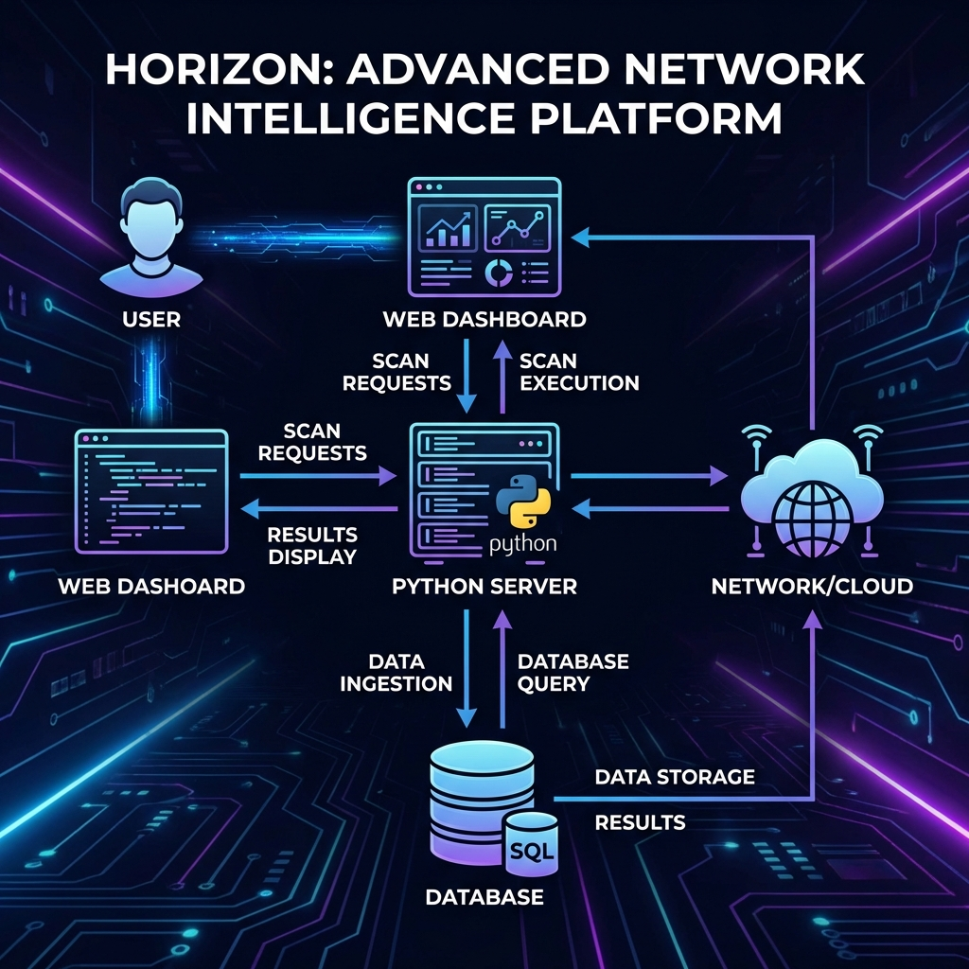
Figure 1: System Architecture and Data Flow

5. Viva Voce Preparation (Q&A)
Q1: Why use Scapy instead of the standard socket library for discovery?
Answer: Scapy allows manipulation of raw packets at Layer 2 (ARP), which is more reliable than ICMP (Ping) as it bypasses many local firewalls.
Q2: How is port scanning performance optimized?
Answer: We use multi-threading with ThreadPoolExecutor to scan multiple ports in parallel, significantly reducing scan time.
Q3: What is the benefit of the mobile QR scan feature?
Answer: It provides seamless 'WebScan' access, allowing administrators to monitor the network from any mobile device without manual configuration.

6. Core Implementation Snippets

ARP Discovery Script
def scan_network(ip_range):
arp_request = scapy.ARP(pdst=ip_range)
broadcast = scapy.Ether(dst='ff:ff:ff:ff:ff:ff')
answered_list = scapy.srp(broadcast / arp_request, timeout=1, verbose=False)[0]
return [{'ip': e[1].psrc, 'mac': e[1].hwsrc} for e in answered_list]

