Statistical_Inference_1

Ajith Masthan

May 17, 2020

# Statistical Inference Part-1

## Overview

Explore the exponential distribution in R and compare it with the Central Limit Theorem. The exponential distribution is simulated in R with rexp(n, lambda) where lambda is the rate parameter. The mean and standard deviation of exponential distribution is 1/lambda. lambda = 0.2 is used for all of the simulations. Distribution of averages of 40 exponentials is investigated with a thousand simulations.

## Simulations

# load neccesary libraries  
library(ggplot2)  
  
# set constants  
lambda <- 0.2 # lambda for rexp  
n <- 40 # number of exponetials  
numberOfSimulations <- 1000 # number of tests  
  
# set the seed to create reproducability  
set.seed(2866)  
  
# run the test resulting in n x numberOfSimulations matrix  
exponentialDistributions <- matrix(data=rexp(n * numberOfSimulations, lambda), nrow=numberOfSimulations)  
exponentialDistributionMeans <- data.frame(means=apply(exponentialDistributions, 1, mean))

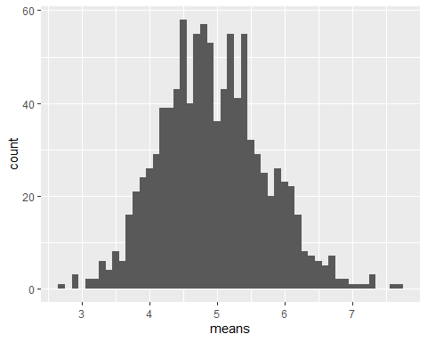

## Sample Mean versus Theoretical Mean

The expected mean mu of a exponential distribution of rate lambda is

mu = 1/lambda

mu <- 1/lambda  
mu

## [1] 5

X_bar is the average sample mean of 1000 simulations of 40 randomly sampled exponential distributions.

meanOfMeans <- mean(exponentialDistributionMeans$means)  
meanOfMeans

## [1] 4.941941

The expected mean is close to average sample mean

## Sample Variance versus Theoretical Variance

The expected standard deviation sigma of a exponential distribution of rate lambda is

sigma = (1/lambda)/sqrt(n)

sd <- 1/lambda/sqrt(n)  
sd

## [1] 0.7905694

The variance Var of standard deviation sigma is

Var=square(sigma)

Var <- sd^2  
Var

## [1] 0.625

Let Var_x is the variance of the average sample mean of 1000 simulations of 40 randomly sampled exponential distribution with standard deviation sigma_x

sd_x <- sd(exponentialDistributionMeans$means)  
sd_x

## [1] 0.7710459

Var_x <- var(exponentialDistributionMeans$means)  
Var_x

## [1] 0.5945119

The Standard deviation and Variance are close

## Distribution

Population Mean & Standard Deviation with a normal distribution of the expected values.

## Warning: Ignoring unknown parameters: arg

## Warning: Removed 2 rows containing missing values (geom_bar).

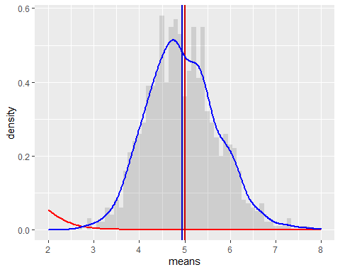

Observarion : The calculated distribution of means of random sampled exponantial distributions matches with the normal distribution with the expected values based on the given lamba