**Title: Event Management Platform**

**1. Project Statement:**

The project aims to develop a streamlined web-based platform that facilitates event management, vendor registration, and payment handling for various event types (e.g., weddings, conferences, DJ events). The platform serves Event Organizers (Users), Vendors, and Admins, focusing on user-friendly event creation, vendor selection, and payment management.

Outcomes:

* Allow users to register, create events, select vendors, and make payments.
* Provide vendors with tools to register and receive purchase confirmations.
* Equip admins with the ability to approve/reject events and manage vendors.
* Ensure a responsive, intuitive interface for users, vendors, and admins.
* Enable users to download event details in PDF format after payment to share as invitations.

**2. Modules to be Implemented:**

1. User Authentication and Role Management
2. Event Creation, Vendor Selection, Payment, and PDF Invitation Download
3. Vendor Registration and Management
4. Admin Dashboard for Event and Vendor Management

**3. Week-wise Learning and Module Implementation Plan:**

Learning Phase: Weeks 1-5

* Week 1: Spring Framework – Introduction to Spring, Spring Boot, and dependency injection.
* Week 2: Microservice Architecture – Understanding microservices, REST API development, and communication between services.
* Week 3: Security – Introduction to JWT-based authentication and role-based access control.
* Weeks 4-5: React Development – Introduction to React, component-based design, and front-end integration with Spring Boot backends.

Project Implementation Phase: Weeks 6-7

**4. Module Descriptions:**

**Module 1: User Authentication and Role Management**

Description:  
Implement user authentication using JWT and role-based access control for Event Organizers, Vendors, and Admins.

Features:

* User registration and login for Event Organizers, Vendors, and Admins.
* Secure access using JWT tokens.
* Role-based access control for features like event creation and vendor management.

**Screenshots:**

**Landing Page:**

**Module 2: Event Creation, Vendor Selection, Payment, and PDF Invitation Download**

Description:  
This module covers the process where users can create events, select vendors adnd venue, make payments, and download event details in PDF format.

Features:

* Users can create events by providing event details such as event type, location, and date.
* Select venues based on location and date.
* Select vendors based on services offered (e.g., photographers, caterers).
* Payment integration using Razorpay.
* After successful payment, users can download event details in PDF format (including location, hostname, event type, etc.). This PDF can be used as an invitation to send to guests.

**Output Screenshots:**

* **Event Creation PageA screenshot of a computer

  Description automatically generated**
* **Venue Selection and Vendor Selection**

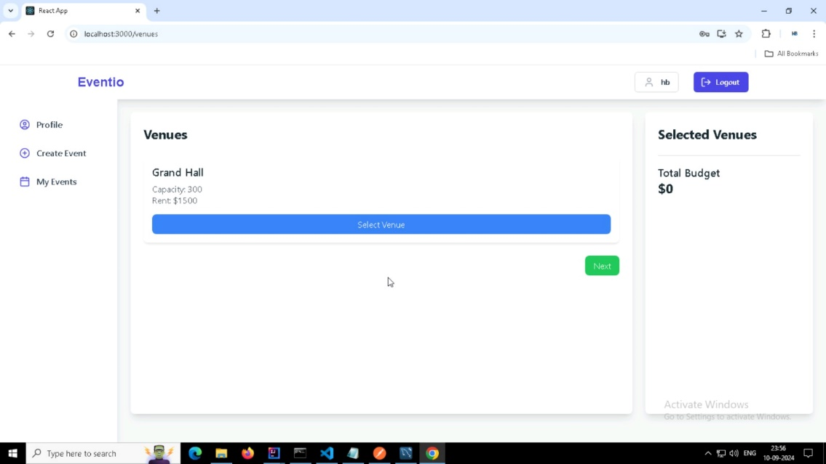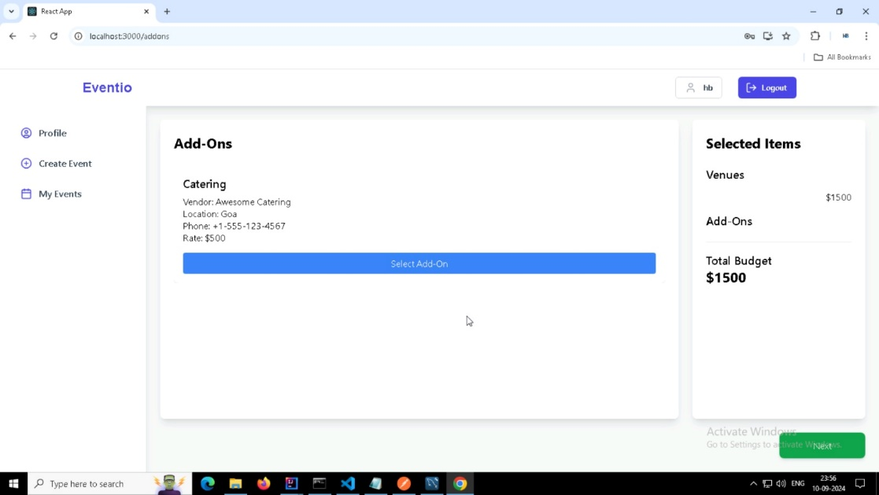

* **Event Summary Page**

* **Payment Section**

* **PDF Invitation Downloaded**

**Module 3: Vendor Registration and Management**

Description:  
Develop functionalities for vendor registration and service management.

Features:

* Vendors can register by filling out a form with their details (name, service type, phone number, location).
* Vendors receive purchase emails when their services are selected by users**.**

**Output Screenshots:**

* **Vendor Registration PageA white rectangular object with black text

  Description automatically generated**
* **Vendor Purchase Order Email**

**Module 4: Admin Dashboard for Event and Vendor Management**

Description:  
Create a simple admin dashboard with event and vendor management functionalities.

Features:

* Admins can view and approve/reject event submissions and vendor registrations.
* Admins can monitor upcoming events and manage vendors.

**Output Screenshots:**

* **Admin DashboardA screenshot of a calendar

  Description automatically generated**
* **Vendor Approval PageA screenshot of a computer

  Description automatically generated**
* **Vendor Details PageA screenshot of a computer

  Description automatically generated**

**5. Evaluation Criteria:**

Milestone 1 Evaluation (Week 7):

Successful implementation of:

* User authentication and role management.
* Event creation, vendor selection, payment integration, and PDF invitation download.
* Admin dashboard with event and vendor management functionalities.

**6. Design Diagrams:**

* **Database DiagramA screenshot of a computer

  Description automatically generated**
* **Data Flow DiagramA diagram of a flowchart

  Description automatically generated**
* **Architecture DiagramA diagram of a event management system

  Description automatically generated**

**7. Output Screenshots:**

* **User Invoice Mail Screenshot**

* **User Profile**

* **Admin Profile**

* **Tutorial PageA screenshot of a social media post

  Description automatically generated**

**8. Timeline Overview:**

Weeks 1-5: Learning Phase

* Spring (Week 1)
* Microservice Architecture (Week 2)
* Security (Week 3)
* React (Weeks 4-5)

Weeks 6-7: Project Implementation

* Week 6: Implement user authentication, event creation, vendor selection, and payment processing.
* Week 7: Complete PDF invitation download, vendor management, admin dashboard, and mail sending process.