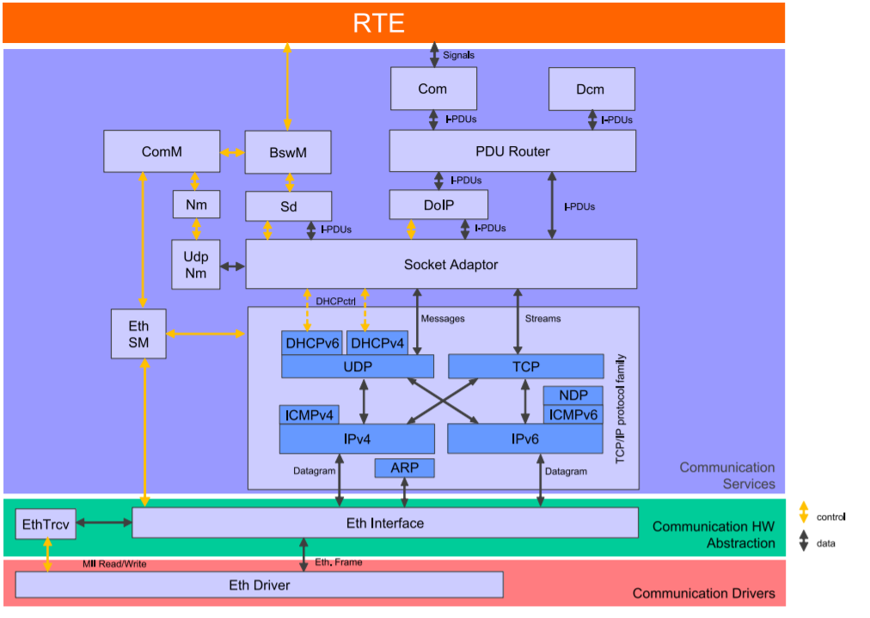
ETHERNET STACK

COM:

This is the topmost module in Autosar BSW service layers and specifically Ethernet com stack. Functionality of the COM module is the same as all other stacks like CAN, Flexray and LIN. as COM module is protocol independent module and works in the same way irrespective of underlying communication protocol stack. It is used to transfer signals to and from the RTE layer. It packs the signals to a PDU at the transmitter and unpacks received PDU to provide signal level access to the application at the receiver

PduR:
Abstract is a PDU(Protocol Data Unit) router, as the name suggests the functionality of this module is routing the PDU to its correct destination from the source module. PduR is second top most module of Autosar Com stack for all communication protocol stack such as Ethernet , Flexray , CAN …etc

DoIP:

DoIP is Diagnostic over IP.
Some of the functionality of DoIP module is:
. Vehicle identification and announcement: Is necessary to detect who is participating in the DoIP communication.

. Routing Activation: Allows that single Diagnostic Message paths are activated or not to treat different protocols different (like UDS and OBD) and to also treat single testers different.

Use case of DoIP module:
- ECU Reprogramming
- Remote vehicle diagnostics
- Measurement reading
- Online data streaming to and from the vehicle
SoAD(Socket Adapter):
A paradigm upon which the TCP/IP protocol family is based is the use of sockets. A socket is uniquely identified by the combination of IP address and port of the remote and local end nodes. Via a socket, packet-oriented UDP and connection-oriented TCP user data are routed from the TCP/IP stack to the application or in the opposite direction.
Main purpose of SoAD module is to interface the upper layer PDU based module (PduR) to the lower layer Socket based TCP/IP module.

TCP/IP:
The TCP/IP Stack (TCP IP) is located between the Socket Adapter (SoAd) and the Ethernet Interface (EthIf) modules. And Autosar TCP/IP module functionality and normal TCP/IP module functionality are the same.from any IP address. It contains multiple modules which perform different functionality. Configuration of IP address will be done in this module,

EthIf :
The Ethernet Interface belongs to the ECU Abstraction Layer, or more precisely, to the Communication Hardware Abstraction in Communication stack.
The Ethernet Interface does not directly access the Ethernet hardware, to send and receive the data it will call the Ethernet driver module. Therefore it is possible to have multiple Ethernet driver modules in the same ECU. and accessing multiple transceivers can be done by using multiple transceiver driver modules.

Eth Driver :
In the AUTOSAR, the Ethernet Driver belongs to the Micro controller Abstraction Layer, or more precisely, to the Communication Drivers.

Main Tasks of Ethernet Driver:
. Provide hardware independent interface to the upper layer for the same type of multiple controllers.
. And with that upper layers can access Ethernet controllers with uniform manners. The interface has a uniform interface name and type.
.

