3. Result:

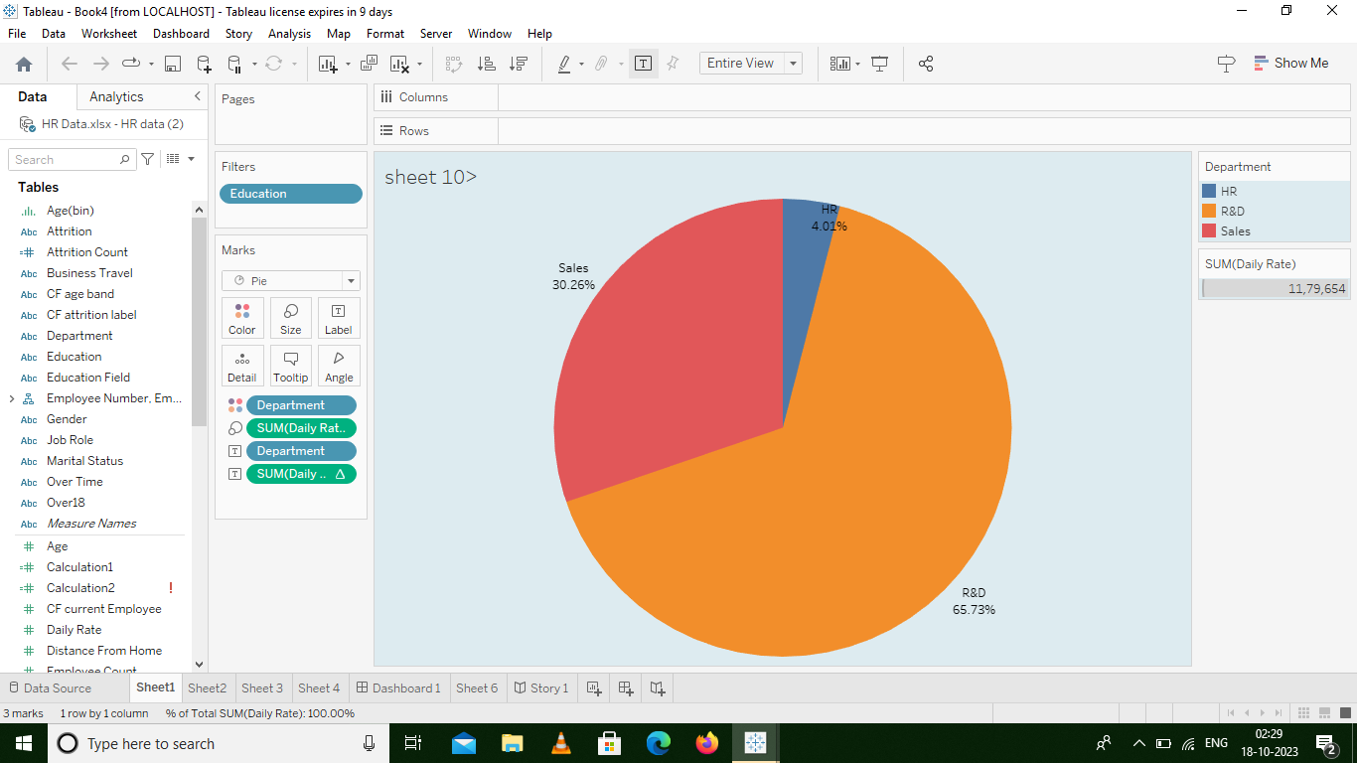

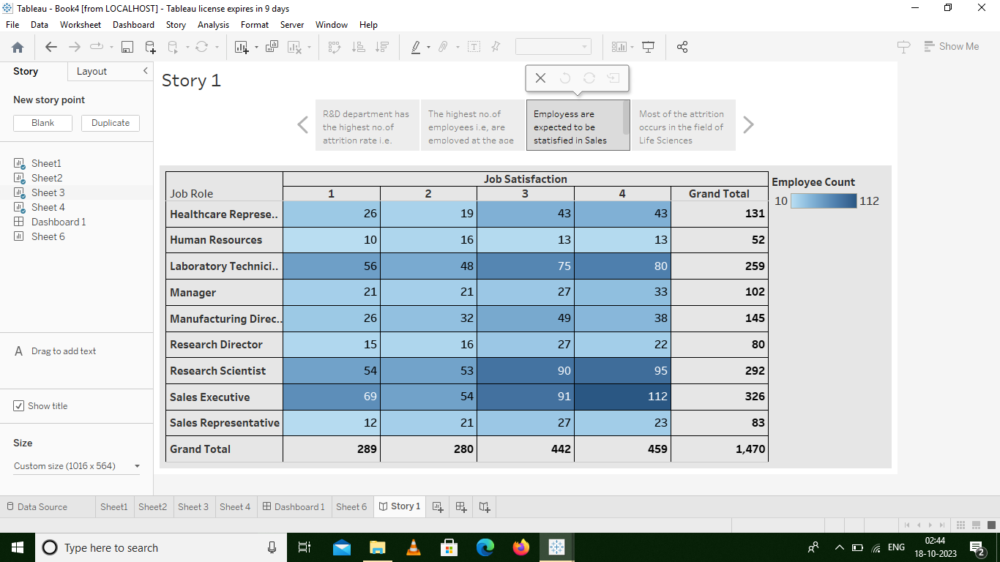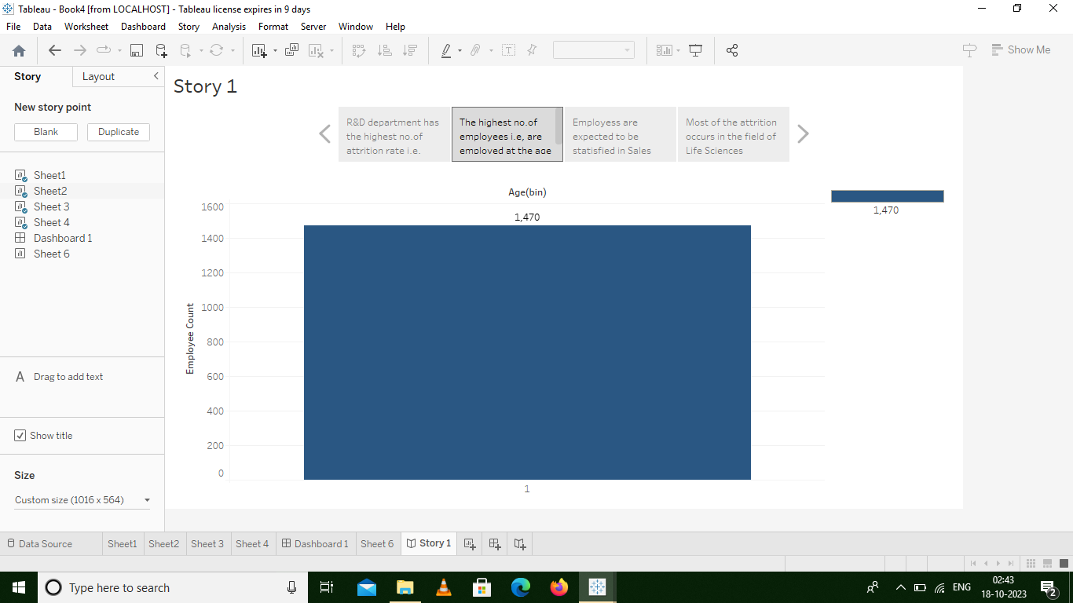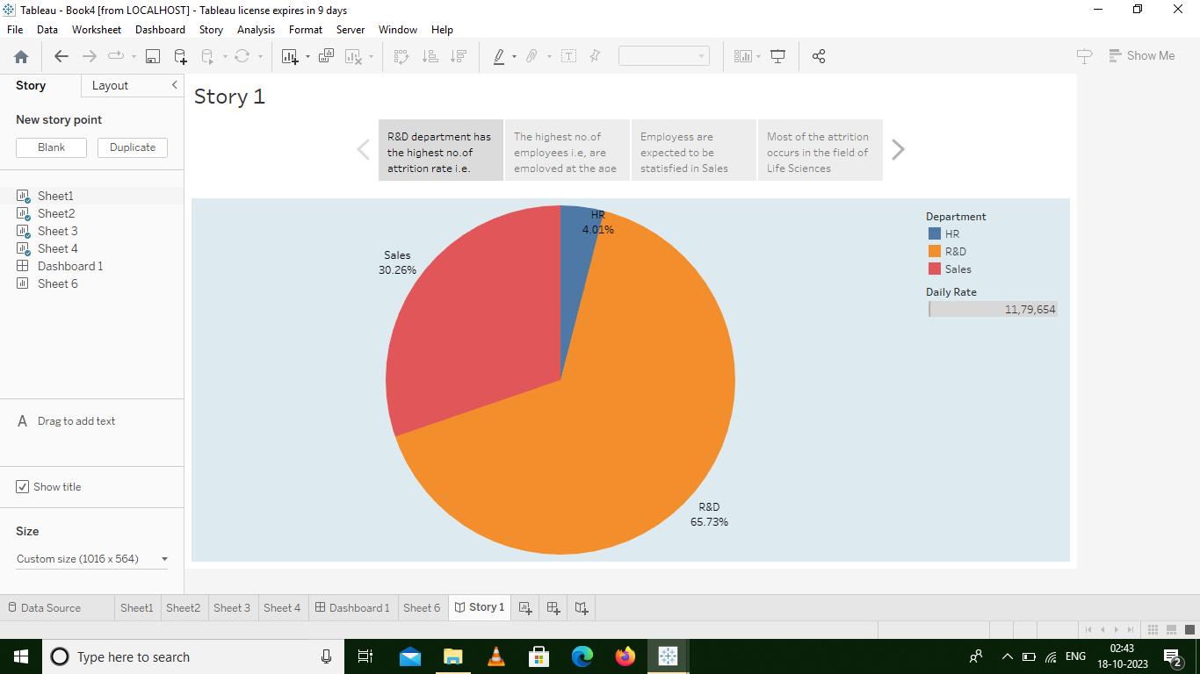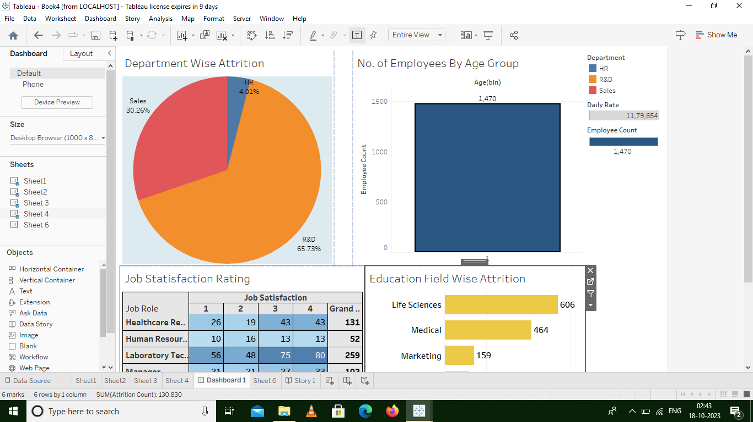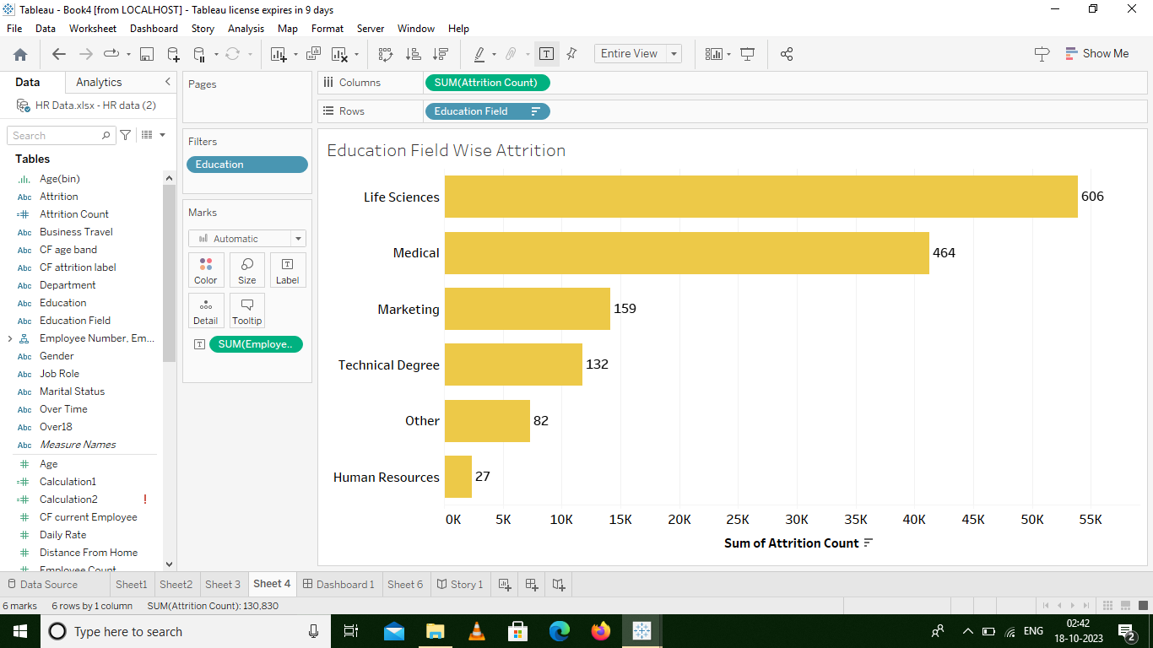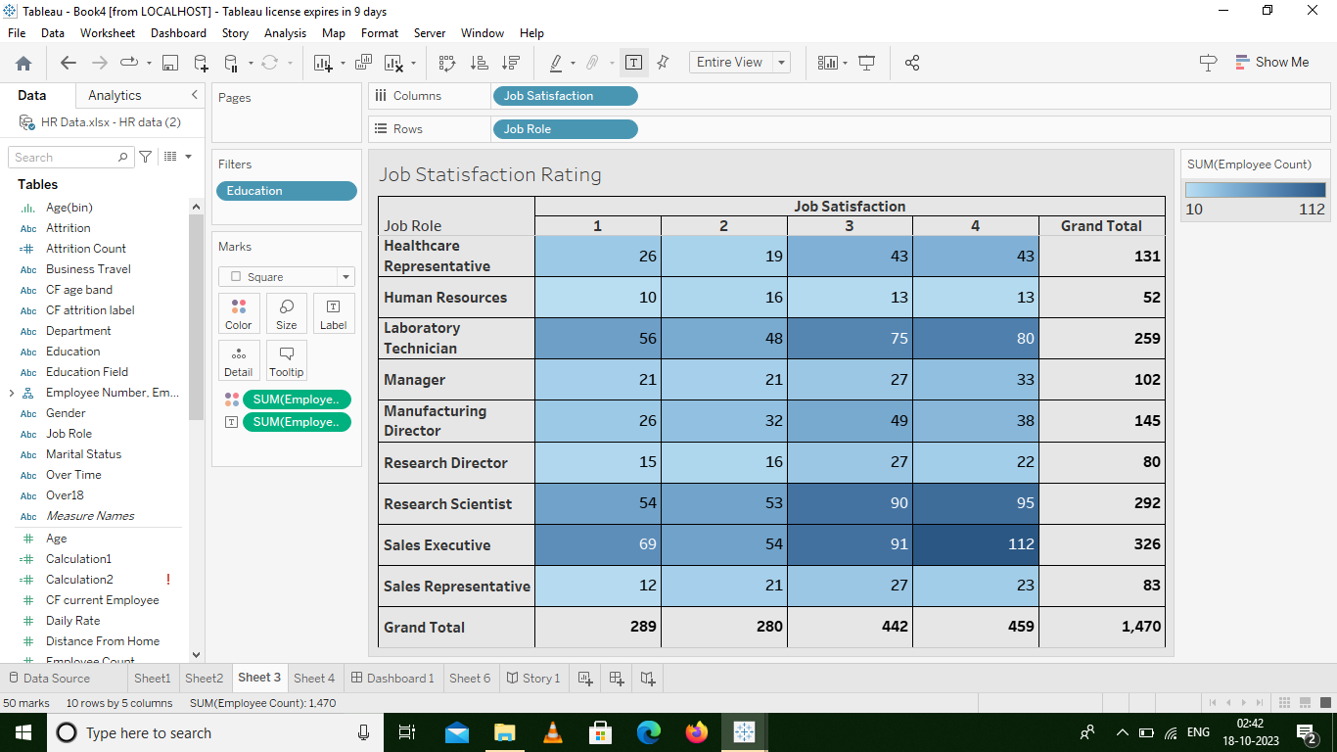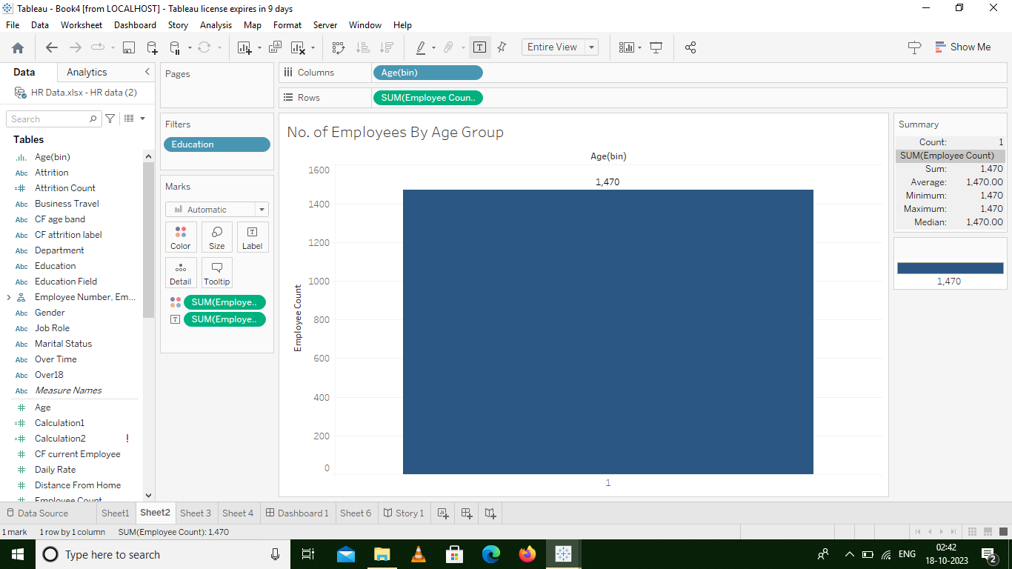

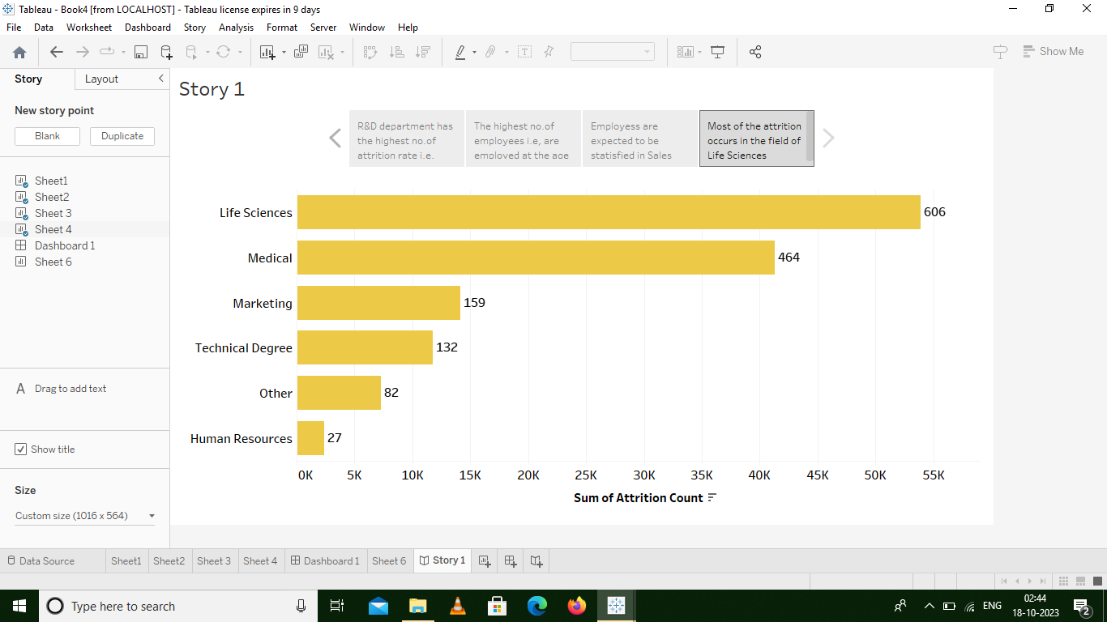

4. Advantages& Disadvantages:

Now that we’ve covered the basics surrounding balanced scorecards, let’s go over the advantages and disadvantages of using this performance measurement method for your organization.

**Advantages of a balanced scorecard:**

Overall, a balanced scorecard helps companies focus on performance measurement in more than one area. It takes into account items that can sometimes get overlooked in a company such as internal processes and current customer satisfaction. Here are some of the biggest advantages of using this method in your business:

### **Disadvantages of a balanced scorecard**

While there are so many advantages to implementing a balanced scorecard system into your workplace, there are also potential roadblocks and disadvantages to balanced scorecards

* Brings structure to business strategy.
* Makes communication easier.
* Facilitates better alignment.
* Connects the individual worker to organizational goals.
* It must be tailored to the organization.
* It needs buy-in from leadership to be successful.
* It can get complicated.

**5. Applications:**

**The HR scorecard is meant to measure leading HR indicators of business performance. Leading indicators are measurements that predict future business growth. These are called HR deliverables. They are also known as HR metrics, and more specifically HR KPIs, as they are metrics that are linked to the business strategy**

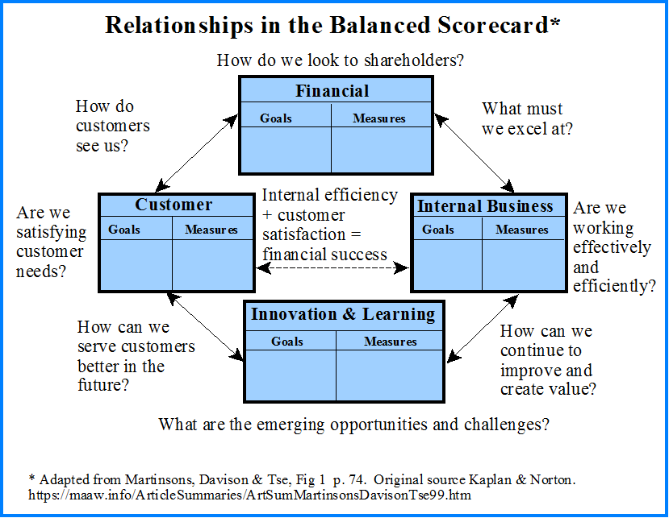

6**. Conclusion:**

**Conclusion: At the end can say that talent management process has provide new ways to Human Resource department to handle problems faced in hiring talent. By the help of talent management process companies are hiring right person for the right job as per their job requirement and description**

**In Conclusion  
  
By collecting and analyzing data related to the people in an organization, HR analytics can help make data-driven decisions, measure the impact of HR initiatives, and shape the future of work. These are just some of the key reasons why HR analytics is important.**

**7. Future Scope:**

**Author by : Charvi Salian. The future of HR Analytics is all about leveraging data to make informed decisions related to the workforce. By measuring, analyzing, and interpreting HR metrics and data, organizations can gain valuable insights into employee performance, engagement, turnover, and more.**

**Marketing has a better scope. It always had a better scope and considering the growth of digital marketing and the number of job opportunities in the field, you can be sure that there will be scope in the future too.**

**Just imagine and compare the number of Marketing and Sales persons with the number of H.R persons an ordinary company needs.You will get the picture.**

**You should also consider the fact that many MBA students are hired for pure Sales roles than Marketing. So based on your wish to get into sales, your decision should be made.**

**The nature of job differs from industry to industry**