ASSIGNMENT-1

Task1:

Report View Page:

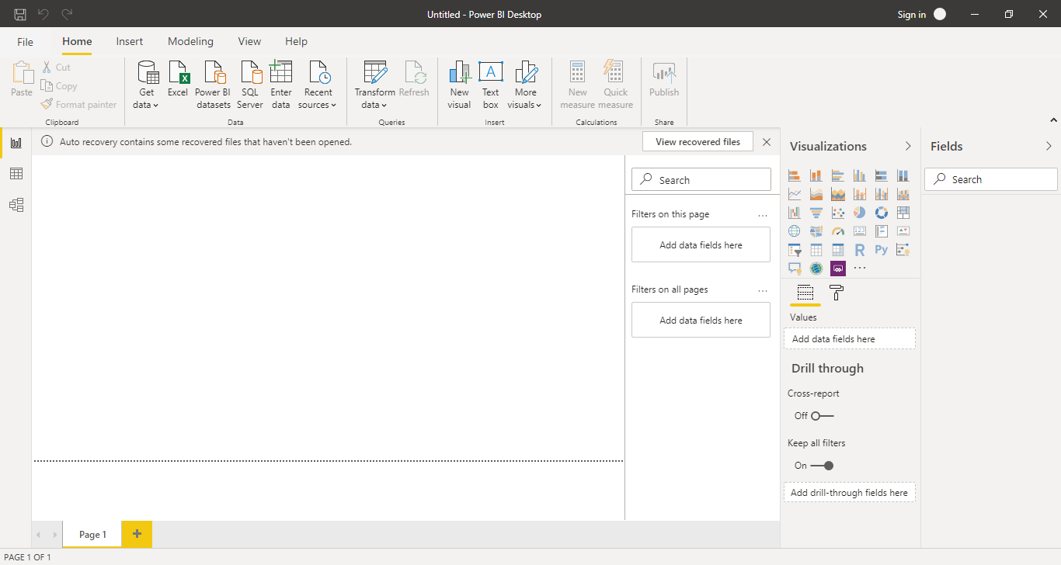

Task 2:

Report View: 

Data View:

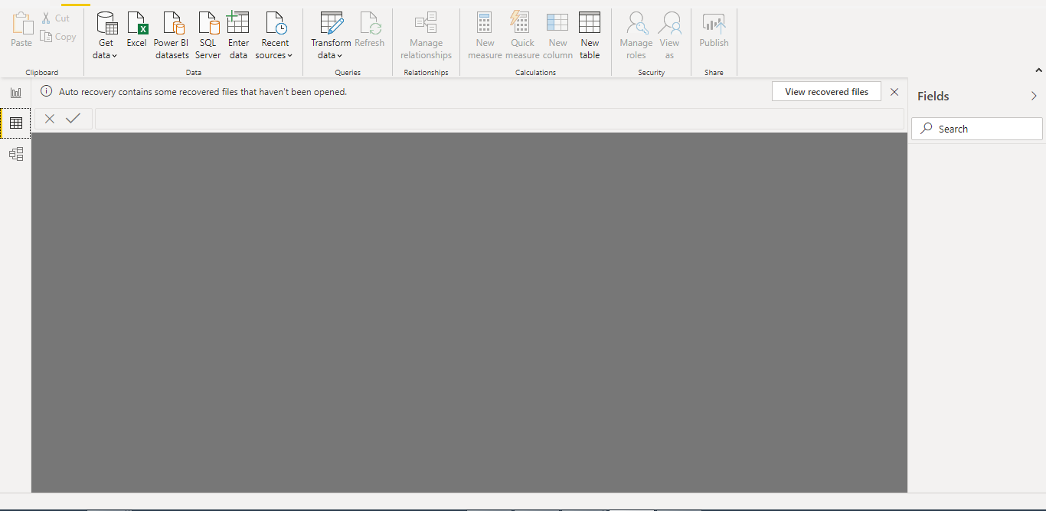

Model View:

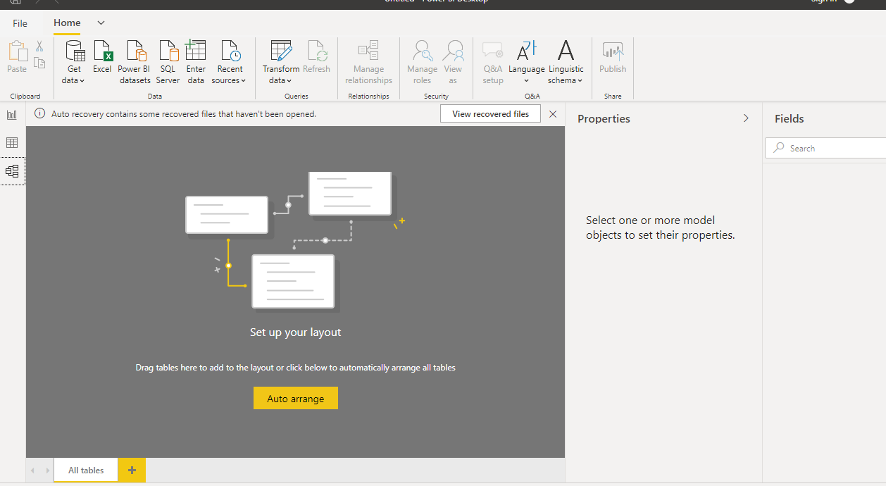

Power Query Editor:

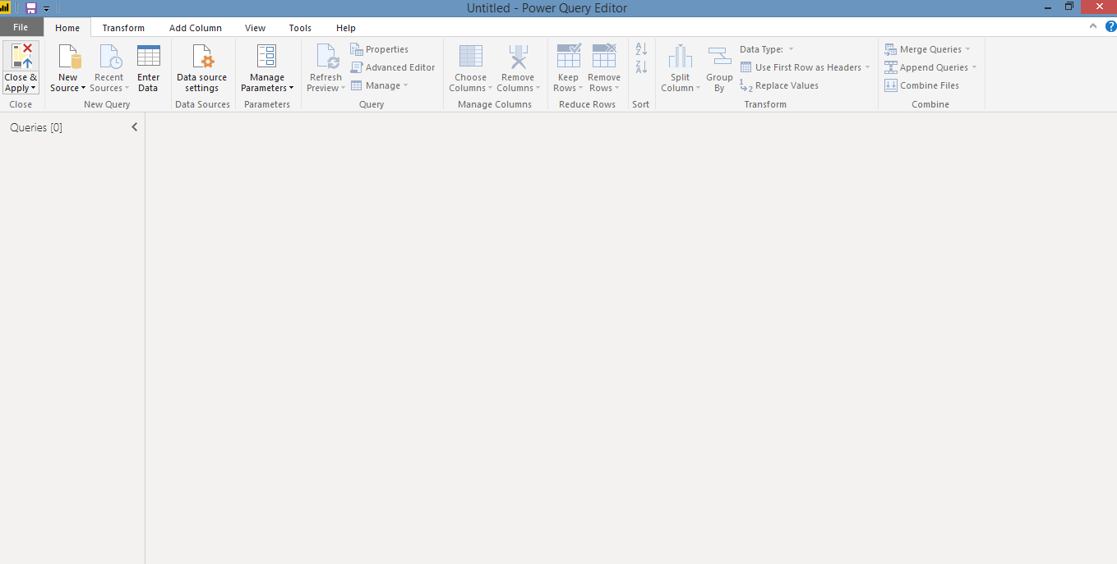

Advance Editor:

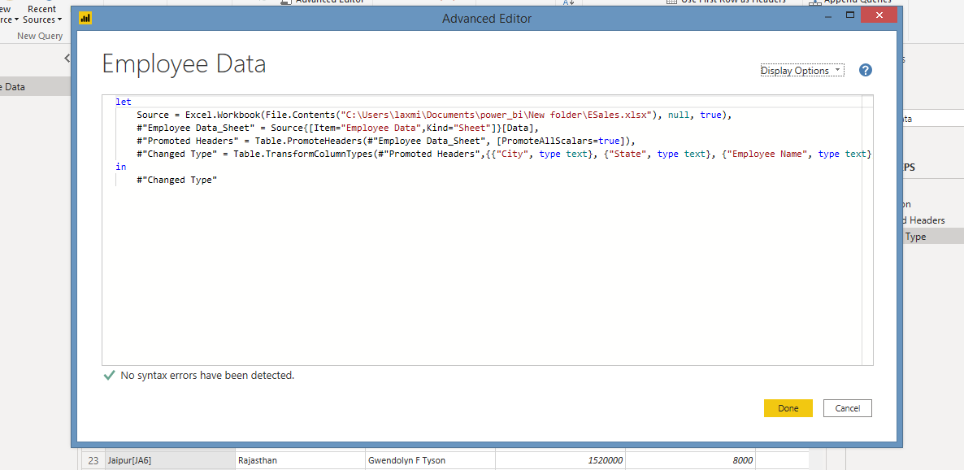

Task 3:

Details of Power BI tool types and their prices:

Power BI Desktop: Free

Power BI Pro: 660 INR

Power BI Premium: 3,30,190 INR

