Contents

GOOGLE SEARCH CONSOLE 1

*HOW IT HELPS?* 1

*TOOLS AND REPORTS OF SEARCH CONSOLE* 1

*ADDING A PROPERTY* 2

*GOOGLE SEARCH CONSOLE DASHBOARD* 2

PERFORMANCE 2

URL INSPECTIONS 4

COVERAGE 5

SITEMAPS – CONFIGURING SITEMAP.XML 6

ENHANCEMENT 6

ROBOTS.TXT 6

# GOOGLE SEARCH CONSOLE

Earlier know as **GOOGLE WEBMASTER TOOL**

|  |  |
| --- | --- |
|  | 1. Google search console monitors and track the data of interaction of web app and search engine bots 2. On the other way - Google Analytics monitors the data of interaction between users and web application. 3. <https://search.google.com/search-console> |

## *HOW IT HELPS?*

Google search Console helps in

1. Monitor
2. Maintain
3. Trouble shoot

## *TOOLS AND REPORTS OF SEARCH CONSOLE*

* Its confirms that google can find crawl your website
* Fixes the indexing problem and request for re-indexing of updated content
* View google search traffic data
* Receives alert when google encounters indexing ,spam or other issues in the site
* Shows – which site sites link to your website
* Trouble shoot for AMP, mobile usability and other search features

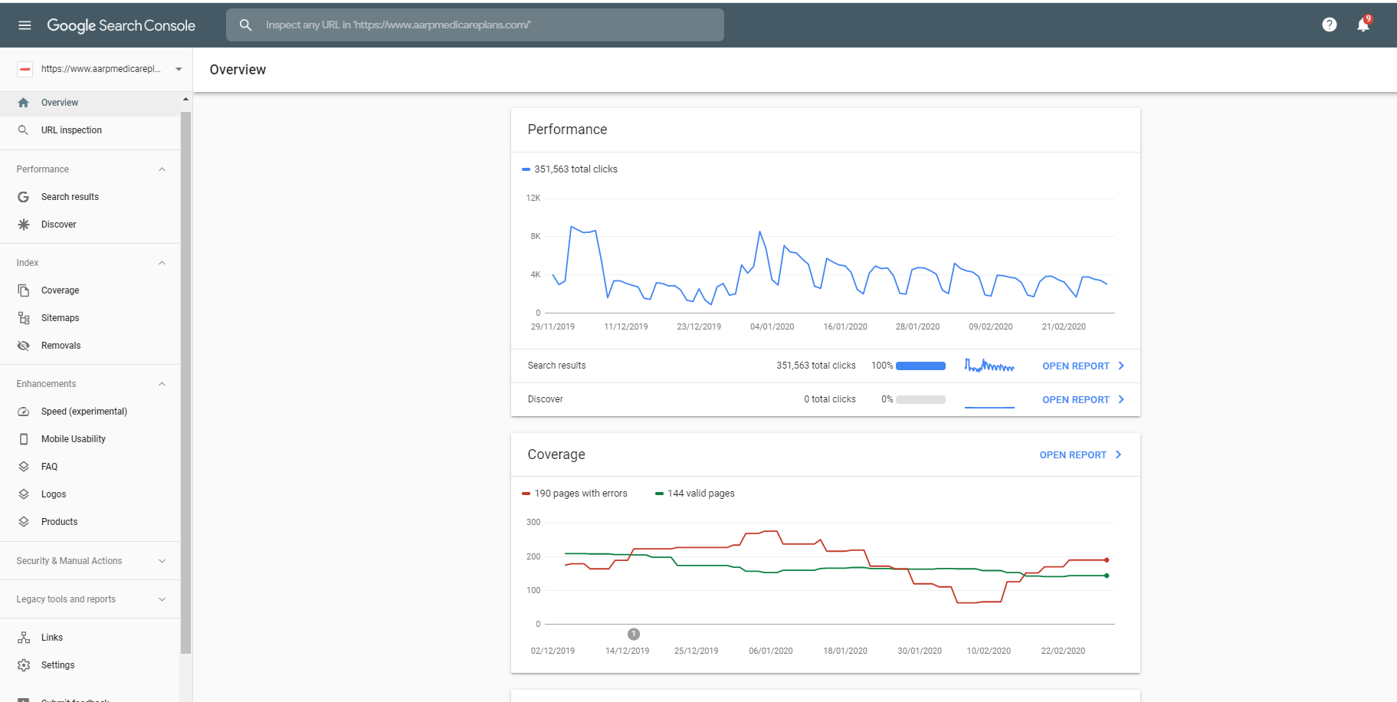

## *ADDING A PROPERTY*

|  |  |
| --- | --- |
|  | * Adding a website to Google search console can be done using ” Add Property” * It can be added in 2 ways   + Using Domain   + Using URL prefix   **ADDING USING DOMAIN**  When we add a domain. it will   * All URLs across the all subdomain will we added * All the urls across http and https will be added.   **ADDING USING URL PREFIX**  When we add a domain. it will   * All URLs across the all subdomain will we added   All the urls across http and https will be added.   * Only URLs under entered address * Only URLs under specified protocol * Allows multiple verification methods |

## *GOOGLE SEARCH CONSOLE DASHBOARD*

### PERFORMANCE

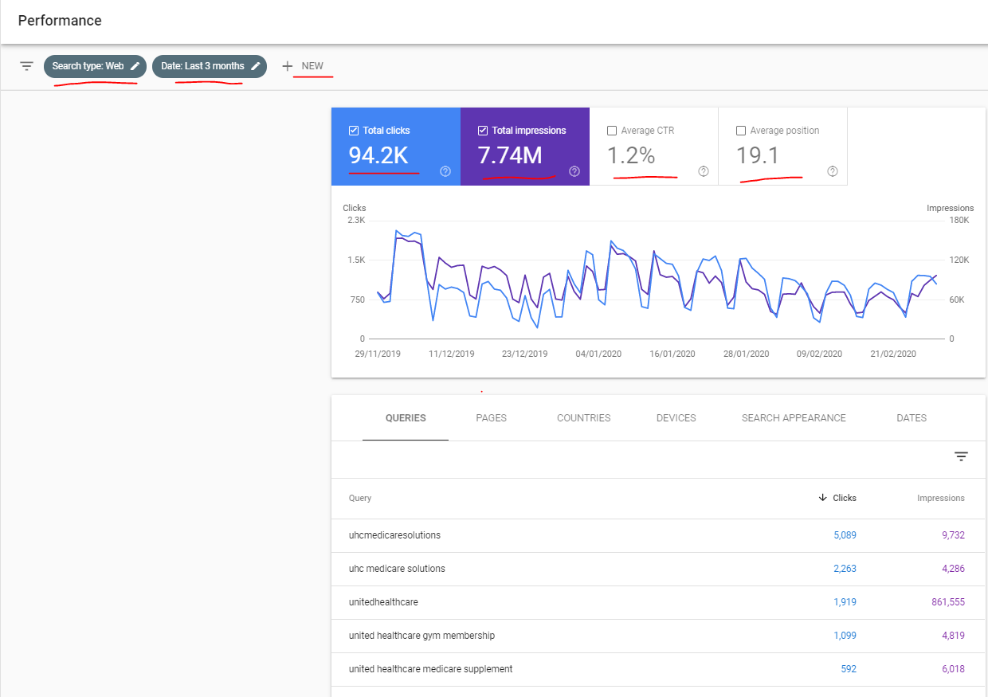

#### FILTERING DATA

|  |  |
| --- | --- |
|  | * The performance data can be filtered based on “Web” ,”Image” and “Video” search |

#### PERFORMANCE MATRICES

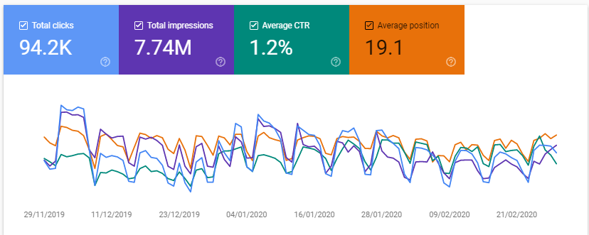

**THIS IS THE OVERALL MATRIX OF THE WHOLE APPLICATION**

|  |  |
| --- | --- |
| **TOTAL CLICKS** | * Total number of clicks in search results. * The same data can also be viewed on page basis |
| **TOTAL IMPRESSIONS** | Number of times it appeared in the search result |
| **AVERAGE CTR**  **(CLICK THROUGH RATE)** | **CTR = (Total Impressions / Total Clicks ) * 100** |
| **AVERAGE POSITIONS** | Average of rank of the page in the search result (impressions). Let say for 100 impressions   * 10 times – Page ranks is 3 * 50 times – Page ranks is 2 * 20 times – Page ranks is 4 * 20 times – Page ranks is 1   So the average position = (3+2+4+1)/4 = **2.5** |

We can view the similar matrices on page basic also based on

|  |  |
| --- | --- |
| **QUERIES** | Data based on the keyword used to search. |
| **PAGES** | Page wise data |
| **COUNTRIES** | Countries wise data |
| **DEVICES** |  |
| **SEARCH APPEARANCE** |  |
| **DATES** | Date wise Data |

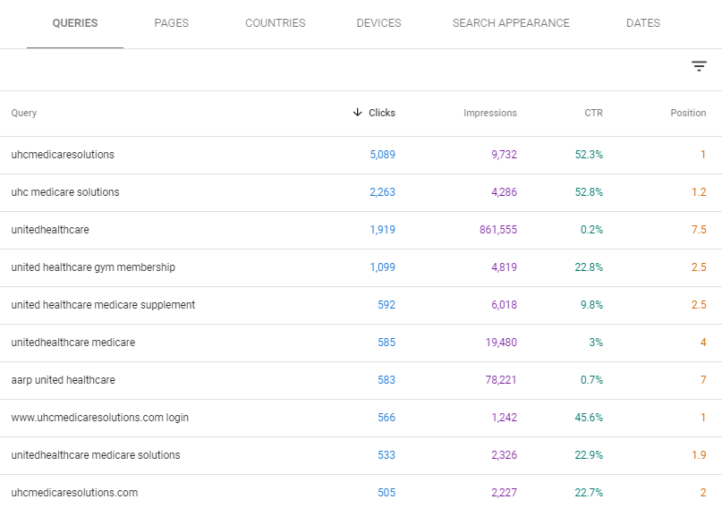

### URL INSPECTIONS

* This helps in inspecting a URL of a property.

|  |  |
| --- | --- |
| **VIEW CRAWLED PAGE** | This option shows how the page will look like for search engine bots. |
| **REQUEST INDEXING** | We can request google to index the page (if not indexed) |

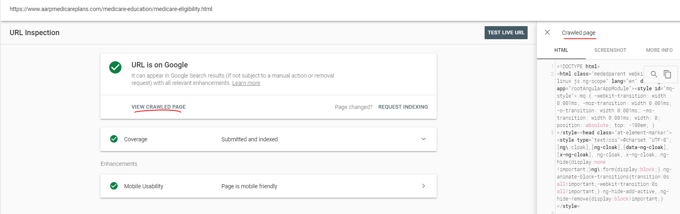

### COVERAGE

**This dashboard gives the information about the coverage of the web application by search engine**

|  |  |
| --- | --- |
|  | We can view the Coverage data based on   1. All Known pages : Data of All indexed pages 2. All submitted pages : Data of All pages which are submitted for indexing 3. Sitemap.xml : data of the pages which are mentioned in sitemap.xml   Usually sitemap.xml are kept at the root folder of the webapp e.g. <https://www.aarpmedicareplans.com/sitemap.xml> |

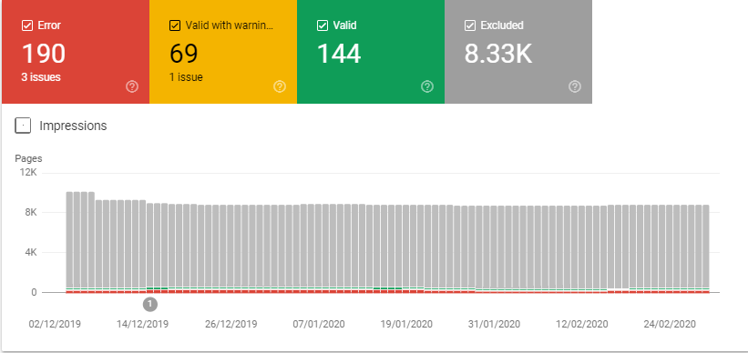

|  |  |
| --- | --- |
| **ERROR** | Its shows the pages that couldn't be indexed for some reason.It’s important because these pages won't appear in Google, which can mean a loss of traffic to your site. |
| **VALID WITH WARNING** | Its shows - Indexed pages having issues |
| **VALID** | Its shows - Indexed pages without issues |
| **EXCLUDED** | Its shows – these pages are not intentionally Indexed pages. When the pages are excluded .They are excluded based on some category. Like   1. Excluded using robot.txt 2. Adding noindex tag   To prevent most search engine web crawlers from indexing a page on your site, place the following meta tag into the <head> section of your page:  **<meta name="robots" content="noindex">**  To prevent only Google web crawlers from indexing a page:  **<meta name="googlebot" content="noindex">** |

### SITEMAPS – CONFIGURING SITEMAP.XML

**WHAT IS SITEMAP.XML?**

* **The Sitemaps protocol allows Google search console to inform search engines about URLs on a website that are available for crawling.**
* A Sitemap is an XML file that lists the URLs for a site.
* It allows Google search console to include additional information about each URL: like
  + When it was last updated,
  + How often it changes, and
  + How important it is in relation to other URLs in the site.
* This allows search engines to crawl the site more efficiently and to find URLs that may be isolated from the rest of the site's content.
* The sitemaps protocol is a URL inclusion protocol and complements robots.txt, a URL exclusion protocol.
* The sitemap can be generated for an application using some sitemap generator like <https://www.xml-sitemaps.com/>
* We generate the sitemap for a web application and keep it in the root of the web application and configure the same path in the Google Search console

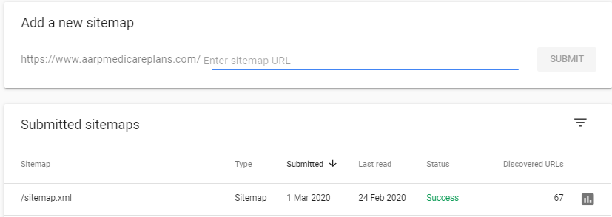

### ENHANCEMENT

---

#### MOBILE USABILITY

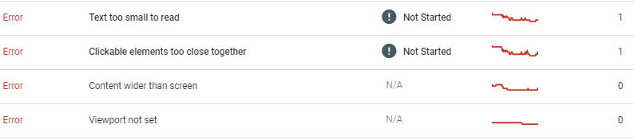

* This gives the data of the issues of pages in mobile view based on the different categories (as above)

### ROBOTS.TXT

* This will help us to control the crawling by search engine bots.
* This file gives the instruction to the search bots - which file, which directory or subdirectory to crawl/ visit and what not to
* The **robots.txt** are placed in the root directory of the web application[<https://www.aarpmedicareplans.com/robots.txt>]

|  |  |  |  |
| --- | --- | --- | --- |
| **SAMPLE SYNTAX OF ROBOTS.TXT FILE** | | | |
| User-agent: *  Disallow: / | User-agent: *  allow: / | User-agent: Googlebot  Disallow: /admin | User-agent: Bingbot  Disallow: /online/registration.html |
| Disallow all search bots to search | Allow all search both to search | **BLOCKING SUBFOLDER** Disallow google bot to search admin folder | **BLOCKING PAGE** : Disallow Bing bot to search /online/registration.html page |

**ROBOTS.TXT TESTER- :**<https://www.google.com/webmasters/tools/robots-testing-tool>