Contents

MARKDOWNS 2

WHY WE USE MARKDOWN 2

IDE 2

ONLINE EDITORS 2

OFFLINE EDITORS 2

HOW MARKDOWN WORKS? 2

PARAGRAPH AND LINE BREAK 3

HEADERS 3

HORIZONTAL LINE 3

BOLD & EMPHASIS 3

STRIKETHROUGH 4

BLOCKQUOTES 4

LIST -ORDERED AND UNORDERED LIST 6

IMAGES 6

INLINE IMAGES 6

REFERENCED IMAGES 6

LINKS 7

CODE STYLES AND BLOCKS 7

INLINE CODE 7

CODE BLOCKS 7

INLINE HTML 8

TABLES 8

MKDOCS 8

MKDOCS INSTALLATION 8

CREATING A NEW MKDOCS PROKJECT 8

CONFIGS 9

DEFAULT WELCOME PAGE 9

ADDING PAGES 9

MKDOCS.YML 9

# MARKDOWNS

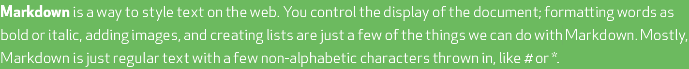

* Lightweight markup language with plain text formatting syntax
* Can be converted into HTML/ XTHML and other formats
* It main purpose is readability and ease of use.

## WHY WE USE MARKDOWN

* Readme Files (Github , etc..)
* Forum & Blog post
* Used in many static site generators.

## IDE

### ONLINE EDITORS

* + <https://stackedit.io/>
  + <https://dillinger.io/>
* Create a new File to write markdown from a “New File” option.

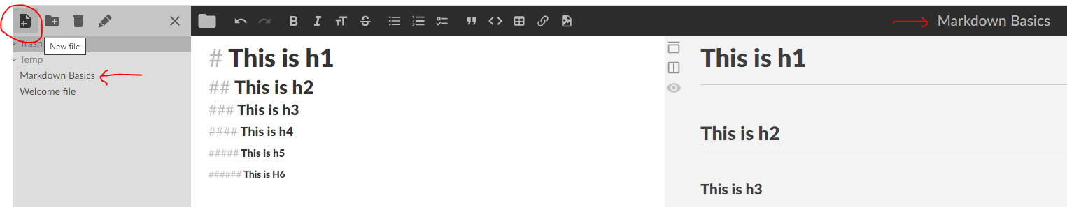

### OFFLINE EDITORS

* **TEXT EDITOR EXTENSION (IN VS CODE OR ATOM).**
* **MARKPAD**
* **HAROOPAD**
* **MARKDOWNPAD2**
* **TYPORA**

## HOW MARKDOWN WORKS?

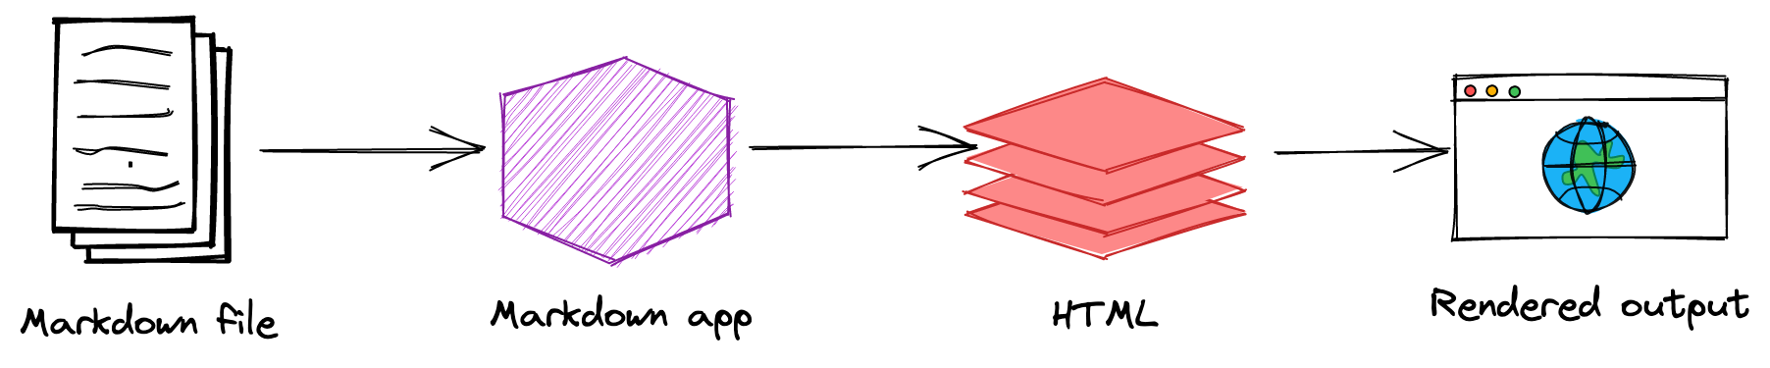

## PARAGRAPH AND LINE BREAK

## HEADERS

|  |  |
| --- | --- |
|  | * Header can be written using “#”. * Markdown supports header till “h6”. As show below |

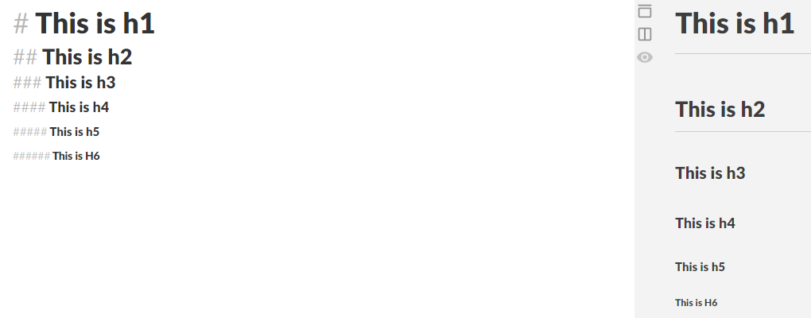

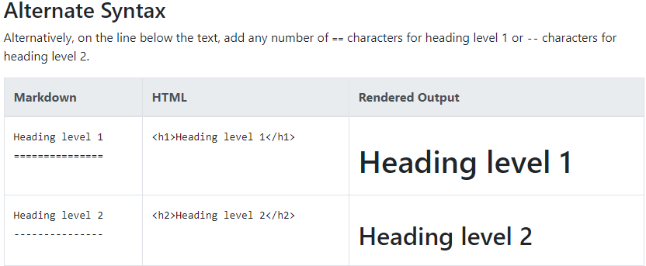

## HORIZONTAL LINE

* To generate horizontal lines in markdown
  + Use 3 consecutive “___” [underscores]
  + Use 3 consecutive “---” [dash]

## BOLD & EMPHASIS

|  |  |
| --- | --- |
|  | * Emphasis text uses “ *” of “_” interchangeably * “**” or “__”🡪 To **bold** the text |

**To emphasize text with bold and italics at the same time, add three asterisks or underscores before and after a word or phrase. To bold and italicize the middle of a word for emphasis, add three asterisks without spaces around the letters.**

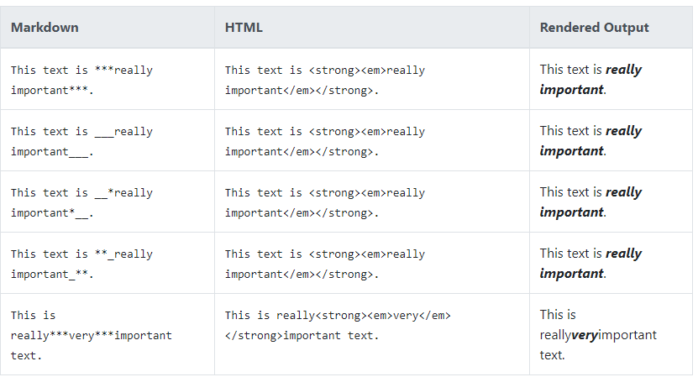

## STRIKETHROUGH

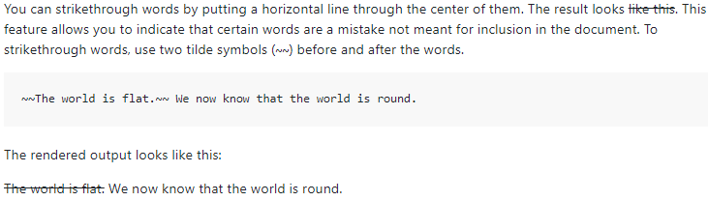

## BLOCKQUOTES

* Markdown uses “**>”** to create blockquotes

|  |  |
| --- | --- |
|  |  |

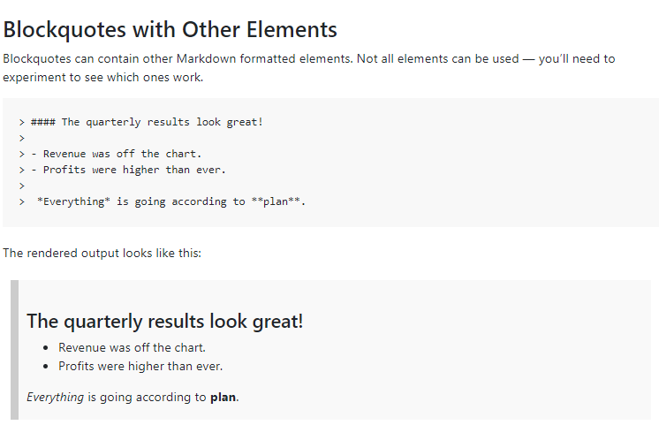

## LIST -ORDERED AND UNORDERED LIST

|  |  |
| --- | --- |
|  |  |
| OUTPUT | OUTPUT |

## IMAGES

### INLINE IMAGES

|  |  |
| --- | --- |
| ![Mars Image](<https://images.unsplash.com/photo-1451188502541-13943edb6acb>) |  |

### REFERENCED IMAGES

|  |  |
| --- | --- |
| Step 1: Create a reference Image  [DemoImage]: https://via.placeholder.com/150/771796 "Placeholder image"  Step 2: Refer the image anywhere in the markdown any number of times using the reference  This is a Place holder Image  ![DemoImage]  ![DemoImage] |  |

## LINKS

|  |  |
| --- | --- |
|  | EXAMPLES  Markdown:  Best Search Engine is [Google](<https://www.google.com/>)  Output |
|  | |

## CODE STYLES AND BLOCKS

* To embed the code in the markdown we use tilde(`)

### INLINE CODE

|  |  |
| --- | --- |
| **MARKDOWN**  To install the node dependencies use `npm install` in the project root | OUTPUT |

### CODE BLOCKS

* To write the code block we use 3 consecutive tilde to start and 3 consecutive tilde to end the code block
* **Alternatively we can use the language as well to write the code blocks for syntax highlighting.As Below.**

|  |  |
| --- | --- |
| ```javascript  let i = 10  ```  ```html  <p>This is HTML text</p>  # It ignores the reserved keyword  ``` |  |

## INLINE HTML

* Markdown supports most of formatting, except few(e.g <) . In those cases we can use inline HTML to get the desired formatting.

## TABLES

|  |  |  |  |  |
| --- | --- | --- | --- | --- |
| **SIMPLE TABLE** | **OUTPUT** | **CENTER ALIGNED** | **RIGHT ALIGNED** | **LEFT ALIGNED** |

# MKDOCS

MkDocs is a **fast**, **simple** and **downright gorgeous** static site generator that's geared towards building project documentation. Documentation source files are written in Markdown, and configured with a single YAML configuration file.



## MKDOCS INSTALLATION

* MkDocs requires a recent version of [Python](https://www.python.org/) and the Python package manager, [pip](https://pip.readthedocs.io/en/stable/installing/), to be installed on your system.

|  |  |
| --- | --- |
| **INSTALLING PIP (Python Package Manager) :**  If you're using a recent version of Python, the Python package manager, [pip](https://pip.readthedocs.io/en/stable/installing/), is most likely installed by default. However, you may need to upgrade pip to the lasted version: | pip install --upgrade pip |
| **INSTALLING MKDOCS (Static Site Generator) :** | pip install mkdocs |
| CHECKINNG MKDOCS VERSION | mkdocs --version |

## CREATING A NEW MKDOCS PROKJECT

|  |  |
| --- | --- |
| **CREATING A NEW PROJECT** | mkdocs new my-project  cd my-project |
| **INITIAL PROJECT STRUCTURE** | The initial MkDocs layout |

## CONFIGS

* There's a single configuration file named mkdocs.yml, and a folder named docs that will contain the documentation source files in the above example – **In the initial project set-up the docs folder just contains a single documentation page, named index.md.**
* MkDocs comes with a built-in dev-server that lets you preview your documentation as you work on it. Make sure you're in the same directory as the mkdocs.yml configuration file, and then start the server by running the mkdocs serve command:

|  |  |
| --- | --- |
| **COMMAND TO START THE DEV SERVER** | **mkdocs serve** |
| * Open up <http://127.0.0.1:8000/>  in your browser, and you'll see the default home page being displayed. * The dev-server also supports auto-reloading, and will rebuild your documentation whenever anything in the configuration file, documentation directory, or theme directory changes. | |

## DEFAULT WELCOME PAGE

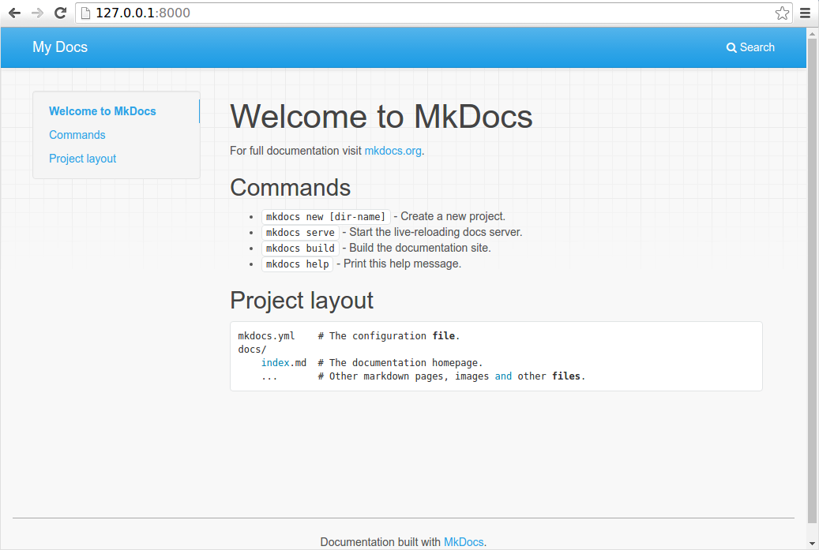

## ADDING PAGES

### MKDOCS.YML

* Project settings are always configured by using a YAML configuration file in the project directory named mkdocs.yml.
* **As a minimum, this configuration file must contain the site_name and site_url settings**. All other settings are optional