Contents

SPRING BOOT 3

WHAT IS SPRING BOOT 3

SPRING BOOT FEATURES 3

BOOTING SPRING BOOT 3

SPRING INITIALIZR 3

SPRING CLI 4

SPRING IDE 4

SPRING BOM 4

SAMLE SPRING BOOT POM.XML 5

SAMPLE SPRING BOOT MAIN CLASS 5

SAMLE PROJECT STRUCTURE 6

REST CONTROLLER 6

SERVICES 7

BEAN 7

SPRING BOOT – BEHIND THE SCENE 8

APPLICATION.PROPERTIES 8

IMPORTANT PROPERTIES 8

COMPONENT SCAN - LOOKUP 8

SPRING BOOT STARTER WEB 9

AUTO CONFIGURATION 9

SPRING JPA 9

CREATING SPRING JPA PROJECT 9

LOGGING IN SPRING BOOT USING SLF4J 10

LOGGING IN CONSOLE 10

LOGGING IN FILE 10

DEPLOYING SPRING APP 11

PACKAGING THE SPRING APP 11

CREATING REST CLIENT 11

SPRING BOOT PROFILES 12

THYMELEAF 12

SUBMITING THE FORM DATA 14

DATABASE CACHING 15

CACHING 15

STEPS TO ENABLE CACHING 16

SWAGGER 16

STEPS TO CREATE A SWAGGER DOCUMENT 16

SWAGGER UI 16

VALIDATION 17

ENABLING VALIDATION 17

SPRING REACTIVE PROGRAMMING 17

CONCEPT OF MONO & FLUX 17

# SPRING BOOT

## SPRING MVC – ON A HIGH LEVEL

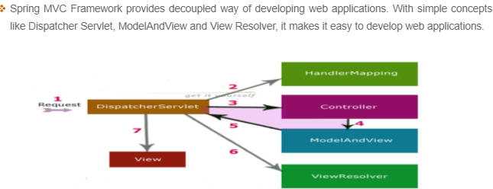

### REQUEST FLOW

1. Request first received by dispatcher servlet
2. Dispatcher servlet takes the help of Handler mapping and get to know the Controller Class name associated with a given request
3. Controller process the request and return the ModelAndView(it contains model data and view name) Object back to the dispatcher servlet.
4. Dispatcher servlet send the model object to the View resolver to get the actual view page
5. Dispatcher servlet – will pass the model to the view page and result is displayed.

## WHAT IS SPRING BOOT

**Spring Boot makes it easy to create stand-alone, production-grade Spring based Applications that you can "just run".**

* We take an opinionated view of the Spring platform and third-party libraries so you can get started with minimum fuss. Most Spring Boot applications need minimal Spring configuration.
* Spring framework is said to be non-invasive means it doesn’t force the programmer to extend or implement any of their pre-defined classes or interface given by Spring boot API
* Spring boot is a light weight framework because of POJO.
* ***Spring boot has an embedded Tomcat – which is bootstrap by Spring boot and deploys the code to tomcat container.***

## SPRING BOOT FEATURES

* **AUTO CONFIGURATION**
  + Spring boot does the configuration for us the type of module we are using . For example – For MVC based application – it configures the Dispatcher Servlet for us. Even for ORM module – we no longer need a to configure Data Source or Transaction Manager – as we use to do in traditional Spring Application.
* **SPRING BOOT STARTERS**
  + This is the parent project of every Spring application and it manages the dependencies.
  + It makes sure that for a particular Spring version correct version of dependent module are downloaded – rather than developer worrying about it.
  + It helps in managing Java version ,Versions of dependencies and default plugin configuration.

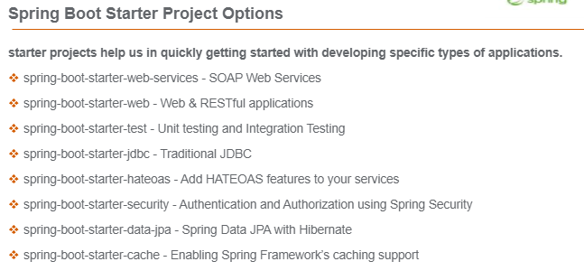

* **EMBEDDED SERVLET CONTAINER**
  + Default container is Tomcat but can be switched to another container like Jetty or Undertow
* **SPRING ACTUATORS**
  + For the” Health Check” of a Spring application. Spring boot has exposed it using multiple endpoints.

## TYPICAL SPRING BOOT ARCHITECTURE

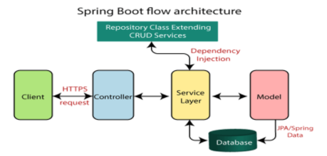

## BOOTING SPRING BOOT

Spring boot can be created in 3 ways

### SPRING INITIALIZR

* The Spring initializr is an online UI on <https://start.spring.io/> which helps us to create a spring boot project.

The gives the configuration to select below items

* The Project Management Tool – Maven /Gradle
* Java Version (8+)
* Dependencies
  + The “Spring web” dependencies are used to create Spring MVC project.
  + “Spring boot Dev tools” helps in hot deployment of Spring App(changes deployed without restarting the server)
* Project specific properties like (Group Id, Artifacts, name)
* Packaging strategies “jar” or war

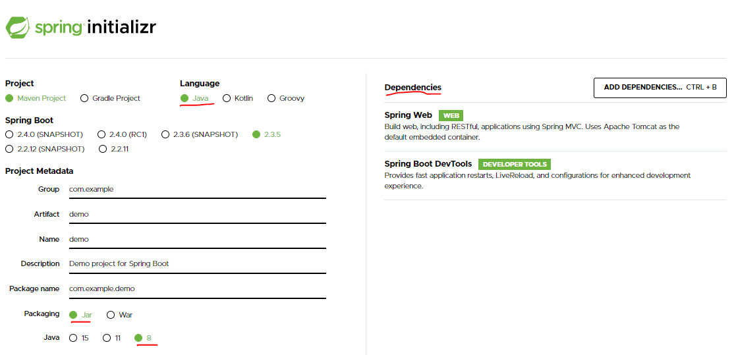

* After the above configuration we can download the zip files and import in a desired editor
* The downloaded zip project will have all the basic classes, configuration and required dependencies

### SPRING CLI

* Spring boot CLI [ <https://docs.spring.io/spring-boot/docs/current/reference/html/getting-started.html#getting-started-installing-the-cli> ]

### SPRING IDE

1. File 🡪 New Maven Project 🡪 create a simple project (without archetype selection)
2. Enter the project details

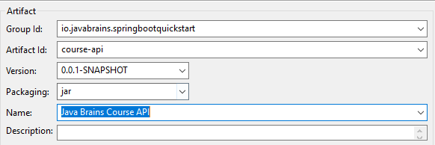

## SPRING BOM

* In our project’s pom.xml we hardly define the dependency . All the default configuration and dependencies and inherited from the parent - **spring-boot-starter-parent**. The project pom just inherits the pom.xml.
* Spring has given “starter” project for each module like “spring-boot-starter-web” for Spring MVC application and ‘spring-boot-starter-data-jpa” for JPA(Hibernate) applications.
* Once these starter projects are added as dependencies – It transitively pulls all the dependent libraries. The list of Jars and its version are listed in the **spring-boot-starter-parent. This version list can be viewed in eclipse in the effective POM**

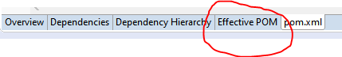

* **The spring-boot-starter-parent project – maintains the version of all the dependencies and its transitive dependencies. Hence Spring call it a BOM(Bills of Material)**

## SAMLE SPRING BOOT POM.XML

* Spring-boot-starter-parent is the parent of all Spring Boot applications.

|  |
| --- |
| <project xmlns="http://maven.apache.org/POM/4.0.0"  xmlns:xsi="http://www.w3.org/2001/XMLSchema-instance"  xsi:schemaLocation="http://maven.apache.org/POM/4.0.0 https://maven.apache.org/xsd/maven-4.0.0.xsd">  <modelVersion>4.0.0</modelVersion>  <groupId>io.javabrains.springbootquickstart</groupId>  <artifactId>course-api</artifactId>  <version>0.0.1-SNAPSHOT</version>  <name>Java Brains Course API</name>  <parent> 🡨 ***Inheritance from Parent POM***  <groupId>org.springframework.boot</groupId>  <artifactId>spring-boot-starter-parent</artifactId>  <version>2.2.2.RELEASE</version>  <relativePath /> <!-- lookup parent from repository -->  </parent>  <dependencies>  <dependency>  <groupId>org.springframework.boot</groupId>  <artifactId>spring-boot-starter-web</artifactId> 🡨 **To support Spring MVC Project**  </dependency>  <dependency>  <groupId>org.springframework.boot</groupId>  <artifactId>spring-boot-devtools</artifactId> 🡨 **Hot deployment**  <scope>runtime</scope>  <optional>true</optional>  </dependency>  </dependencies>  <properties>  <**java.version>1.8</java.version> 🡸 Java Version**  </properties>  <build>  <plugins>  <plugin>  <groupId>org.springframework.boot</groupId>  <artifactId>spring-boot-maven-plugin</artifactId>  </plugin>  </plugins>  </build>  </project> |

## SAMPLE SPRING BOOT MAIN CLASS

|  |
| --- |
| import org.springframework.boot.SpringApplication;  import org.springframework.boot.autoconfigure.SpringBootApplication;  **@SpringBootApplication**  public class CourseApiApp {  public static void main(String[] args) {  SpringApplication.run(CourseApiApp.class, args);  }  } |

The above annotation does below things for us internally

* **SET UP THE DEFAULT CONFIGURATION (AUTO CONFIGURATION)**
* **START THE SPRING APPLICATION CONTEXT** 
  + Application context act as a container of all spring-based components like Controller/ Service / Repositories
  + This manages the life cycle of those components
* **PERFORM THE CLASS PATH SCAN**
  + To manage the spring-based component it must scan the files look for the Annotation which a java can has
  + It manages the components the it has been annotated. For example – the components are marked with @Service annotation are treated as service and spring always treat it as a singleton class.
* **START THE TOMCAT SERVER.**
  + Spring boot has in built tomcat container.
  + Running the Spring boot Application “main” class starts the Tomcat container too.

## SAMLE PROJECT STRUCTURE

|  |  |
| --- | --- |
|  | * The Spring Test Suite are marked by @**SpringBootTest** annotation. * It searches of for an annotation **@SpringBootApplication** – and using this class create a container – with all the beans – so that it can execute all the test cases.   Note: Due to above bean creation steps . Test methods can able to autowire the beans into the test cases. |

### REST CONTROLLER

|  |
| --- |
| **package** io.javabrains.springbootstarter.topic;  **import** java.util.List;  **import** org.springframework.beans.factory.annotation.Autowired;  **import** org.springframework.web.bind.annotation.PathVariable;  **import** org.springframework.web.bind.annotation.RequestBody;  **import** org.springframework.web.bind.annotation.RequestMapping;  **import** org.springframework.web.bind.annotation.RequestMethod;  **import** org.springframework.web.bind.annotation.RestController;  @RestController  **public** **class** TopicController {  @Autowired  **private** TopicService topicService;  @RequestMapping(path = "/topics")  **public** List<Topic> getAllTopics() {  **return** topicService.getAllTopics();  }    @RequestMapping(path = "/topics/{id}")  **public** Topic getTopics(@PathVariable String id) {  **return** topicService.getTopic(id);  }    @RequestMapping(path = "/topics",method = RequestMethod.***POST***)  **public** **void** addTopic(@RequestBody Topic topic) {  topicService.addTopic(topic);  }    @RequestMapping(path = "/topics/{id}",method = RequestMethod.***PUT***)  **public** **void** updateTopic(@RequestBody Topic topic, @PathVariable String id) {  topicService.updateTopic(topic, id);  }    @RequestMapping(path = "/topics/{id}",method = RequestMethod.***DELETE***)  **public** **void** deleteTopic(@RequestBody Topic topic, @PathVariable String id) {  topicService.deleteTopic(topic, id);  }  } |

### SERVICES

If Spring Component is annotated as a service. Spring makes it a Singleton class and creates just one instance of the service which in turn used by multiple controller by auto wiring.

|  |
| --- |
| package io.javabrains.springbootstarter.topic;  import java.util.ArrayList;  import java.util.Arrays;  import java.util.List;  import org.springframework.stereotype.Service;  @Service  public class TopicService {  private List<Topic> topics = new ArrayList<>(Arrays.asList(  new Topic("spring", "Spring Framework", "Spring Framework") ,  new Topic("Java", "Core Java", "Core Java"),  new Topic("springboot", "Spring Boot", "Spring Boot"))  );  public List<Topic> getAllTopics(){  return topics;  }  public Topic getTopic(String id) {  return topics.stream().filter(t -> t.getId().equals(id)).findFirst().get();  }  public void addTopic(Topic topic) {  topics.add(topic);  }  public void updateTopic(Topic topic, String id) {  for(int topicLength = 0 ; topicLength < topics.size() ; topicLength ++) {  Topic topic2 = topics.get(topicLength);  if(topic2.getId().equals(id)) {  topics.set(topicLength, topic);  }  }  }  public void deleteTopic(Topic topic, String id) {  for(int topicLength = 0 ; topicLength < topics.size() ; topicLength ++) {  Topic topic2 = topics.get(topicLength);  if(topic2.getId().equals(id)) {  topics.remove(topicLength);  }  }  }  } |

### BEAN

|  |
| --- |
| **package** io.javabrains.springbootstarter.topic;  **public** **class** Topic {  **private** String id;  **private** String name;  **private** String description;  **public** Topic() { }  **public** Topic(String id, String name, String description) {  **super**();  **this**.id = id;  **this**.name = name;  **this**.description = description;  }  **public** String getId() {  **return** id;  }  **public** **void** setId(String id) {  **this**.id = id;  }  **public** String getName() {  **return** name;  }  **public** **void** setName(String name) {  **this**.name = name;  }  **public** String getDescription() {  **return** description;  }  **public** **void** setDescription(String description) {  **this**.description = description;  }  } |

## SPRING BOOT – BEHIND THE SCENE

* **spring-boot-starter-parent:** 
  + The **Spring boot starter parent** project is parent project which gets inherited by our custom Spring boot project. It has some default configuration which will be inherited by the custom Spring boot app.
  + Due to this inheritance don’t have to do any configuration on a custom app level
* **spring-boot-starter-web**
  + The “**spring-boot-starter-web**” is dependencies we add as a dependencies of custom Spring boot Application . This will download all the web related dependencies. So now adding just one dependencies download all the related web dependencies unlike adding the dependencies individually.

The “**spring-boot-starter-web” dependencies decide what dependency to download but the version of the of those dependencies depends upon the Spring version (Spring boot starter parent)**

* **EMBEDDED TOMCAT:**

## APPLICATION.PROPERTIES

Spring boot project comes with some default configuration. We still can override those default configuration using **application.properties**

### IMPORTANT PROPERTIES

|  |  |
| --- | --- |
| spring.datasource.url  spring.datasource.username  spring.datasource.password  spring.jpa.hibernate.ddl-auto  spring.jpa.database-platform  spring.datasource.driverClassName | DATABASE PROPERTIES |
| server.port | To set custom server port numer |
| spring.jpa.show-sql | Default is FALSE. Set it to TRUE to print the SQL Query |
| server.servlet.context-path | To set the context path of the application. |
| logging.level.root | To set the log level of the application .e.g. logging.level.root=error |

* This url will have all the keys/configuration which can be used in application.properties file : <https://docs.spring.io/spring-boot/docs/current/reference/html/appendix-application-properties.html>

## COMPONENT SCAN - LOOKUP

|  |  |
| --- | --- |
| @SpringBootApplication  **@ComponentScan("com.javabrains")**  public class CourseApiApp {  public static void main(String[] args) {  SpringApplication.run(CourseApiApp.class, args);  }  } | * By default Spring scans the component ,service, controller, repository in its child package * If the Service & component do not reside in the child page. The Spring boot starter class must know the package when it must search. That can be done using @ComponentScan annotation |

## SPRING BOOT STARTER WEB

* The Spring boot started web is leverage to create Spring MVC project and Rest API
* The project has to inherit the starter web project - The inheritance is accomplished in pom.xml file using <parent> tag.

|  |
| --- |
| <parent>  <groupId>org.springframework.boot</groupId>  <artifactId>spring-boot-starter-parent</artifactId>  <version>2.2.2.RELEASE</version>  <relativePath /> <!-- lookup parent from repository -->  </parent> |

## AUTO CONFIGURATION

1. Spring Interface Injection
2. Hot reloading in+6 Spring Boot -> Add dev tools module – spring-boot-devtools
3. Deploy the Spring boot to external web server – Package it as war

## SPRING JPA

* Spring Data JPA is a separate project which lets spring with ORM based application.

### CREATING SPRING JPA PROJECT

|  |  |
| --- | --- |
| * For demo application – We will be using a in memory DB – Apache Derby * Create Spring Starter Project and select below dependencies   + Spring Data JPA   + Apache Derby or MySQL   + Spring Web |  |

#### SAMPLE CRUD JPA PROJECT

|  |  |
| --- | --- |
|  | **ENTITY**  @Entity  public class Product {  **@Id**  **@GeneratedValue(strategy = GenerationType.IDENTITY)**  private int id;  private String name;  private String description;  private Double price;  //setter & getters  } |
| **REPOSITORY INTERFACE**  **public** **interface** ProductRepository **extends** JpaRepository<Product, Integer> {  } | |
| **APPLICATION.PROPERTIES**  spring.datasource.url=jdbc:mysql://localhost:3306/springbasics?useLegacyDatetimeCode=false&serverTimezone=UTC  spring.datasource.username=root  spring.datasource.password=root  spring.jpa.hibernate.ddl-auto=update  spring.jpa.database-platform=org.hibernate.dialect.MySQL5InnoDBDialect  spring.datasource.driverClassName=  com.mysql.cj.jdbc.Driver  spring.jpa.show-sql=true  server.servlet.context-path=/productapi | |
| @RestController  **public** **class** ProductController {  @Autowired  ProductRepository productRepository;  @RequestMapping(value = "/products", method = RequestMethod.***GET***)  **public** List<Product> getProducts() {  **return** productRepository.findAll();  }  @RequestMapping(value = "/products/{id}", method = RequestMethod.***GET***)  **public** Product getProduct(@PathVariable("id") **int** id) {  **return** productRepository.findById(id).get();  }  @RequestMapping(value = "/products", method = RequestMethod.***POST***)  **public** Product createProduct(@RequestBody Product product) {  **return** productRepository.save(product);  }  @RequestMapping(value = "/products", method = RequestMethod.***PUT***)  **public** Product updateProduct(@RequestBody Product product) {  **return** productRepository.save(product);  }  @RequestMapping(value = "/products/{id}", method = RequestMethod.***DELETE***)  **public** **void** deleteProduct(@PathVariable("id") **int** id) {  productRepository.deleteById(id);  }  } | |

## LOGGING IN SPRING BOOT USING SLF4J

### LOGGING IN CONSOLE

Logging in console is the default behavior in Spring boot

|  |
| --- |
| import org.slf4j.Logger;  import org.slf4j.LoggerFactory;  @RestController  public class ProductController {  private static final Logger LOGGER = LoggerFactory.getLogger(ProductController.class) ;  @RequestMapping(value = "/products/{id}", method = RequestMethod.GET)  public Product getProduct(@PathVariable("id") int id) {  LOGGER.info("Finding the product with id="+ id); 🡨 PRINTS THE INFO LOG LEVEL IN CONSOLE  return productRepository.findById(id).get();  }  } |

### LOGGING IN FILE

|  |  |
| --- | --- |
| **OPTION 1**  logging.file.path=logs/temp/  **OPTION 2**  logging.file.name= logs/application.log | * OPTION 1: Specify the log file path using this property. Note that the log file name **is spring.log**. * OPTION 2: Specify the own log file name using this property |

## DEPLOYING SPRING APP

### PACKAGING THE SPRING APP

* The Spring application are standalone application which can run on its own
* **STEPS TO RUN SPRING BOOT APP**
  + Step 1: **mvn clean install** 🡪 This will create a jar/ war file in the target folder of the app
  + Step 2: java -jar <JAR_FILE_NAME>
* PACKAGING SPRING APP
  + The Spring app can be packaged as “jar” or “war” depending upon the pom.xml configuration

|  |  |
| --- | --- |
| PACKAGING AS JAR | PACKAGING AS WAR |
| Packaging as jar can run from command line. | Unlike jar packaging as war need a container where the app can be deployed |

## CREATING REST CLIENT

* Rest Client are the client application which are consumers of REST APIs
* We use RestTemplate Class to create Rest Clients.
* The RestTemplate class gives methods to hit the Rest APIs . These methods are specific to different HTTP methods (GET /POST etc..)- <https://docs.spring.io/spring-framework/docs/current/javadoc-api/org/springframework/web/client/RestTemplate.html>

|  |  |
| --- | --- |
| **HTTP METHODS** | **COMMON REST TEMPLATE METHODS** |
| GET | getForObject() |
| POST | postForObject() |
| PUT | put() |
| DELETE | delete() |

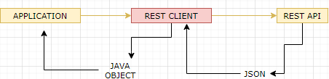

**Note: The object serialization in to JSON and de-serialization from JSON to java object happens automatically**

|  |
| --- |
| **package** com.udemy.spring.product;  **import** **static** org.junit.jupiter.api.Assertions.*assertEquals*;  **import** **static** org.junit.jupiter.api.Assertions.*assertNotNull*;  **import** org.junit.jupiter.api.Test;  **import** org.springframework.boot.test.context.SpringBootTest;  **import** org.springframework.web.client.RestTemplate;  **import** com.udemy.spring.product.entities.Product;  @SpringBootTest  **class** ProductrestapiApplicationTests {  /* GET METHOD REST CLIENT/*  @Test  **public** **void** testGetProduct() {  RestTemplate restTemplate = **new** RestTemplate();  Product product = restTemplate.getForObject("http://localhost:8080/productapi/products/1", Product.**class**);  *assertNotNull*(product);  System.***out***.println(product);  *assertEquals*("IPhone", product.getName());  }  /* POST METHOD REST CLIENT/*  @Test  **public** **void** testCreateProduct() {  RestTemplate restTemplate = **new** RestTemplate();  Product productToBeCreated = **new** Product();  productToBeCreated.setName("Laptop");  productToBeCreated.setDescription("Lenovo Laptop");  productToBeCreated.setPrice(6000d);  Product product = restTemplate.postForObject("http://localhost:8080/productapi/products", productToBeCreated, Product.**class**);  *assertNotNull*(product);  System.***out***.println(product);  *assertEquals*("Laptop", product.getName());  }  /* PUT METHOD REST CLIENT/*  @Test  **public** **void** testUpdateProduct() {  RestTemplate restTemplate = **new** RestTemplate();  Product productToBeUpdated = restTemplate.getForObject("http://localhost:8080/productapi/products/1", Product.**class**);  productToBeUpdated.setPrice(4000d);  restTemplate.put("http://localhost:8080/productapi/products", productToBeUpdated);  }  /* DELETE METHOD REST CLIENT/*  @Test  **public** **void** testDeleteProduct() {  RestTemplate restTemplate = **new** RestTemplate();  restTemplate.delete("http://localhost:8080/productapi/products/8");  }  } |

## SPRING BOOT PROFILES

* For environment (like DEV, PROD, STAGE etc.) specific configuration we use Spring Profiles.

## THYMELEAF

|  |  |
| --- | --- |
| * It’s a templating engine. * Instead of using JSP on the view for a MVC application we use HTML – which can have static and dynamic code – which in turn compiled into static HTML by Thymeleaf templating engine. * Reference : <https://www.thymeleaf.org/doc/tutorials/3.0/usingthymeleaf.html> | Java Template Engines. Introduction | by nderground | HackerNoon.com |  Medium |
| * To create a project having thymeleaf templating engine add the web and thymeleaf dependencies |  |
| * Usually for any code changes in template – We need to restart the container – it happens due to caching. * To avoid the caching add the a property in in application .properties | spring.thymeleaf.cache=false |

|  |  |
| --- | --- |
| import java.util.Arrays;  import java.util.List;  import org.springframework.stereotype.Controller;  import org.springframework.web.bind.annotation.ModelAttribute;  import org.springframework.web.bind.annotation.RequestMapping;  import org.springframework.web.servlet.ModelAndView;  import com.udemy.spring.thymeleafdemo.models.Student;  **@Controller**  public class HelloController {  @RequestMapping("/hello")  public String greetHello() {  return "**hello**";  } | **TEMPLATES**   * All theymeleaf templates should add the below namespace in the html tag. * In this method – we are returning “hello” , hence the file name of the template file is “***hello.html***”   <html xmlns:th=*"http://www.thymeleaf.org/"*> |
| @RequestMapping("/data")  public ModelAndView sendData() {  ModelAndView modelAndView = new ModelAndView("data");  modelAndView.addObject("message", "This is my message");  return modelAndView;  } | ***Rendering a String***   * Template file name : ***data.html***   The message is :  <div th:text=*"${message}"*></div> |
| @RequestMapping("/student")  public ModelAndView getStudent() {  ModelAndView modelAndView = new ModelAndView("**student**");  Student student = new Student();  student.setId(1);  student.setName("John");  modelAndView.addObject("student", student);  return modelAndView;  } | ***Rendering the Object***   * Template file name : ***student.html***   Name<div th:text=*"${student.name}"*></div>  Id <div th:text=*"${student.id}"*></div> |
| @RequestMapping("/students")  public ModelAndView getStudents() {  ModelAndView modelAndView = new ModelAndView("**studentlist**");  Student student = new Student();  student.setId(1);  student.setName("John");  Student student1 = new Student();  student1.setId(2);  student1.setName("Ram");  Student student2 = new Student();  student2.setId(3);  student2.setName("Alex");  List<Student> students = Arrays.asList(student,student1,student2);  modelAndView.addObject("students", students);  return modelAndView;  } | ***Rendering the list of Object***   * Template file name : ***studentlist.html*** * Below table has row – iterating the list of student data.   <table>  <th>ID<th><th>Name<th>  <tr th:each=*"student : ${students}"*> <td th:text=*"${student.id}"*></td> <td th:text=*"${student.name}"*></td></tr>  </table> |

### SUBMITING THE FORM DATA

* In the below application , the form in studentForm.html has been two way binded with Student Object and its property.

Note:

* URL are mapped using @{} – refer URL of form
* Properties are mapped using *{} – Refer inputs field in HTML

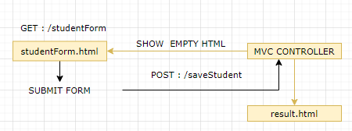

#### CREATING EMPTY FORM

|  |
| --- |
| @RequestMapping("/studentForm")  public ModelAndView displayStudentForm() {  ModelAndView modelAndView = new ModelAndView("**studentForm**");  Student student = new Student();  modelAndView.addObject("student", student);  return modelAndView;  } |
| studentForm.html  <html xmlns:th=*"http://www.thymeleaf.org/"*>  <head>  <title>Student Data</title>  </head>  <body>  <form th:action**=*"@{/saveStudent}"*** th:object=*"${student}"* method=*"post"*>  ID: <input type=*"text"* th:field=*"*{id}"*/>  Name: <input type=*"text"* th:field=*"*{name}"*/>  <input type=*"submit"* value=*"Save"*/>  <input type=*"reset"* value=*"Reset"*/>  </form>  </body>  </html> |

#### DISPLAYING FORM IN RESULT HTML

|  |
| --- |
| @RequestMapping(value = "/saveStudent", method = RequestMethod.***POST***)  **public** ModelAndView saveStudent(@ModelAttribute Student student) {  ModelAndView modelAndView = **new** ModelAndView("result");  modelAndView.addObject("student", student);  **return** modelAndView;  } |
| result.html  <html xmlns:th=*"http://www.thymeleaf.org/"*>  <head>  <title>Data Saved</title>  </head>  <body>  <div th:text=*"${student.id}"*></div>  <div th:text=*"${student.name}"*></div>  </body>  </html> |

## DATABASE CACHING

* When client access our application, our application, which uses ORM tools like hibernate to read the data from the database, will execute a **select query internally** on the database table to retrieve the data.
* The **data** is then converted into an **object**, which is then passed to our application, which then sends it back to the client as required.
* Every time a client requests data from our application or ORM tool, the select statement will be executed, and the process will repeat again.
* Instead of repeatedly performing the same read operation, we employ **caching or a cache**.

### CACHING

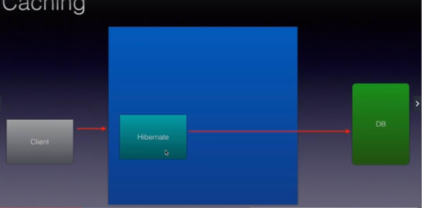

* **Caching** stores data or objects in temporary locations. When a request comes in for the **first time**, this ORM tool or the caching framework will read the data, transform it to an object, and store it in a temporary location or on disc.
* The next time a request comes in, these ORM frameworks will check to see if the data for that request is already in the cache. If it exists, **no database select queries or database communication will be performed; simple take the object from cache, process it, and return it to the client**.
* There multiple cache provider link “**HazelCast” or “EhCache**”.
* When the objects start getting stored in the cache . if the cache size increases beyond a limit might crash the application – hence the cache needs to be cleared. This process is called “**Eviction**”. There are different policy to clear the cache like LRU, LFU, RANDOM, NONE

### STEPS TO ENABLE CACHING

1. **ADDING DEPENDENCIES**
2. **CREATE CACHE CONFIGURATION**
3. **ENABLE AND USE CACHING**
4. **EVICT CACHE**

#### ADDING MAVEN DEPEPENDCIES

<dependency>

<groupId>org.springframework.boot</groupId>

<artifactId>spring-boot-starter-cache</artifactId>

</dependency>

<dependency>

<groupId>com.hazelcast</groupId>

<artifactId>hazelcast</artifactId>

</dependency>

<dependency>

<groupId>com.hazelcast</groupId>

<artifactId>hazelcast-spring</artifactId>

</dependency>

#### CREATE CACHE CONFIGURATION

## SWAGGER

* It’s a way to document the Restful webservice – which show how the request -response will look like for an exposed restful webservices in JSON or YAML format.
* These documents are generated from the source code or can be handwritten using some Swagger Editor
* For handwritten use Swagger Editor : <https://editor.swagger.io/>

### STEPS TO CREATE A SWAGGER DOCUMENT

#### ADD MAVEN DEPENDENCY

* Add latest Swagger Maven dependency : <https://mvnrepository.com/artifact/io.springfox/springfox-swagger2>
* Example

<dependency>

<groupId>io.springfox</groupId>

<artifactId>springfox-swagger2</artifactId>

<version>3.0.0</version>

</dependency>

#### ENABLE SWAGGER

|  |  |
| --- | --- |
| Enable swagger from the Main Class using  @EnableSwagger2 annotation | @SpringBootApplication  @EnableSwagger2  **public** **class** ProductrestapiApplication {  **public** **static** **void** main(String[] args) {  SpringApplication.*run*(ProductrestapiApplication.**class**, args);  }  } |

#### ACCESS SWAGGER ENDPOINT

* Access the swagger endpoint at : **/v2/api-docs**
* Example : <http://localhost:8080/productapi/v2/api-docs>

### SWAGGER UI

#### STEPS TO CREATE A SWAGGER UI DOCUMENT

#### ADD MAVEN DEPENDENCY

* Add latest Swagger Maven dependency : <https://mvnrepository.com/artifact/io.springfox/springfox-swagger-ui>
* Example

<dependency>

<groupId>org.springdoc</groupId>

<artifactId>springdoc-openapi-ui</artifactId>

<version>1.5.10</version>

</dependency>

#### ENABLE SWAGGER

|  |  |
| --- | --- |
| Enable swagger from the Main Class using  @EnableSwagger2 annotation | @SpringBootApplication  @EnableSwagger2  **public** **class** ProductrestapiApplication {  **public** **static** **void** main(String[] args) {  SpringApplication.*run*(ProductrestapiApplication.**class**, args);  }  } |

#### ACCESS SWAGGER UI ENDPOINT

* Access the swagger endpoint at: **/swagger-ui.html**
* Example : <http://localhost:8080/productapi/swagger-api.html>

## VALIDATION

Spring boots provides annotation to validate the request data/format before it is processed.

### ENABLING VALIDATION

**ADD MAVEN DEPENDENCIES**

<dependency>

<groupId>org.springframework.boot</groupId>

<artifactId>spring-boot-starter-validation</artifactId>

</dependency>

# SPRING REACTIVE PROGRAMMING

|  |  |
| --- | --- |
| MAVEN  <dependencies>  <dependency>  <groupId>org.springframework.boot</groupId>  <artifactId>**spring-boot-starter-webflux**</artifactId>  </dependency>  <dependency>  <groupId>io.projectreactor</groupId>  <artifactId>**reactor-test**</artifactId>  <scope>test</scope>  </dependency>  </dependencies> | **ADDING DEPENDECIES in STS** |

## CONCEPT OF MONO & FLUX