Architecture diagram:

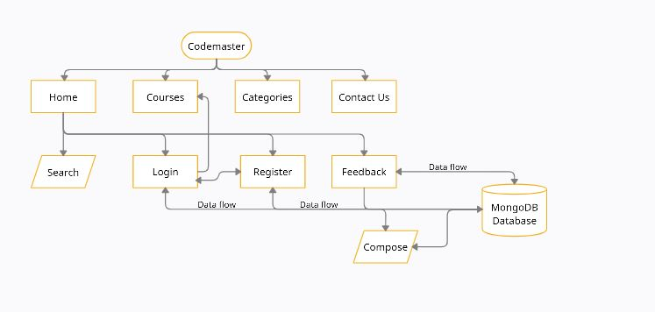

Modules:

Home Module:

Get Access to courses on programming languages for FREE !

Courses Module:

All the programming courses available in our website is listed here.

Categories module:

You can choose a category like Latest technologies or web development?

Feedback module:

Users can share their views about the website and developments for the website.

Search Module:

Search for a particular language in the search bar.

Register module:

Doesn’t have an account register to access the courses page(Sign up followed by Sign in).

Login module:   
 If you already have an account then sign in to access the courses page.

The First page visible to the user as soon as he opens the codemaster website is the Home page.

It consist of many modules like Home,Courses,Categories,Feedback,Search,Register and Login.From Register form the user can access the login form and vice versa.Datas from Login,Register and Feedback forms are stored in MongoDB database.

.