Workers' Compensation Claims & Operational Performance Analytics
Role: Business Analyst | Data Analyst
An end-to-end business analytics project analysing 100,100 workers' compensation claims across 8,000 members. The project transforms raw claims data into actionable business insights through Python data cleaning, SQL exploratory analysis, and an interactive Tableau dashboard.
🔗 Live Tableau Dashboard: View Dashboard
🗄️ Dataset: Workers' Compensation Claims Data - generated by ChatGPT.

1. Business Requirement
The organisation needed better visibility into its workers' compensation claims to understand financial exposure, workplace injury patterns, employee recovery timelines, and claims processing efficiency.
Management required a centralised reporting solution to answer questions such as:
- Which injury causes contribute to the highest claim volumes and financial costs?
- How much money remains outstanding across Open and Pending claims?
- Which injury types result in longer employee recovery periods?
- Which claims management teams experience the greatest review delays?
- Are system issues associated with increased claims rework?
- Which injury cause takes the longest to close?
- How can claims lodgement and processing delays be reduced?
Business Objective: Develop an interactive analytical solution that enables management to monitor claims performance, identify operational inefficiencies, understand financial liabilities, and make informed decisions around workplace safety and claims management.

2. Project Overview & Workflow
The project followed an end-to-end analytics workflow:
- Data Cleaning – Python: Cleaned, standardised, validated, and prepared the raw claims dataset using Pandas and NumPy.
- Data Validation – Python: Checked duplicate claims, missing values, date inconsistencies, invalid financial values, and business logic.
- Database Integration – Azure SQL Edge: Loaded the cleaned dataset into a SQL database running through Docker.
- Exploratory Data Analysis – SQL: Used SQL queries, aggregations, CTEs, window functions, and statistical measures to investigate claims performance.
- Dashboard Development – Tableau: Built an interactive dashboard to communicate key findings and business performance indicators.
- Business Recommendations: Translated analytical findings into actionable recommendations for management.

3. Dataset Overview
The original dataset contained 100,100 records and 33 columns.
After cleaning and removing duplicate claim records, the final dataset contained:

Metric | Result
Initial records | 100,100
Duplicate records removed | 100
Final records | 100,000
Unique members | 8,000
Total claims | 100,000
Original columns | 33
Final columns | 34
Key Data Categories:
- Claim Information: Claim ID, Member ID, Claim Status.
- Dates: Injury Date, Lodgement Date, Closure Date, Last Review Date.
- Member Information: Member Sector, Region, Workforce Size.
- Injury Information: Injury Type, Body Region, Injury Severity, Cause of Injury.
- Financial Information: Paid Amount, Outstanding Reserve, Incurred Cost.
- Recovery Information: Days Lost, Return-to-Work Status, Return-to-Work Days.
- Operational Information: Team, Review Count, Processing Days, Rework Count.
- Quality & System Information: QA Result, System Issue Flag, Overdue Review Flag, High Cost Claim Flag.
📸 Dataset Preview
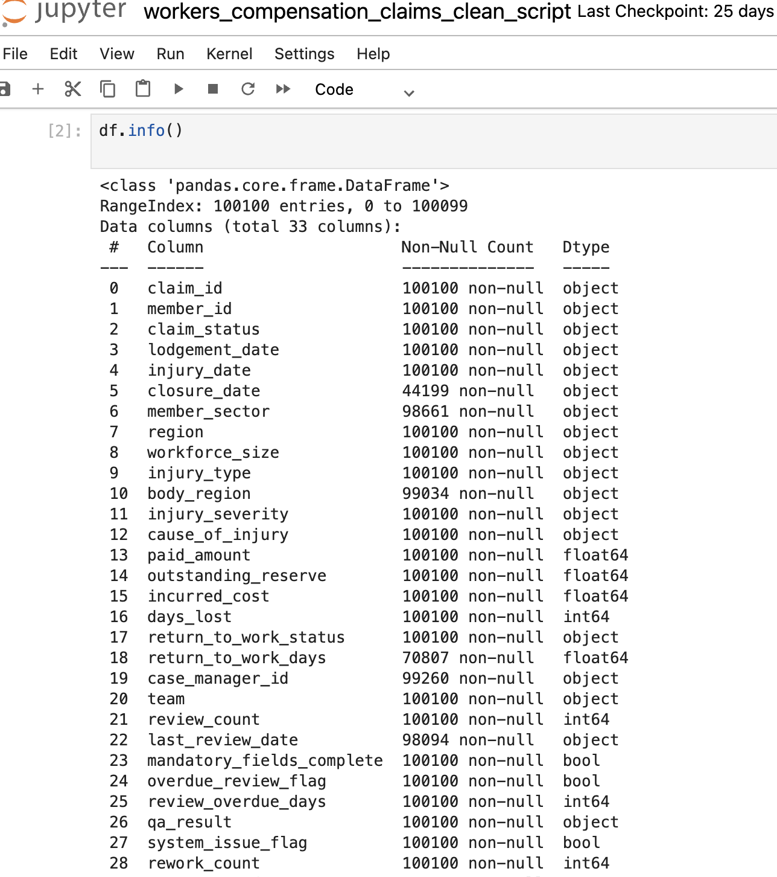
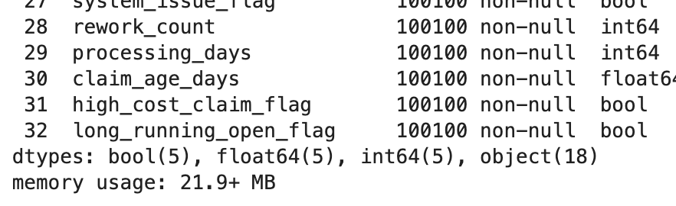

4. Data Cleaning & Preparation – Python
Tools: Python, Pandas, NumPy
The raw CSV dataset was imported into a Pandas DataFrame for data cleaning and preparation.

Step 1: Initial Data Inspection
Inspected the dataset using df.info() and df.isna().sum() to understand:
- Number of records and columns.
- Data types of each column.
- Missing values across the dataset.
- Memory usage and general data quality.
📸 Screenshot: Initial Dataset Inspection
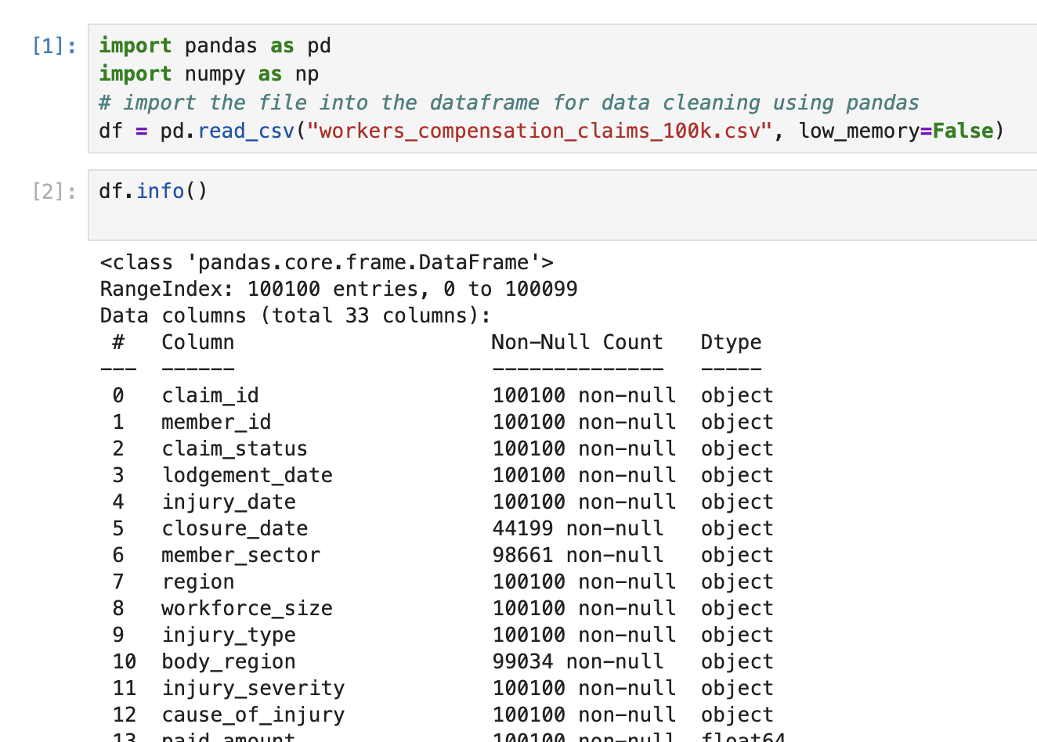
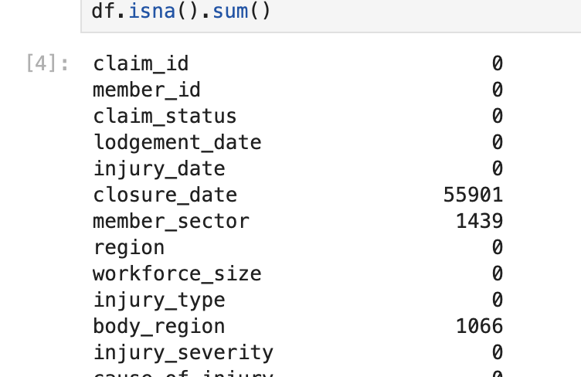

Step 2: Column Name & Text Standardisation
Standardised column names by:
- Removing leading and trailing spaces.
- Converting column names to lowercase.
- Replacing special characters and spaces with underscores.
Standardised text fields by:
- Removing unnecessary whitespaces.
- Replacing inconsistent representations of missing values with proper null values.
- Converting categorical values to a consistent format.
- Standardising claim statuses, injury severity, return-to-work statuses, and QA results.
- Restoring conventional Australian region abbreviations such as NSW, VIC, QLD, and WA.

📸 Screenshot: Standardised Columns & Categories
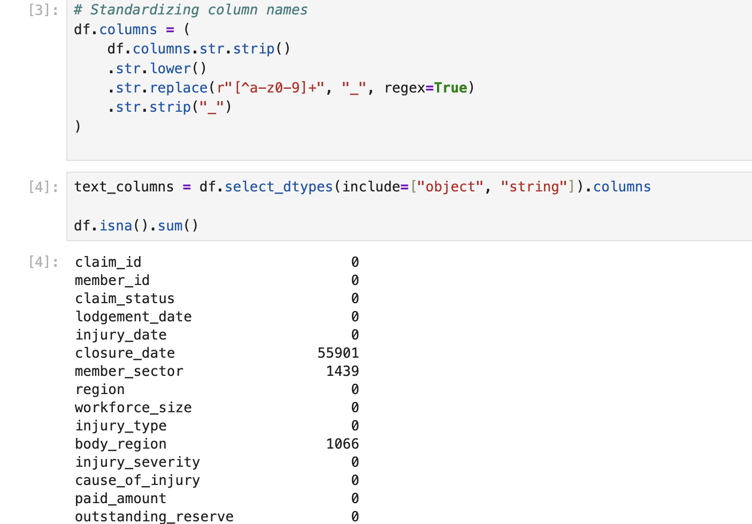
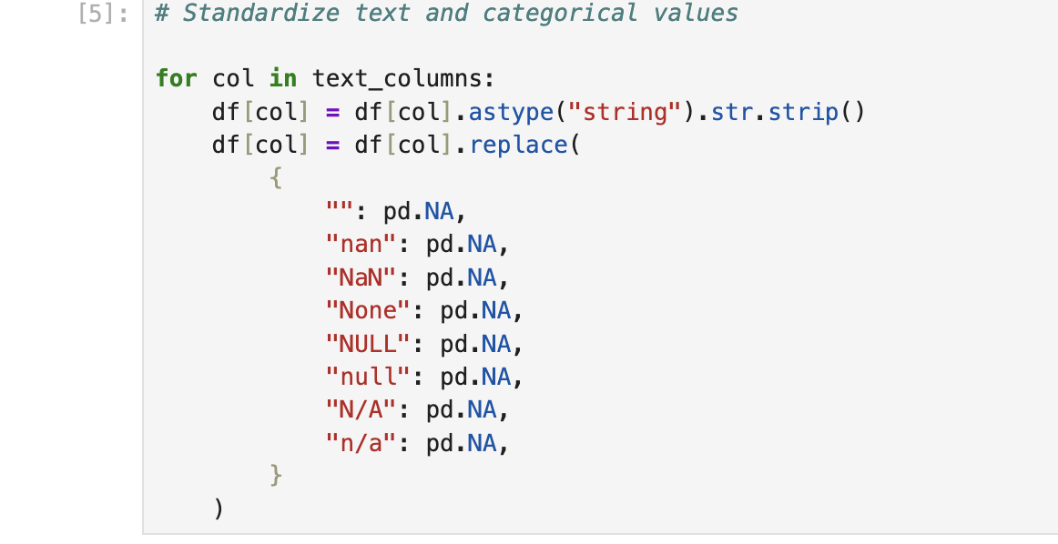
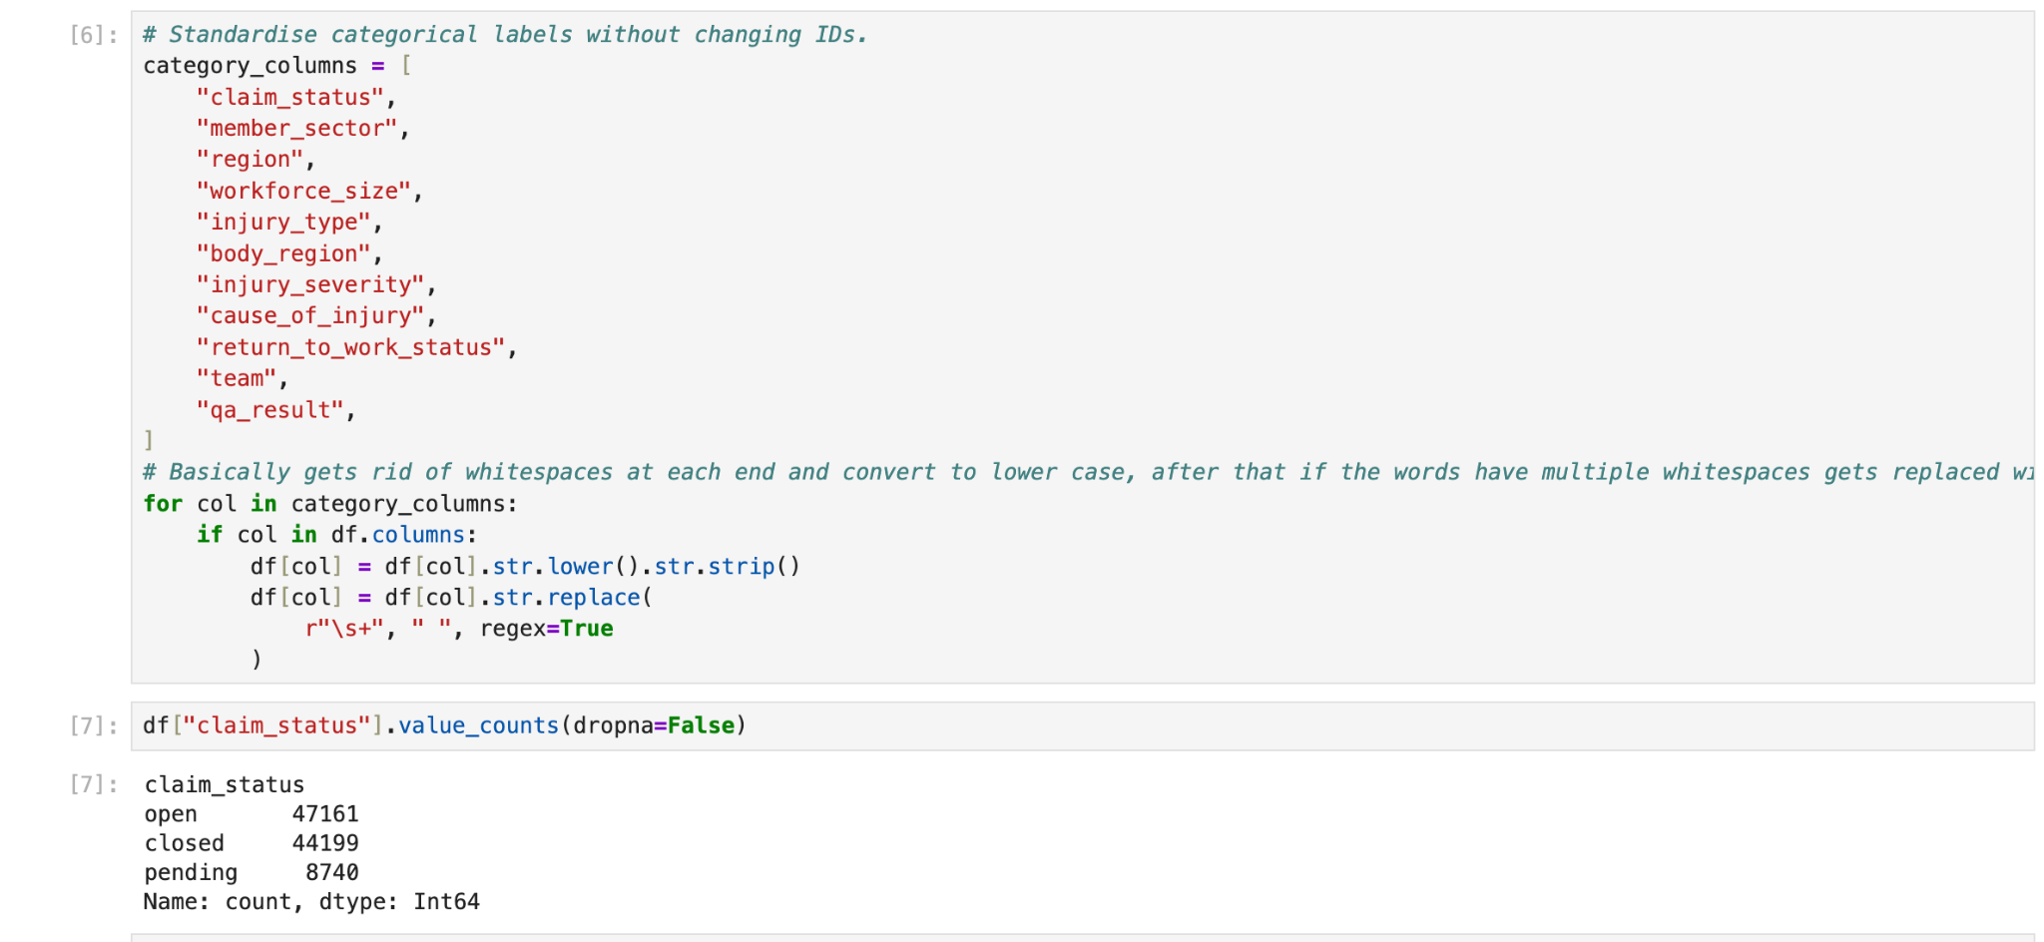
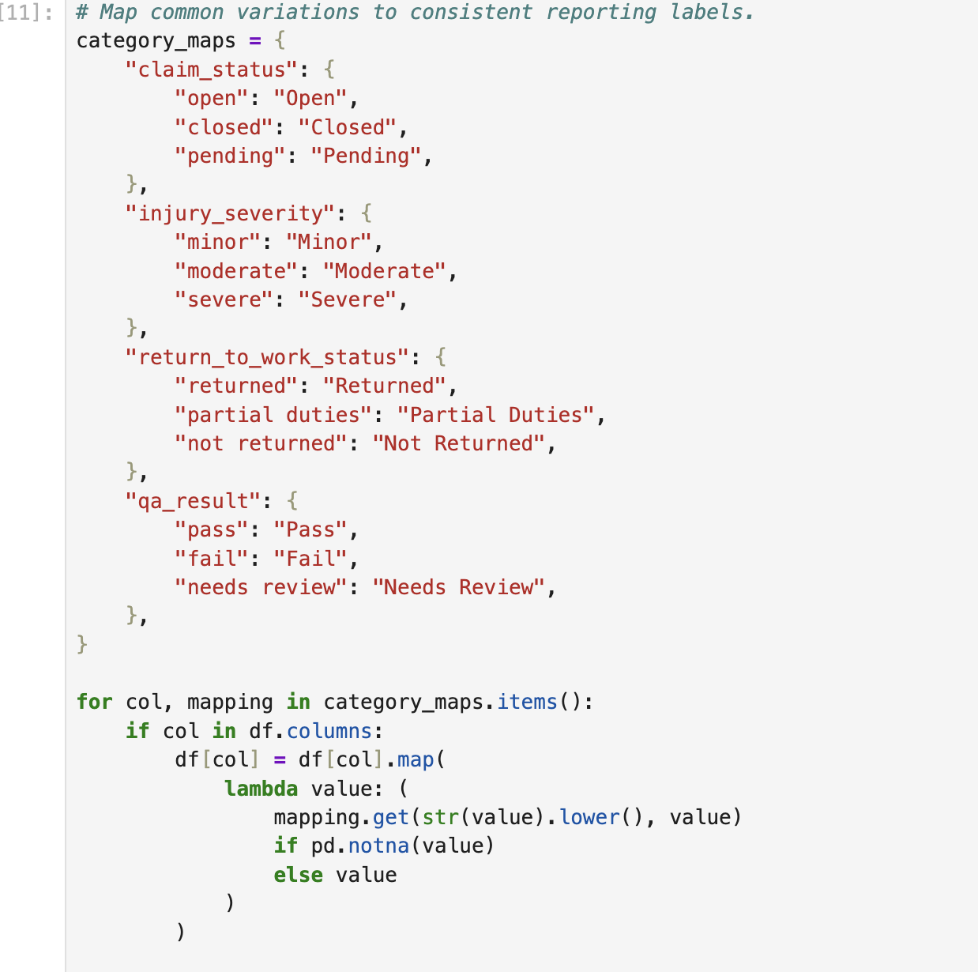

Step 3: Duplicate Identification & Removal
Identified duplicate claim records using claim_id.
- Removed duplicate claim IDs while retaining the first occurrence.
- Removed any remaining exact duplicate rows.
Result: 100 duplicate records removed, leaving 100,000 unique claims.
📸 Screenshot: Duplicate Removal
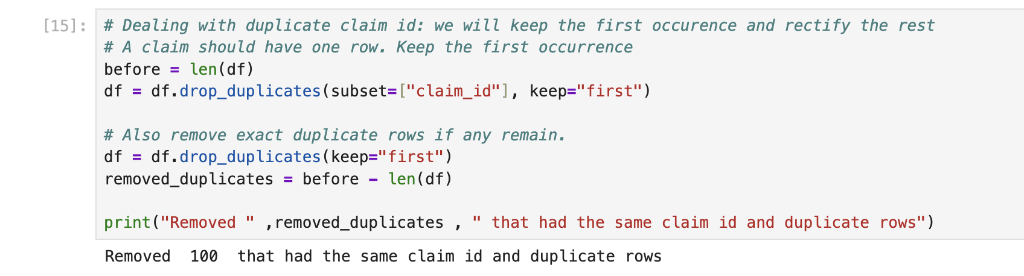
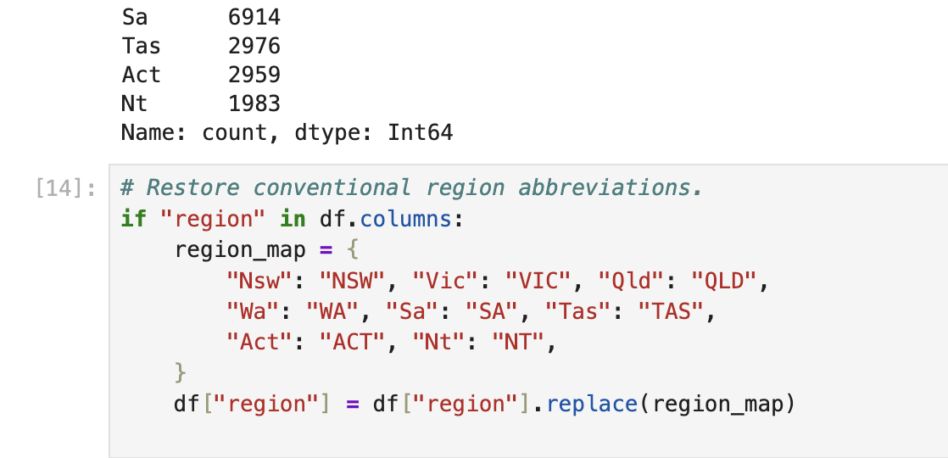

Step 4: Date Standardisation & Validation
Converted the following columns into proper datetime formats:
- Injury Date
- Lodgement Date
- Closure Date
- Last Review Date
Additional validation included:
- Identifying dates occurring after the dataset snapshot date of 13 October 2026.
- Checking whether injury dates occurred after lodgement dates.
- Checking whether closed claims had missing closure dates.
- Checking whether open or pending claims incorrectly contained closure dates.
The validation checks showed no injury-after-lodgement issues, no closed claims without closure dates, and no open or pending claims with closure dates.

📸 Screenshot: Date Validation
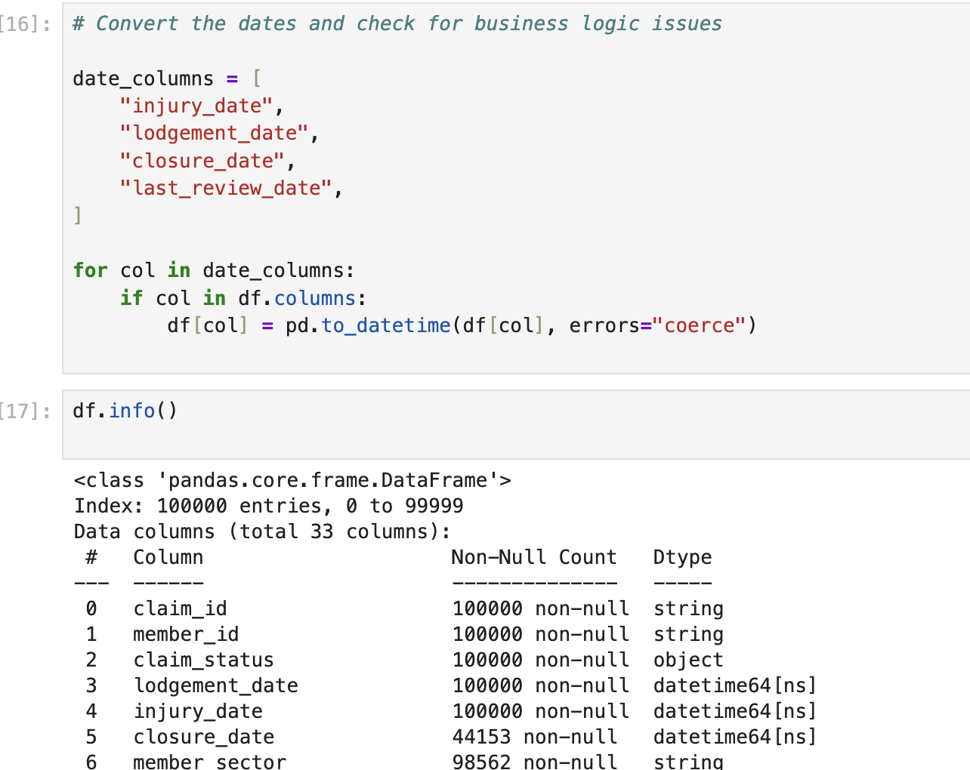
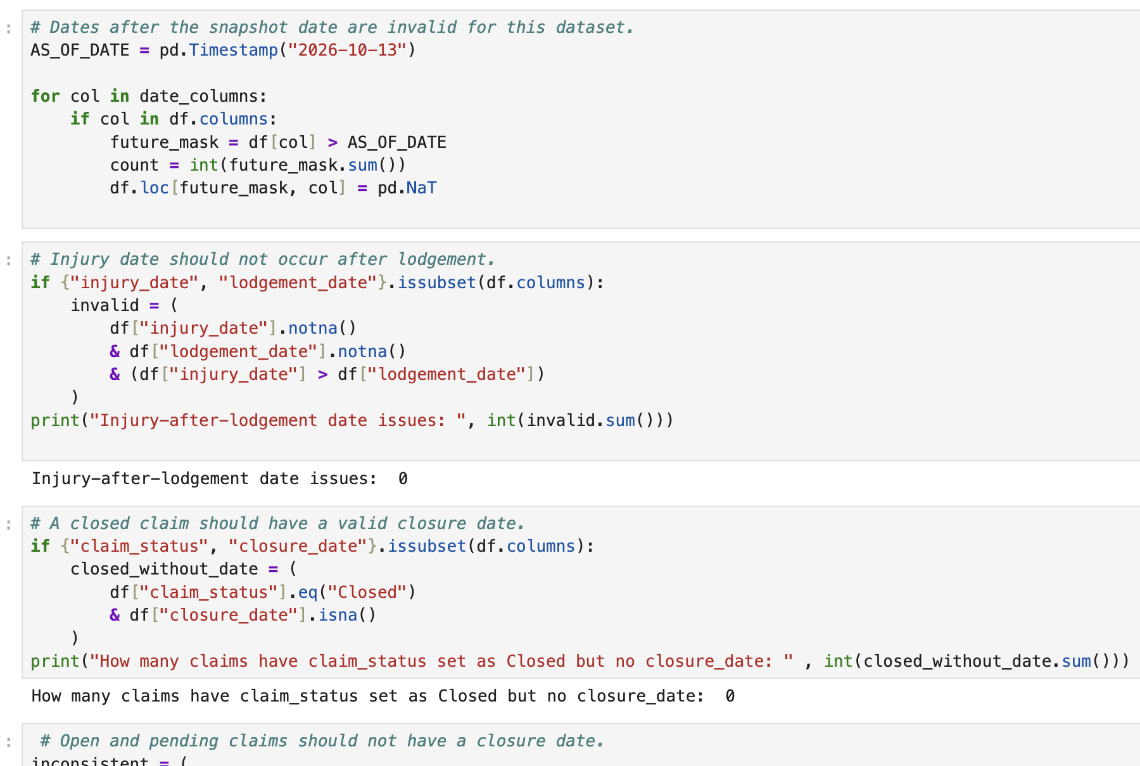
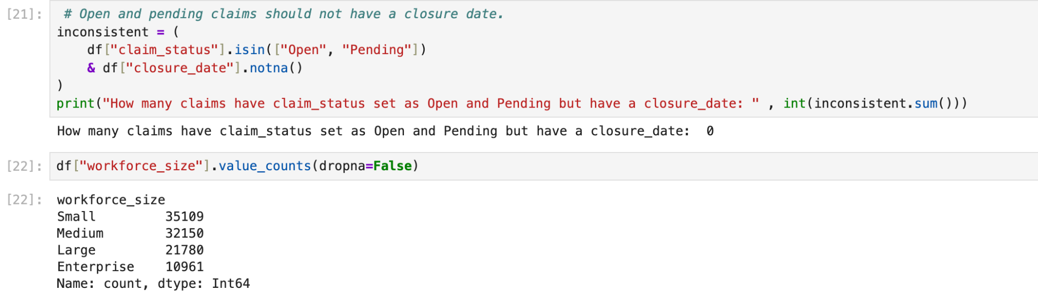

Step 5: Numerical Data Validation
Converted financial and operational columns into appropriate numeric formats.
Validated the following fields:
- Paid Amount
- Outstanding Reserve
- Incurred Cost
- Days Lost
- Return-to-Work Days
- Review Count
- Review Overdue Days
- Processing Days
- Rework Count
- Claim Age Days
Negative values were treated as invalid for these measures and replaced with null values.
Result: 250 negative values were identified and replaced with nulls in the days_lost column.

📸 Screenshot: Numerical Validation
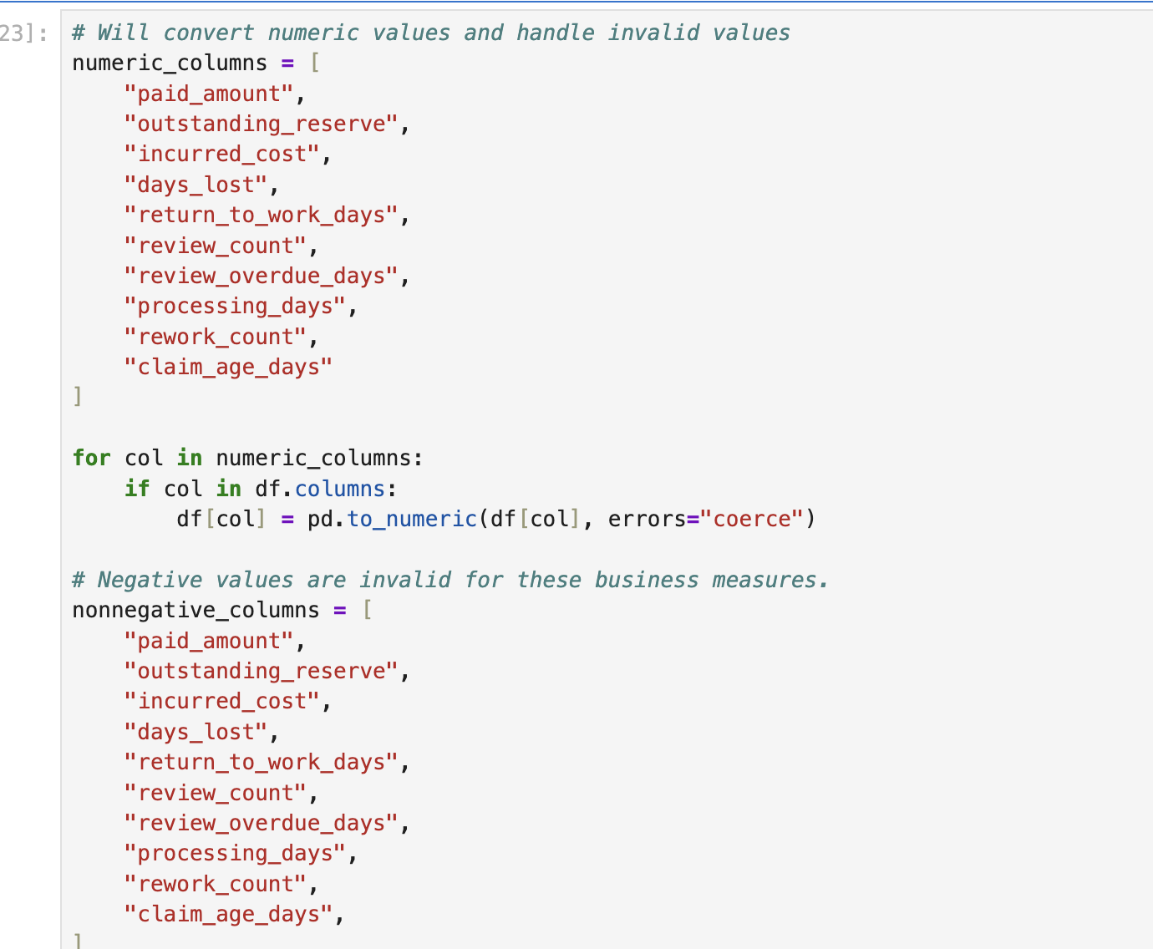
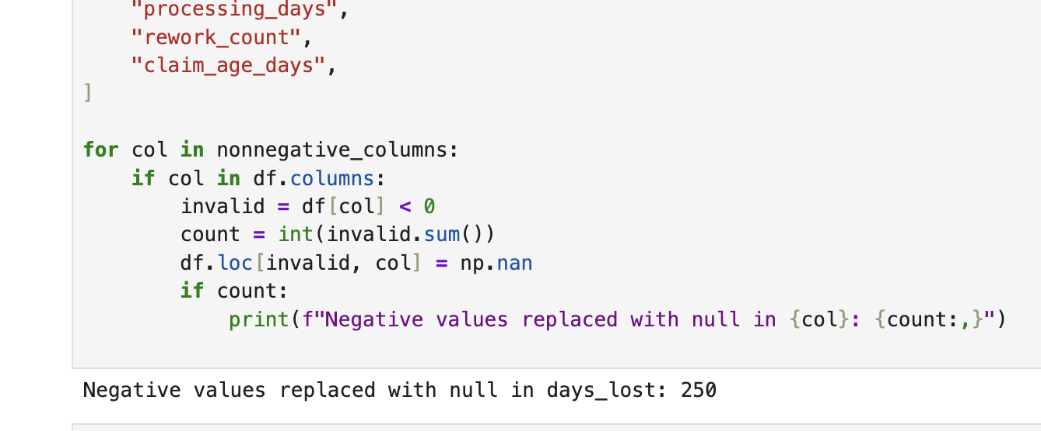

Step 6: Missing Value Handling
Handled missing categorical values by replacing them with Unknown where appropriate.
Missing descriptive information was addressed in fields such as:
- Member Sector
- Region
- Workforce Size
- Injury Type
- Body Region
- Injury Severity
- Cause of Injury
- Return-to-Work Status
- Team
- QA Result
Missing IDs and dates were not artificially populated.
📸 Screenshot: Missing Value Handling
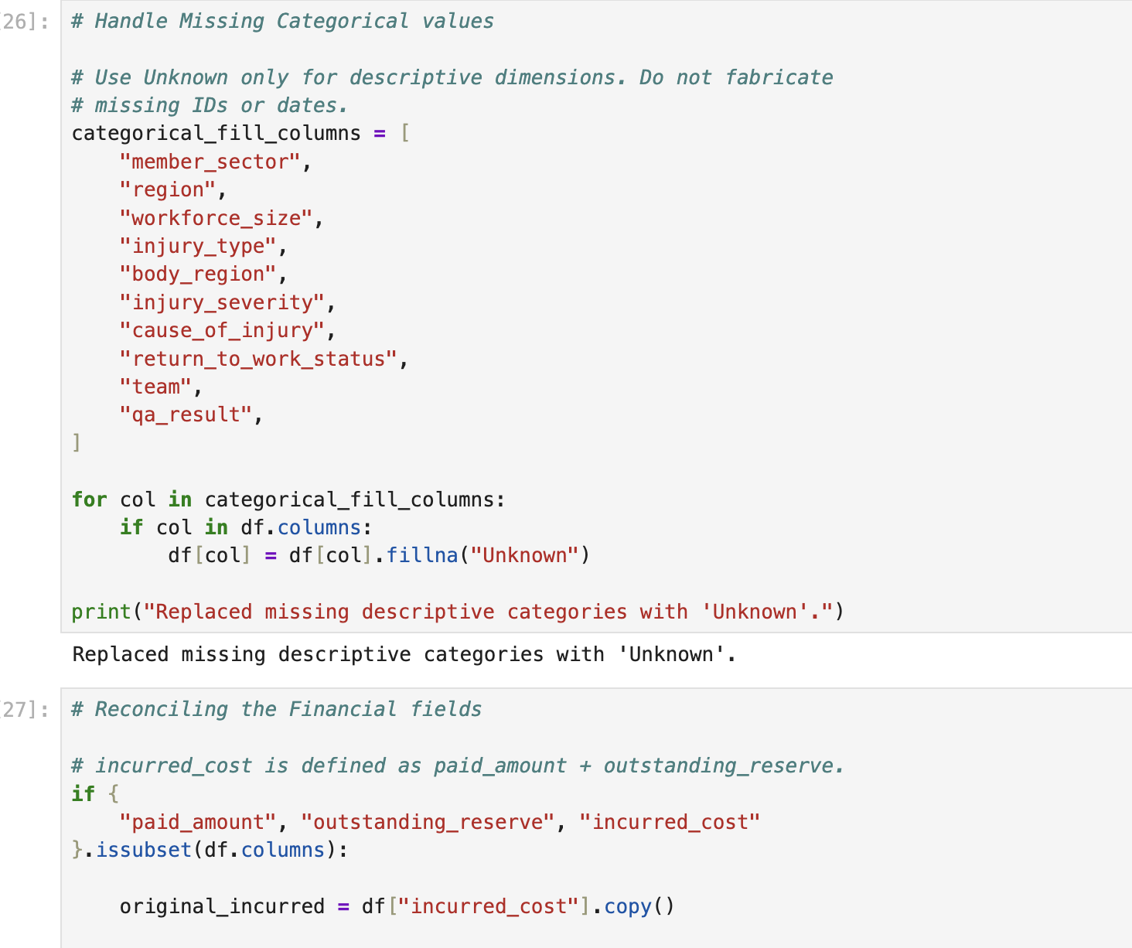

Step 7: Financial Data Reconciliation
Validated the relationship between the financial fields.
The dataset's business rule defines:
Incurred Cost = Paid Amount + Outstanding Reserve
Recalculated incurred costs and checked for mismatches.
Result: No incurred-cost mismatches were identified.
Also introduced a validation flag to identify closed claims with outstanding reserves, rather than silently overwriting potentially inconsistent financial values.
📸 Screenshot: Financial Reconciliation
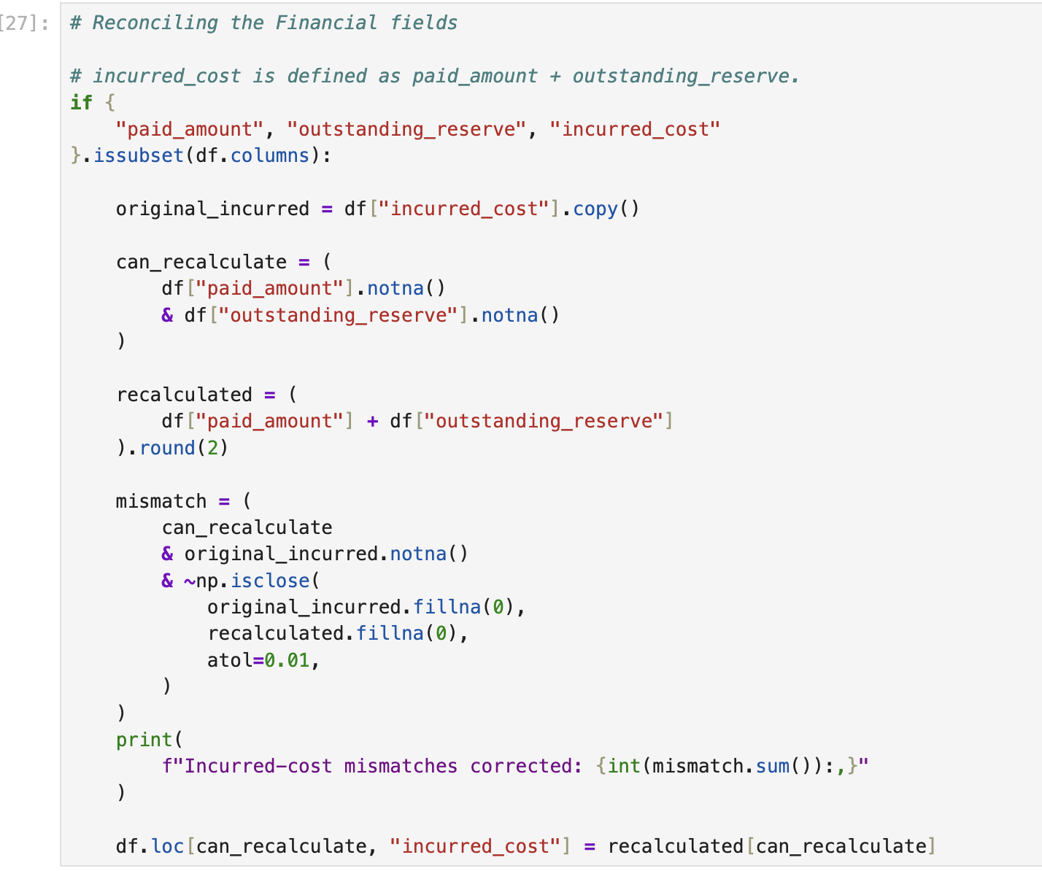

Step 8: Final Dataset Inspection
Performed a final inspection of the cleaned DataFrame to confirm:
- 100,000 records remained.
- All 33 original columns were retained.
- One additional data quality flag was introduced.
- Date, numerical, categorical, and Boolean columns had appropriate data types.
- Missing descriptive categories were handled consistently.
Final Output: 100,000 records and 34 columns.
📸 Screenshot: Final Cleaned Dataset
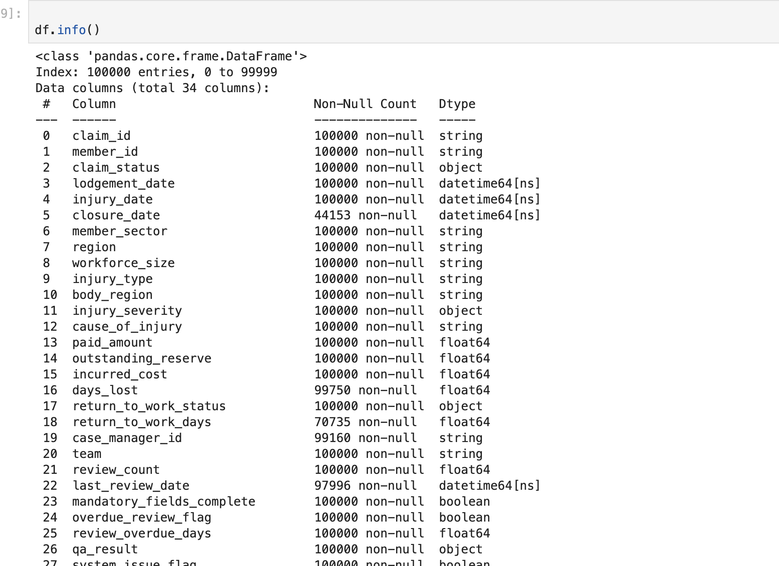

5. Database Integration – Azure SQL Edge
Tools: Azure SQL Edge, Docker, SQLAlchemy, PyMSSQL
After completing the data cleaning process, the final dataset was loaded into an Azure SQL Edge database running inside a Docker container.

Steps Performed
- Established a connection between Python and Azure SQL Edge using SQLAlchemy.
- Verified the database connection.
- Created the worker_compensation_claims table.
- Loaded the cleaned DataFrame into the database using Pandas to_sql().
- Exported a separate cleaned CSV file for future use.
Database: worker_compensation_claims_db
Table: worker_compensation_claims
📸 Screenshot: Successful Database Connection
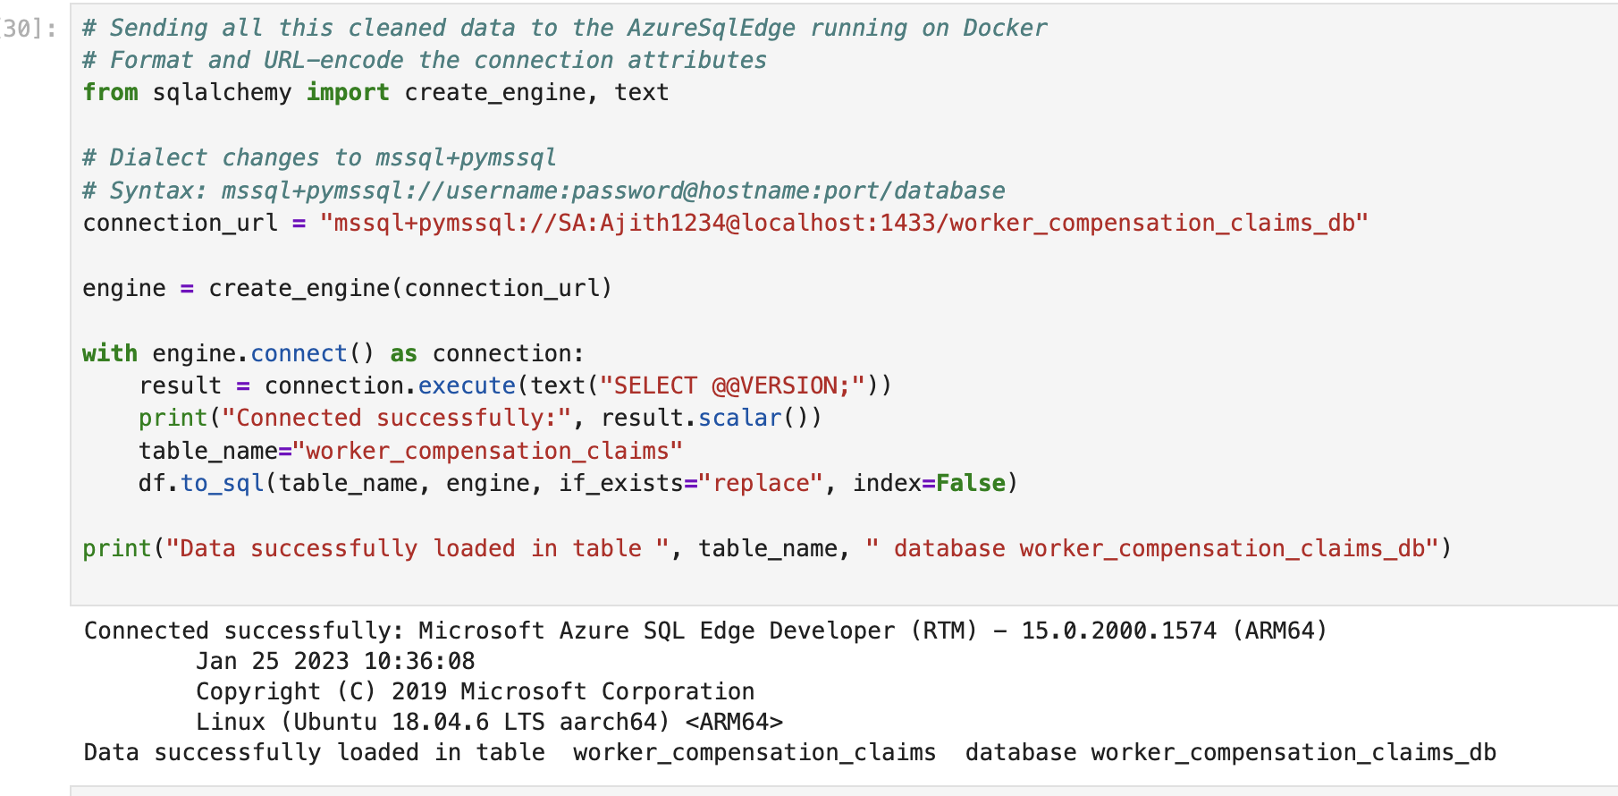

📸 Screenshot: Data Loaded into SQL Table
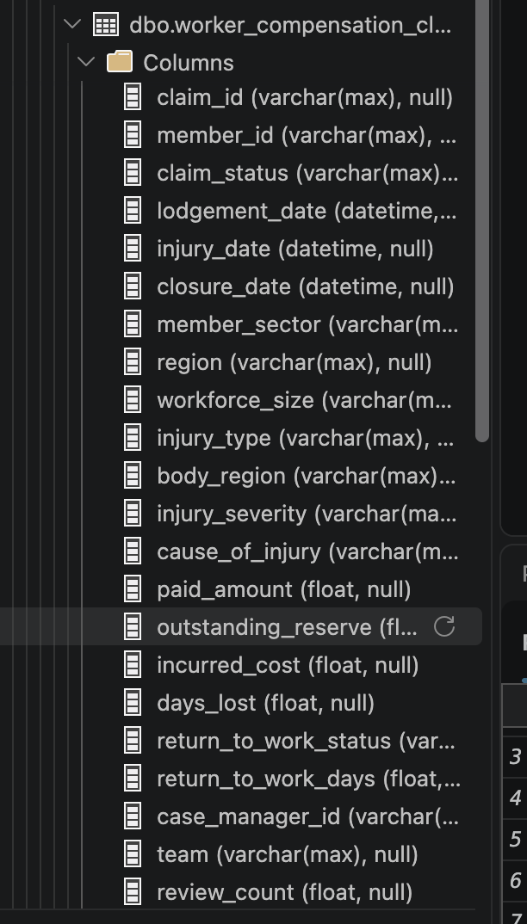

6. Exploratory Data Analysis – SQL
Tools: T-SQL, Azure SQL Edge
Once the cleaned data was available in SQL, I performed exploratory analysis to identify financial, operational, and workplace injury trends.
The analysis focused on the following business questions.

6.1 Claims Portfolio Overview
Investigated:
- Total unique members.
- Total claims.
- Distribution of Open, Pending, and Closed claims.
- Percentage contribution of each claim status.
Key Finding:
- 8,000 unique members.
- 100,000 claims.
- 47.11% Open claims.
- 44.15% Closed claims.
- 8.73% Pending claims.
📸 Screenshot: Claims Overview SQL Query & Results
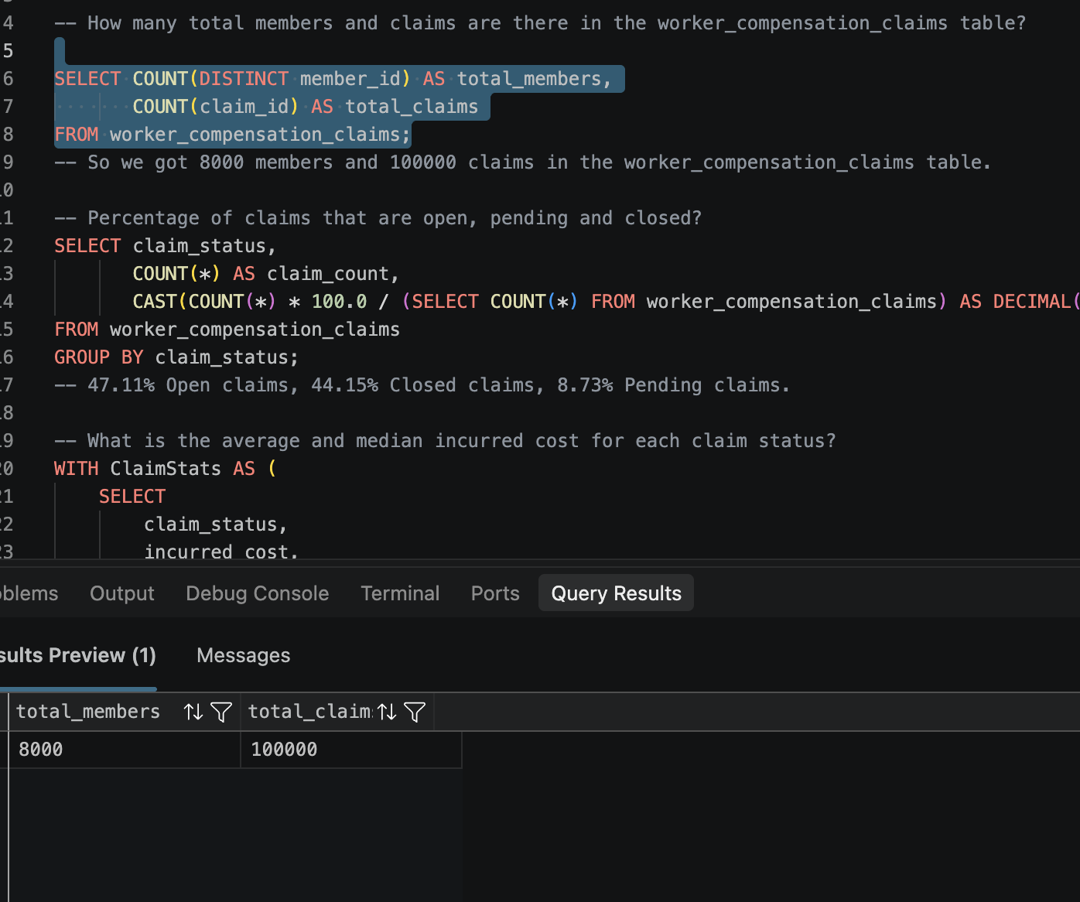
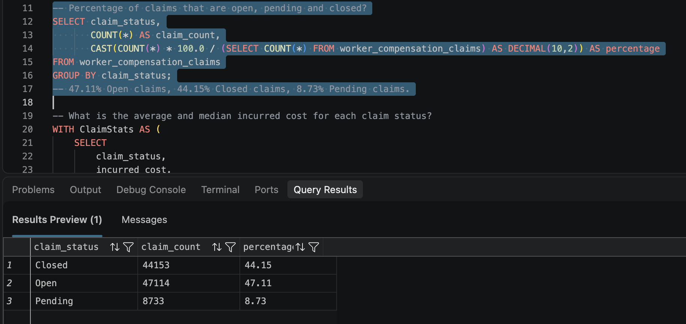

6.2 Financial Exposure Analysis
Investigated:
- Average incurred cost by claim status.
- Median incurred cost by claim status.
- Outstanding settlement reserves for Open and Pending claims.
- Outstanding reserves for Closed claims.
Key Findings:
- Open claims have an average incurred cost of approximately $18,000.
- Pending and Closed claims have average incurred costs of approximately $11,500.
- Open claims have a median incurred cost of approximately $6,047.
- Pending and Closed claims have median incurred costs of approximately $3,980.
- Open and Pending claims have approximately $663.95 million in outstanding reserves.
- Closed claims have $0 in outstanding reserves.

📸 Screenshot: Financial Analysis SQL Query & Results
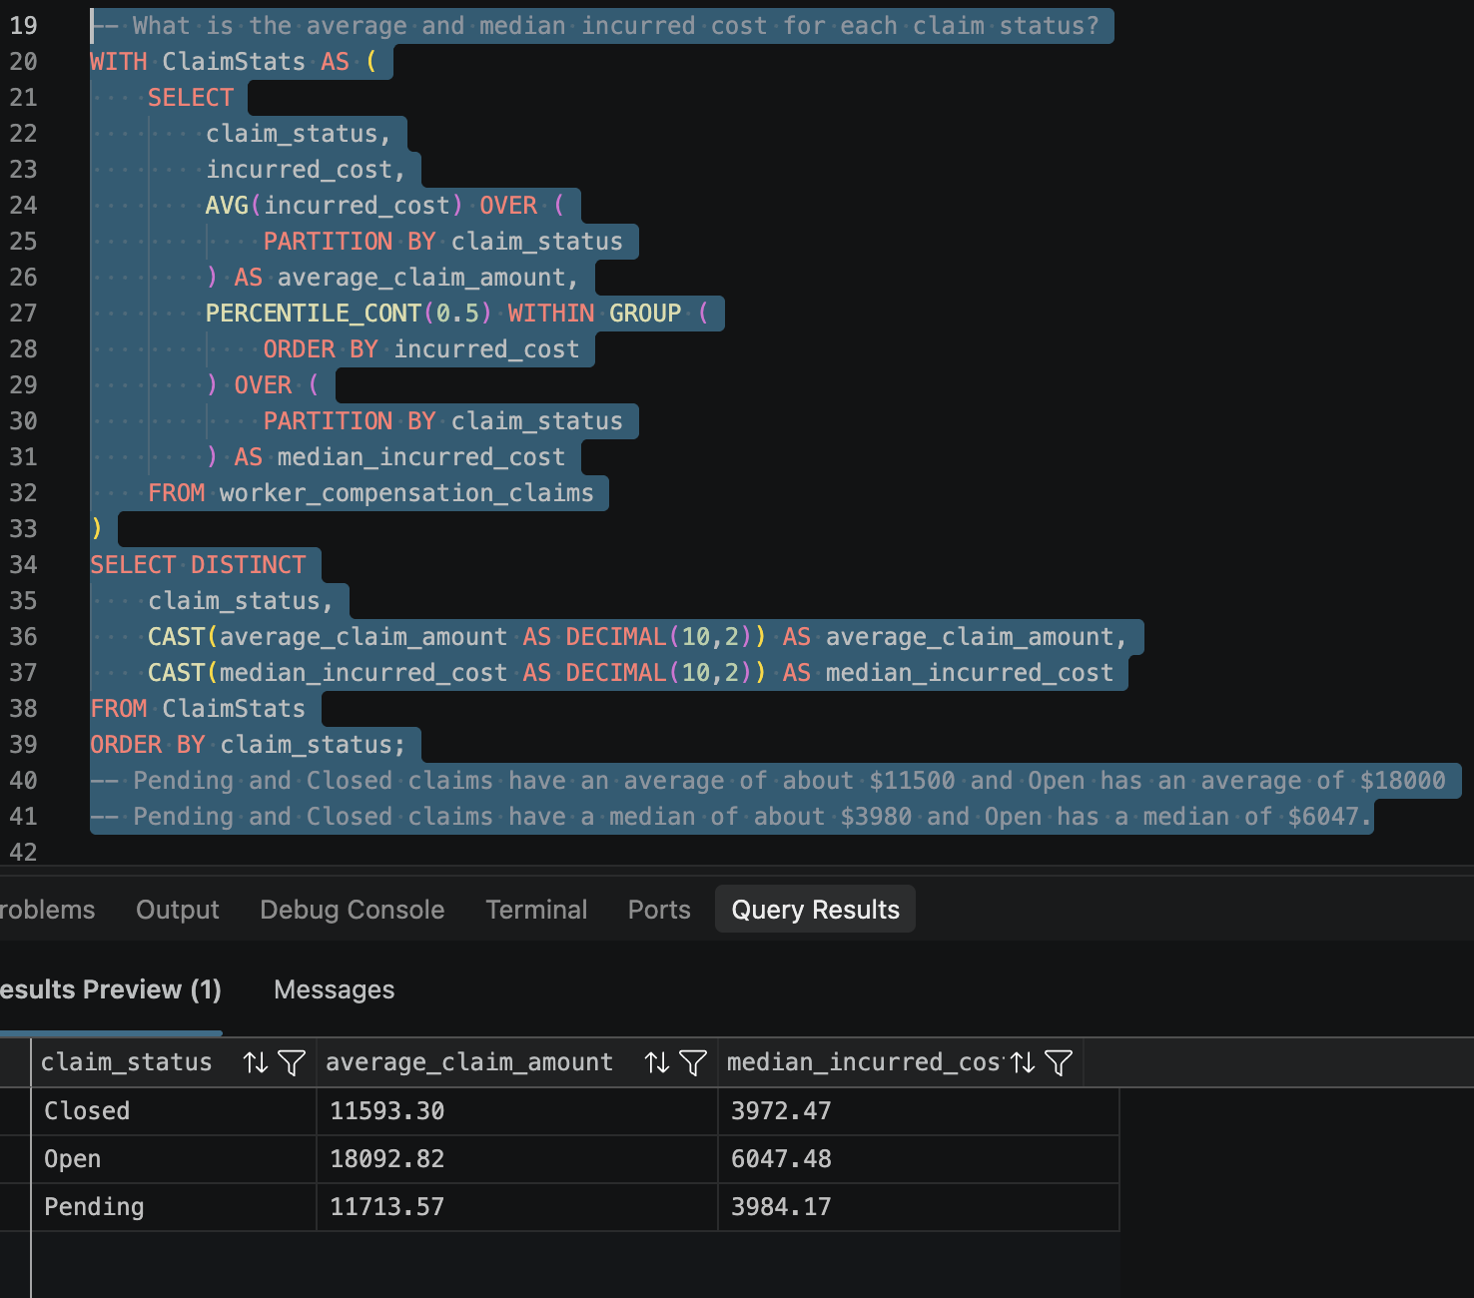
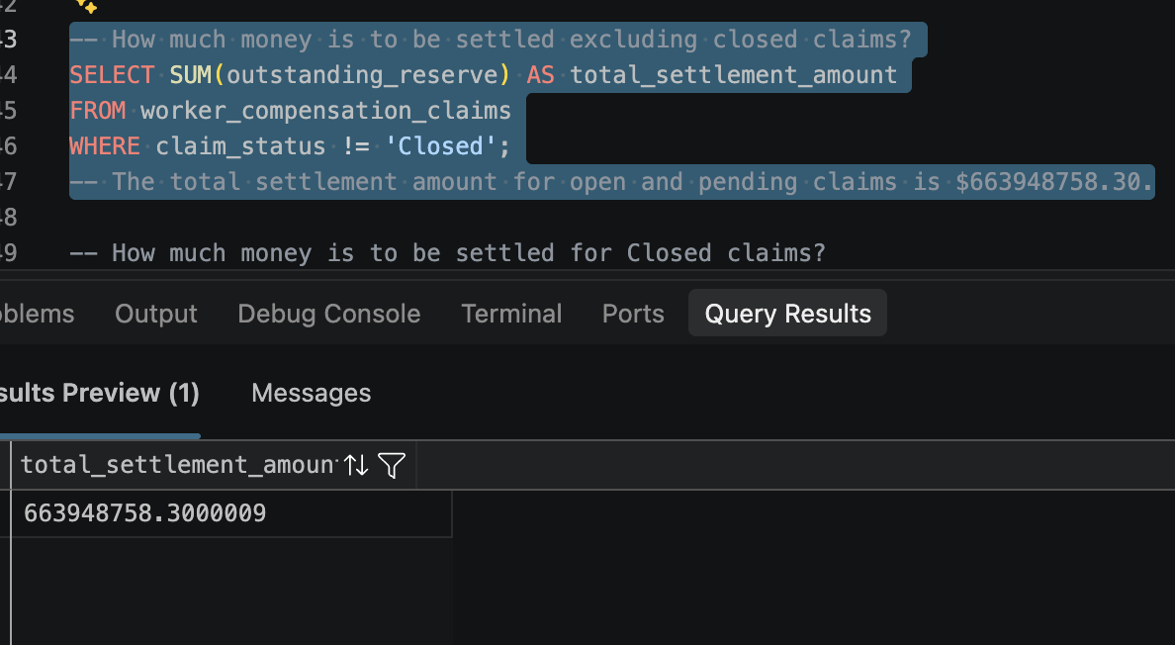
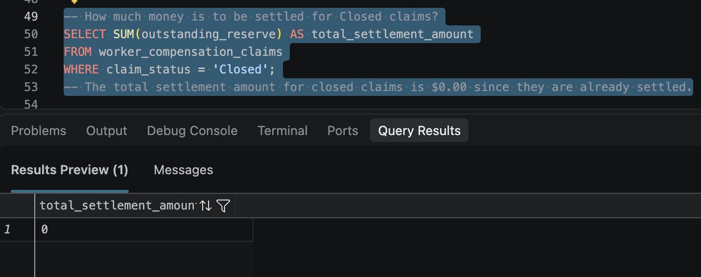

6.3 Injury Cause & Cost Analysis
Investigated:
- Injury causes contributing to the highest total incurred costs.
- Claim volumes by injury cause.
- Injury costs across different workforce sizes.
- Median incurred cost per claim by injury cause.
- Injury causes with the greatest financial impact across member sectors.
Key Findings:
- Manual Handling and Slips, Trips, and Falls are among the leading contributors to total incurred costs and claim volumes.
- Small and Medium workforce categories have substantial claim volumes and incurred costs.
- Exposure, Machinery, and Slips, Trips, and Falls have among the highest median incurred costs per claim.
📸 Screenshot: Injury Cause Analysis
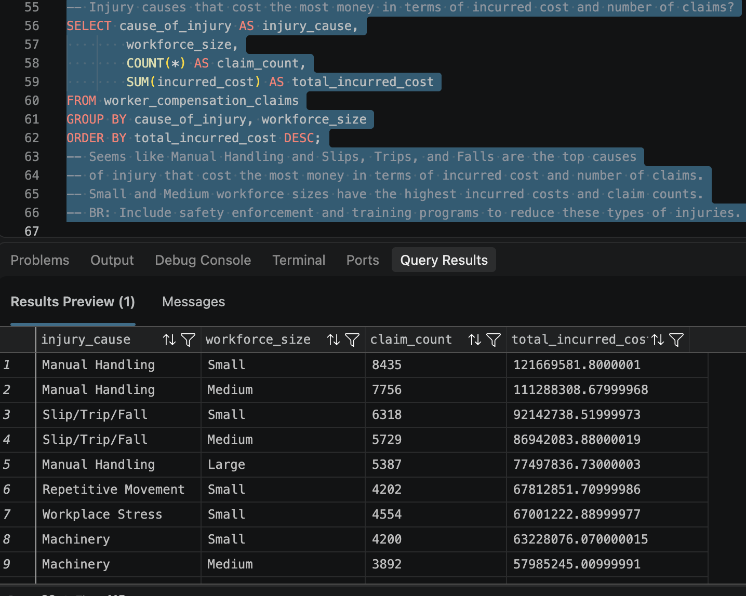
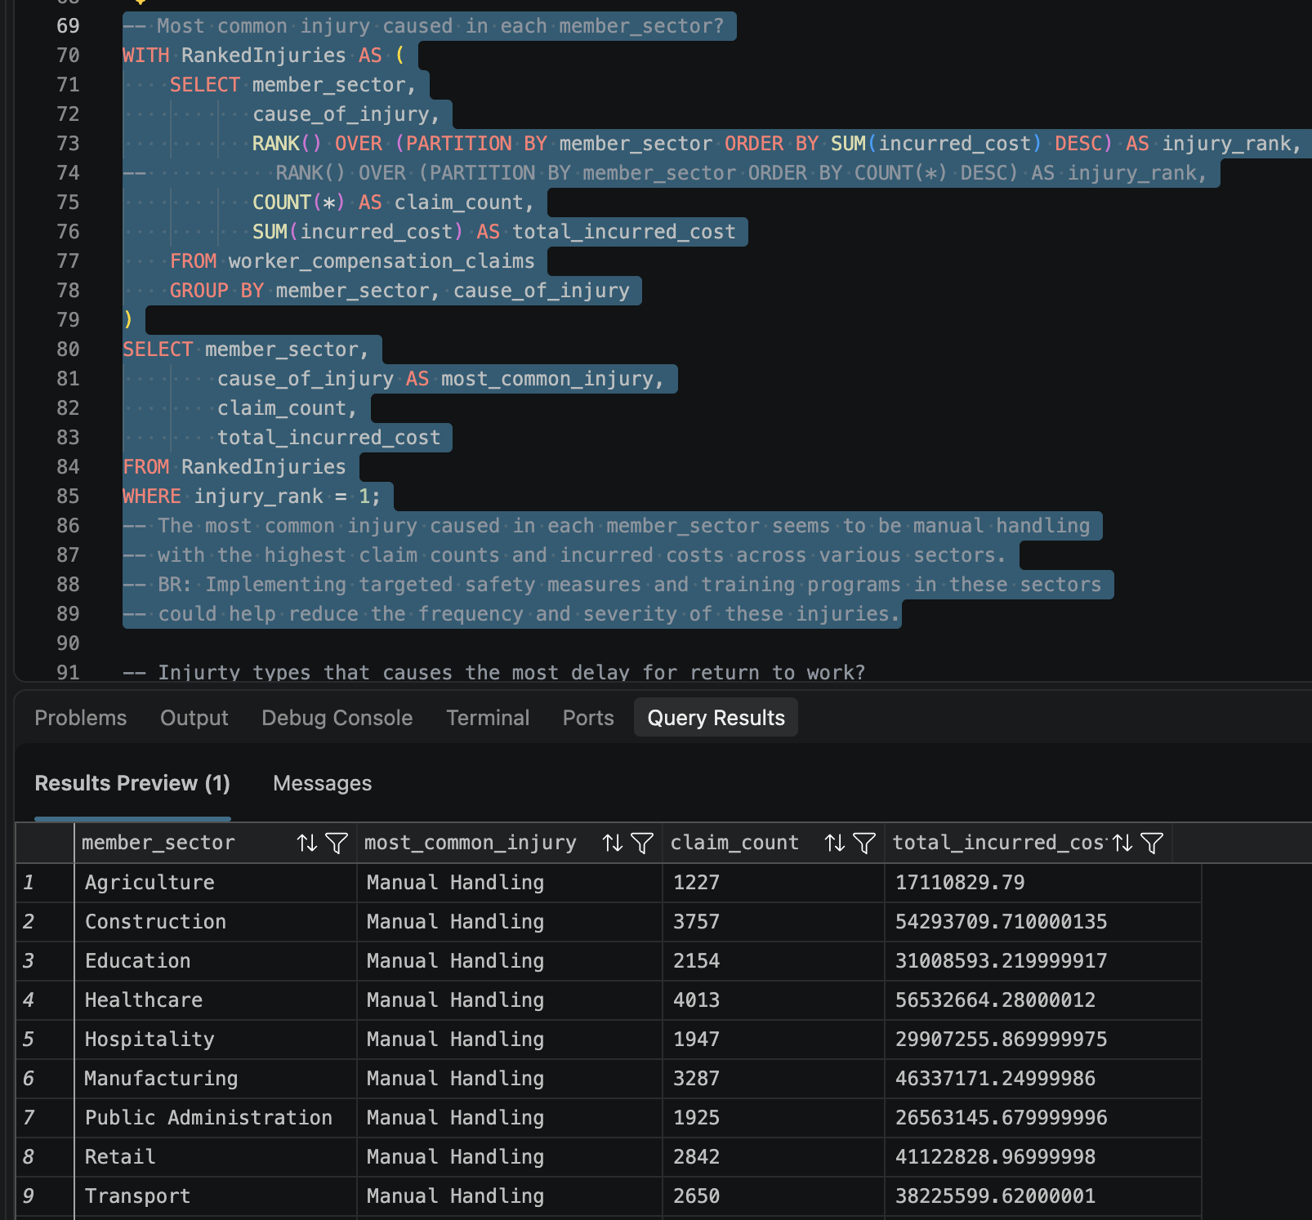

6.4 Return-to-Work Analysis
Investigated the median number of days employees take to return to work across different injury types.
Key Findings:
- Major Physical injuries have a median return-to-work period of 63 days.
- Psychological injuries have a median return-to-work period of 55 days.
📸 Screenshot: Return-to-Work Analysis
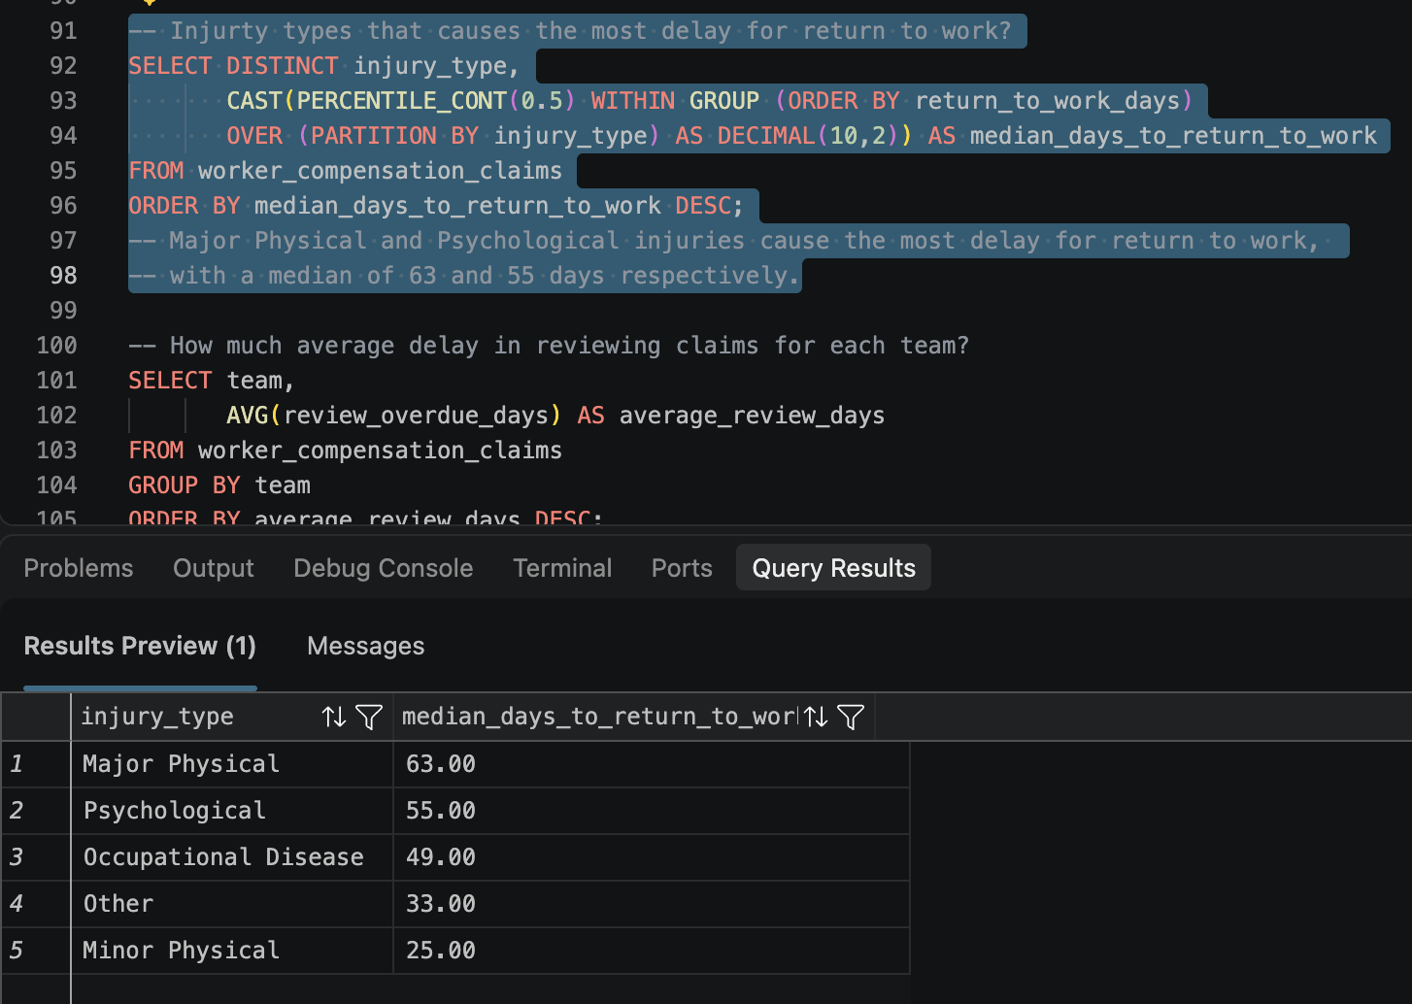

6.5 Claims Review & Operational Performance
Investigated:
- Average review delays across claims management teams.
- Relationship between system issues and review delays.
- Average rework count for claims with and without system issues.
Key Findings:
- Complex Claims has the highest average review delay at approximately 16.16 days.
- Recovery Support has an average review delay of approximately 7.21 days.
- Claims with system issues have an average rework count of 2.66.
- Claims without system issues have an average rework count of 0.65.
📸 Screenshot: Operational Performance Analysis
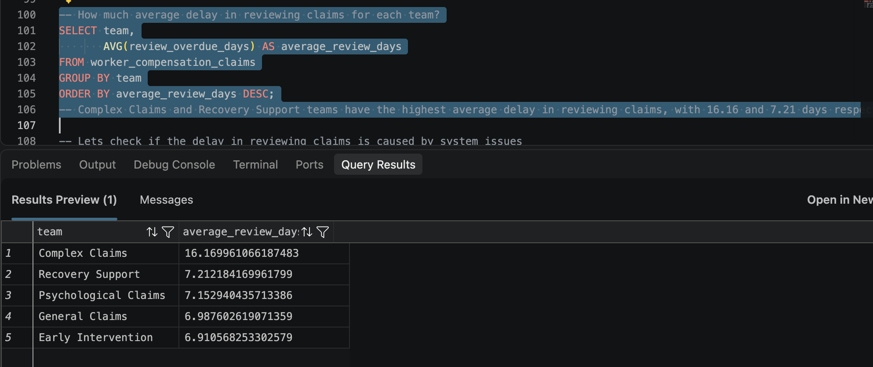
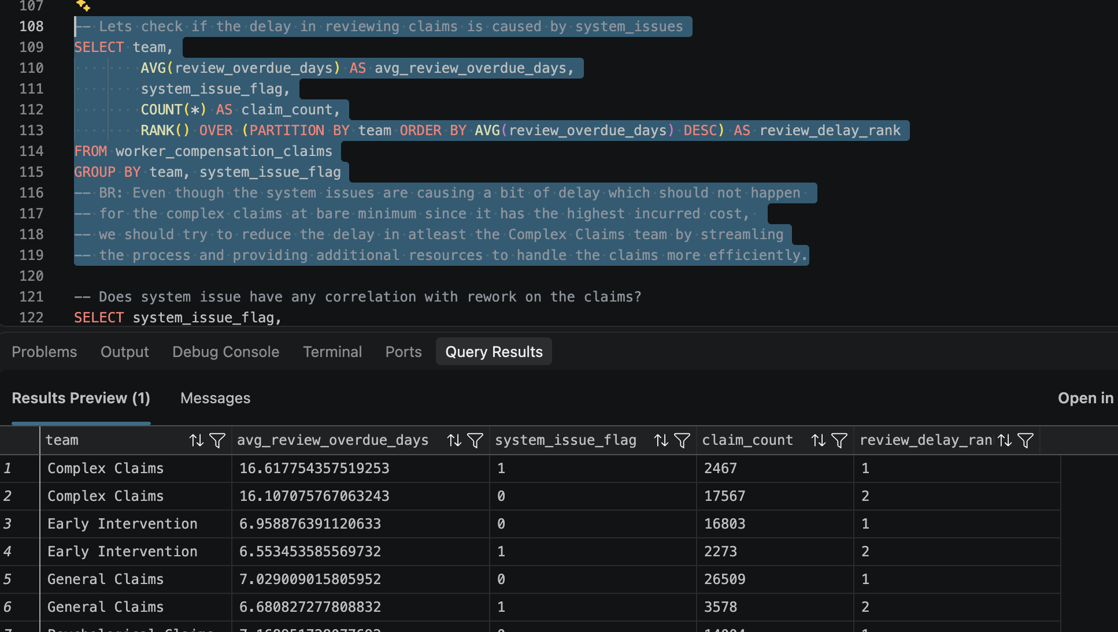
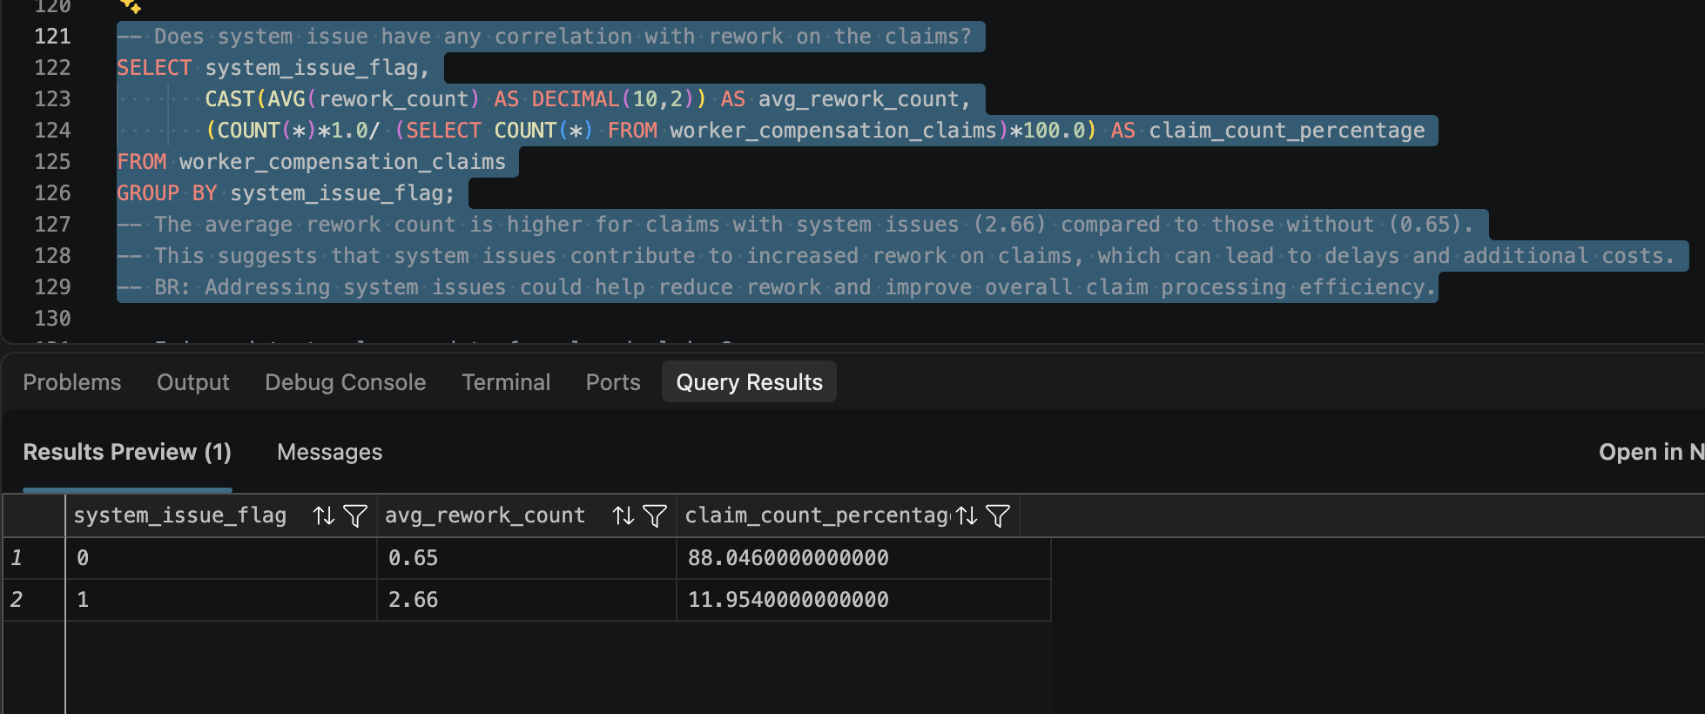

6.6 Claims Closure & Lodgement Analysis
Investigated:
- Average time between injury date and closure date for Closed claims.
- Average time between injury date and lodgement date for Open and Pending claims.
- Injury causes associated with longer closure and lodgement timelines.
Key Findings:
- Exposure, Other, and Repetitive Movement injuries are associated with longer average closure timelines.
- Most injury categories take approximately 15 days on average to be lodged.
📸 Screenshot: Closure & Lodgement Analysis
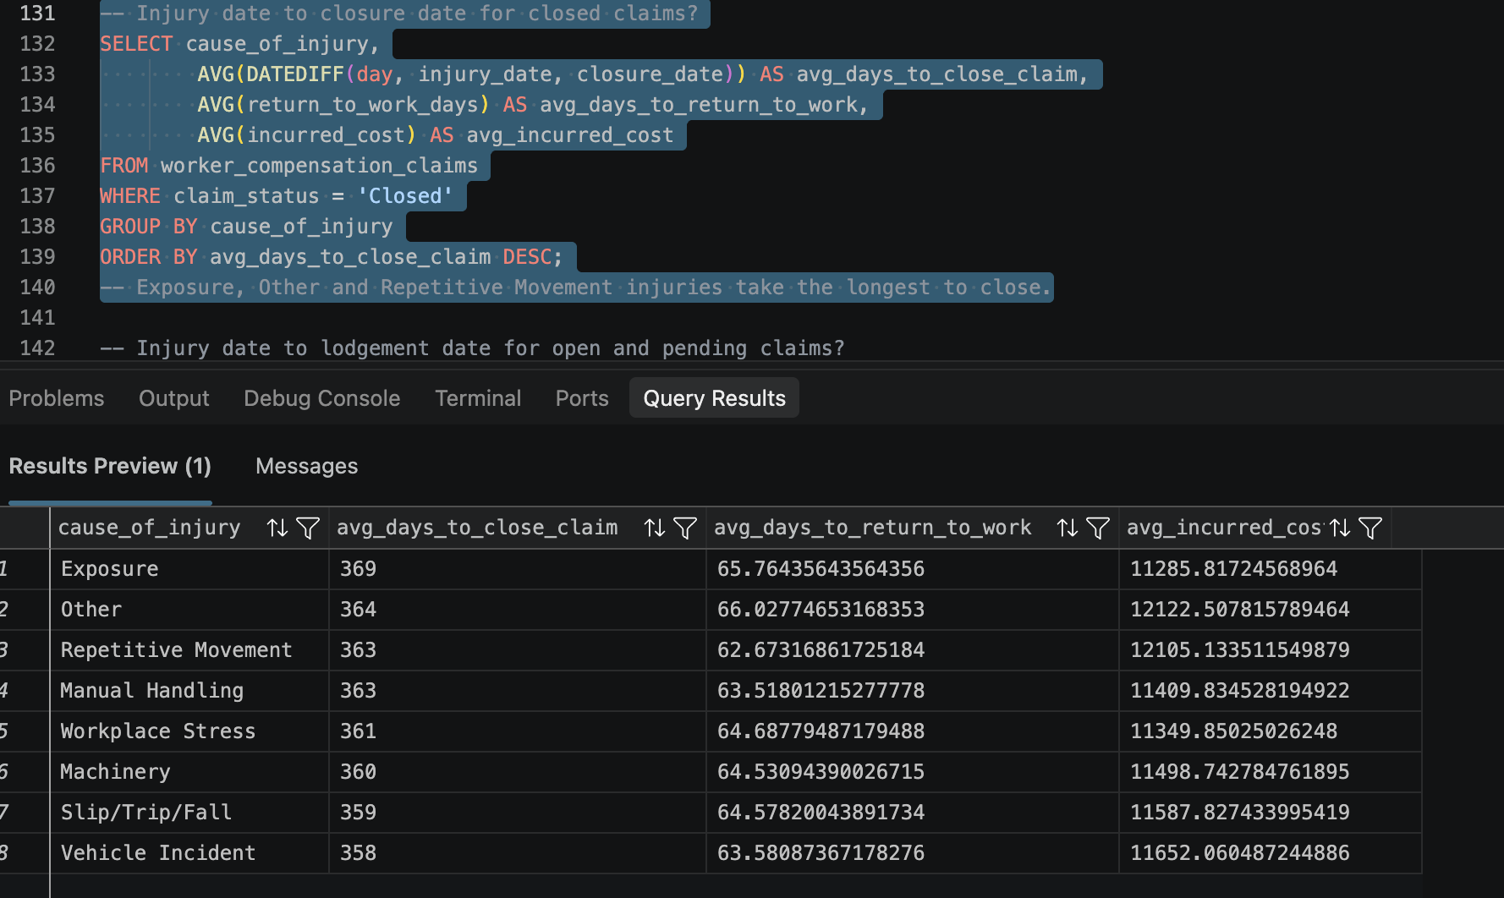
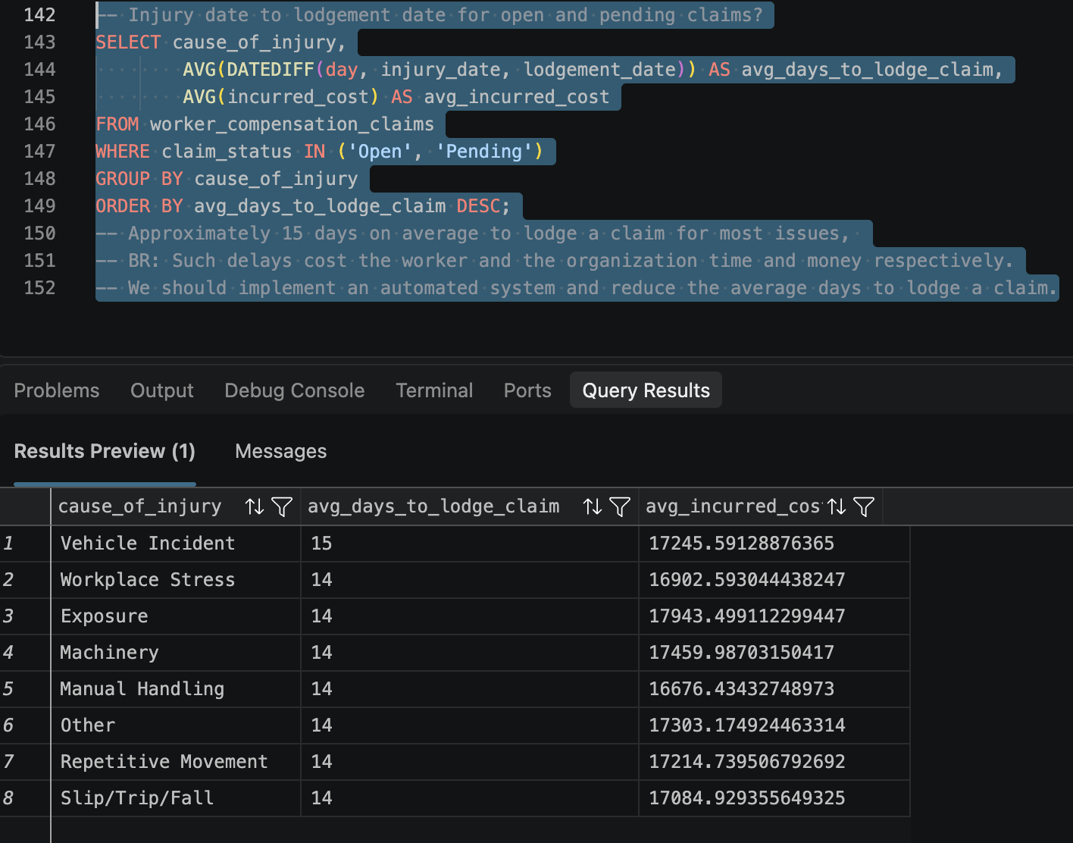

7. Tableau Dashboard Development
Tool: Tableau
After completing the exploratory analysis, I translated the SQL findings into an interactive Tableau dashboard to make the results accessible to business stakeholders.

Dashboard Preview
!Tableau Dashboard

Dashboard Components
The dashboard focuses on the following areas:
- Claims Overview: High-level KPIs covering total claims, members, and claim status distribution.
- Financial Exposure: Incurred costs and outstanding settlement reserves.
- Injury Analysis: Claim volumes and financial costs by injury cause.
- Sector Analysis: Injury patterns across member sectors and workforce sizes.
- Return-to-Work Analysis: Recovery timelines across injury types.
- Operational Performance: Review delays across claims management teams.
- System Issues & Rework: Comparison of rework levels based on system issue flags.
- Claims Resolution: Closure and lodgement timelines by injury cause.
📸 Additional Dashboard Screenshots
!Dashboard Financial Analysis
!Dashboard Injury Analysis
!Dashboard Operational Analysis

8. Key Business Findings
The analysis identified several important areas requiring management attention:

Business Area | Key Finding
Claims Portfolio | 100,000 claims across 8,000 members
Claims Status | 47.11% of claims remain Open
Financial Exposure | $663.95M in outstanding reserves for Open and Pending claims
Injury Causes | Manual Handling and Slips, Trips, and Falls are major contributors to incurred costs
Injury Severity | Major Physical injuries have a 63-day median return-to-work period
Review Performance | Complex Claims has a 16.16-day average review delay
System Issues | Claims with system issues have 2.66 average reworks versus 0.65 without
Claims Closure | Exposure, Other, and Repetitive Movement have longer closure timelines

9. Business Recommendations
Based on the findings, the following recommendations are proposed for management.

1. Strengthen Workplace Injury Prevention
Prioritise targeted safety training and preventive measures for Manual Handling and Slips, Trips, and Falls, as these are among the major contributors to claim volumes and total incurred costs.

2. Improve Financial Exposure Management
Introduce regular monitoring of Open and Pending claims to track the approximately $663.95 million in outstanding settlement reserves and improve financial forecasting and settlement planning.

3. Improve Complex Claims Processing
Investigate the operational bottlenecks within the Complex Claims team, which has the highest average review delay of approximately 16.16 days. Consider reviewing resource allocation and streamlining the review process.

4. Reduce System-Related Rework
Investigate recurring system issues contributing to higher claims rework. Prioritise improvements that reduce unnecessary manual intervention and repeated processing.

5. Improve Return-to-Work Outcomes
Develop targeted recovery and return-to-work support strategies for employees experiencing Major Physical and Psychological injuries, which have median recovery periods of 63 and 55 days, respectively.

6. Streamline Claims Lodgement
Investigate delays between injury occurrence and claim lodgement. Consider introducing automated notifications and simplified reporting procedures to reduce reporting delays.

7. Monitor Long-Running Claims
Review claims associated with Exposure, Other, and Repetitive Movement injuries to identify opportunities to improve closure timelines and reduce prolonged claim management.

