## **Algorithm and Structure Data**



Name : *Aji Tirto Prayogo/L200164008*

**Faculty Communication dan Informatics**

**2018**

Input

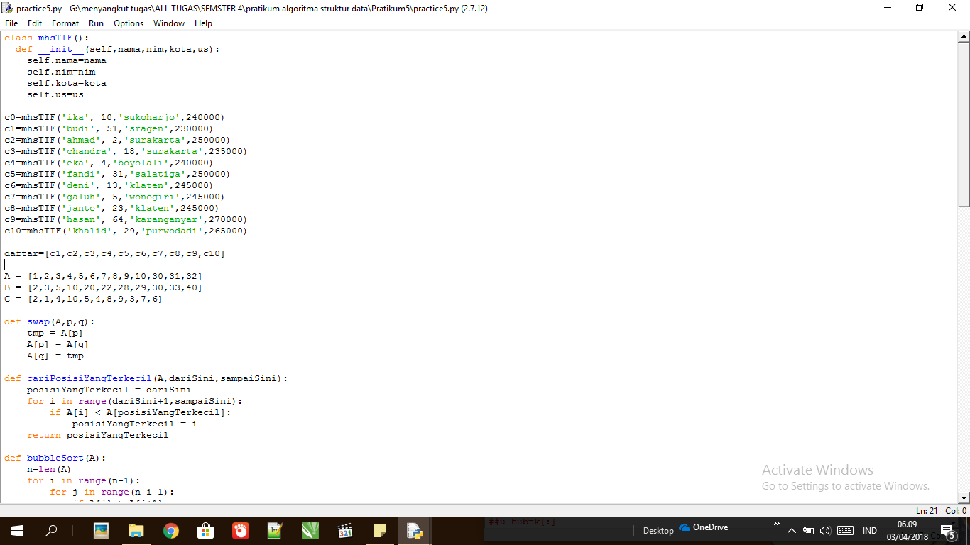

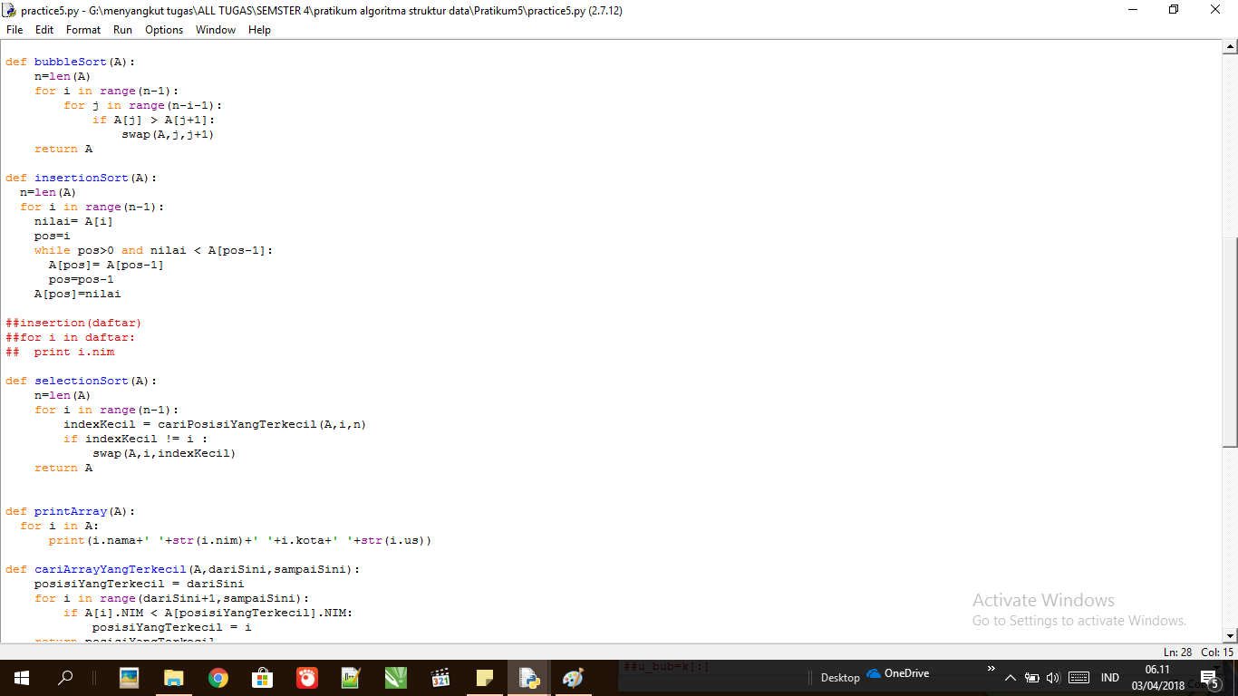

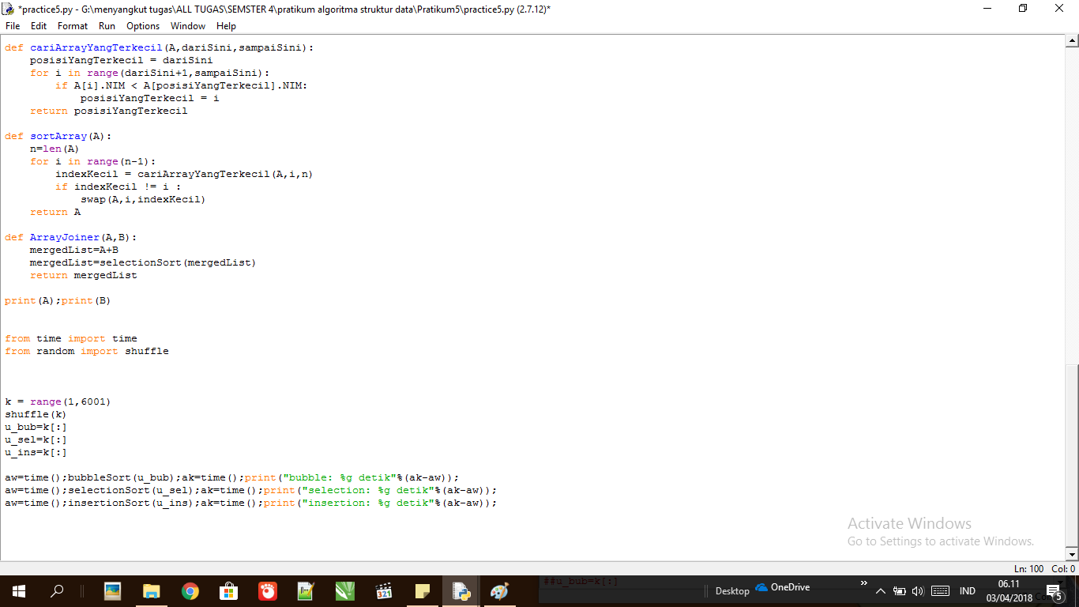

**Output**

