LITERATURE REVIEW

AI-Powered MSME Credit Assessment Using Alternative Data: a review of literature on alternative data, machine learning and explainable AI in MSME credit risk assessment
Tanishq Ratdiya · Ajit Jain · Utkarsh Dwivedi
Guide: Dr. Anjali Dalvi Co-guide: Dr. Aishwarya Mishra
Symbiosis Institute of Technology, Pune, Maharashtra, India

Abstract Micro Small and Medium Enterprises (MSMEs) contribute nearly 30% of India’s GDP and 48% of its exports, yet face a credit gap of Rs. 25–30 lakh crore. This is because traditional scorecards depend on audited financials and bureau histories that most MSMEs lack. This paper reviews the literature on machine learning (ML), alternative data (UPI, GST, bank-statement cash flows and supplier cycles) and explainable AI (XAI) for MSME credit risk. Twenty studies published between 2010 and 2026 are grouped into five clusters: ML benchmarks, alternative data, model architectures, XAI and fairness/governance. Gradient-boosted trees performed best in six of nine comparative studies. LightGBM reached an AUC of 0.96 against 0.82 for logistic regression, and XGBoost reached 0.93 against 0.81 on 15,045 SMEs. Alternative data improved AUC from 0.683 to 0.736 for e-commerce footprints and from 0.59 to 0.66 for 417,578 Indian fintech applications. India-specific models using UPI and GST features reported AUCs of 0.765–0.784 and a 48.3–51.7% reduction in expected loss, but only on synthetic data. Five gaps are identified: reliance on consumer bureau data, explanations limited to static plots, no deployable end-to-end system, fairness metrics not linked to group default rates, and no real-data validation in India. Each component of the proposed system is mapped to supporting evidence from the literature.
Keywords · Machine Learning · Gradient Boosting · XGBoost · LightGBM · Random Forest · Explainable Artificial Intelligence (XAI) · LIME · Probability of Default · SMOTE · Financial Inclusion

1 Introduction
Access to formal credit is among the most long-standing challenges faced by micro, small and medium enterprises (MSMEs). Banks find lending to small firms expensive because verified information on which to judge a borrower is scarce or costly to obtain. In the seminal work on credit markets in [1], lenders that are unable to observe borrower quality ration credit instead of increasing interest rates, as higher rates will attract riskier borrowers and drive away safe ones. The information problem is particularly acute with regard to small firms: unlike large corporations, small firms rarely file audited accounts. They have shorter operating histories, and many operate primarily in cash or under informal supplier credit agreements [2].
For most of recent five decades lenders have dealt with this issue using statistical scorecards derived from audited financial statements, standardized application forms and credit bureau data (like CIBIL in India or FICO score in USA). The review in [3] attributes these practices to the statistical classification efforts in the 1950s and 1960s, and remark that they require borrowers with long-standing documented track records [4]. In reality, an applicant who has never borrowed, lacks an audited balance sheet, or has not been banked with for some time, is likely to be automatically scored as high risk despite the underlying business having strong and stable cash flows [5]. This is the well known "thin-file" or "credit invisible" problem.
The magnitude of the resultant financing gap is significant. Indian MSMEs account for nearly 30 percent of gross domestic product and about 48 percent of export earnings, yet there exists a credit shortfall of roughly Rs. 25–30 lakh crore (SIDBI and TransUnion CIBIL 2022, [5]). The MSME finance gap globally is pegged at over US$5 trillion by International Finance Corporation (IFC), with developing economies suffering the most pain points 6]. Literature assessed shows that legacy credit systems are skewed against informal, cash-based, first generation firms because they were built to serve formal businesses who own collateral and have had longstanding relationships with banks [6], [7]. If true, the MSME credit challenge is largely a measurement issue, not one of creditworthiness.
Two innovations have shifted what can now be measured. One is the rise of alternative data: digital footprints of financial activity that exist beyond the traditional bureau system. This includes digital-payment and Unified Payments Interface (UPI) transaction histories, Goods and Services Tax Network (GSTN) filing data, point-of-sale (POS) and mobile-money transaction data, utility bills payment histories, supply and invoice cycles, amongst others [4]–[6]. Many of these signals are especially available in India because of its digital public infrastructure, and the Reserve Bank of India’s Account Aggregator framework offers a consent-based mechanism for a borrower to share such data with a lender [8]. The other is the evolution of machine-learning (ML) techniques that are able to distil a predictive signal from high-dimensional, non-linear and noisy data such as these [9], [10].
These changes come with responsibilities of their own. Credit decisions are made at high stakes and have legal implications. If a model can’t say why an applicant was rejected, it will struggle to answer a regulator, an auditor or the applicant herself. Europe’s Artificial Intelligence Act treats AI systems which score the creditworthiness of natural persons as high-risk applications [11], while the Reserve Bank of India has drafted the nation’s first principles-based framework on AI and ML for the financial sector (called FREE-AI), complete with principles of explainability, fairness, and accountability [5], [12]. Even before regulation comes into force, the case has been made in [13] that for high stakes decisions in general, bankers should use models they can inspect over black boxes with post-hoc explanations. If MSME lending models are expected to be deployable in practice, they will have to balance accuracy with explainability and fairness.
This literature review paper touches upon various topics which are related to each other and discusses literature that falls under the intersection of these topics, in support of the design of an AI-powered MSME credit-assessment system that uses alternative data. The key contributions of this review are as follows:
- Layered taxonomy. Twenty studies published between 2010 and 2026 are organised into five clusters (benchmarking, alternative-data ingestion, ensemble modelling, post-hoc explainability, and fairness/governance) that correspond to the stages of a credit-decisioning pipeline.
- Quantitative cross-study comparison. Datasets (size, format and application), classifiers (LR, RF, GBM, XGBoost, LightGBM and deep networks) and evaluation parameters (ROC-AUC, Brier score, F1, KS statistic, expected loss and DIR) are tabulated and ordered by year, showing where gradient-boosted trees dominate and where results are confounded by synthetic or bureau-derived data.
- MSME- and India-specific research gaps. Five open problems are isolated: missing operational cash-flow features (UPI, GST, bank statements) in real-data models, batch-only SHAP/LIME explanations, absence of deployable scoring services, fairness metrics decoupled from cohort default rates, and reliance on synthetic digital-public-infrastructure data.
- Evidence-traced reference architecture. A calibrated ensemble classifier, per-request TreeSHAP attributions exposed through a REST API, PD-based three-tier risk banding and cohort-level fairness logging are specified, and every component is traced to supporting findings in the reviewed literature.
The rest of the paper is structured as follows. Section 2 provides background information on traditional credit scoring, MSME financing gap, alternative data in India and the review methodology. Section 3 summarizes the literature cluster-wise. Section 4 compares the reviewed papers based on the reported results and their evaluation practices. Section 5 discusses the identified gaps. Section 6 maps the proposed system architechture with literature. Section 7 highlights challenges, threats to validity, future scope. Finally Section 8 concludes.
Several terms recur throughout the reviewed literature and are used with specific meaning related to finance, statistics, and machine learning. Table 1 lists the abbreviations used throughout the remainder of this review, with their full forms and meanings.

Table 1 List of abbreviations
Abbreviation | Full form | Meaning in this review
AA | Account Aggregator | RBI-regulated framework through which individuals/firms can consent to share financial information with lenders
ADSF | Alternative Data Scoring Framework | Six-pillar weighted composite credit score proposed for MSME lending
AI / ML | Artificial Intelligence / Machine Learning | Data-driven models that learn default patterns from historical records
API | Application Programming Interface | REST endpoints through which the scoring and explanation services are called
AUC / ROC | Area Under the Curve / Receiver Operating Characteristic | Ability of a model to rank applicants by their probability of default (1.0 = perfect, 0.5 = random)
CDR | Call-Detail Record | Telecom log of calls and messages used as mobile-phone alternative data
CIBIL | Credit Information Bureau (India) Limited | Indian credit bureau (TransUnion CIBIL) whose scores form traditional bureau data
CV | Cross-Validation | Repeated train/test splitting (e.g., stratified k-fold) used to estimate out-of-sample performance
DBN / MLP | Deep Belief Network / Multilayer Perceptron | Deep and shallow neural-network classifiers benchmarked against tree ensembles
DIR | Disparate Impact Ratio | Approval rate of a comparison group divided by that of a reference group; values under 0.80 are commonly used to flag disparate impact
DPI | Digital Public Infrastructure | India's shared digital rails, such as UPI, GSTN and the Account Aggregator framework
EAD / LGD / EL | Exposure at Default / Loss Given Default / Expected Loss | Value outstanding at default, percentage of exposure lost if the borrower defaults, and EL = PD × LGD × EAD
EMI | Equated Monthly Instalment | Fixed monthly loan repayment; missed EMIs are a behavioural risk signal
FREE-AI | Framework for Responsible and Ethical Enablement of AI | RBI framework setting explainability, fairness and accountability principles for AI in finance
GBM | Gradient Boosting Machine | Sequential tree ensemble in which each tree fits the residuals of the previous ones
GST / GSTN | Goods and Services Tax / GST Network | Indian indirect-tax system and the portal whose filings provide turnover and compliance data
KS | Kolmogorov–Smirnov statistic | Maximum separation between the score distributions of defaulters and non-defaulters
LightGBM | Light Gradient Boosting Machine | Histogram-based, leaf-wise gradient boosting library
LIME | Local Interpretable Model-agnostic Explanations | Fits a local surrogate model to explain one prediction
LR | Logistic Regression | Linear baseline used in traditional credit scorecards
MSME | Micro, Small and Medium Enterprise | Enterprise classified in India by investment in plant and machinery and by annual turnover
NABARD / SIDBI | National Bank for Agriculture and Rural Development / Small Industries Development Bank of India | Indian development banks whose aggregate statistics were used to calibrate synthetic data
PD | Probability of Default | Probability that a borrower will default within a given horizon, as predicted by the model
POS | Point of Sale | Card or digital payment terminal whose transaction logs serve as alternative data
RBI | Reserve Bank of India | India's central bank and financial-sector regulator
RF | Random Forest | Bagged ensemble of decorrelated decision trees
SHAP | SHapley Additive exPlanations | Attributes a prediction to its input features using Shapley values; global or per applicant
SMOTE | Synthetic Minority Over-sampling Technique | Creates synthetic minority-class (defaulter) examples during training to offset class imbalance
SVM | Support Vector Machine | Margin-based classifier included in credit-scoring benchmarks
UPI | Unified Payments Interface | India's real-time mobile payment system; transaction histories serve as alternative data
XAI | Explainable Artificial Intelligence | Methods that make model predictions understandable to users
XGBoost | eXtreme Gradient Boosting | Regularised, scalable gradient boosting library

2 Background and review methodology

2.1 Evolution of credit scoring
Credit scoring began as a form of statistical classification. Using linear discriminant analysis and later logistic regression, individuals or applications were classified into "good" and "bad" categories, using a handful of application and repayment variables [3]. The study in [14] demonstrated that using discriminant analysis on a handful of financial ratios was able to predict bankruptcy for corporate borrowers. The resulting Z-score model quickly became one of the most popular tools for commercial lending. The work in [15] has shown that small and medium enterprises behave sufficiently differently from larger corporates to require separate default models. They demonstrated that a logistic model using financial ratios specific to SMEs outperformed a generic corporate model.
These ratio-dependent models are dependent on another technology: audited financial statements. For many Indian MSMEs, particularly micro enterprises, these statements are unavailable, unaudited, or too far removed from the ground truth of a business' operations. Bureau-based scorecards are dependent on a similar condition: previous borrowing experience. In both situations, the model isn't necessarily incorrect but is simply blind: it has no measuring stick for the borrower who needs a first loan the most.
ML's introduction expanded the pool of applicable models. The systematic reviews in [16]–[18] catalogue this shift from individual statistical classifiers to ensembles, neural nets, and hybrids. These works also describe increased focus on issues like class imbalance, evaluation metrics, and model interpretability. Benchmark studies, reviewed in Sect. 3.1, find that tree-based ensembles, in particular, reliably outperform logistic regression [9], [19]. Meanwhile, policy researchers have recognised that large technology platforms and fintech lenders use such models along with digital trace data from their own platforms, allowing them to learn informational advantages when it comes to lending to small businesses [20].

2.2 The MSME credit gap
Figure-level estimates of the MSME finance gap differ based on methodology, but they consistently point toward one direction. Indian estimates peg the gap at Rs. 25–30 lakh crore (SIDBI and TransUnion CIBIL 2022, [5]) and globally, the gap is said to be in excess of US$5 trillion [6]. The Study in [2] suggest that reason why the gap has continued to persist overtime depends on lending technologies available to banks. Banks that rely on financial-statement lending and asset-based lending must depend on hard-information which small firms lack. Relationship lending allows banks to use soft-information gleaned over time with borrowers. However, it cannot be scaled efficiently, and first-time borrowers do not benefit from it.
Three characteristics of the Indian MSME segment accentuate this issue. One, the segment consists of a majority of micro enterprises. Within that category, there are a large number of proprietorships where financials of the business and household are blurred. Two, a significant amount of business still takes place in cash, leaving no auditable trail behind. And three, collateral requirements leave out firms that may not have significant tangible assets in terms of land/buildings but have large amounts of working capital/inventory/receivables. Each of these gaps limits the usefulness of traditional scorecards and makes a stronger case for behavioural data.

2.3 Alternative data and India's digital public infrastructure
Alternative data can be defined as non-traditional signals of financial behaviour that fall outside of the traditional bureau system [4]–[6]. From the literature reviewed these signals have been categorised into families including: digital transaction activity (payments, transfers UPI volumes, inflows and outflows), tax and statutory compliance information (GST filing regularity and turnover growth), supply-chain data (invoice ageing, vendor payment delays and supply side cycles), utility and bill-payment data, open-banking/account-aggregator information, as well as more contentiously, mobile phone metadata, psychometric responses, and social-network/social-media signals. The study in [5] further define these signals as a form of "reputational collateral" that allows a borrower to demonstrate financial prudence and regular earnings streams even without an audited balance sheet.
This Project focus specifically on India, whose extensive digital public infrastructure renders many of these families particularly salient. Due to UPI (Unified Payments Interface), India now has ubiquitous digital payment infrastructure for small-value transactions. Because of this, a firm’s payment history now speaks to both the volume and volatility of its sales. GST filings can speak to turnover and compliance behaviour over regular intervals. India’s Account Aggregator framework enables borrowers to share bank-statement and other financial data with lenders via a consent-based intermediary [8]. These sources together could allow, in theory, the construction of cash-flow-based credit features for firms that would otherwise go unseen by a bureau-based scorecard.
Table 2 summarises the main categories of alternative data identified in our literature review, listing 15 studies from the latest to the earliest, with examples of features which fall under each, their typical sources, and a headline statistic reported by each study.

Table 2 Categories of alternative data identified in the reviewed literature
Ref. | Year | Data category | Example signals / features | Typical source | Key statistic reported
[4] | 2026 | Behavioural and social “thick data” | Mobile-usage, social-media and microblog indicators | Mobile and social platforms | Conceptual framework; no metric reported
[5] | 2026 | Digital payments, tax filings, bank cash flow | UPI volume and in/out ratio, GST filing delay, sales volatility, vendor payment delay, average balance | UPI history, GSTN returns, bank statements | MSME AUC 0.784, Brier 0.184; expected loss −48.3% vs random approval
[6] | 2025 | Six-pillar multi-source data | Mobile metadata, POS/mobile-money logs, psychometrics, supply-chain, social-capital and open-banking data | Telecoms, mobile-money, open-banking APIs | Multi-source scoring +20–35% accuracy over single-source models
[21] | 2024 | Social-network and regional data | Default status of the applicant's social circle, regional economic ratings, local population size | Home Credit loan portfolio | AUC 0.7936 with alternative predictors, above bureau-only models
[22] | 2023 | Granular loan-performance data | Quarterly securitisation (loan-level) data vs annual balance-sheet data | Investment-bank securitisation files, Orbis | Test macro-F1 0.552 (securitisation) vs 0.736 (balance sheet) for historical RF
[23] | 2022 | Bank-account and credit-line behaviour | Volatility of utilised credit balance, remaining credit (%), length of customer relationship | Bank account and transaction records | LightGBM AUC 0.96 vs 0.82 for the bank's LR scorecard
[24] | 2021 | Cashless-payment behaviour | Share of cashless (online transfer, mobile, POS) vs cash transactions | Six months of bank statements (35M+ transactions) | +31 pp cashless share → +2.7 pp approval and −42 bp interest rate
[25] | 2021 | Super-app behaviour | In-app engagement, payment-method use, payment errors | Multi-service mobile marketplace | KS ≈ +10 pp; cost savings rose from 20.5–31.3% to 29.3–36.0%
[26] | 2021 | Psychometric and e-mail data | 350 psychometric items, 53 e-mail-usage features | Questionnaires, e-mail metadata | Test AUC 0.751 (demographic + psychometric) vs 0.624 (demographic only)
[7] | 2021 | Transaction-level behavioural data | Payment timeliness, transaction-volume volatility, invoice ageing, supplier-payment cycles | Bank logs, POS, invoices, payroll | Review; behavioural signals outperform static ratio scores
[27] | 2020 | Mobile-phone footprint | Apps installed, call logs, SMS counts, contacts, social-media log-in | Smartphone (fintech app) | AUC 0.59 (bureau) → 0.66 (bureau + footprint) on 417,578 applications
[28] | 2020 | Digital footprint | Device type, operating system, e-mail domain, time of purchase | E-commerce checkout | AUC 0.683 (bureau) vs 0.696 (footprint) vs 0.736 (combined)
[10] | 2019 | Digital application and e-commerce footprint | Platform usage and online shopping behaviour | Fintech platform | ML + non-traditional data beats logit; gain largest for short credit histories
[29] | 2019 | Mobile-phone metadata | Calling behaviour, call-network centrality | Telecom operator (5 months of CDRs) | Calling-behaviour features give the most profitable scorecard (22,000 obs.)
[30] | 2010 | Card-transaction data | Spending categories and account balances combined with bureau data | Commercial bank | Out-of-sample R² 85%; loss savings 6–25%

The more intrusive categories in Table 2 (mobile-phone metadata, psychometric, social-media and digital-footprint data) implicate privacy, consent and fairness concerns that have been taken seriously in the literature [4], [28]. The project described below limits itself to bank-statement, GST, UPI/digital-payment and supply-chain data, which pertain to the firm’s financial activities and can be acquired with borrower consent.

2.4 Review methodology
The review proceeds in a narrative format. The original collection was sourced from literature on journal articles, working papers and preprints focused on alternative-data credit scoring, MSME finance, ensemble ML for credit risk modeling, and explainable AI (XAI). Included studies were kept if they met at least one:
- Report an empirical credit-scoring model which incorporates non-traditional or behavioural data;
- Pertain to MSME or thin-file credit assessment specifically;
- Contribute benchmark evidence on the performance of ML classifiers for credit scoring; or
- Propose an explainability, fairness or governance framework for AI-based credit scoring.
Out-of-scope studies were excluded from the synthesis. There remain 10 core studies published between 2010 and 2026, plus [3] for historical context, and a further 10 recent studies published between 2020 and 2025 that were added to widen the empirical evidence base. Core studies are supplemented by methodological references (such as on SHAP, LIME, SMOTE, gradient boosting) and regulatory background (such as on the EU AI Act) as needed to explain or evaluate the core studies. Table 3 lists all 20 studies from the latest to the earliest, along with publication outlet and cluster assignment.

Table 3 Studies included in the review
Ref. | Year | Authors | Outlet | Cluster(s)
[4] | 2026 | Abdellatif, Yang & Nigussi | European Journal of Sustainable Development | D, E
[5] | 2026 | Yadav, Pandey & Mishra | International Journal of Technology, Health and Sustainability | B, C, D, E
[31] | 2025 | Cheraghali & Molnár | Journal of Small Business Management | A, C
[32] | 2025 | Shreya & Pathak | arXiv preprint 2506.19383 | C, D
[6] | 2025 | Shokunbi | Iconic Research and Engineering Journals | B
[21] | 2024 | Hlongwane, Ramaboa & Mongwe | PLOS ONE | B, C
[22] | 2023 | Bitetto, Cerchiello, Filomeni, Tanda & Tarantino | Socio-Economic Planning Sciences | C, D
[23] | 2022 | de Lange, Melsom, Vennerød & Westgaard | Journal of Risk and Financial Management | C, D
[33] | 2021 | Gunnarsson, vanden Broucke, Baesens, Óskarsdóttir & Lemahieu | European Journal of Operational Research | A
[26] | 2021 | Djeundje, Crook, Calabrese & Hamid | Expert Systems with Applications | B
[25] | 2021 | Roa, Correa-Bahnsen, Suarez, Cortés-Tejada, Luque & Bravo | Expert Systems with Applications | B, D
[24] | 2021 | Ghosh, Vallee & Zeng | Rodney L. White Center (Wharton) Working Paper | B
[7] | 2021 | Elebe & Imediegwu | Journal of Frontiers in Multidisciplinary Research | B, C, D
[27] | 2020 | Agarwal, Alok, Ghosh & Gupta | Indian School of Business Working Paper | B, C
[34] | 2020 | Bussmann, Giudici, Marinelli & Papenbrock | Frontiers in Artificial Intelligence | C, D
[28] | 2020 | Berg, Burg, Gombović & Puri | Review of Financial Studies | A
[10] | 2019 | Gambacorta, Huang, Qiu & Wang | BIS Working Papers No. 834 | B, C
[29] | 2019 | Óskarsdóttir, Bravo, Sarraute, Vanthienen & Baesens | Applied Soft Computing | A
[9] | 2015 | Lessmann, Baesens, Seow & Thomas | European Journal of Operational Research | A
[30] | 2010 | Khandani, Kim & Lo | Journal of Banking & Finance | A

Twenty studies comprise the five clusters according to the layers in the proposed system architecture: (A) Foundational benchmark studies focused on ML-driven credit scoring. (B) Alternative-data ingestion and financial-inclusion frameworks. (C) ML architectures for credit risk. (D) Integration of explainable AI. (E) Fairness, policy and governance. More than one cluster can apply to a single study; the study in [5], for example, applies to four categories. Fig. 1 shows the resulting taxonomy, naming the main work or algorithm in each cluster. Fig. 2 shows the year of publication of each study and its cluster assignment.

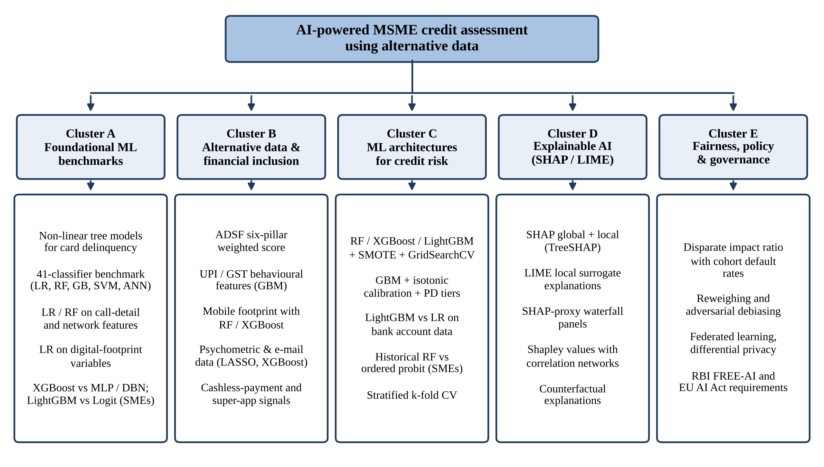
Fig. 1 Taxonomy of the reviewed literature, organised into five clusters that parallel the layers of the proposed system; each box lists the main work or algorithm studied in that cluster

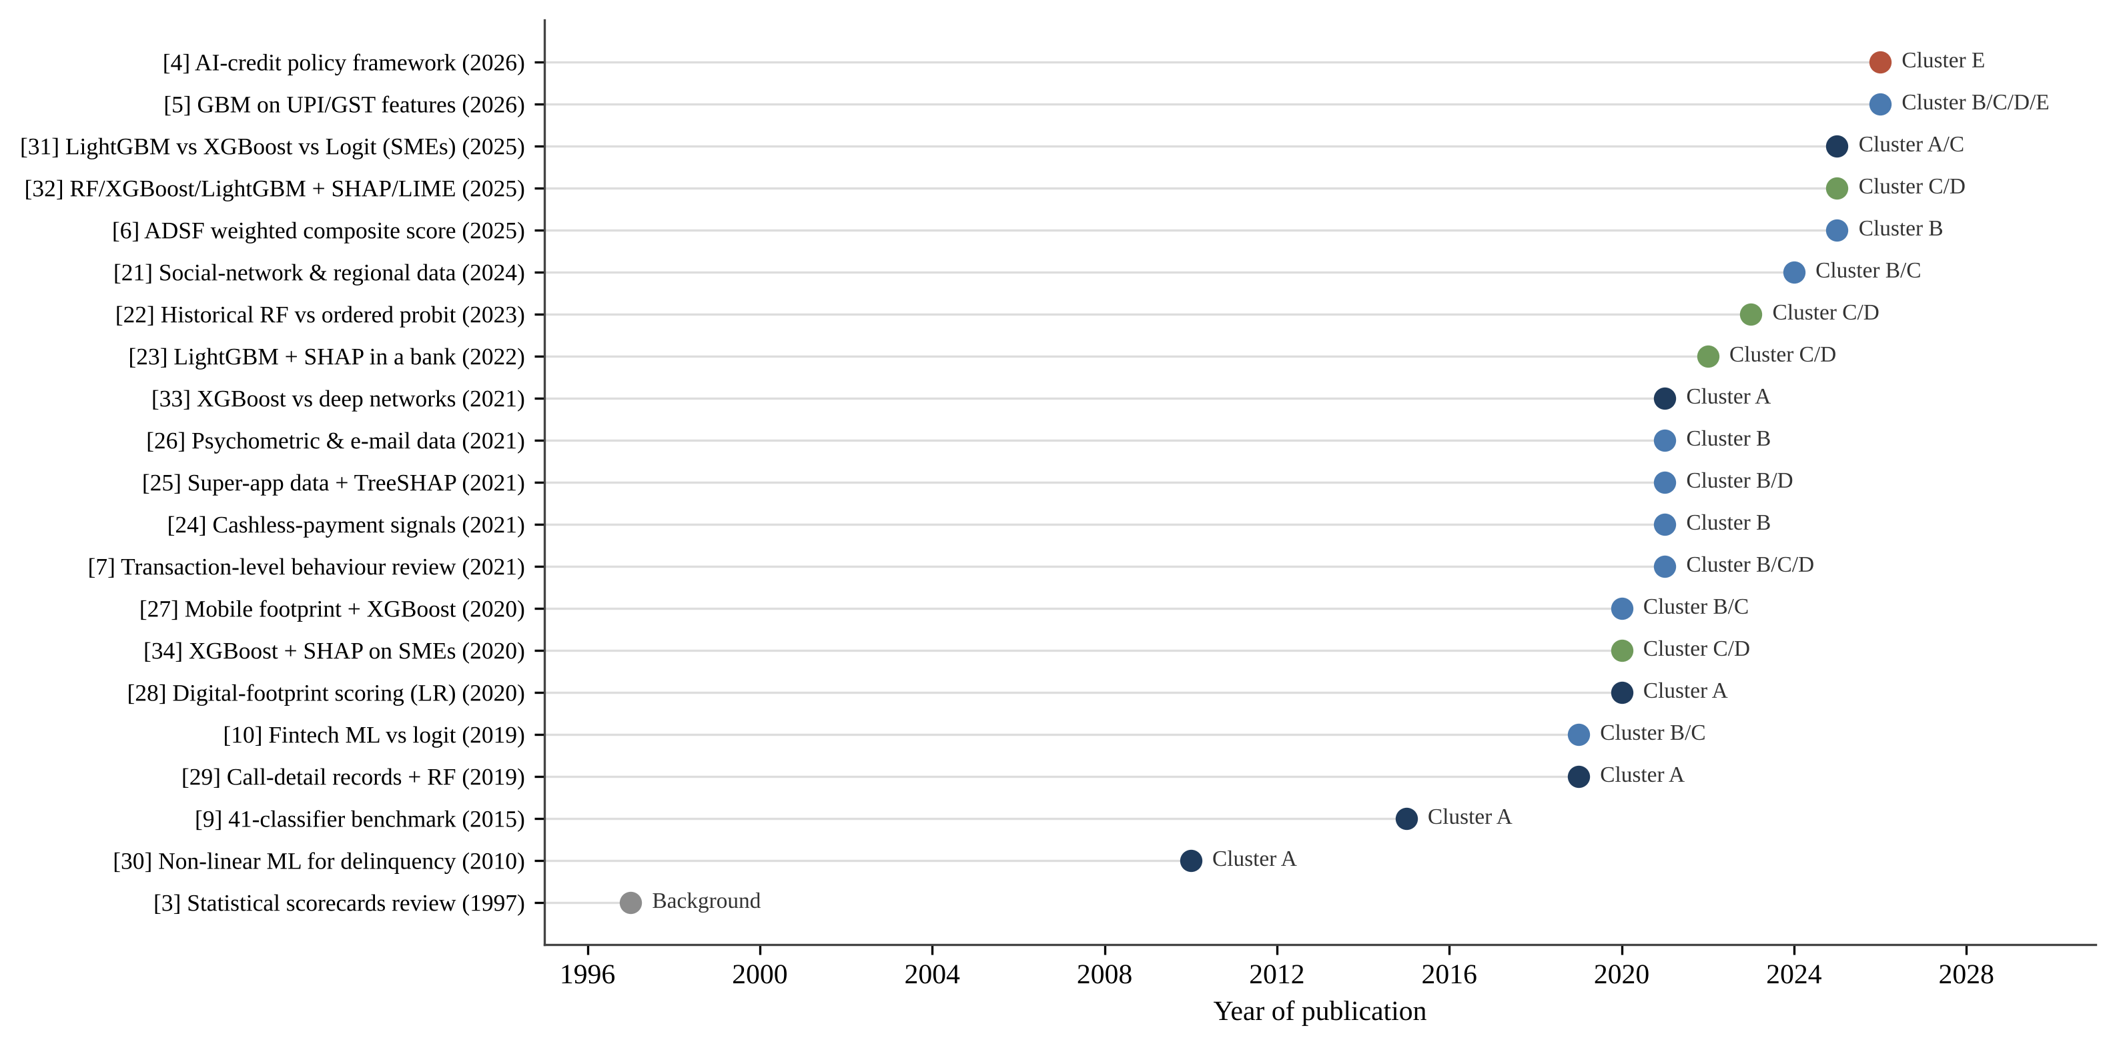
Fig. 2 Publication timeline of the reviewed studies and their cluster assignment

Two observations about Fig. 2 are worth highlighting. First, the seminal work establishing benchmarks (Cluster A) precedes most MSME-specific work by years. Second, work combining alternative data, ML and explainability for MSMEs is recent (2025–26), highlighting a nascent research space.

3 Study of the literature
This chapter provides an overview of findings from reviewed literature organized by cluster. Each subsection discusses what the individual studies add, how they interconnect, and what gaps remain for an MSME-targeted, deployable solution.

3.1 Cluster A: foundational benchmark studies in ML-driven credit scoring
Four papers provide the empirical and methodological foundation for the MSME-focused research discussed here.
Non-linear ML for consumer delinquency [30]. The Study constructed non-linear, non-parametric ML forecasting models of consumer delinquency and default using “a proprietary panel of credit-card transactions and credit-bureau records for an unbalanced sample of active credit card borrowers who received their credit cards from a large U. S. commercial bank between January 2005 and April 2009.” Their models, which were estimated separately for delinquency and default, yielded out-of-sample R² of 85% for realized delinquencies. Their preferred models implied cost savings of between 6% and 25% of total losses when compared with rules-based credit-line management. Further, the models predicted the increase in delinquencies leading up to the 2008 crisis. The study showed, over a decade before the MSME papers discussed below, that ML could dramatically outperform rules-based decisioning without the benefit of alt-data. Its downside for present purposes is that it covers only already-banked individual consumers who already have a bureau history; the data includes only bank-owned transactional and bureau data; and there is no post-hoc interpretability layer provided.
41-classifier benchmark [9]. Improving on the benchmark provided in [19], the Study empirically benchmarked 41 classification algorithms over eight real-world retail credit-scoring datasets. Compared algorithms included random forests, gradient boosting, heterogeneous ensembles, support vector machines and neural networks. They compared classifiers to a logistic-regression baseline using the area under the ROC curve (AUC), the H-measure [35], the Brier score [36] and the percentage correctly classified. They concluded that advanced ensemble and boosting classifiers "consistently and statistically significantly outperform logistic regression and single classifiers" but warns that "statistically significant accuracy gains are not always large enough to be managerially meaningful for scorecard adoption." Because Random Forest, XGBoost and LightGBM all are part of the ensemble family of classifiers, this benchmark justifies, almost by itself, the ensemble-centric design choices made in the MSME studies of Cluster C. As a pure algorithm benchmark however, it uses no alternative or behavioural data, no MSME context and included no explainability component.
Call-detail records and network analytics [29]. The Study collaborated with a Latin American telecom operator to associate mobile-phone call-detail records (CDRs) and social-network graph features with microloan repayment performance. The study trained logistic-regression and random-forest classifiers on calling-behaviour features as well as network-centrality features, evaluating them against both statistical (AUC) and profit-based economic thresholds. Calling-behaviour features alone yielded the most profitable scorecard, and was the single most predictive feature group out of all specifications. This demonstrated that telecom network data could be used in place of bureau data for unbanked or thin-file populations. The work directly predates mobile and digital-behaviour variables created in [6] and [5] and is validated on individual microloan borrowers in a market with mature CDR infrastructure. It does not focus on MSME operational cash-flow variables or provide a SHAP-style interpretability layer.
Digital-footprint credit scoring [28]. Analyzing over 250,000 e-commerce transactions at checkout from a German online retailer, the study shows whether device type, operating system, purchase time of day, and e-mail domain – easily-accessible variables they refer to as "digital footprint" data-points – have predictive power. They find that these predictors match or exceed the information content of bureau scores, and yield similar AUCs for otherwise unscoreable customers. This study is limited to individual consumer e-commerce credit, utilizes classical rather than ensemble ML, and bases its conclusions on logistic-regression-derived default prediction models. Digital-footprint data supplements, but does not substitute for, bureau data. Privacy and regulatory concerns around the use of digital footprint are not discussed.
Together, these four papers provide three pieces of evidence upon which much of the rest of the literature builds: that non-linear ML models perform better than rules and linear scorecards on credit data [9], [30] that non-traditional behavioural signals contain information similar to bureau data [28], [29] and that this predictive information is mostly valuable for borrowers without bureau histories. Reviews of the literature have come to similar findings [16], [17].

3.2 Cluster B: alternative-data ingestion and financial-inclusion frameworks
The second bundle branches out from traditional credit scoring to how alternative data can help bring credit to firms that have been left out.
Alternative Data Scoring Framework [6]. This study introduces the Alternative Data Scoring Framework (ADSF), an expansive conceptual framework which encompasses six tiers of information: mobile metadata, digital transaction behaviour, psychometric variables, supply-chain information, community and social-capital data, and open-banking data. Each category has its own weighted value when calculating the ADSF:
ADSF Score = w₁X₁ + w₂X₂ + … + w₆X₆ (1)
where Xᵢ is the score resulting from category of data i and the weights wᵢ are adjusted to local prevalence and past predictive power of each data source. For example, in a market with broad mobile but little open-banking coverage, the weights attached to mobile metadata and digital transaction behaviour would be higher. Fig. 3 shows the framework architecture.

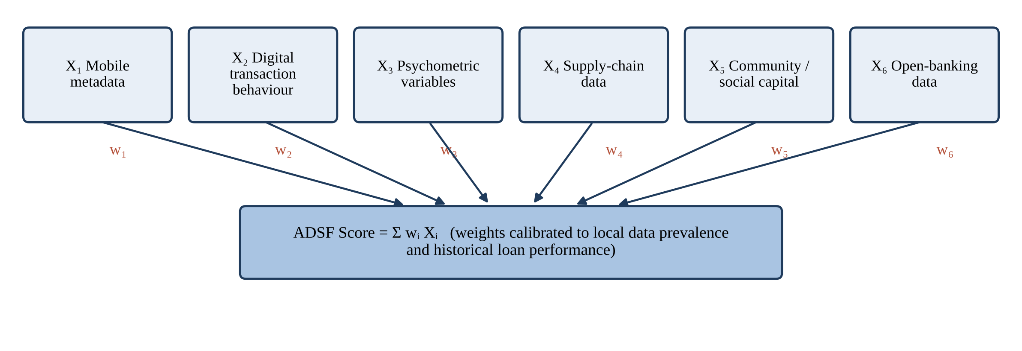
Fig. 3 Structure of the Alternative Data Scoring Framework (ADSF) proposed in six data pillars combined through market-specific weights into a composite score

Its attractiveness stems from being explicit about how each portion of the score is derived and from acknowledging data availability variances between markets. Citing evidence from Sub-Saharan Africa, Asia, and Latin America, the author details how multi-channel scoring can increase predictive accuracy by 20–35% compared to single-source models and how it can lower default rates amongst thin-file borrowers. He also discusses digital identity, data-protection law, and open-banking legislation as three areas of regulation that underpin this type of scoring. The ADSF does not train any classifiers, test any datasets, or recommend any explainability tooling, remaining high-level throughout.
UPI- and GST-based scoring for India [5]. The study craft a similar data philosophy, albeit one purpose-built for Indian borrowers. At the individual level, they derive features such as UPI transaction volume & in/out ratio, expenditure-to-income ratio, savings rate, EMI defaults, and utility-bill payment history. For MSMEs, they use GST filing delay, GST growth rate, working-capital turnover, vendor payment delay, average bank balance, digital-sales ratio, and business tenure. This alternative-data taxonomy is by far the most India-specific, as well as operationally-grounded, in the corpus. It is the closest thing to a structural comparison for the feature set this project seeks to build from bank statements, GST filings, and UPI transaction history.
Transaction-level behavioural scoring for MSMEs [7]. The study discuss fintech and bank-led credit scoring pilots involving the use of transaction-level behavioural data for MSMEs ranging from digital-payment histories and bank transaction logs to mobile-money and point-of-sale (POS) data, supplier, payroll and invoice histories, and social, utility and e-commerce footprints. They conclude that payment timeliness, transaction-volume volatility, invoice ageing and supplier-payment cycles emerge as leading, near real-time predictors of financial health in the absence of formal audited data, and that these behavioural signals have better performance than static financial-ratio scores for thin-file MSMEs.
Fintech ML with non-traditional data [10]. The strongest causal evidence in this bundle is offered by this study, which uses proprietary loan-level data from a large Chinese fintech lender. The data covers loans originated between May and September 2017 and followed through October 2018. The study compare an ML model trained on traditional variables alongside nontraditional data (digital-application and e-commerce footprints) against traditional logit-based models. Not only does the ML model with non-traditional data outperform the traditional models in loss predictions and defaults, but its marginal benefit is largest during an exogenous regulatory shock to shadow banking activity. Critically, the marginal benefit of the alternative data is largest for borrowers with the shortest credit histories, and the effect diminishes for borrowers with longer bureau histories, speaking directly to use cases for thin-file customers. Evidence is limited to individual consumer loans and one platform, and does not include MSME operational cash-flow variables or interpretability layer.
The four Cluster B papers share exactly one conclusion: that alternative data contain predictive information conventional data do not, and that this predictive gain is largest for precisely those borrowers who are excluded by conventional scoring. Beyond that, they differ considerably in empirical methodology. The study in [10] provides careful loan-level evidence, but lacks a MSME focus. The works in [6] and [7] provide an MSME focus but no novel modeling. The study in [5] uses an India-specific model trained on synthetically generated MSME data.

3.3 Cluster C: machine-learning architectures for credit risk
3.3.1 Ensemble learners
The supervised learning models from MSME-related papers fall into the category of tree ensembles. Random forests [37] average the outputs of decision trees trained on bootstrapped samples of the data and on random subsets of features. This decorrelates the trees and reduces variance without overly compromising their fit, mitigating overfitting. Gradient boosting trains trees sequentially such that each tree tries to explain the residuals of the existing ensemble of trees. XGBoost [38] tunes gradient boosting with regularisation, sparsity-aware split searching and efficient parallelisation. LightGBM [39] implements histogram-based splitting, gradient-based one-side sampling and leaf-wise tree growth to allow training speedups on large datasets. Each can model non-linear relationships and interactions between variables and can handle mixed types of input features without manual intervention, making them useful for behavioural information like payments delays and transaction volatility. Table 4 compares the classifiers used in 16 studies, ordered from the latest to the earliest, together with the best-performing model in each and the advantages and limitations reported.

Table 4 Comparison of classifiers used in the reviewed credit-scoring studies
Ref. | Year | Classifiers compared | Best model and metric | Advantages reported | Limitations reported
[5] | 2026 | Gradient boosting (scikit-learn) vs LR; isotonic calibration | GBM: AUC 0.784 (MSME), 0.765 (individual); Brier 0.184 / 0.195 | Calibrated PDs feed three-tier decisions and expected-loss simulation | Synthetic data (5,000 records per model); no code released
[31] | 2025 | Logit, LightGBM, XGBoost and other estimators; >6,100 model–subsample runs | LightGBM best out of sample, XGBoost close second | Built-in feature selection; no rebalancing needed | Logit needs explicit feature selection and rebalancing
[32] | 2025 | RF, XGBoost, LightGBM with SMOTE and GridSearchCV | LightGBM: accuracy 90.07%, ROC-AUC 0.7203, precision 0.2757 | Fast training; business-optimal on approval and default rates | Low precision on imbalanced data; bureau-style features
[21] | 2024 | Tree ensembles vs LR with model-X knockoff feature selection | AUC 0.7936 with alternative predictors | Knockoffs control false discoveries among added variables | Single public consumer dataset
[22] | 2023 | Historical RF vs ordered probit (pooled and historical) | Historical RF: test macro-F1 0.736 vs 0.472 | Captures non-linearity; SHAP and permutation importance | Small sample (464 SMEs)
[23] | 2022 | LightGBM vs bank's LR scorecard | LightGBM: AUC 0.96 vs 0.82 (+17%) | Large gain; SHAP shows drivers of default | Single Norwegian bank; consumer loans
[33] | 2021 | LR, DT, RF, XGBoost, MLP (1–5 layers), DBN on 10 datasets | XGBoost: average rank 2.5 (MLP-1 3.1, LR 3.9, DBN 8.7–9.2) | XGBoost accurate and efficient | Deep networks no better and far costlier to train
[26] | 2021 | LR, ridge, LASSO, XGBoost, neural networks | Test AUC 0.751 with demographic + psychometric data | Regularised models handle 400+ alternative variables | Small Mexican sample (1,826 borrowers)
[25] | 2021 | Tree-based models with TreeSHAP vs bureau-only models | KS ≈ +10 pp with super-app features | Reveals non-linear behavioural patterns | Requires validation across jurisdictions
[27] | 2020 | LR, RF, XGBoost with 5-fold CV | AUC 0.66 (bureau + mobile footprint) vs 0.59 | Scores applicants without bureau history (AUC 0.58) | Young salaried individuals only
[34] | 2020 | LR vs XGBoost, explained with SHAP | XGBoost: AUC 0.93 vs 0.81 | Shapley values give per-SME explanations | Financial-ratio data only
[28] | 2020 | Logistic regression | AUC 0.736 (footprint + bureau) | Simple, transparent coefficients | No ensemble methods
[10] | 2019 | Fintech ML model vs traditional logit | ML better in loss and default prediction | Advantage largest under regulatory shock | Single platform; no explainability
[29] | 2019 | LR, decision tree, RF (500 trees); 10-fold CV | Calling-behaviour model most profitable (EMP) | Profit-based evaluation | Individual borrowers only
[9] | 2015 | 41 classifiers incl. RF, GB, SVM, ANN, heterogeneous ensembles | Heterogeneous ensembles and RF significantly beat LR | Robust multi-metric benchmark (AUC, H, Brier, PCC) | Gains not always managerially meaningful
[30] | 2010 | Non-linear, non-parametric tree models vs rules | Out-of-sample R² 85% | 6–25% loss savings; anticipated 2008 surge | No interpretability layer

3.3.2 Ensemble pipeline with SMOTE, SHAP and LIME [32]
This study proposes the pipeline that bears the closest methodological resemblance to our own. Operating on a merged multi-source consumer-lending dataset (application forms, bureau data, previous applications, credit-card history and external-source scores), with binary defaulter labels provided, the study train three ensemble classifiers: Random Forest, XGBoost and LightGBM. Pre-processing steps include median and mode imputation, one-hot encoding of categoricals and StandardScaler transformation. Model class imbalance – which is extreme in default datasets – is managed with Synthetic Minority Over-sampling Technique SMOTE [40] and GridSearchCV is used to tune each model. Fig. 4 summarises their pipeline.

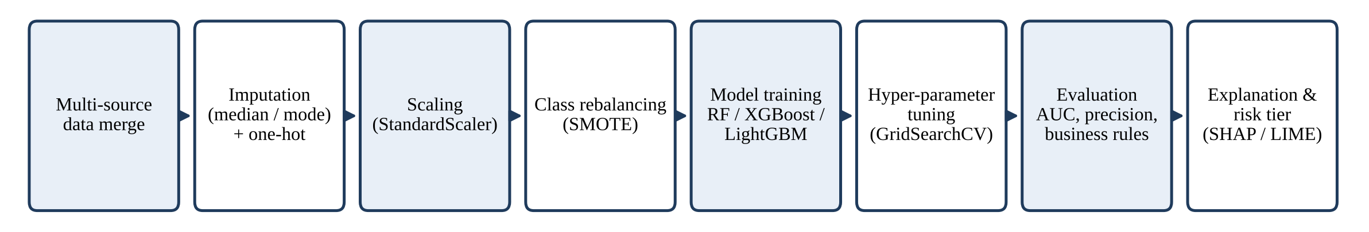
Fig. 4 Typical ensemble credit-scoring pipeline, as implemented

LightGBM was chosen as the optimal model from a business perspective, at 90.07% accuracy, 0.7203 ROC-AUC and 0.2757 precision. The scoring used traditional model metrics as well as business criteria such as approval rate, default rate, false positives rate, false negatives rate etc. The selected model feeds into a three-tier Low/Mod/Highest risk decision engine which is mapped to approve / manual review / reject decisions as well as interest-rate and loan-condition logic. Automated HTML and JSON output reporting is produced by the system. The tension between high accuracy and only middling precision in our selected model is itself revealing and will be discussed in Sect. 4.3.
3.3.3 Calibrated gradient boosting on UPI and GST features [5]
The study trained two parallel scikit-learn Gradient Boosting Classifier architectures [41], one using borrower-level records and one using MSME-level records. Each classifier was trained on 5,000 synthetically generated records matched to NABARD, SIDBI–CIBIL and RBI aggregate statistics. Each model uses an stratified 80/20 train–test split and are benchmarked against logistic-regression baselines. Each classifier was post-calibrated with isotonic regression [42], which translates raw classifier scores into well-calibrated probabilities. The calibration quality was determined by computing the Brier score [36], which was less than 0.20 for both classifiers. The individual-level classifier had an area under the ROC curve of 0.765 and a Brier score of 0.195, while the MSME-level classifier had an area under the curve of 0.784 and a Brier score of 0.184.
Loans are evaluated using a straightforward three-tier decision system based on the applicant's risk of defaulting. If an applicant's default probability is below 20%, the application is automatically approved. If the risk falls between 20% and 40%, it is referred to a human reviewer for further evaluation. If the risk exceeds 40%, the application is rejected. Additionally, the overall potential risk to the loan portfolio is calculated using the standard expected loss formula, which multiplies the probability of default by the expected loss percentage and total loan amount.
EL = PD × LGD × EAD (2)
where LGD is the loss given default and EAD the exposure at default. Relative to random approval, AI-based selection decreased expected loss by 51.7% for individuals and 48.3% for MSMEs. Feature-importance analysis ranked sales volatility (0.246), GST filing delay (0.190) and vendor payment delay (0.145) as the top three MSME risk indicators, while utility-bill payment score (0.246) and savings rate (0.203) topped the list for individuals (Fig. 5). These rankings have direct value for feature selection here.

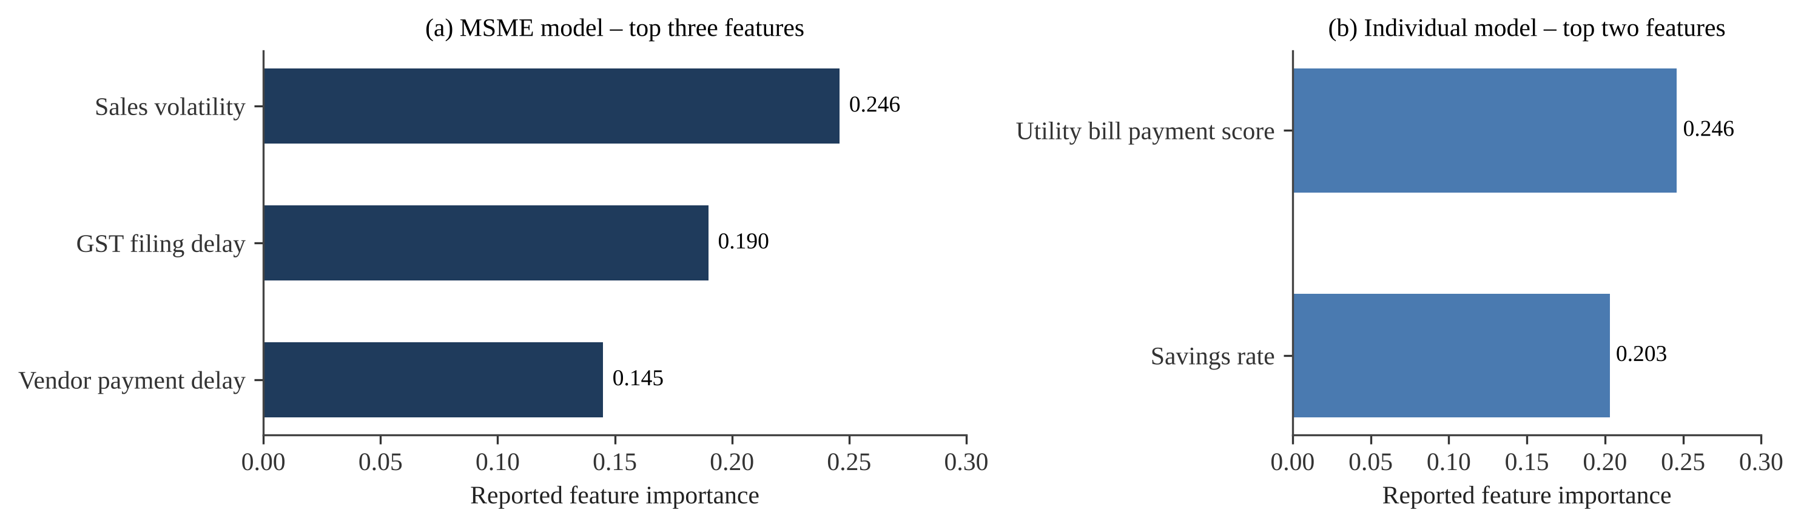
Fig. 5 Top-ranked feature importances reported for (a) the MSME model and (b) the individual-borrower model

3.3.4 Comparative and methodological context
The study in [10] and the review in [7] provide context for the broader methodological landscape. Each find that discrimination is markedly stronger for ensemble and boosting methods like XGBoost and gradient boosting than for logistic-regression baselines, due to their ability to model non-linear relationships between behavioural variables. Each also highlights use of k-fold or stratified cross-validation [43] to ensure results generalise across heterogeneous MSME and borrower profiles. One further point about methodology is highlighted in [5]: when output from models is fed into a PD threshold decision rule as well as an expected-loss calculation, the calibration of predicted probabilities becomes as important as their rank-ordering. As boosted trees are known to produce distorted probability estimates without post-hoc calibration [44], calibration should be considered part of the model, not an optional refinement.

3.4 Cluster D: explainable AI integration
3.4.1 Explanation techniques
Explainability is considered a first-class design requirement in all the empirical MSME papers we survey. Two post-hoc techniques are most prevalent. SHAP (SHapley Additive exPlanations) explains a prediction by assigning each feature an importance value using Shapley values from cooperative game theory. There are efficient exact algorithms for tree ensemble models [45]. Given a model f and an instance x with M features, the SHAP explanation is additive:
f(x) = φ₀ + φ₁ + φ₂ + … + φ_M (3)
where φ₀ is the expected model output and φⱼ is feature j’s contribution. Taking the mean of |φⱼ| across many instances provides global importance rankings. In contrast, the φⱼ for a single applicant provides local explanation. Another technique is LIME which fits a sparse linear surrogate model locally around the applicant to be explained [46]. Counterfactual explanations (the smallest change to the inputs that changes the decision) provide a third option which is well suited to borrower facing recourse [47]. Table 5 compares these techniques.

Table 5 Comparison of explanation techniques relevant to credit scoring
Technique | Characteristics | Advantages | Disadvantages | Use in reviewed studies
SHAP [45] | Shapley-value attribution; additive; global and local; exact TreeSHAP for tree ensembles | Well grounded in theory; one technique provides both global rankings and per-applicant explanation | Kernel version is slow for nonlinear models; correlated features cancel each other out | [5] (SHAP-proxy), [32], [22], [23], [25], [34]; discussed by [4], [7]
LIME [46] | Local surrogate (sparse linear) model trained around one instance | Fast; model agnostic; intuitive green/red feature bars | Explanation varies between runs; depends on how you sample neighborhood | [32]; discussed by [7]
Counterfactual explanations [47] | Smallest input change that would change decision | Clearly actionable to applicants; allows for recourse and appeals | Many valid counterfactuals exist; may recommend impossible changes | Discussed by [4]
Global feature importance | Impurity- or permutation-based ranking of features | Easy to compute; included with tree libraries | Lacks per-applicant view; impurity importance is biased | [5], [22]
Inherently interpretable models [13] | Scorecards, sparse linear or monotonic models | Explanation is exact; more easily accepted by regulators | Can lose accuracy on complex datasets | Not implemented in the reviewed MSME studies

The survey in [48] provides an overview of the XAI field more broadly. They emphasise that appropriate explanations depend on their end-user: different information may be required by a model developer, a credit officer, a regulator and a customer who has been rejected for credit. The study in [49] show in a credit-risk application that explanations based on Shapley values can be used in conjunction with correlation-network analysis to cluster borrowers by their drivers of risk. This illustrates how SHAP output can be used to gain an understanding at both portfolio and individual levels.
3.4.2 SHAP and LIME in the reviewed studies
The study in [32] employs both methods. SHAP produces global feature-importance rankings, visualized as beeswarm summary plots and bar graphs for each model. For every model, SHAP reveals external-source credit scores (EXT_SOURCE_1–3) explain the majority of the decision logic, which serves as a useful reminder that any model trained on bureau-like data is simply inheriting the bureau's opinion of a borrower. LIME produces per-applicant local explanations in seconds, highlighting features that decrease risk in green and increase risk in red within the HTML applicant report itself.
The study in [5] takes the same idea and apply it to meeting regulatory requirements, showing how it maps to the explainability principle in the RBI FREE-AI framework. The SHAP-proxy attributions are presented as waterfall charts along with simple-language fact panels at the borrower level. The three example borrowers are a "safe borrower" who was approved at a PD of 13.5%, a "moderate borrower" who was rejected at a PD of 55.0% where savings rate is the principal risk-amplifying factor and a "high-risk borrower" who was rejected at a PD of 86.4% where risk is controlled by expense-to-income ratio (Fig. 6). Each explanation offers prescriptive guidance – save more money or cut discretionary spending – the type of explanation you would want to see come out of a credit-decision appeal process, and what the present project's PDF report generator seeks to reproduce.
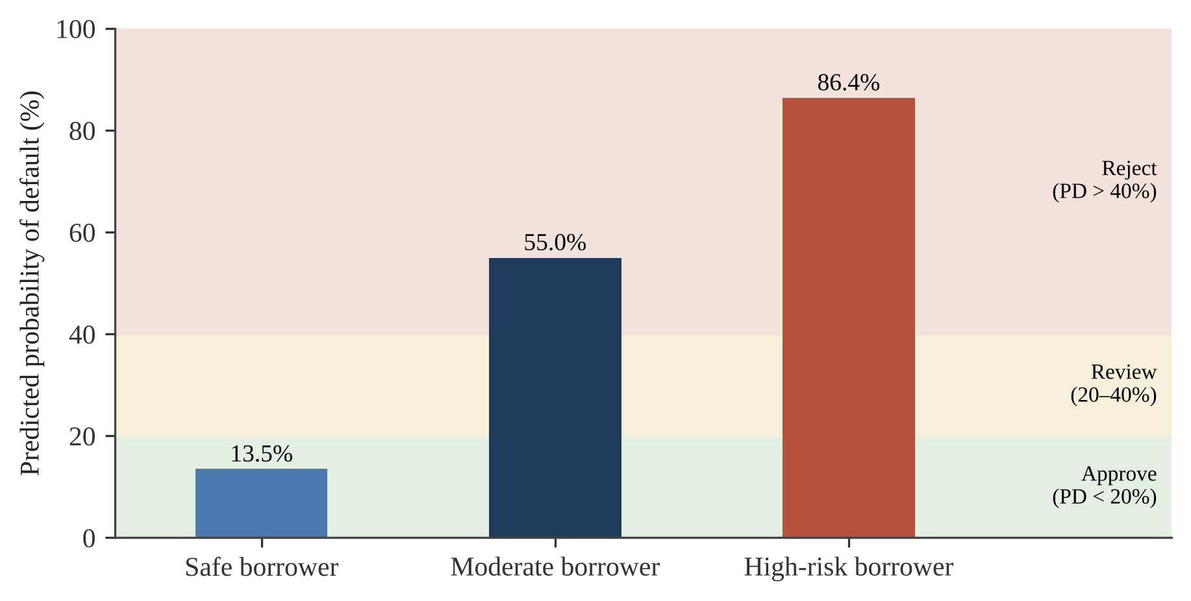
Fig. 6 Borrower-level PD , shown against the three-tier decision thresholds
3.4.3 Explainability as governance infrastructure
The studies in [7] and [4] frame SHAP, counterfactual explanations and fairness-aware learning within model governance rather than as optional model diagnostics. The first ties explainability directly to regulatory approval and stakeholder trust specific to fintech lending decisions. The second presents the inherent lack of transparency in algorithmic decision-making, or the "black-box problem", as a potential source for new information asymmetry and even "data-opoly" risk if left unaddressed. They point to the recent Article 6 of EU AI Act classification of credit-scoring as a high-risk application requiring transparency and meaningful human oversight [11] as having the potential to set a de-facto global standard. It is cautioned in [13] that, because post-hoc explanations only approximate a model's decisions rather than opening the model up to inspection, they should be validated and interpretable models should be used whenever possible if they provide commensurate performance. This concern applies less to models with inherently interpretable structures. For tree ensembles, the computational shortcuts in TreeSHAP can be eliminated. The exact TreeSHAP algorithm uses the model's true structure to compute attributions [45].

3.5 Cluster E: fairness, policy and governance
3.5.1 Measuring fairness
There are many competing formal definitions of fairness in credit scoring. Group parity measures look at outcomes such as approval rates across groups; error-rate measures like equality of opportunity look at true-positive rates [50]. The disparate impact ratio (DIR) compares the approval rate of a protected or comparison group with that of the reference group:
DIR = P(approve | group g) / P(approve | reference group) (4)
The typical threshold for determining disparate impact is a DIR less than 0.80, referred to as the "four-fifths rule" [51]. The study in [52] demonstrates that fairness metrics for credit scoring cannot universally coexist and that imposing them comes at a calculable cost to profits. Therefore, lenders must determine which metrics are most important to them. Through empirical methods, the study [53] find that the use of more flexible ML models in mortgage lending can increase overall accuracy but exacerbate group disparities, suggesting the need to measure accuracy and fairness independently.
3.5.2 Fairness in the reviewed studies
The study in [5] is the only one in our review to operationalise a quantitative fairness metric end-to-end. They calculate DIR across income bands for the individual model and across GST-compliance cohorts for the MSME model, then benchmark these values against an acceptable band of 0.80–1.25 derived from the RBI FREE-AI guidelines. All four income-band DIR values pass, with values ranging from 0.979 to 1.175. In the MSME model, DIR values for the “Moderate” and “Poor” GST-compliance cohorts fall well below the band at 0.260 and 0.054 respectively; however, the study claim these are contextually acceptable due to the same cohorts having substantially higher observed default rates of 50.1 and 71.4% (Fig. 7). The key methodological takeaway is that low DIR values should be considered along with group-level default rates in order to differentiate between discriminatory model structure and legitimate risk differentiation.

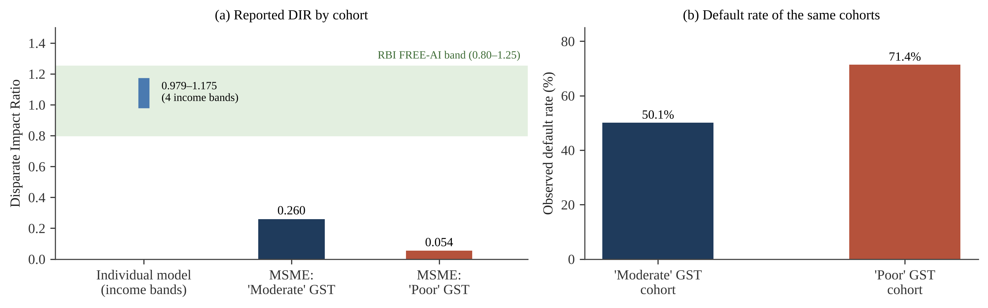
Fig. 7 Fairness results reported in: (a) disparate impact ratio by cohort against the RBI FREE-AI band; (b) observed default rates of the two MSME cohorts that fall below the band

This result is nonetheless useful but should be taken with caution. GST compliance itself is a behaviour, not a protected characteristic. Thus, this analysis proves whether our model penalises risk relevant behaviours but does not say whether our model discriminates based on protected attributes. One more stringent audit would be to examine whether GST compliance serves as proxy for protected characteristics e.g. owner's gender, region of firm etc. This audit would also involve assessing error-rate fairness alongside approval-rate parity [50], [52].
3.5.3 Policy frameworks
The policy framework in [4] takes the broadest view in scope. The study synthesize seven theoretical lenses: information-asymmetry theory, institutional theory, development-finance theory, the technology acceptance model, the triple bottom line, an AI-ethics and corporate-social-responsibility governance design model, and requirements for alignment with the UN Sustainable Development Goals. Standing on the shoulders of these giants, they derive an umbrella policy framework for AI-augmented MSME credit scoring in the Middle East and North Africa region, leveraging mobile-usage, social-media and microblog behavioural data as “thick data”. The paper proposes but does not build or test a model. Its contribution is an argument that technical efficacy (accuracy, AUC) is a necessary but not sufficient condition for ethical AI. Ethics, governance, data-protection law and human-in-the-loop review need to be designed into the system from the beginning. It positions XAI tools, fairness-aware learning (both reweighing and adversarial debiasing) and privacy-preserving techniques (federated learning, differential privacy) as part of this governance package.
Guidance texts reinforce this direction. The EU AI Act requirements include risk-management, data-governance, transparency and human-oversight mandates for high-risk credit-scoring systems [11]. The RBI FREE-AI principles articulate responsible and ethical AI use in the Indian financial sector, including explainability, fairness and accountability principles [12]. Taken together, for an Indian MSME credit offering these texts mean specific design requirements: Explain decisions to the applicant. Monitor outcomes across cohorts. Have a human able to review and intervene on borderline decisions.

3.6 Recent empirical evidence (2020–2026)
Ten recent studies widen the evidence base beyond the core corpus. Three use real SME data. The study in [34] trained XGBoost on 15,045 mostly Southern-European SMEs (10.9% default rate) and reported an AUC of 0.93 against 0.81 for logistic regression, explained with SHAP. The work in [22] compared a historical random forest with an ordered probit on 464 Italian SMEs (3,009 quarterly observations); the forest reached a test macro-F1 of 0.736 against 0.472 for the probit on balance-sheet variables. In [31], the study evaluated more than 6,100 model and subsample combinations on U.S. SME data and found LightGBM best out of sample, closely followed by XGBoost, with neither needing rebalancing.
Five studies quantify the value of alternative data. The study in [27] used 417,578 loan applications to an Indian mobile-only fintech lender and found that mobile and social footprints raised AUC from 0.59 (bureau score alone) to 0.66. The work in [24] analysed 86,447 loan applications to the Indian micro-business lender Indifi, with more than 35 million bank-statement transactions, and found that an interquartile (31-percentage-point) increase in cashless payments was associated with a 2.7-percentage-point higher approval probability and a 42-basis-point lower interest rate. In [26], the study showed that psychometric and e-mail-usage data lifted test AUC from 0.624 (demographics only) to 0.751 for 1,826 borrowers in Mexico. The study in [25] added super-app behaviour for 50,000 and 30,000 users in two countries and raised the KS statistic by about ten percentage points, with cost savings of 20.5–36.0%. The work in [21] added social-network default status and regional indicators to the Home Credit data and reached an AUC of 0.794.
The remaining two studies concern model choice and explanation in banks. The study in [33] benchmarked logistic regression, decision trees, random forests, XGBoost and deep networks on ten datasets of 690 to 150,000 loans; XGBoost had the best average rank (2.5) and deep networks did not outperform shallower ones. The work in [23] combined LightGBM with SHAP on 13,969 Norwegian consumer-loan customers and reported an AUC of 0.96 against 0.82 for the bank's logistic-regression scorecard. Taken together, these studies confirm the core findings with real data, but none of them combines MSME cash-flow data from India with live explanations and a deployable system.

3.7 Cross-cluster synthesis
When analyzed together, the five research groups provide a comprehensive framework for applying machine learning to credit risk assessment. The first group demonstrates that machine learning models using non-traditional data predict consumer defaults much more accurately than traditional credit scorecards. The second group identifies key operational indicators—such as tax payment history, sales volatility, payment speed, and supplier cycles—as the most reliable data points for assessing businesses that lack standard financial records. The third group outlines the best technical practices for building these models, favoring tree-based algorithms paired with proper data balancing, fine-tuning, and probability calibration. The fourth group focuses on explainability, establishing SHAP as the leading method for explaining model outputs to users and regulators, complemented by tools like LIME and counterfactual scenarios. Finally, the fifth group highlights essential governance standards, emphasizing that transparency, fairness monitoring, data privacy, and human oversight must be integrated into the system from the beginning.
Each poses assumptions based on the answers to prior questions. However, to date they have not been answered collectively with respect to a single population. The most compelling empirical studies (Clusters A and C) focus on individual consumers, across the US, Germany, Latin America and China; the MSME specific and India-specific data (Clusters B and E) is primarily theoretical or synthetic. The most comprehensive study [5] overlaps four of the five clusters, but does so using synthetic data and without demonstrating a scalable solution. This presents the opportunity of this work: unite the methodological agreement of Clusters A, C and D with the data priorities of Cluster B and the governance considerations of Cluster E, within a deployed system for Indian MSMEs.
The second cross-cutting finding relates data to explanation. The study in [32] discovered that external-source bureau scores dominated the SHAP rankings of all three of their models. That means the explanations offered by SHAP largely restated the bureau’s judgement. By contrast, the MSME features used in [5], like GST filing delay and vendor payment delay, describe actions that the borrower understands and can alter. Choice of input data therefore determines not just accuracy, but also the value of the explanation: an explanation based on operational behaviour can help a borrower, one based on an inscrutable third-party score cannot. This gives us yet another reason to prefer operational cash-flow features for MSME assessment.

4 Comparative analysis of the reviewed studies

4.1 Comparative synthesis
Table 6 provides an overview of each study's dataset/methodology, key findings, and unanswered research questions. The 20 studies are ordered from the latest to the earliest, and each entry is reduced to short phrases with the main statistics reported.

Table 6 Comparative synthesis of the reviewed literature on alternative-data MSME credit scoring
Ref. | Year | Dataset / data types | ML / XAI methodology | Key findings | Identified research gaps
[4] | 2026 | Conceptual (MENA); mobile, social-media, microblog “thick data” | No model; XAI, fairness-aware learning, federated learning, DP as governance | Seven theory lenses; AI scoring cuts information asymmetry only with guardrails | No dataset, model, metric or prototype
[5] | 2026 | 5,000 individual + 5,000 MSME synthetic records (UPI, GST, bank) | GBM + isotonic calibration vs LR; SHAP-proxy; DIR; EL simulation | AUC 0.765 / 0.784; Brier 0.195 / 0.184; EL −51.7% / −48.3%; income DIR 0.979–1.175 | Synthetic data; no API, database or UI
[31] | 2025 | U.S. SME failure data | >6,100 model–subsample combinations; Logit, XGBoost, LightGBM, others | LightGBM best, XGBoost second; no rebalancing needed | Financial data only; no alternative data or XAI
[32] | 2025 | Multi-source consumer lending data (application, bureau, previous loans, card history) | RF, XGBoost, LightGBM; SMOTE; GridSearchCV; SHAP + LIME; 3-tier engine | LightGBM: accuracy 90.07%, ROC-AUC 0.7203, precision 0.2757; EXT_SOURCE scores dominate SHAP | Bureau-style data; static plots; no API
[6] | 2025 | Secondary evidence: Sub-Saharan Africa, Asia, Latin America | ADSF six-pillar weighted score; no classifier | Multi-source scoring +20–35% accuracy; lower thin-file defaults | No model, validation or XAI
[21] | 2024 | Home Credit portfolio + social-network and regional variables | Model-X knockoffs; tree ensembles vs LR | AUC 0.7936 with alternative data | Consumer loans; no MSME or India data
[22] | 2023 | 464 Italian SMEs, 3,009 quarterly obs. (2015–2017) | Historical RF vs ordered probit; SHAP, PFI | Test macro-F1 0.736 vs 0.472 | Small sample; no cash-flow data
[23] | 2022 | 13,969 Norwegian consumer-loan customers; >13M records | LightGBM + SHAP vs bank LR | AUC 0.96 vs 0.82 (+17%); credit-balance volatility top driver | Consumer loans; one bank
[33] | 2021 | 10 credit datasets, 690–150,000 loans each | LR, DT, RF, XGBoost, MLP, DBN; Bayesian tests | XGBoost rank 2.5 vs LR 3.9; deep nets no better | No alternative data or XAI
[26] | 2021 | 1,826 Mexican + 16,358 Nigerian borrowers; psychometric, e-mail | LR, ridge, LASSO, XGBoost, NN | Test AUC 0.624 → 0.751 with psychometric data | Individuals; no explainability
[25] | 2021 | 50,000 + 30,000 super-app users, two countries | Tree models + TreeSHAP vs bureau-only | KS ≈ +10 pp; savings 20.5–36.0% | Consumer credit; jurisdiction-specific
[24] | 2021 | 86,447 Indifi micro-business applications; 35M+ bank-statement transactions | Econometric (OLS, IV) analysis of cashless share | +31 pp cashless → +2.7 pp approval, −42 bp rate, lower default | No predictive classifier or XAI
[7] | 2021 | Review: bank logs, POS, mobile money, invoices, payroll, utility data | Survey of SVM, LR, RF, XGBoost, DL; k-fold CV; SHAP/LIME; fairness audits | Behavioural signals beat static ratios for thin-file MSMEs | No original model, data or system
[27] | 2020 | 417,578 Indian fintech applications (2016–2018); 13.5% default | LR, RF, XGBoost; 5-fold CV | AUC 0.59 → 0.66 with mobile footprint; 0.58 without bureau score | Salaried individuals; privacy concerns
[34] | 2020 | 15,045 European SMEs (ECAI); 10.9% default | XGBoost vs LR; SHAP | AUC 0.93 vs 0.81 | Ratio data; no alternative data
[28] | 2020 | ≈250,000 German e-commerce checkouts | LR on digital-footprint variables | AUC 0.696 footprint, 0.683 bureau, 0.736 combined | Consumers; LR only; privacy not addressed
[10] | 2019 | Chinese fintech loans, May–Sep 2017, tracked to Oct 2018 | ML with non-traditional data vs logit; regulatory shock | ML better; edge largest for short histories and under stress | Consumers; one platform; no XAI
[29] | 2019 | 22,000 obs.; 5 months of CDRs; ≈4.5% default | LR, DT, RF; AUC and EMP profit | Calling behaviour most predictive and profitable | Individuals; no MSME cash-flow data
[9] | 2015 | 8 retail credit-scoring datasets | 41 classifiers vs LR; AUC, H-measure, Brier, PCC | Ensembles significantly beat LR | No alternative data, MSME context or XAI
[30] | 2010 | U.S. bank card transactions + bureau data, 2005–2009 | Non-linear, non-parametric ML vs rules | Out-of-sample R² 85%; 6–25% loss savings | Banked consumers only; no XAI

4.2 Reported performance
As the studies covered draw upon different datasets, populations and definitions and measures of outcomes, it is not possible to directly compare their reported results in some sort of league table. Table 7 instead lists, for 18 empirical or quantitative studies ordered from the latest to the earliest, the dataset used (size, format and application) together with the evaluation parameters reported.

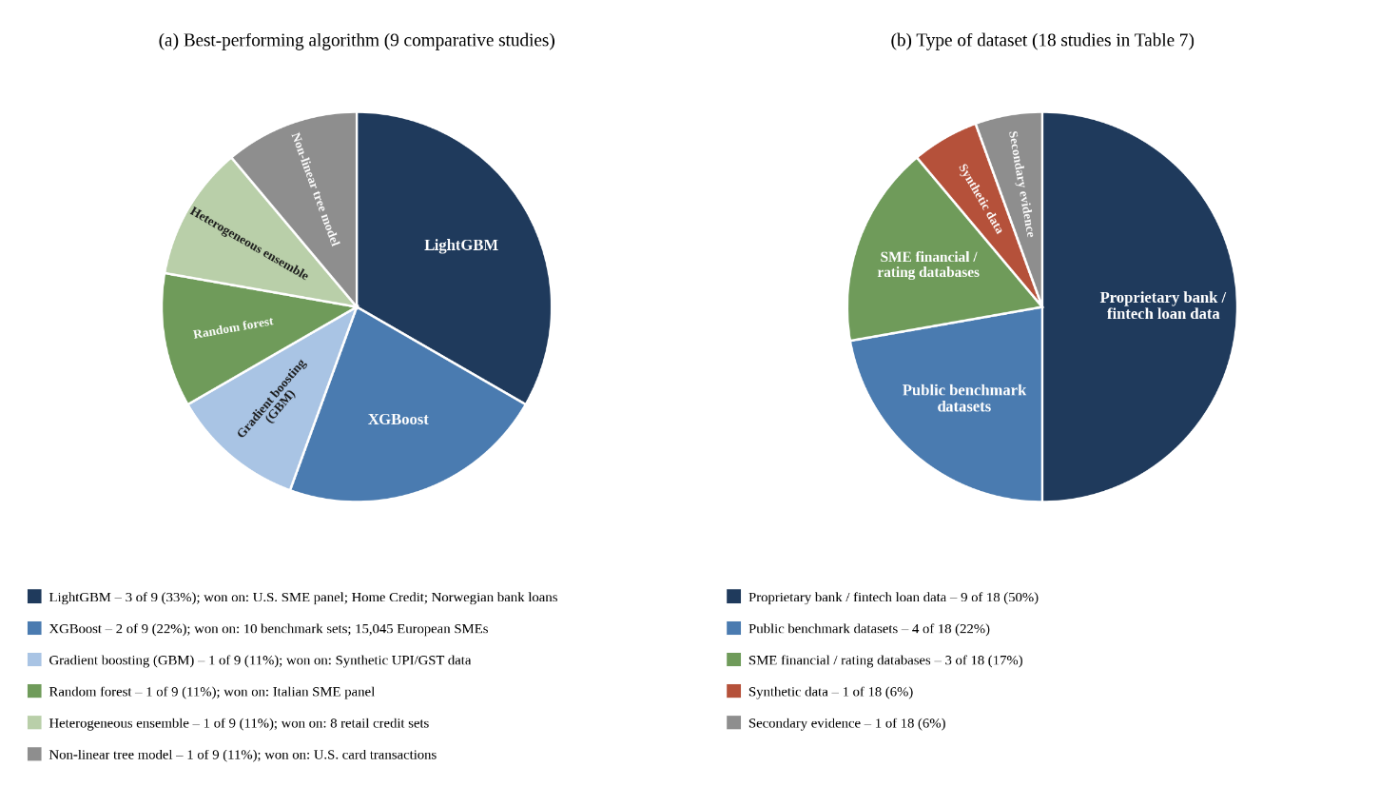
Fig. 8 (a) Best-performing algorithm in the nine studies that compared classifiers on the same data, with the datasets on which each algorithm won; (b) type of dataset used in the 18 studies of Table 7

Figure 8 summarises which dataset proved more promising with which algorithm. Panel (a) counts, among the nine studies that compared several classifiers on the same data, the algorithm that performed best and names the datasets on which it won; panel (b) shows the type of dataset used across the 18 studies in Table 7. Gradient-boosted trees (LightGBM, XGBoost and scikit-learn GBM) were best in six of the nine comparisons, on bank, SME and public benchmark data alike, while random-forest-type ensembles won on the smaller Italian SME panel and the older retail benchmarks. AUCs of 0.72–0.79 on retail and alternative data represent useful but decidedly imperfect discrimination, which is common for retail and small-business default prediction. The values from [5] were calculated on synthetic data drawn to match published aggregates, so are almost certain to be optimistic compared to performance on actual transaction-level records; the value from [32] was calculated on actual but bureau-style data. Neither should be regarded as indicative of what an MSME model applied to real UPI, GST and bank statement data would attain.

Table 7 Dataset description and evaluation parameters reported in the reviewed studies
Ref. | Year | Dataset | Size | Format | Application | Evaluation parameters | Nature of evidence
[5] | 2026 | Synthetic UPI, GST and bank records calibrated to NABARD, SIDBI–CIBIL, RBI data | 5,000 individual + 5,000 MSME | Tabular (synthetic) | Individual and MSME credit scoring | AUC 0.765 / 0.784; Brier 0.195 / 0.184; EL −51.7% / −48.3% vs random approval | Synthetic data
[31] | 2025 | U.S. SME failure data | >6,100 model–subsample runs | Tabular firm financials | SME default prediction | Out-of-sample ranking: LightGBM 1st, XGBoost 2nd | Real data
[32] | 2025 | Home Credit default-risk tables (application, bureau, previous loans, card balance) | ≈307.5k applications (main table) | Multi-table CSV | Consumer loan default | Accuracy 90.07%; ROC-AUC 0.7203; precision 0.2757 | Real public dataset
[6] | 2025 | Pilots in Sub-Saharan Africa, Asia and Latin America | n.r. | Mixed (CDR, POS, psychometric) | MSME lending | Accuracy +20–35% vs single-source models | Secondary evidence
[21] | 2024 | Home Credit portfolio + social-network and regional data | ≈307.5k applications | Tabular CSV | Consumer credit scoring | AUC 0.7936 (alternative data model) | Real public dataset
[22] | 2023 | Italian SME securitisation data + Orbis balance sheets | 464 SMEs; 3,009 obs. | Quarterly panel | SME rating prediction | Test macro-F1: HRF 0.736 vs probit 0.472 | Real data
[23] | 2022 | Norwegian bank unsecured consumer loans | 13,969 customers; >13M records | Account and transaction panel | Consumer default | AUC 0.96 (LightGBM) vs 0.82 (LR) | Real bank data
[33] | 2021 | German, Australian, Taiwan, GMSC, Benelux 1–3, UK, HMEQ, Thomas | 690–150,000 loans per set | Tabular CSV | Retail credit scoring | Average rank: XGBoost 2.5, LR 3.9, DBN 8.7–9.2 | Real benchmark data
[26] | 2021 | Mexican and Nigerian bank borrowers | 1,826 + 16,358 | Tabular (415 alt. variables) | Microcredit | Test AUC 0.751 vs 0.624; default 18% / 2% | Real data
[25] | 2021 | Super-app users in two Latin American countries | 50,000 + 30,000 | App-event logs + bureau | Consumer credit | KS ≈ +10 pp; cost savings up to 36.0% | Real data
[24] | 2021 | Indifi micro-business loan applications with bank statements (2015–2019) | 86,447 applications; 35M+ transactions | Bank-statement transactions | Micro-business lending | Approval +2.7 pp; rate −42 bp per 31 pp cashless share | Real data
[27] | 2020 | Indian mobile-only fintech lender (2016–2018) | 417,578 applications | Smartphone footprint + bureau | Consumer loans | AUC 0.59 → 0.66; 5-fold CV | Real data
[34] | 2020 | European External Credit Assessment Institution SME data | 15,045 SMEs | Tabular financial ratios | SME credit risk | AUC 0.93 (XGBoost) vs 0.81 (LR) | Real data
[28] | 2020 | German e-commerce checkouts | ≈250,000 | Transaction + footprint | Purchase-on-account credit | AUC 0.683 / 0.696 / 0.736 | Real transaction data
[10] | 2019 | Chinese fintech consumer loans (2017–2018) | n.r. | Loan-level records | Consumer loans | Default and loss prediction vs logit | Real loan-level data
[29] | 2019 | Bank and telecom data (Latin America) | 22,000 obs. | CDR graph + tabular | Microloans / credit cards | AUC; expected maximum profit (EMP) | Real telecom and loan data
[9] | 2015 | 8 retail credit-scoring datasets | 8 datasets | Tabular | Retail credit scoring | AUC, H-measure, Brier score, PCC | Real benchmark data
[30] | 2010 | U.S. bank card transactions + bureau records | n.r. (one bank's card holders) | Monthly panel | Card delinquency | Out-of-sample R² 85%; loss savings 6–25% | Real bank data

4.3 Evaluation practices
Issues in evaluating these measures mentioned by study of the reviewed studies bear directly on the design of the present project.
Accuracy can be deceptive when applied to imbalanced data. Consider a binary classifier where default is the minority outcome. A classifier that predicts "no default" for every applicant in a portfolio where the historical default rate is 10% has an accuracy of 90% and is obviously useless. Take for example the LightGBM model selected in [32]. Its accuracy of 90.07% comes with a precision of 0.2757, which means that about three quarters of applicants predicted to default did not. Metrics such as ROC-AUC [54] and H measure [35] measure classifier performance independently of a particular classification threshold, and should be reported along with precision, recall, and cost-weighted error rates.
Calibration is important when decisions are informed by probabilities. When predicted probabilities inform PD thresholds (thresholds used in pricing or expected-loss calculations), the model that best ranks borrowers will make the most incorrect decisions if poorly calibrated. Researchers should report calibration metrics like the Brier score [36] and reliability curves along with discrimination measures like AUC, and adjust for miscalibration using techniques like isotonic regression calibration [42] when appropriate, as recently done in [5].
Business metrics are orthogonal to statistical metrics. The benchmark in [9] warns that statistically significant improvement does not always imply managerial significance. The studies in [29] and [32] review models according to profit-based or business-rule metrics such as approval rate, default rate among approved loans, expected loss. Both statistical and business criteria should be considered when selecting a model for a lending system.
Validation was performed by stratified k-fold cross-validation (k=5) to preserve class balance in each fold and provide more stable estimates than a single split of the data [43]. Resampling methods such as SMOTE should only be applied within training folds. SMOTE applied before splitting leaks synthetic copies of test-set information into training, inflating reported performance. Validation was also performed on an out-of-time hold-out sample where available. Data are often collected over time, and where this is the case an out-of-time hold-out sample provides a stronger test than random splitting.

4.4 Analytical summary
Table 8 lists the 20 reviewed studies, from the latest to the earliest, according to dimensions of relevance to an MSME credit-assessment system, following the style of analytic summary matrices used in surveying algorithms. A solid mark (●) indicates that the study implements/empirically evaluates the dimension; a hollow mark (○) indicates that it discusses the dimension only.

Table 8 Analytical summary of the reviewed studies against key dimensions (● implemented / empirical; ○ discussed conceptually; – not addressed)
Ref. | Year | Alt. data | MSME focus | India data | Empirical model | Ensemble / non-linear ML | Real data | XAI | Fairness | API / UI system
[4] | 2026 | ● | ● | – | – | – | – | ○ | ○ | –
[5] | 2026 | ● | ● | ● | ● | ● | – | ● | ● | –
[31] | 2025 | – | ● | – | ● | ● | ● | – | – | –
[32] | 2025 | – | – | – | ● | ● | ● | ● | – | –
[6] | 2025 | ● | ● | – | – | – | – | – | – | –
[21] | 2024 | ● | – | – | ● | ● | ● | – | – | –
[22] | 2023 | – | ● | – | ● | ● | ● | ● | – | –
[23] | 2022 | – | – | – | ● | ● | ● | ● | – | –
[33] | 2021 | – | – | – | ● | ● | ● | – | – | –
[26] | 2021 | ● | – | – | ● | ● | ● | – | – | –
[25] | 2021 | ● | – | – | ● | ● | ● | ● | – | –
[24] | 2021 | ● | ● | ● | ● | – | ● | – | – | –
[7] | 2021 | ● | ● | – | – | ○ | – | ○ | ○ | –
[27] | 2020 | ● | – | ● | ● | ● | ● | – | – | –
[34] | 2020 | – | ● | – | ● | ● | ● | ● | – | –
[28] | 2020 | ● | – | – | ● | – | ● | – | – | –
[10] | 2019 | ● | – | – | ● | ● | ● | – | – | –
[29] | 2019 | ● | – | – | ● | ● | ● | – | – | –
[9] | 2015 | – | – | – | ● | ● | ● | – | – | –
[30] | 2010 | – | – | – | ● | ● | ● | – | – | –
Proposed project | – | ● | ● | ● | ● | ● | planned | ● | logged | ●

Figure 9 summarises the matrix into frequencies. The trend is evident. The majority of papers employ alternative data and train an empirical model, and within that group the majority use non-linear or ensemble methods. By comparison only a minority mention MSMEs, deploy explanation methods or evaluate fairness. Only three papers use India-specific data, just one operationalises a fairness metric, and none publish code for a deployable system complete with API, persistent database and user interface.

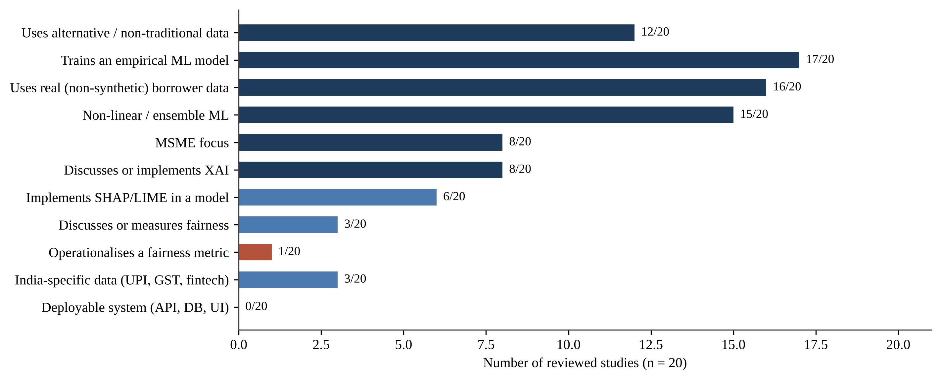
Fig. 9 Coverage of key research dimensions across the twenty reviewed studies (derived from Table 8)

5 Research gaps and systemic justification
The comparison highlighted five gaps overall. When looking at these gaps as a whole they help to justify the design of the proposed system. Table 9 summarises each gap, supporting evidence and response to the gap within the project.

5.1 Gap 1: consumer and bureau-style data versus MSME operational cash flow
The closest parallel to the present project in the sample, ML pipeline engineering-wise, is [32], which uses application, bureau and previous-application data for retail loans exclusively. The study in [10] analyses retail loans as well. MSME-specific operating data such as GST filings, invoice and vendor-payment cycles, and working-capital turnover is outside the purview of what either of these papers engineers as features. The recent SME studies [22], [31], [34] do use real SME data, but rely on balance-sheet and financial-ratio variables rather than operational cash-flow signals. The study in [5] is the only sample paper to consider both retail and MSME borrowers. Live data streams are not used by this paper for either category of borrower either. The project in this dissertation differs from all of the above papers in how it constructs its MSME training data. The data is sourced from bank transactions as well as GST data, UPI transaction history and cash-flow information.

5.2 Gap 2: black-box prediction without integrated interpretability
SHAP is mentioned elsewhere in the literature [4], [7] and used as-is to generate static plots or waterfall charts in the two empirical papers that reference it [5], [32]. However, in none of these studies is SHAP hooked into a live, queryable backend that can spit out an explanation for a new applicant if asked. The explainability layer is always treated as a batch-generation afterthought: a visual artefact to be saved to disk (PNG plot or HTML panel) rather than served as an explainer-as-a-service. By contrast, the XAI module of our proposed system mounts SHAP as a first-class, API-exposed component: global and local attributions are computed by the FastAPI backend upon every scoring request, then sent to the dashboard and PDF report generator.

5.3 Gap 3: absence of an end-to-end, deployable system architecture
Each paper reviewed stops at the modelling phase, or at most, the reporting-template phase. The pipeline in [32] generates static HTML and JSON reports. The study in [5] showcases a modelling & simulation prototype without persistence layer, authentication or UI. The works in [6] and [4] describe purely conceptual frameworks, without any software artefact. The work in [7] compiles prior research and the study in [10] runs an internal study – neither is intended to be productised. No one publishes an actual database schema, nor REST API contract, nor interactive web front end for loan officers or applicants. This project's selection of FastAPI+PostgreSQL and React/Next.js tech is intended to bridge this gap of producing a persistent, multi-user, API-first credit-analysis platform out of a validated modelling pipeline.

5.4 Gap 4: fairness auditing linked to contextual risk
The study in [5] is unique among reviewed works in operationalising a quantitative fairness metric end-to-end, and its central observation, that a low DIR must necessarily be contextualised alongside group-level default rates, is not cited nor stress-tested by any study. The framework in [4] engages with fairness/data-opoly concerns only at the policy-narrative level. It should be noted that the projects risk-categorisation layer is meant to record the necessary data inputs for such a contextualised fairness audit; building out a full governance dashboard was beyond the scope of the present work.

5.5 Gap 5: India-specific alternative data under-integrated with deployable ML
The single reviewed work to utilize India-specific DPI (UPI, GSTN and Account Aggregator framework) data in a trained classifier is [5]. The classifier's performance is benchmarked against 5,000 synthetically generated records per class, tuned to published national totals vs. sampled transaction-level data, and its code is not publicly executable. This work augments theirs by applying that same category of India-focused features to a productionizable, interpretable MSME credit-scoring pipeline.

Table 9 Summary of research gaps and the corresponding response in the proposed project
Gap | Evidence from the literature | Response in the proposed project
1. Consumer data vs MSME cash flow | Existing strongest ML pipelines are trained on retail/bureau-style data [32], [10]; recent SME models use balance-sheet ratios [31], [22], [34]; only one models MSMEs on alternative data, and on synthetic data [5] | MSME training features compiled from bank transactions, GST filings, UPI history and cash-flow information
2. Interpretability not integrated | Explainability: SHAP appears only as static plots or batch waterfall charts [5], [32] | Computed at scoring time per request by FastAPI backend, fed directly to dashboard and PDF reports
3. No deployable architecture | None of the reviewed studies publish a database schema, REST API or interactive UI | This FastAPI + PostgreSQL + React/Next.js platform enables reproducible, multi-user, persistent scoring
4. Fairness not linked to risk context | Only paper operationalises DIR in any meaningful way with default-rate context [5]; only discusses fairness at policy level [4] | Risk-tier layer will log the cohort data necessary for contextual DIR & default-rate audits
5. India-specific data not in deployable ML | Only MSME study uses UPI/GST features [5]; synthetic data, no executable code; other Indian studies cover consumers or use econometrics [24], [27] | The same class of India-relevant features, in a live, explainable, deployable pipeline

6 Alignment with the proposed system architecture

6.1 Architecture overview
Architecturally, the proposed solution is layered, as depicted in Fig. 10. Bank statement data, GST return data, UPI and digital-payment transaction histories, along with rudimentary business-profile information are fed into a feature-engineering layer. The engineered features are ingested by an ML core that trains and evaluates Random Forest, XGBoost, and LightGBM models. SHAP-based explanations for global and per-applicant decisions are computed by a XAI module from the chosen model. Calibrated probabilities of default are translated to Low/Medium/High risk categories that map to approve/consider/reject decisions by a risk-categorisation layer. FastAPI serves scoring and explanation endpoints, and application, score, explanation, and audit-log persistence in PostgreSQL. A React/Next.js dashboard that displays Plotly visualisations interfaces with the backend to present the scoring results to loan officers, and a report generator creates PDF copies of each credit assessment.

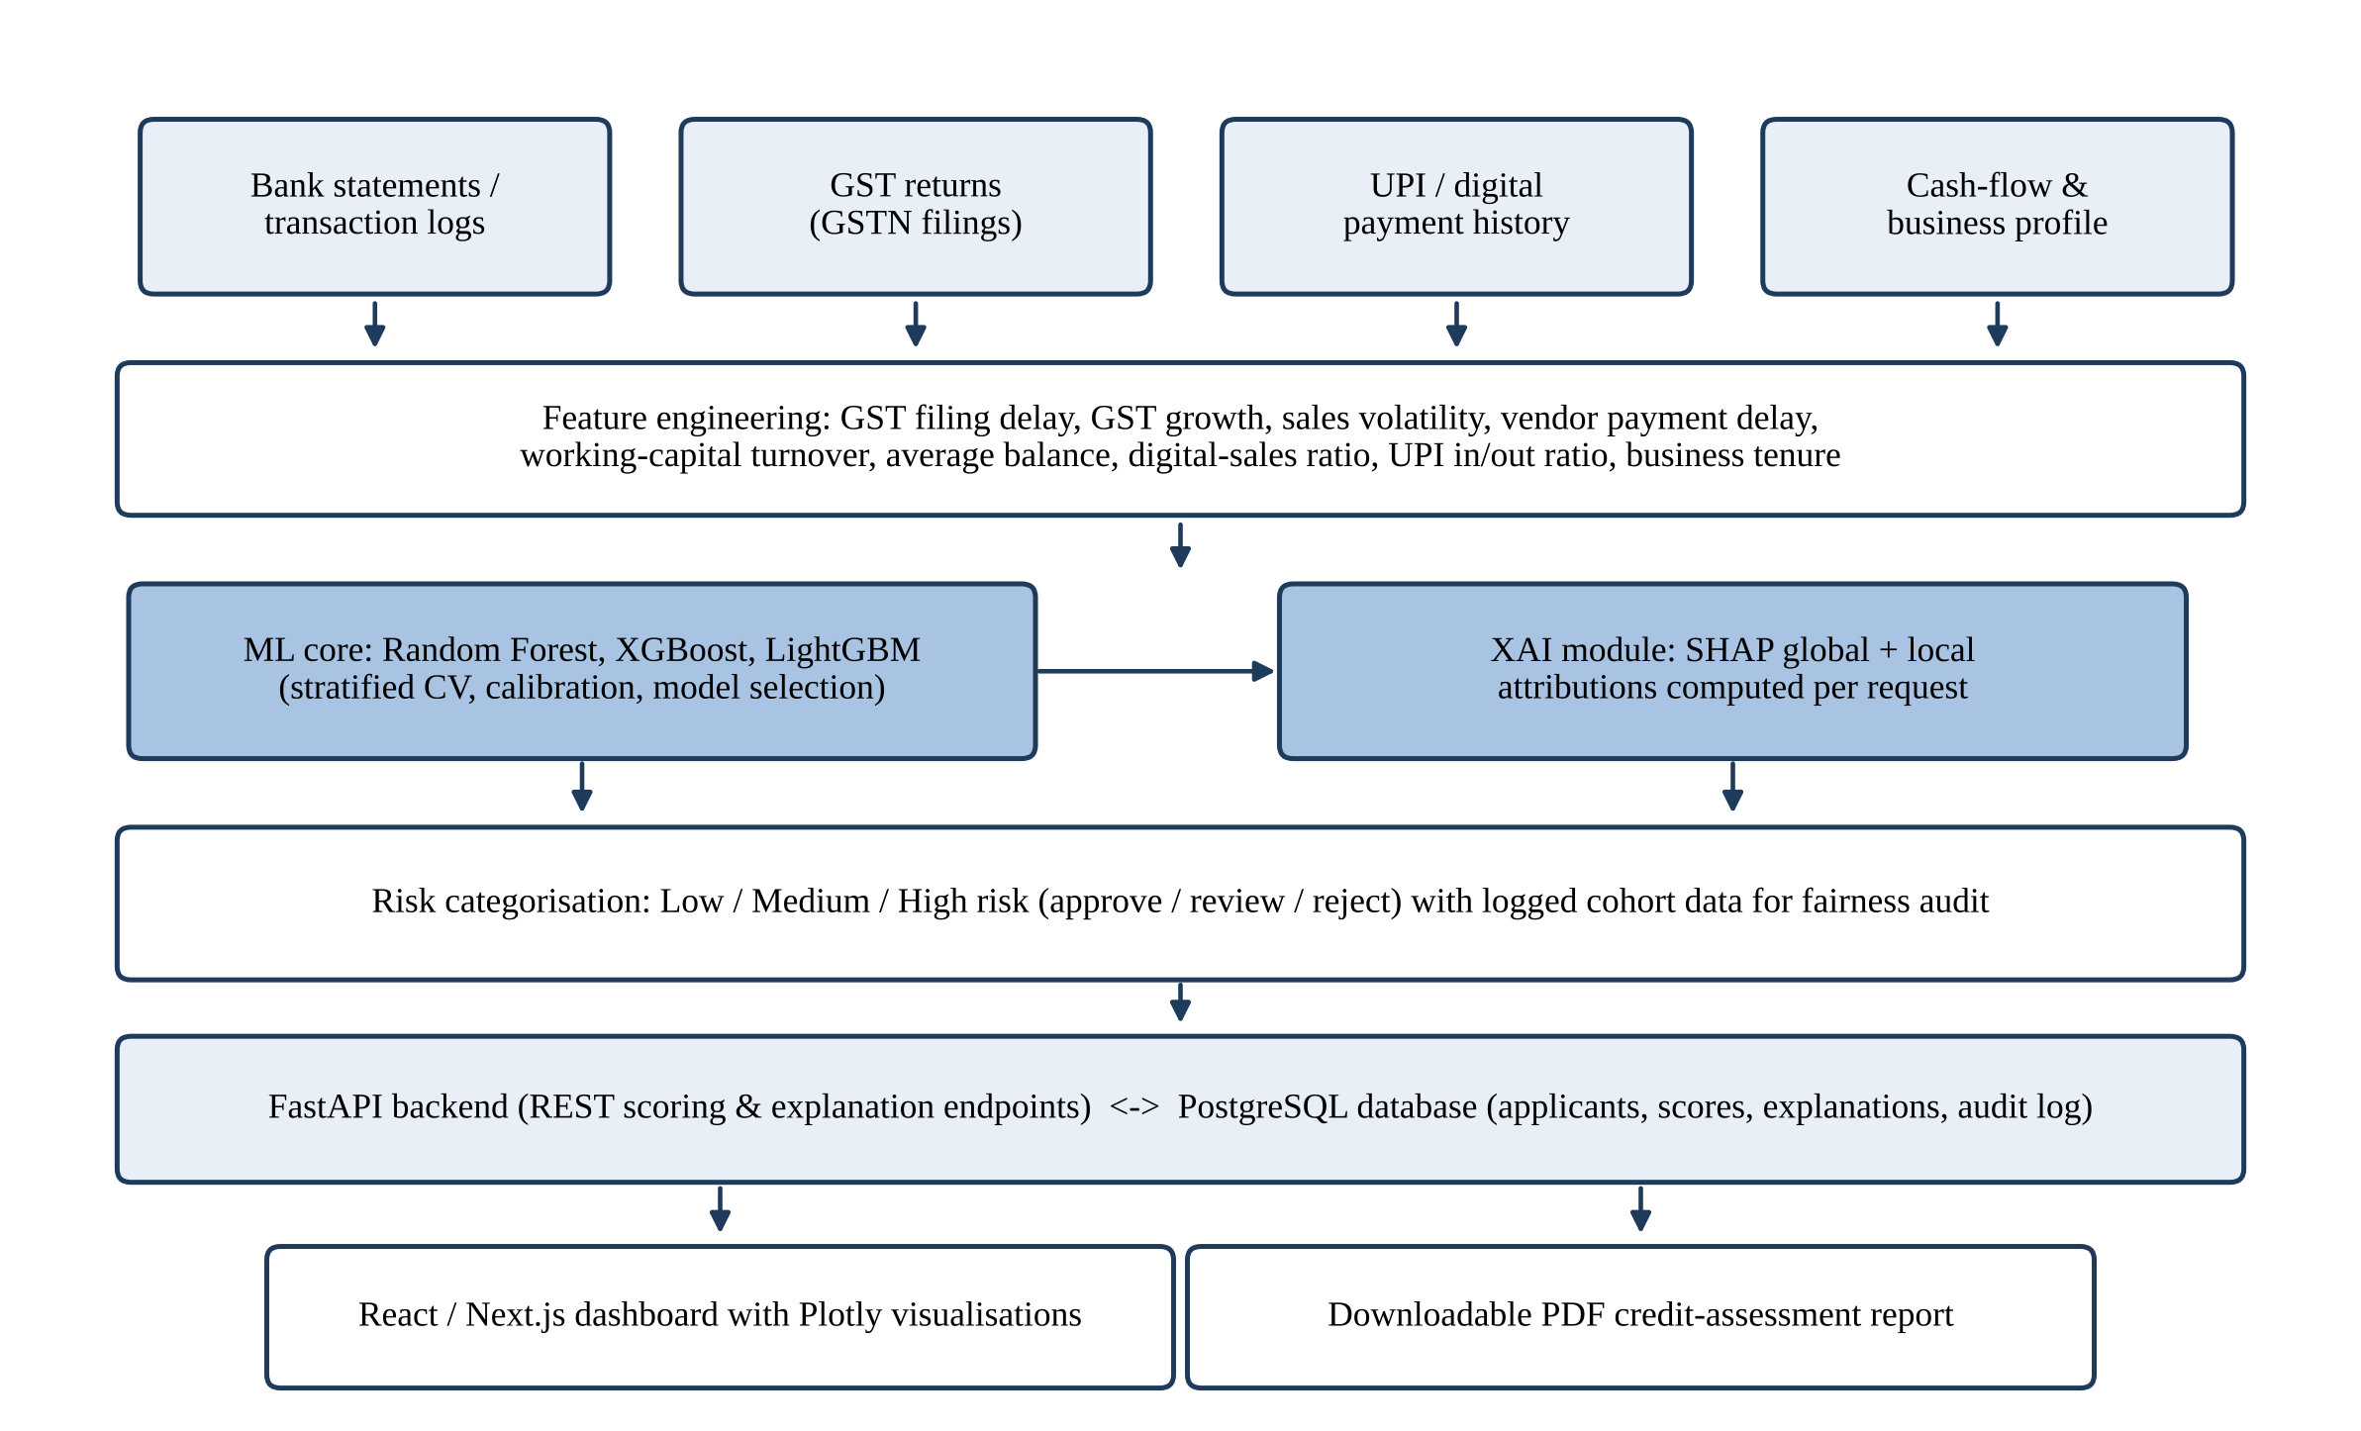
Fig. 10 Layered architecture of the proposed AI-powered MSME credit-assessment system

6.2 Grounding of each component in the literature
Each architecture decision can be linked to at least one finding, gap or best practice covered in the literature review above. A summary is provided in Table 10, with the supporting studies in each row listed from the latest to the earliest.

Table 10 Mapping of the proposed technical architecture to the grounding literature
System component | Grounding in the reviewed literature
ML core (XGBoost, Random Forest, LightGBM) | Same three-classifier comparison as [32], where LightGBM was business-optimal; boosting beats linear baselines [31], [23], [33], [7], [34], [10]; large-scale benchmark [9]; early non-linear consumer model [30].
Alternative-data feature set (bank transaction logs, GST filings, digital payment history, cash-flow metrics) | MSME feature taxonomy: GST filing delay, vendor payment delay, working-capital cycle [5]; transaction-behaviour signals [6], [7]; behavioural and digital data can replace bureau data [24], [27], [28], [29]; consumer bureau schema of [32], [10] avoided (Gap 1).
XAI module (SHAP, global + local attribution) | Follows SHAP/LIME reporting of [32] and SHAP-proxy waterfall panels of [5], but serves SHAP live from the backend instead of static plots (Gap 2); meets transparency principle of [4] and RBI FREE-AI [12].
Risk categorisation (Low / Medium / High risk) | Generalises three-tier PD hierarchies (approve / review / reject) of [5], [32]; keeps source data for the contextual DIR audit of [5] (Gap 4); SHAP-compatible data limits equal-opportunity metrics on arbitrary labels.
FastAPI backend + PostgreSQL database | Adds the persistent, queryable, multi-user service layer missing in every reviewed paper (Gap 3); turns batch SHAP and model pipelines of [5], [32] into live scoring.
React/Next.js dashboard with Plotly visualisations | Interactive version of the static HTML/JSON applicant and business-impact reports of [32]; applies the understandable-explanation principle of [5] required by RBI FREE-AI and the EU AI Act [4].
Downloadable PDF credit-assessment reports | Portable form of the applicant, business-impact and XAI reports of [32] and the plain-language SHAP-proxy panels of [5], for lender case files and borrower appeals.

6.3 Candidate feature set
Table 11 lists the potential MSME features that will be extracted from the project’s data sources. Included are indicative definitions for each feature, together with links to the literature that support them. Sources include mainly the MSME taxonomy published in [5] and the transaction-level signals reviewed in [7]. Considered an initial guide for feature engineering, the definitive set of features will be influenced by data availability, data quality, and feature-importance and SHAP analysis after model training.

Table 11 Candidate MSME features for the proposed system, with indicative definitions and grounding
Feature | Source | Indicative definition | Grounding
GST filing delay | GST returns | Average days overdue in the observation window | [5] – 2nd most important MSME feature
GST turnover growth rate | GST returns | Change in turnover declared vs. comparable period (percent) | [5]
Sales volatility | GST returns, UPI, bank statements | CV of monthly turnover/inflows (= std / mean) | [5] – most important MSME feature; [7]
Vendor payment delay | Bank statements, invoices | Days beyond terms paid to suppliers on average | [5], [7]
Working-capital turnover | Bank statements, GST returns | Turnover per year / Average WC | [5]
Average bank balance | Bank statements / Account Aggregator | Average of daily balances at end of day or month-end during observation window | [5]
Digital-sales ratio | UPI, bank statements | Ratio of digital transactions to total sales value | [5], [6]
UPI transaction volume and in/out ratio | UPI history | Number of UPI transactions per month and amount; UPI inflows as % of UPI outflows | [5]
Net cash-flow stability | Bank statements | Percent of months with positive cash flow; standard deviation of monthly cash flow | [6], [7]
Business tenure | Business profile, GST registration | Elapsed months from GST registration/business startup | [5]

6.4 Modelling and evaluation protocol
Adopting evaluation techniques from Sect. 4.3, the modelling workflow for this project is detailed below:
- Pre-processing. Missing values are filled (with median for numeric, mode for categorical features), categorical features are encoded, and numeric columns are scaled if needed [32].
- Imbalance handling. SMOTE [40] or class weighting is applied to training folds only, preventing synthetic information from leaking to validation folds.
- Model training and tuning. Random Forest, XGBoost, and LightGBM models are trained and tuned using stratified k-fold cross validation [43]. The study retains a logistic-regression baseline for comparison [9].
- Calibration. Predicted probabilities are calibrated using isotonic regression or Platt scaling, then evaluated with the Brier score and reliability curves [5], [44].
- Evaluation. Models are compared across ROC-AUC, precision, recall, and the Brier score. Business metrics such as approval rate, and default rate amongst approved applicants are reported [29], [32].
- Explanation. TreeSHAP attributions are calculated for every applicant. SHAP values are summarised to show global feature importance [45].
- Risk tiers and fairness logging. Calibrated PDs are assigned to risk tiers (Low/Medium/High) using thresholds inspired by [5]. Cohort information is logged to evaluate DIR and default rates by cohort.

6.5 Illustrative scoring workflow
To illustrate the interplay between components, consider the lifecycle of a single assessment request. A loan officer enters an applicant record using the dashboard, uploads/link applicant bank statements, GST return summaries and UPI transaction history (with applicant permission), the backend validates and persists the raw records to PostgreSQL, runs the feature-engineering routines to calculate the features listed in Table 11 over the relevant observation window, and feeds the resulting record into the selected model to produce a calibrated probability of default. The risk-categorisation layer maps this probability to a Low/Medium/High risk tier and associated approve-review-reject recommendation. Within the same request, the XAI module computes the SHAP attribution of each feature for this applicant and highlights the features that most increased/reduced the estimated risk.
Decision score, explanation and cohort attributes used for fairness monitoring are logged to an audit journal. Outcome risk tier, probability, a waterfall chart of top factors and a benchmark comparison of applicant's key metrics are presented on the dashboard. The decision can be accepted, or (for medium risk decisions particularly) vetted by the officer by reviewing evidence then choosing to override with a recorded justification. Doing so maintains the human-in-the-loop concept advocated in [4] and in the EU AI Act [11]. Finally, a PDF report can be generated to include in the case file or given to the applicant. This report summarises the decision, key drivers, and includes language-accessible recommendations for improving their chances of future approval, reminiscent of the borrower-facing explanation in [5].
Since each request elicits both decision and rationale from the same version of the stored model, the workflow enables ex-post examination as well: given logs, an auditor can reproduce any decision made in the past, and aggregate logs can be analysed to compare approval rates and downstream default rates for cohorts, etc. (as suggested in Sect. 3.5).

6.6 Synthesis
Cumulatively, the articles reviewed provide validation for each individual layer: alternative MSME data sources [5], [6], ensemble ML [10], [32], SHAP-based explainability [5], [32], and fairness/policy alignment [4]. No reviewed article provides all four together with a deployable system architecture. The project will accomplish this.

7 Challenges, threats to validity and future directions

7.1 Practical challenges
A number of obvious practical challenges stem from the literature above and are likely to impact the project.
Access to data and labels. Verified repayment data for MSME transactions will be tough to come by outside of a lending institution. The study in [5] had to resort to synthetic data to enable an India-specific study. Training data provenance will need to be clearly defined for this project. If synthetic or semi-synthetic data is used, it should be calibrated to match published stats and labelled accordingly.
Incomplete and inconsistent data. Bank statements come in many formats. GST & UPI transaction records may be partial, late or don't match up. Feature engineering must accommodate gaps, seasonality & reconciling sources.
Concept drift. The study in [10] finds that model performance degrades following regulatory shocks, and that payment behaviour evolves with the business cycle and with the ongoing digitization of payments. Once a system is deployed it needs to be monitored for changes in input distributions and performance over time. Retraining should be done periodically.
Consent and privacy. Alternative data should be collected with informed consent and only be used for its intended purpose. Channels that require consent (e.g. the Account Aggregator framework announced by RBI in 2016) should be preferred over scraping or bulk collection, and more intrusive data categories in Table 2 should be avoided wherever possible [4], [28].
Explanation fidelity and gaming. Since post-hoc explanations only approximate model behaviour [13], overly detailed explanations can in principle be used to game the model by manipulating features that do not actually reflect creditworthiness. To prevent this, explanations should focus on behaviours that are both predictive and genuinely within the borrower's control, e.g. timely filing of GST payments and payments to vendors.

7.2 Regulatory and ethical considerations in the Indian context
An MSME credit-assessment system implemented in India would exist in conjunction with a number of frameworks. India's Account Aggregator framework mandates consent as the principle for financial information sharing between institutions [8], so data gathering should utilize its consent artefacts over custom uploads where feasible. The RBI's expectations of explainability, fairness, accountability and governance for the use of AI in regulated institutions has been laid out in its FREE-AI framework [12], requiring documented model development processes, monitoring of decisions across borrower demographics, and defined lines of human oversight. The EU AI Act's designation of credit scoring as a high-risk application does not directly impact Indian lenders, but as legislation [11] that is widely cited as setting best practice standards for responsible AI, it has been referenced in [4] as an international standard that is becoming expected worldwide.
Three ethical pledges ensue for the project. Firstly, data minimisation: only information that has a demonstrable connection to repayment capacity and business operations should be utilised. This rules out the more invasive data-points detailed in Table 2. Secondly, contestability: decisions should be accompanied by an explanation that the applicant can understand as well as provide the option for human review should the applicant request it. Thirdly, proportionality: under no circumstances should a model output obviate the credit officers decision, particularly in the case of marginal cases and nascent enterprises with little to no historical data. These pledges are instantiated in the architecture through consent-based datapoints, per-request SHAP explanations, PDF reports, and a Medium-risk review tier.

7.3 Threats to validity of this review
This review has several limitations. The central corpus is relatively small (ten core studies, supplemented by ten recent studies), and several of the most MSME-specific ones are newer articles, published either in venues with short peer-review track records or as preprints. Their results should be considered provisional. Studies don't report directly comparable results due to differences in datasets, outcome definitions and metrics. Cluster assignment requires judgement, and some studies touch on multiple clusters. Finally, this review is limited to the English-language literature and may omit related research published by Indian regulators, industry bodies, or lenders in non-academic formats.

7.4 Future directions
Several ideas for future work are suggested by our limitations:
- Indigenously validated models. Validate alternative-data MSME models against real, consented UPI, GST and bank-statement data with observed repayment outcomes, preferably in collaboration with a lender.
- SHAP applications. Test whether generating live, per-applicant SHAP explanations actually leads to better loan officer decisions and borrower understanding, rather than merely producing explanation plots.
- Expanded fairness analysis. Apply the contextual disparate impact ratio (DIR) framework of [5] to protected attributes and proxies, as well as to error-rate parity criteria [50], [52].
- Federated learning. Use federated learning or differential privacy, which [4] only discusses conceptually, to allow models to learn from other lenders’ data without requiring pooling of raw data.
- Interpretable models. Benchmark ensemble models with SHAP against intrinsically interpretable models such as monotonic gradient boosting or scorecards on engineered alternative data features, as advocated in [13].
- Actionable recourse. Link counterfactual explanations [47] with dynamic credit limits that adjust over time based on periodic re-scoring, so borrowers know how improving certain behaviors would improve their scores.

8 Conclusion
This review looked across the literature on alternative data, ML, and XAI in MSME credit risk assessment. The ten core works that serve as pillars for this effort, together with ten recent studies from 2020–2025, were categorised into five groupings that reflect levels in a real-world credit-assessment stack. Basic benchmarks demonstrate that ensemble ML methods outperform linear scorecards, and that alternative, non-bureau behavioural data is information-rich, especially for thin-file borrowers. The alternative-data/inclusion work describes what signals matter for MSMEs (GST filing behaviour, sales volatility, vendor payment delay, digital-payment behaviours, etc.) and India-specific research shows how those signals can be captured using the country's digital public infrastructure. Finally, the XAI/governance literature shows why explainability and fairness are prerequisites, not nice-to-haves (EU AI Act, RBI FREE-AI).
Finally, this comparison illuminates gaps that the current review did not identify in existing work. No publication included in this review leverages MSME operational cash-flow data; uses ensemble ML techniques; provides live per-applicant explanations; incorporates contextual fairness auditing; or packages a deployable API, database and user interface into a single distribution. The only model trained on Indian MSME alternative data (UPI and GST features) uses synthetically generated training data and does not release source code. AI-Powered MSME Credit Assessment Using Alternative Data, the system proposed herein, attempts to fill this void: it features engineered from MSME bank statements, GST filings and UPI transaction histories; trains and evaluates Random Forest, XGBoost and LightGBM algorithms; serves SHAP explanations via a FastAPI application; translates calibrated probabilities to Low/Medium/High risk categories while storing information necessary to facilitate fairness audits; and displays its output via a React/Next.js web dashboard and PDF reports. Each of these decisions is motivated by the literature reviewed here, and collectively they are intended to transform validated research into an applied and explainable tool.
Acknowledgements
Authors gratefully acknowledge their project guide Dr. Anjali Dalvi and Co-guide Dr. Aishwarya Mishra, Symbiosis Institute of Technology, Pune for their constant help and valuable suggestions during the preparation of this review.
Compliance with ethical standards
Conflict of interest: The authors declare that there is no conflict of interest.
Data availability This article is based on published studies and regulatory documents, without any new data collection. Figures containing quantitative results are sourced from the original articles.

References
[1] J. E. Stiglitz and A. Weiss, “Credit rationing in markets with imperfect information,” Amer. Econ. Rev., vol. 71, no. 3, pp. 393–410, 1981.
[2] A. N. Berger and G. F. Udell, “A more complete conceptual framework for SME finance,” J. Bank. Finance, vol. 30, no. 11, pp. 2945–2966, 2006, doi: 10.1016/j.jbankfin.2006.05.008.
[3] D. J. Hand and W. E. Henley, “Statistical classification methods in consumer credit scoring: A review,” J. Roy. Statist. Soc. Ser. A, vol. 160, no. 3, pp. 523–541, 1997, doi: 10.1111/j.1467-985X.1997.00078.x.
[4] S. H. Abdellatif, C. Yang, and A. Nigussi, “Artificial intelligence enhanced credit scoring for MSMEs: A policy framework for financial sustainability in emerging economies,” Eur. J. Sustain. Develop., vol. 15, no. 2, pp. 585–602, 2026, doi: 10.14207/ejsd.2026.v15n2p585.
[5] G. C. Yadav, V. Pandey, and K. Mishra, “AI-powered alternative credit scoring system for MSMEs and individual borrowers in India,” Int. J. Technol. Health Sustain., vol. 2, no. 2, pp. 687–694, 2026.
[6] T. A. Shokunbi, “Alternative data scoring for MSME lending: A blueprint for financial inclusion,” Iconic Res. Eng. J., vol. 9, no. 1, pp. 1986–1991, 2025, doi: 10.64388/IREV9I1-1712949.
[7] O. Elebe and C. C. Imediegwu, “A credit scoring system using transaction-level behavioral data for MSMEs,” J. Frontiers Multidiscip. Res., vol. 2, no. 1, pp. 312–322, 2021, doi: 10.54660/.IJFMR.2021.2.1.312-322.
[8] Reserve Bank of India, “Master Direction – Non-Banking Financial Company – Account Aggregator (Reserve Bank) Directions, 2016,” Reserve Bank of India, Mumbai, India, Master Direction, 2016.
[9] S. Lessmann, B. Baesens, H.-V. Seow, and L. C. Thomas, “Benchmarking state-of-the-art classification algorithms for credit scoring: An update of research,” Eur. J. Oper. Res., vol. 247, no. 1, pp. 124–136, 2015, doi: 10.1016/j.ejor.2015.05.030.
[10] L. Gambacorta, Y. Huang, H. Qiu, and J. Wang, “How do machine learning and non-traditional data affect credit scoring? New evidence from a Chinese fintech firm,” Bank for International Settlements, Basel, Switzerland, BIS Working Paper No. 834, Dec. 2019.
[11] European Union, “Regulation (EU) 2024/1689 of the European Parliament and of the Council of 13 June 2024 laying down harmonised rules on artificial intelligence (Artificial Intelligence Act),” Official Journal of the European Union, L series, Regulation, Jul. 2024.
[12] Reserve Bank of India, “Report of the committee to develop a Framework for Responsible and Ethical Enablement of Artificial Intelligence (FREE-AI) in the financial sector,” Reserve Bank of India, Mumbai, India, Committee Report, 2025.
[13] C. Rudin, “Stop explaining black box machine learning models for high stakes decisions and use interpretable models instead,” Nature Mach. Intell., vol. 1, no. 5, pp. 206–215, 2019, doi: 10.1038/s42256-019-0048-x.
[14] E. I. Altman, “Financial ratios, discriminant analysis and the prediction of corporate bankruptcy,” J. Finance, vol. 23, no. 4, pp. 589–609, 1968, doi: 10.1111/j.1540-6261.1968.tb00843.x.
[15] E. I. Altman and G. Sabato, “Modelling credit risk for SMEs: Evidence from the U.S. market,” Abacus, vol. 43, no. 3, pp. 332–357, 2007, doi: 10.1111/j.1467-6281.2007.00234.x.
[16] F. Louzada, A. Ara, and G. B. Fernandes, “Classification methods applied to credit scoring: Systematic review and overall comparison,” Surv. Oper. Res. Manage. Sci., vol. 21, no. 2, pp. 117–134, 2016, doi: 10.1016/j.sorms.2016.10.001.
[17] X. Dastile, T. Celik, and M. Potsane, “Statistical and machine learning models in credit scoring: A systematic literature survey,” Appl. Soft Comput., vol. 91, Art. no. 106263, 2020, doi: 10.1016/j.asoc.2020.106263.
[18] S. Bhatore, L. Mohan, and Y. R. Reddy, “Machine learning techniques for credit risk evaluation: A systematic literature review,” J. Banking Financial Technol., vol. 4, pp. 111–138, 2020, doi: 10.1007/s42786-020-00020-3.
[19] B. Baesens, T. Van Gestel, S. Viaene, M. Stepanova, J. Suykens, and J. Vanthienen, “Benchmarking state-of-the-art classification algorithms for credit scoring,” J. Oper. Res. Soc., vol. 54, no. 6, pp. 627–635, 2003, doi: 10.1057/palgrave.jors.2601545.
[20] J. Frost, L. Gambacorta, Y. Huang, H. S. Shin, and P. Zbinden, “BigTech and the changing structure of financial intermediation,” Econ. Policy, vol. 34, no. 100, pp. 761–799, 2019, doi: 10.1093/epolic/eiaa003.
[21] R. Hlongwane, K. K. K. M. Ramaboa, and W. Mongwe, “Enhancing credit scoring accuracy with a comprehensive evaluation of alternative data,” PLOS ONE, vol. 19, no. 5, Art. no. e0303566, 2024, doi: 10.1371/journal.pone.0303566.
[22] A. Bitetto, P. Cerchiello, S. Filomeni, A. Tanda, and B. Tarantino, “Machine learning and credit risk: Empirical evidence from small- and mid-sized businesses,” Socio-Econ. Plann. Sci., vol. 90, Art. no. 101746, 2023, doi: 10.1016/j.seps.2023.101746.
[23] P. E. de Lange, B. Melsom, C. B. Vennerød, and S. Westgaard, “Explainable AI for credit assessment in banks,” J. Risk Financial Manag., vol. 15, no. 12, Art. no. 556, 2022, doi: 10.3390/jrfm15120556.
[24] P. Ghosh, B. Vallee, and Y. Zeng, “FinTech lending and cashless payments,” Rodney L. White Center for Financial Research, The Wharton School, Philadelphia, PA, USA, Working Paper, 2021. [Online]. Available: https://rodneywhitecenter.wharton.upenn.edu/wp-content/uploads/2021/10/Zeng_2021_WP-Fintech-lending-and-cashless-payments.pdf
[25] L. Roa, A. Correa-Bahnsen, G. Suarez, F. Cortés-Tejada, M. A. Luque, and C. Bravo, “Super-app behavioral patterns in credit risk models: Financial, statistical and regulatory implications,” Expert Syst. Appl., vol. 169, 2021, arXiv:2005.14658.
[26] V. B. Djeundje, J. Crook, R. Calabrese, and M. Hamid, “Enhancing credit scoring with alternative data,” Expert Syst. Appl., vol. 163, Art. no. 113766, 2021, doi: 10.1016/j.eswa.2020.113766.
[27] S. Agarwal, S. Alok, P. Ghosh, and S. Gupta, “Financial inclusion and alternate credit scoring for the millennials: Role of big data and machine learning in fintech,” Indian School of Business, Hyderabad, India, Working Paper, Feb. 2020. [Online]. Available: https://www.jbs.cam.ac.uk/wp-content/uploads/2020/08/2020-06-conference-paper-agarwal-alok-ghosh-gupta.pdf
[28] T. Berg, V. Burg, A. Gombović, and M. Puri, “On the rise of fintechs: Credit scoring using digital footprints,” Rev. Financial Stud., vol. 33, no. 7, pp. 2845–2897, 2020, doi: 10.1093/rfs/hhz099.
[29] M. Óskarsdóttir, C. Bravo, C. Sarraute, J. Vanthienen, and B. Baesens, “The value of big data for credit scoring: Enhancing financial inclusion using mobile phone data and social network analytics,” Appl. Soft Comput., vol. 74, pp. 26–39, 2019, doi: 10.1016/j.asoc.2018.10.004.
[30] A. E. Khandani, A. J. Kim, and A. W. Lo, “Consumer credit-risk models via machine-learning algorithms,” J. Bank. Finance, vol. 34, no. 11, pp. 2767–2787, 2010, doi: 10.1016/j.jbankfin.2010.06.001.
[31] H. Cheraghali and P. Molnár, “SME default prediction: A systematic methods evaluation,” J. Small Bus. Manage., vol. 63, no. 4, pp. 1466–1517, 2025, doi: 10.1080/00472778.2024.2390500.
[32] Shreya and H. Pathak, “Explainable artificial intelligence credit risk assessment using machine learning,” arXiv:2506.19383, 2025. [Online]. Available: https://arxiv.org/abs/2506.19383
[33] B. R. Gunnarsson, S. vanden Broucke, B. Baesens, M. Óskarsdóttir, and W. Lemahieu, “Deep learning for credit scoring: Do or don’t?,” Eur. J. Oper. Res., vol. 295, no. 1, pp. 292–305, 2021, doi: 10.1016/j.ejor.2021.03.006.
[34] N. Bussmann, P. Giudici, D. Marinelli, and J. Papenbrock, “Explainable AI in fintech risk management,” Frontiers Artif. Intell., vol. 3, Art. no. 26, 2020, doi: 10.3389/frai.2020.00026.
[35] D. J. Hand, “Measuring classifier performance: A coherent alternative to the area under the ROC curve,” Mach. Learn., vol. 77, no. 1, pp. 103–123, 2009, doi: 10.1007/s10994-009-5119-5.
[36] G. W. Brier, “Verification of forecasts expressed in terms of probability,” Mon. Weather Rev., vol. 78, no. 1, pp. 1–3, 1950, doi: 10.1175/1520-0493(1950)078<0001:VOFEIT>2.0.CO;2.
[37] L. Breiman, “Random forests,” Mach. Learn., vol. 45, no. 1, pp. 5–32, 2001, doi: 10.1023/A:1010933404324.
[38] T. Chen and C. Guestrin, “XGBoost: A scalable tree boosting system,” in Proc. 22nd ACM SIGKDD Int. Conf. Knowl. Discov. Data Mining, San Francisco, CA, USA, 2016, pp. 785–794, doi: 10.1145/2939672.2939785.
[39] G. Ke et al., “LightGBM: A highly efficient gradient boosting decision tree,” in Proc. Adv. Neural Inf. Process. Syst. (NeurIPS), 2017, vol. 30, pp. 3146–3154.
[40] N. V. Chawla, K. W. Bowyer, L. O. Hall, and W. P. Kegelmeyer, “SMOTE: Synthetic minority over-sampling technique,” J. Artif. Intell. Res., vol. 16, pp. 321–357, 2002, doi: 10.1613/jair.953.
[41] F. Pedregosa et al., “Scikit-learn: Machine learning in Python,” J. Mach. Learn. Res., vol. 12, pp. 2825–2830, 2011.
[42] B. Zadrozny and C. Elkan, “Transforming classifier scores into accurate multiclass probability estimates,” in Proc. 8th ACM SIGKDD Int. Conf. Knowl. Discov. Data Mining, Edmonton, AB, Canada, 2002, pp. 694–699, doi: 10.1145/775047.775151.
[43] R. Kohavi, “A study of cross-validation and bootstrap for accuracy estimation and model selection,” in Proc. 14th Int. Joint Conf. Artif. Intell. (IJCAI), Montreal, QC, Canada, 1995, vol. 2, pp. 1137–1145.
[44] A. Niculescu-Mizil and R. Caruana, “Predicting good probabilities with supervised learning,” in Proc. 22nd Int. Conf. Mach. Learn. (ICML), Bonn, Germany, 2005, pp. 625–632, doi: 10.1145/1102351.1102430.
[45] S. M. Lundberg and S.-I. Lee, “A unified approach to interpreting model predictions,” in Proc. Adv. Neural Inf. Process. Syst. (NeurIPS), 2017, vol. 30, pp. 4765–4774.
[46] M. T. Ribeiro, S. Singh, and C. Guestrin, “‘Why should I trust you?’ Explaining the predictions of any classifier,” in Proc. 22nd ACM SIGKDD Int. Conf. Knowl. Discov. Data Mining, San Francisco, CA, USA, 2016, pp. 1135–1144, doi: 10.1145/2939672.2939778.
[47] S. Wachter, B. Mittelstadt, and C. Russell, “Counterfactual explanations without opening the black box: Automated decisions and the GDPR,” Harvard J. Law Technol., vol. 31, no. 2, pp. 841–887, 2018.
[48] A. Barredo Arrieta et al., “Explainable artificial intelligence (XAI): Concepts, taxonomies, opportunities and challenges toward responsible AI,” Inf. Fusion, vol. 58, pp. 82–115, 2020, doi: 10.1016/j.inffus.2019.12.012.
[49] N. Bussmann, P. Giudici, D. Marinelli, and J. Papenbrock, “Explainable machine learning in credit risk management,” Comput. Econ., vol. 57, no. 1, pp. 203–216, 2021, doi: 10.1007/s10614-020-10042-0.
[50] M. Hardt, E. Price, and N. Srebro, “Equality of opportunity in supervised learning,” in Proc. Adv. Neural Inf. Process. Syst. (NeurIPS), 2016, vol. 29, pp. 3315–3323.
[51] M. Feldman, S. A. Friedler, J. Moeller, C. Scheidegger, and S. Venkatasubramanian, “Certifying and removing disparate impact,” in Proc. 21st ACM SIGKDD Int. Conf. Knowl. Discov. Data Mining, Sydney, NSW, Australia, 2015, pp. 259–268, doi: 10.1145/2783258.2783311.
[52] N. Kozodoi, J. Jacob, and S. Lessmann, “Fairness in credit scoring: Assessment, implementation and profit implications,” Eur. J. Oper. Res., vol. 297, no. 3, pp. 1083–1094, 2022, doi: 10.1016/j.ejor.2021.06.023.
[53] A. Fuster, P. Goldsmith-Pinkham, T. Ramadorai, and A. Walther, “Predictably unequal? The effects of machine learning on credit markets,” J. Finance, vol. 77, no. 1, pp. 5–47, 2022, doi: 10.1111/jofi.13090.
[54] T. Fawcett, “An introduction to ROC analysis,” Pattern Recognit. Lett., vol. 27, no. 8, pp. 861–874, 2006, doi: 10.1016/j.patrec.2005.10.010.

