SQL QUERIES

--1

select * from posts;

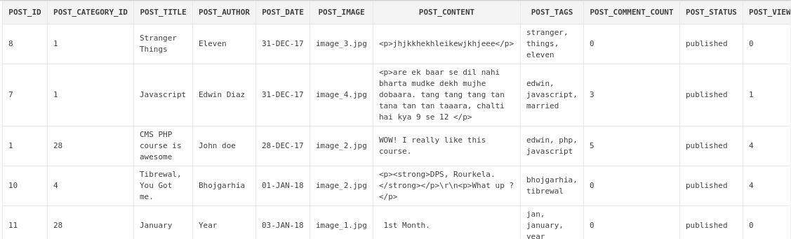

--2
select post_id,post_title,post_author from posts;

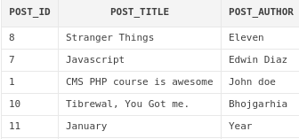

--3
select post_id,post_title,post_author from posts
where post_id >= 10;

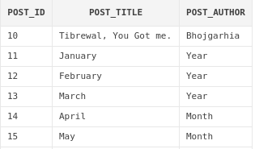

--4

select post_id,post_title,post_author from posts
where post_id >= 10 and post_author='Year';

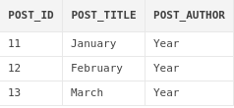

--5

select post_id,post_title,post_author from posts
where post_id >= 14 or post_author='Year';

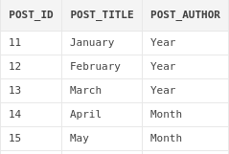

--6
select post_id ,post_id + 10 calculation
from posts;
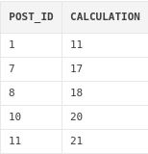

--7
select distinct user_firstname , user_role from users;
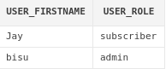

--8

select user_id , user_time from users_online
order by user_time ASC;
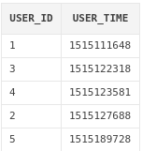

--9

select comment_author,comment_email
from comments
where comment_author like 'Y%' or comment_author like 'C%';

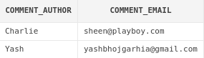

--10

select comment_author from comments
union
select username from users;

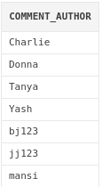

--11

select comment_author from comments
intersect
select username from users;

--12

select comment_date from comments
except
select post_date from posts;

--13
select min(user_time) from users_online;
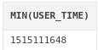

--14
select max(user_time) from users_online;
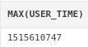

--15
select round(avg(user_time)) from users_online;

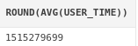

--16
select sum(user_time) from users_online;
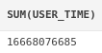

--17
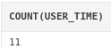
select count(user_time) from users_online;

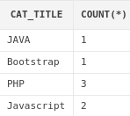
--18
select cat_title , count(*)
from categories
group by cat_title;

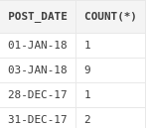
--19
select post_date , count(*)
from posts
group by post_date;

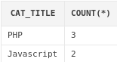
--20
select cat_title , count(*)
from categories
group by cat_title
having count(*) > 1;

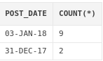
--21
select post_date , count(*)
from posts
group by post_date
having count(*) >= 2;

