AI Travel Itinerary Planner Document & Guide

1. What is n8n?
- Workflow Automation: n8n is a powerful, flexible automation tool that allows you to visually connect any app or API together without heavy coding.
- How Workflows Function: Workflows consist of “nodes” mapped together on a graphical canvas. A workflow always starts with a Trigger node, and the output data from one node flows seamlessly into the next core node down the chain to perform operations on that data.
- Agentic AI Systems: By incorporating advanced LangChain nodes, n8n moves beyond rigid, pre-programmed flows to create Agentic workflows. The AI becomes the “brain” routing the conversation, reading the user intent, dynamically deciding which external tools to call (like web searches or API hooks), and reasoning entirely on its own to achieve the user’s implicit goal.

2. Types of Nodes in n8n
- Trigger Nodes: The starting points of workflows. They launch the flow automatically based on events.
  - Example: A Chat Trigger waits for a user to type a message to start an interactive chat session, or a Webhook waits for an HTTP request.
- Action Nodes (Basic Nodes): Standard nodes performing a single distinct, pre-programmed job.
  - Example: An HTTP Request fetching server data, a Set node to format outputs, or a Gmail/SMTP node to fire an email off in the background.
- AI Agent Nodes: The decision-makers that take a connected Language Model (LLM) and a set of system instructions, interacting autonomously to solve prompts.
  - Example: The Agent node acts as the conversational travel planner.
- Language Model Nodes: The actual AI brains connected to the an Agent.
  - Example: The OpenAI Chat Model securely passes instructions to underlying base models like GPT-4o.
- Memory Nodes: Nodes that track and store previous interactions so the chatbot can handle follow-up questions natively without losing context.
  - Example: Window Buffer Memory stores the last few messages tied uniquely to the current user’s chat session ID.
- Tool Nodes: Specialized capabilities granted to the Agent so it can interact with the outside world. The agent chooses when to execute these functions.
  - Example: The Search (SerpAPI) searches live Google results, or the Calculator strictly processes tight budgets mathematically.
- Logic Nodes: These control the flow of data depending on conditions.
  - Example: The If node branches the workflow down path A or path B based on checking true/false field values.

3. Use Case: Chat-Based AI Travel Planner
The workflow we are building is an Interactive AI Travel Itinerary Planner. Traditionally, building a customized travel itinerary requires hours of manual research across tabs. By leveraging n8n, LangChain, and OpenAI, we created a conversational assistant that: - Seamlessly chats with users to discover their destination, budget, and specific preferences. - Autonomously uses live web search (SerpAPI) to fetch current prices and popular attractions. - Calculates and guarantees the trip fits within a user’s strict budget using a Calculator tool. - Outputs a structured, day-by-day itinerary directly into the chat interface.
This transforms a rigid web-form process into a dynamic, intelligent conversation that remembers context and adapts to mid-conversation changes.

4. Pre-Requisites
Before building your agent, you will need active accounts and API keys for the services used in the workflow.
Note: If you encounter any blocks or errors while setting up your OpenAI or SerpAPI accounts, try repeating the process. A second attempt often resolves the issue.

1. Sign up to n8n
- Cloud version: Go to n8n.cloud and sign up for an account. This is the easiest way to get started.

2. Create OpenAI API Key
- Go to the OpenAI Platform.
- Sign up or log into your account.
- Navigate to the API keys page (usually found under your profile or the left sidebar).
- Click “Create new secret key”. Name it something like n8n Travel Agent.
- Copy this key immediately (it is only shown once) and add it as an OpenAI credential in your n8n workspace.

3. Create SerpAPI Key
- Go to SerpApi and register for an account (they offer a free tier covering up to 100 searches/month).
- Once logged in, go to your Dashboard.
- Copy your API Key from the dashboard.
- Create a new SerpAPI credential inside your n8n workspace and paste the key.

5. Manual Workflow Creation Guide: “AI Travel Itinerary Planner with Email Delivery”
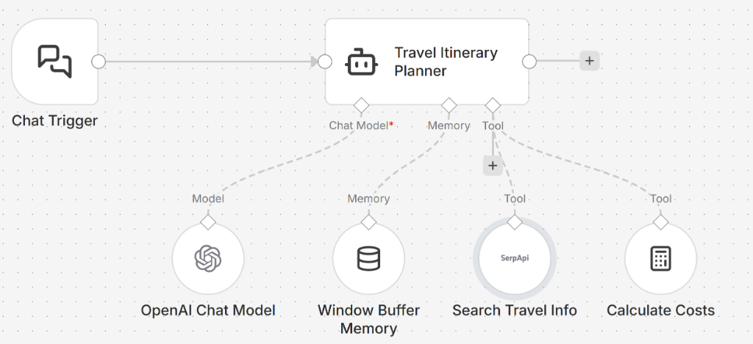
AI Travel Itinerary Planner Workflow
You can manually re-build the specific AI Travel Itinerary Planner natively inside your n8n workspace by re-creating the structure defined in your .json file. Follow these exact node instructions:
Step 1: Start the Conversation (Chat Interface) - Add a Chat Trigger node. - What it does: This provides the interactive chat window UI for the end-user and automatically passes an ongoing sessionId parameter to track the conversation.
Step 2: Add the Agent Brain - Add an AI Agent node. - Name it Travel Itinerary Planner. - Wire the output of the Chat Trigger directly into the Main input of the Agent. - Prompt Setup: In the options, choose the Add option drop-down list to select System message, and set it to: > “You are an expert travel planner assistant. Speak naturally with the user to discover their destination, budget, duration, and preferences. Once you have enough information, use your tools (like SerpAPI and Calculator) to generate a detailed day-by-day itinerary. CRITICAL INSTRUCTION: You MUST format the final itinerary exclusively as a Markdown table with exactly these three columns: | Day | Plan | Cost |”
Step 3: Connect the LLM - Click the Add (+) button on your Travel Itinerary Planner AI Agent node to add a Chat model. - Select the OpenAI Chat Model. - Choose your OpenAI Credentials and set the model block to gpt-4o.
Step 4: Enable Chat Memory for the Trip Planning - Click the Add (+) button on your Travel Itinerary Planner AI Agent node to add Memory. - Select Simple Memory - Configuration: Click into the memory node. Ensure the Session ID setting explicitly tracks ={{ $('Chat Trigger').item.json.sessionId }} (or select the “Connected Chat Trigger Node” dropdown). - What it does: This ensures the AI remembers user budgets and preferences mid-conversation rather than forgetting between messages.
Step 5: Provide External Tools to the Trip Planner - Click the Add (+) button on your Travel Itinerary Planner AI Agent node to add a Tool. - Tool 1: Search Travel Info - Add a Search (SerpAPI) tool and enter your SerpAPI credentials. - This allows the bot to search current real-world flight prices, top-rated hotels, and active local events instead of hallucinating data. - Click the Add (+) button again on your AI Agent node to add another Tool. - Tool 2: Calculate Costs - Add a Calculator tool. - The agent will use this to accurately calculate the day-by-day cost against the user’s hard budget limitation without making math errors.
Summary of Data Flow: User inputs text in Chat Trigger -> Flows into Travel Planner Agent -> The Agent utilizes OpenAI to reason, pulls past context from Simple Memory, and actively queries SerpAPI and the Calculator to structure the response mathematically back to the user as a Markdown table.

6. Sample Prompts for Different Agentic Use Cases
Test out your new chatbot’s capabilities natively in the n8n interface using these examples:

1. Memory Usage (Window Buffer Context)
Prompt 1: “I want to take my partner on a 3-day anniversary trip to Rome. We absolutely despise seafood, and love classical architecture.” Prompt 2 (Sent immediately after): “Actually, Paris might be more romantic. Change the destination to Paris, but keep the 3-day duration and the deep food constraints the exact same.”

2. Tool Calling (Search & Calculate)
Prompt: “I have exactly $2,500 for a 4-day trip to London. I want to see a popular play in the West End taking place this month. Use your search to find the price for one, use your calculator to determine how much I’d have left over for a modest hotel, and lay it out in the table.”

3. Multi-Agent Workflows (Handoffs to Specialists)
Prompt: “I need a full content strategy for a new coffee brand. Have your Research Agent find 5 trending coffee topics, have your SEO Agent write the keywords, and then have your Writer Agent generate the blog post drafts.” (Note: This requires explicitly connecting multiple sub-Agents as ‘tools’ to one master Supervisor Agent node!)

4. Data Retrieval (Live API Querying)
Prompt: “What is the detailed live weather forecast for Helsinki over the coming weekend? Recommend an itinerary entirely based on whether it is going to rain or be sunny.”

5. Decision-Making Agents (Reasoning)
Prompt: “I need to travel from Chicago to Miami next week for a conference. Search for the absolute cheapest travel method, and search for the fastest travel method. Use the calculator to explain the robust time-vs-money difference, and decide which is a better overall value if I value my time specifically at $75 per hour.”

