ASSIGNMENT 4

Ajit Kolekar

2020-09-25

# Markdown Basics

## Favorite Foods

1. Indian
2. Mexican
3. Thai

## Images

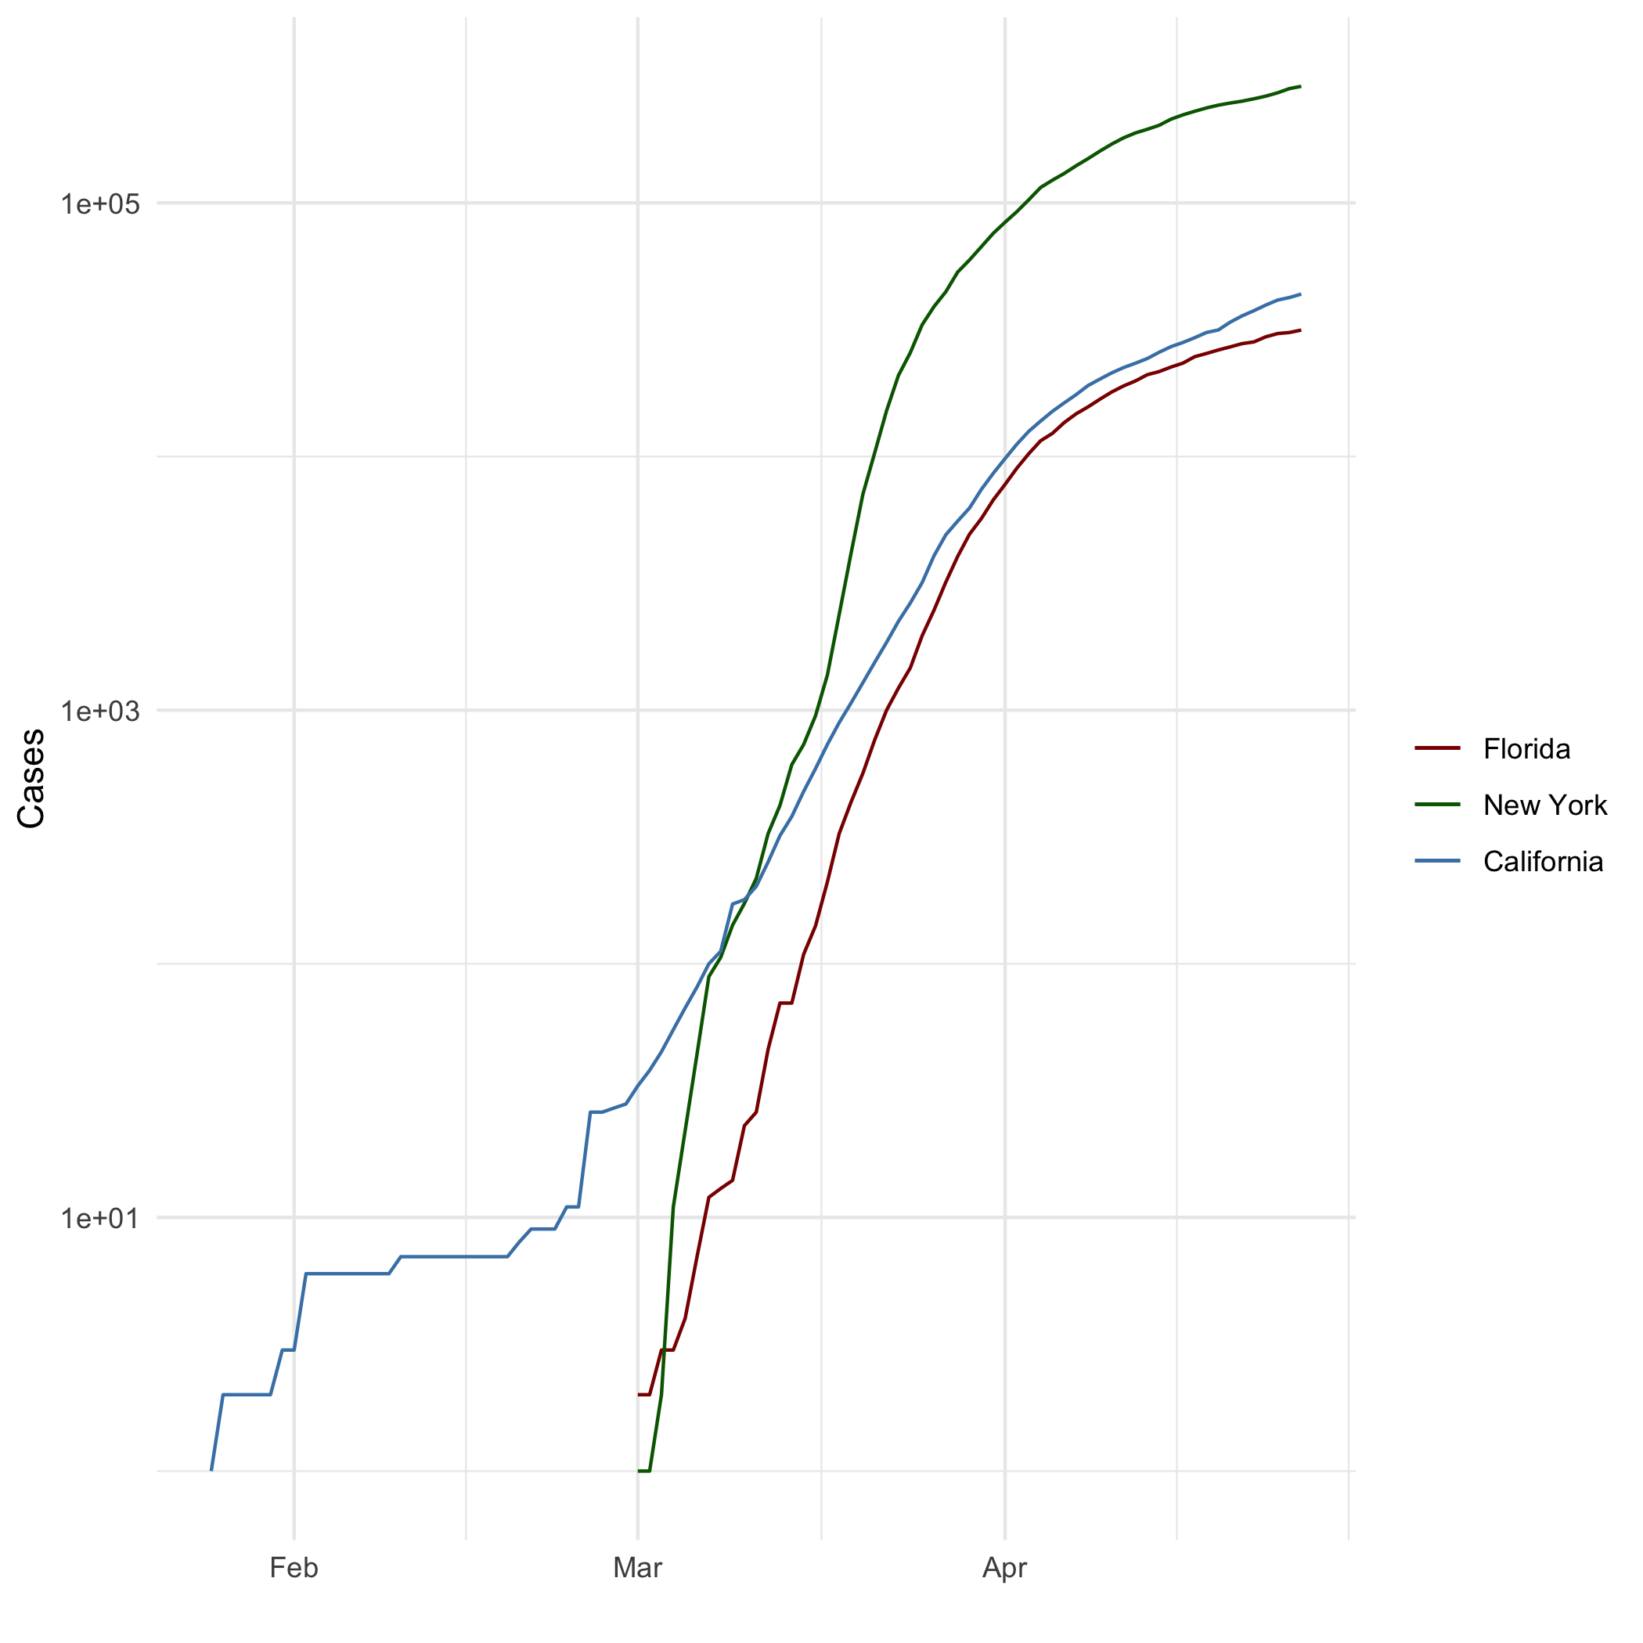

All Cases (Log Plot)

## Add a Quote

On this road called life, you have to take the good with the bad, smile with the sad, love what you got, and remember what you had. Always forgive, but never forget, learn from your mistakes, but never forget. People change. Things go wrong. But just remember, the ride goes on.

## Add an Equation

$$x^{2}+y^{2}=z^{2}$$

## Add a Footnote

This is my first program with RMarkdown[1]

## Add Citations

* R for Everyone (Lander 2014)
* Discovering Statistics Using R (Field, Miles, and Field 2012)

# Inline Code

## NY Times COVID-19 Data

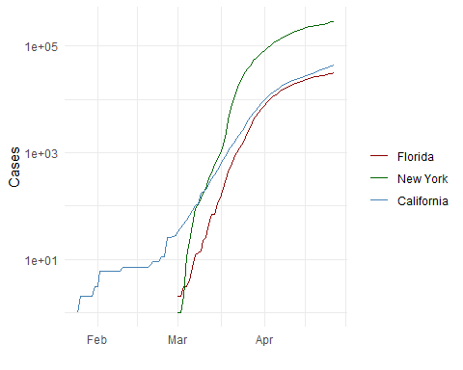

## R4DS Height vs Earnings

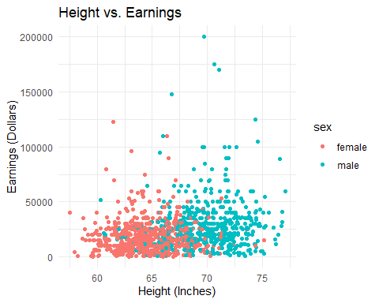

# Tables

## Knitr Table with Kable

One Ring to Rule Them All

|  |  |  |  |  |
| --- | --- | --- | --- | --- |
| name | race | in_fellowship | ring_bearer | age |
| Aragon | Men | TRUE | FALSE | 88 |
| Bilbo | Hobbit | FALSE | TRUE | 129 |
| Frodo | Hobbit | TRUE | TRUE | 51 |
| Galadriel | Elf | FALSE | FALSE | 7000 |
| Sam | Hobbit | TRUE | TRUE | 36 |
| Gandalf | Maia | TRUE | TRUE | 2019 |
| Legolas | Elf | TRUE | FALSE | 2931 |
| Sauron | Maia | FALSE | TRUE | 7052 |
| Gollum | Hobbit | FALSE | TRUE | 589 |

## Pandoc Table

##   
## --------------------------------------------------------------  
## Name Race In Fellowship? Is Ring Bearer? Age   
## ----------- -------- ---------------- ----------------- ------  
## Aragon Men TRUE FALSE 88   
##   
## Bilbo Hobbit FALSE TRUE 129   
##   
## Frodo Hobbit TRUE TRUE 51   
##   
## Galadriel Elf FALSE FALSE 7000   
##   
## Sam Hobbit TRUE TRUE 36   
##   
## Gandalf Maia TRUE TRUE 2019   
##   
## Legolas Elf TRUE FALSE 2931   
##   
## Sauron Maia FALSE TRUE 7052   
##   
## Gollum Hobbit FALSE TRUE 589   
## --------------------------------------------------------------  
##   
## Table: One Ring to Rule Them All

# References

Field, A., J. Miles, and Z. Field. 2012. *Discovering Statistics Using R*. SAGE Publications. <https://books.google.com/books?id=wd2K2zC3swIC>.

Lander, J. P. 2014. *R for Everyone: Advanced Analytics and Graphics*. Addison-Wesley Data and Analytics Series. Addison-Wesley. <https://books.google.com/books?id=3eBVAgAAQBAJ>.

1. This is my first footnote in RMarkdown