**Integrations:**

1. **Inventory Availability Service**

VF Component : FIL_FGP_CheckoutReviewInclude and FIL_FGP_OrderReviewNewFieldsApex class : FIL_FGP_OrderReviewNewFieldCtrl

VF Page : FIL_FGP_CheckoutInclude

**Inventory Availability URLs:**

All these are available in Setup-> Custom Settings -> Inventory Service

Inventory Service URL

Client Id

Client Secret

Inventory Resource URL

Security token URL

**Inventory Sample Request :**

{

"Inventory": {

"items": {

"item": [

{

"siteId": "89898",

"endsystem": "SOMS-UK",

"CustomerNumber": "899",

"BillToLocation": "89898",

"ShipToAbbreviation": "89898",

"ShipToPartSiteId": "89898",

"BillToToPartSiteId": "89898",

"RequestDate": "2018098-09",

"p_from_system": "CloudCraze",

"CatalogNumber": "FTJ9000",

"Quantity": "99"

},

{

"siteId": "89898",

"endsystem": "SOMS-UK",

"CustomerNumber": "899",

"BillToLocation": "89898",

"ShipToAbbreviation": "89898",

"ShipToPartSiteId": "89898",

"BillToToPartSiteId": "89898",

"RequestDate": "2018098-09",

"p_from_system": "CloudCraze",

"CatalogNumber": "FTJ9000",

"Quantity": "99"

}

]

}

}

}

**Inventory Sample Response :**

{

"Inventory": {

"items": {

"item": [

{

"siteId": "89898",

"CustomerNumber": "899",

"BillToLocation": "89898",

"ShipToAbbreviation": "89898",

"CatalogNumber": "FTJ9000",

"AvailableQuantity": "99",

"Errors": "FTJ9000"

},

{

"siteId": "89898",

"CustomerNumber": "899",

"BillToLocation": "89898",

"ShipToAbbreviation": "89898",

"CatalogNumber": "FTJ9000",

"AvailableQuantity": "99",

"Errors": "FTJ9000"

}

]

}

}

}

**Remote Site Settings:**

**Go to Setup -> Search Remote Site Settings (In Quick Find/Search)-> Remote Site Settings**

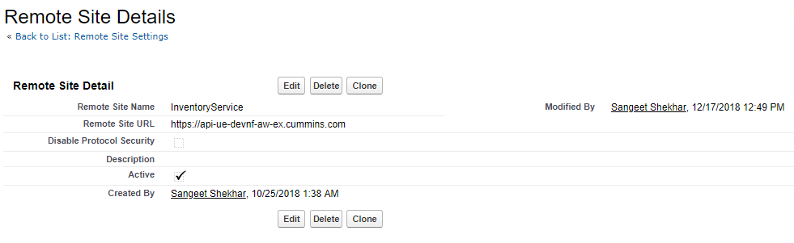

**Certificate and Key Management:**

**Go to Setup -> Search Certificate and Key Management (In Quick Find/Search)-> Certificate and Key Management**

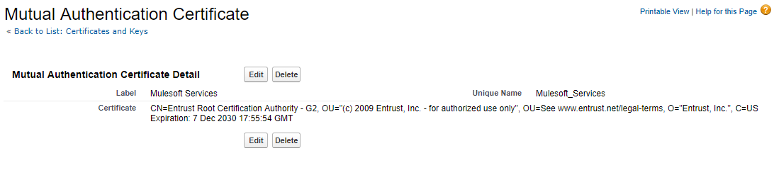

1. **Pricing and Promos Service**

VF Component : FIL_FGP_CheckoutReviewInclude and FIL_FGP_OrderReviewNewFieldsApex class : FIL_FGP_OrderReviewNewFieldCtrl

VF Page : FIL_FGP_CheckoutInclude

**Pricing and Promos Availability URLs:**

All these are available in Setup-> Custom Settings -> Pricing Service

Pricing Service URL

Client Id

Client Secret

Pricing Resource URL

Security token URL

**Pricing Sample Request :**

{

"Pricing": {

"siteId": "89898",

"Customer_Id": "89898",

"endsystem": "SOMS-UK",

"CustomerNumber": "899",

"bill_to_site_id" : "99",

" ship_to_siteid" : "99",

"BillToLocation": "89898",

"ShipToAbbreviation": "89898",

"RequestDate": "2018-08-09",

"TotalWeight": "899",

"TotalPrice": "899",

"TotalQuanity": "899",

"DefaultCurrency": "899",

"CustomerCodes": {

"item": [

{

"code": "FTJ9000",

"codevalue": "FTJ9ss00"

},

{

"code": "FTJ9ss00",

"codevalue": "FTJ9ss00"

}

]

},

"items": {

"item": [

{

"CatalogNumber": "FTJ9000",

"Quantity": "99",

"ShippedQuantity": "0",

"inventory_item_id" : "899"

},

{

"CatalogNumber": "FTJ9000",

"Quantity": "99",

"ShippedQuantity": "0",

"inventory_item_id" : "899"

}

]

}

}

}

**Pricing Sample Response:**

{

"Pricing": {

"siteId": "89898",

"CustomerNumber": "899",

"BillToLocation": "89898",

"ShipToAbbreviation": "89898",

"TotalOrderDiscount": "899",

"items": {

"item": [

{

"CatalogNumber": "FTJ9000",

"PromotionalLineDiscount": "899",

"Quantity": "99",

"LineItemPrice": "99",

"Error": "Error"

},

{

"CatalogNumber": "FTJ9000",

"PromotionalLineDiscount": "899",

"Quantity": "99",

"LineItemPrice": "99",

"Error": "Error"

}

]

}

}

}

The order details will be able to show these pricing fields to the user:

1. Unit Price: This will simply be the value returned from Line Item Price in the response message.
2. Quantity: This is the quantity the user has selected.
3. Gross Amount: This will be the unit price multiplied by the quantity.
4. Promotional Discount: This calculation is shown in the attached spreadsheet. The percentage field to utilize will be based on the value sent for the Promotional Line Discount in the response message.
5. Volume Discount: This calculation is shown in the attached spreadsheet. The percentage field to utilize will be based on the value sent for the Total Order Discount in the response message.
6. Net Amount: This will be the Gross Amount minus the Promotional Discount and Volume Discount value.
7. Total Gross: This will the sum of all the Gross Amount values for all parts in the checkout.
8. Total Promotional Discount: This will the sum of all the Promotional Discount values for all parts in the checkout.
9. Total Volume Discount: This will be the sum of all the Volume Discount values for all parts in the checkout.
10. Total Net: This will the Total Gross minus the Total Promotional Discount and the Total Volume Discount values.

Attached below details out the calculations for these fields (including rounding rules) and has an example.



Please note: If any discount field is returned as 0, do not include this field on the page.

**Exception Handling for Inventory and Pricing Realtime – OrderReview Page**

If the inventory or the pricing realtime call fail for some reason and there is no data being retrieved back from the order management system, a popup should appear to the user with the following text:

We are experiencing some technical difficulties at this time.

Please note that inventory and price details may not be current.  Actual pricing will be reflected once the order has been acknowledged.

You may still submit your order and it will be processed once services are restored.

The popup will have an “Proceed” button to exit out of the popup.

The pricing and inventory data will not be updated for the user’s order lines and it will take them to the order review page.

**Remote Site Settings:**

**Go to Setup -> Search Remote Site Settings (In Quick Find/Search)-> Remote Site Settings**

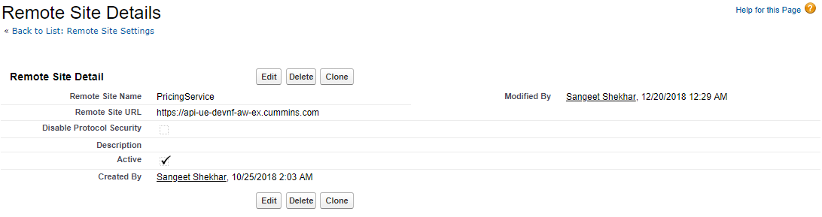

**Certificate and Key Management:**

**Go to Setup -> Search Certificate and Key Management (In Quick Find/Search)-> Certificate and Key Management**

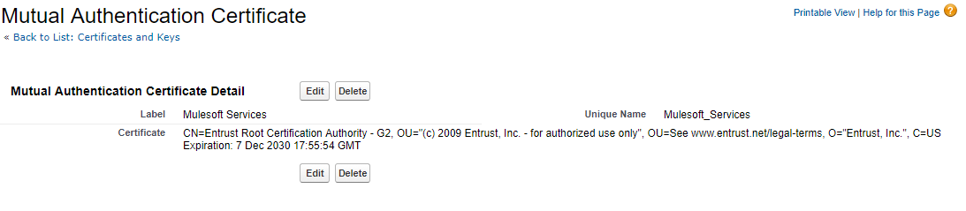

1. **Order Submission Service**

**Apex class -** FIL_FGP_OrderSubmitCtrl

**VF Page -** FIL_FGP_OrderSubmitProcessPage

**Order Submission URLs:**

All these are available in Setup-> Custom Settings -> OrderSubmission Service

OrderSubmission Service URL

Client Id

Client Secret

OrderSubmission Resource URL

Security token URL

**Order Sample Request:**

{

"OrderHeader": {

"siteId": "89898",

"CustomerId": "899",

“CustomerText”

"CustomerNumber": "899",

"BillToLocation": "89898",

"BillToPartySiteId" : "899",

"ShipToAbbreviation": "89898",

"ShipToSiteId": "89898",

"OrderType": "test",

"PortalOrderNumber": "89898",

"ShippingOption": "Standard" ,

"CustomerPONumber": "89898",

"Notes": "89898",

"OMSOrderNumber": "89898",

"OrderSubmitdate": "89898",

"ActionCode": "New",

"SourceSystem": "ORACLE" ,

"CustomerCodes": {

"item": [

{

"code": "FTJ9000",

"codevalue": "FTJ9ss00"

},

{

"code": "FTJ9ss00",

"codevalue": "FTJ9ss00"

}

]

},

"items": {

"item": [

{

"PortalOrderLineNumber" : "89898",

"POLineNumber": "89898",

"CustomerPartNumber": "89898",

"CatalogNumber": "89898",

"ShortPartNumber": "89898",

"Quantity": "89898",

"RequestDate": "89898",

"Price": "89898",

},

{

"PortalOrderLineNumber" : "89898",

"POLineNumber": "89898",

"CustomerPartNumber": "89898",

"CatalogNumber": "89898",

"ShortPartNumber": "89898",

"Quantity": "89898",

"RequestDate": "89898",

"Price": "89898",

}

]

}

}

}

**Order Sample Response:**

{

"OrderResponse": {

"siteId": "89898",

"OrderId": "899" ,

"Status" : "true",

"token" : "3444"

}

}

**Remote Site Settings:**

**Go to Setup -> Search Remote Site Settings (In Quick Find/Search)-> Remote Site Settings**

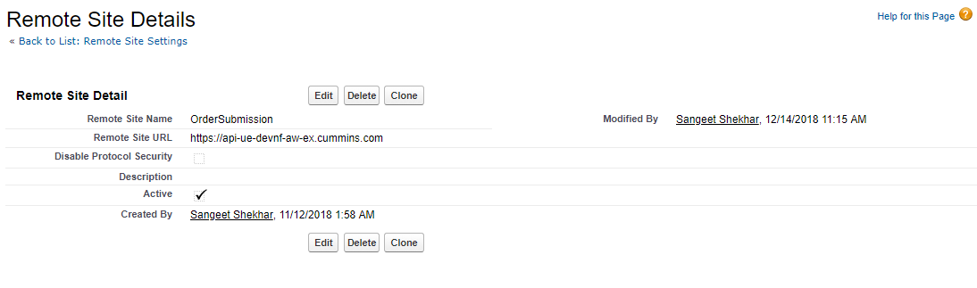

**Certificate and Key Management:**

**Go to Setup -> Search Certificate and Key Management (In Quick Find/Search)-> Certificate and Key Management**

