 | 

DEPARTMENT OF COMPUTER SCIENCE & ENGINEERING
ABES ENGINEERING COLLEGE, GHAZIABAD
Dr. A.P.J. Abdul Kalam Technical University, Uttar Pradesh
SOFTWARE REQUIREMENTS
SPECIFICATION (SRS)
Project Title: Retail Inventory Management System (RIMS)
A Full Stack Web-Based Inventory Management Application
————————————————————————————
SUBMITTED BY:  Ajit Kumar Saini (Roll No: 2400320100114)  Degree: Bachelor of Technology (B.Tech)  Academic Year: 2026 - 2027 | UNDER THE GUIDANCE OF:  Ms: Sakshi Mohinia  Project Guide  Status: 3rd Year Project Specification  Date of Submission: 01/10/2026

1. Introduction
1.1 Purpose
This document specifies the software requirements of the Retail Inventory Management System (RIMS). It describes the functional, non-functional, interface and data requirements so that developers, testers, the project guide and evaluators share a common understanding of what the system must do. It is intended for the development team, faculty reviewers and future maintainers.
1.2 Scope of the System
RIMS is a centralized, web-based application that replaces manual inventory records. It manages products, warehouses, stock levels, customers, customer orders, suppliers and purchase orders, and protects them with JWT-based authentication and role-based authorization (USER and ADMIN). An Angular 22 (TypeScript) frontend communicates with a Spring Boot backend through REST APIs, and data is stored in a MySQL database. Key boundary guidelines include:
- In-Scope Capabilities: Product catalog, warehouse, multi-warehouse inventory, customer, order, supplier and purchase order management, with JWT authentication and role-based authorization (USER and ADMIN).
- Out-of-Scope Boundaries (current release): Barcode/QR scanning, payment gateway, shipment tracking, email/SMS notifications, advanced analytics, mobile application and AI-based demand forecasting.
1.3 Definitions, Acronyms, and Abbreviations
Category | Term / Acronym | Definition / Standard Context
Standard | SRS | Software Requirements Specification
Inventory | SKU | Stock Keeping Unit – unique code identifying a product
Procurement | PO | Purchase Order raised to a supplier
Security | JWT | JSON Web Token used for stateless authentication
Architecture | REST / API | Representational State Transfer / Application Programming Interface
Database | CRUD | Create, Read, Update, Delete
Database | JPA | Java Persistence API (via Spring Data JPA)
Security | RBAC | Role-Based Access Control

1.4 References
- IEEE Std 830-1998: IEEE Recommended Practice for Software Requirements Specifications.
- Project Report: Retail Inventory Management System, ABES Engineering College, Ghaziabad.
- Official Documentation: Spring Boot, Spring Data JPA, Spring Security, MySQL, Angular, Tailwind CSS, Apache Maven.
1.5 Document Overview
Section 2 gives the overall product description. Section 3 lists functional requirements, use cases and data requirements. Section 4 specifies external interfaces and REST endpoints. Section 5 defines non-functional requirements. Section 6 presents the system models. Section 7 covers verification, limitations and future scope. Section 8 lists risks and open issues, and Section 9 is the academic sign-off.
2. Overall Description
2.1 Product Perspective
RIMS is a self-contained, three-tier web system: (1) an Angular 22 presentation tier (TypeScript, Tailwind CSS, Angular Router and HttpClient), (2) a Spring Boot application tier organized into Controller, Service, Repository, Entity and Security layers, and (3) a MySQL data tier (database: retail_inventory). The tiers communicate over HTTP using JSON REST APIs; protected requests carry the header Authorization: Bearer <JWT>. The context-level view of the system and its four external entities is shown in Figure 2.1.
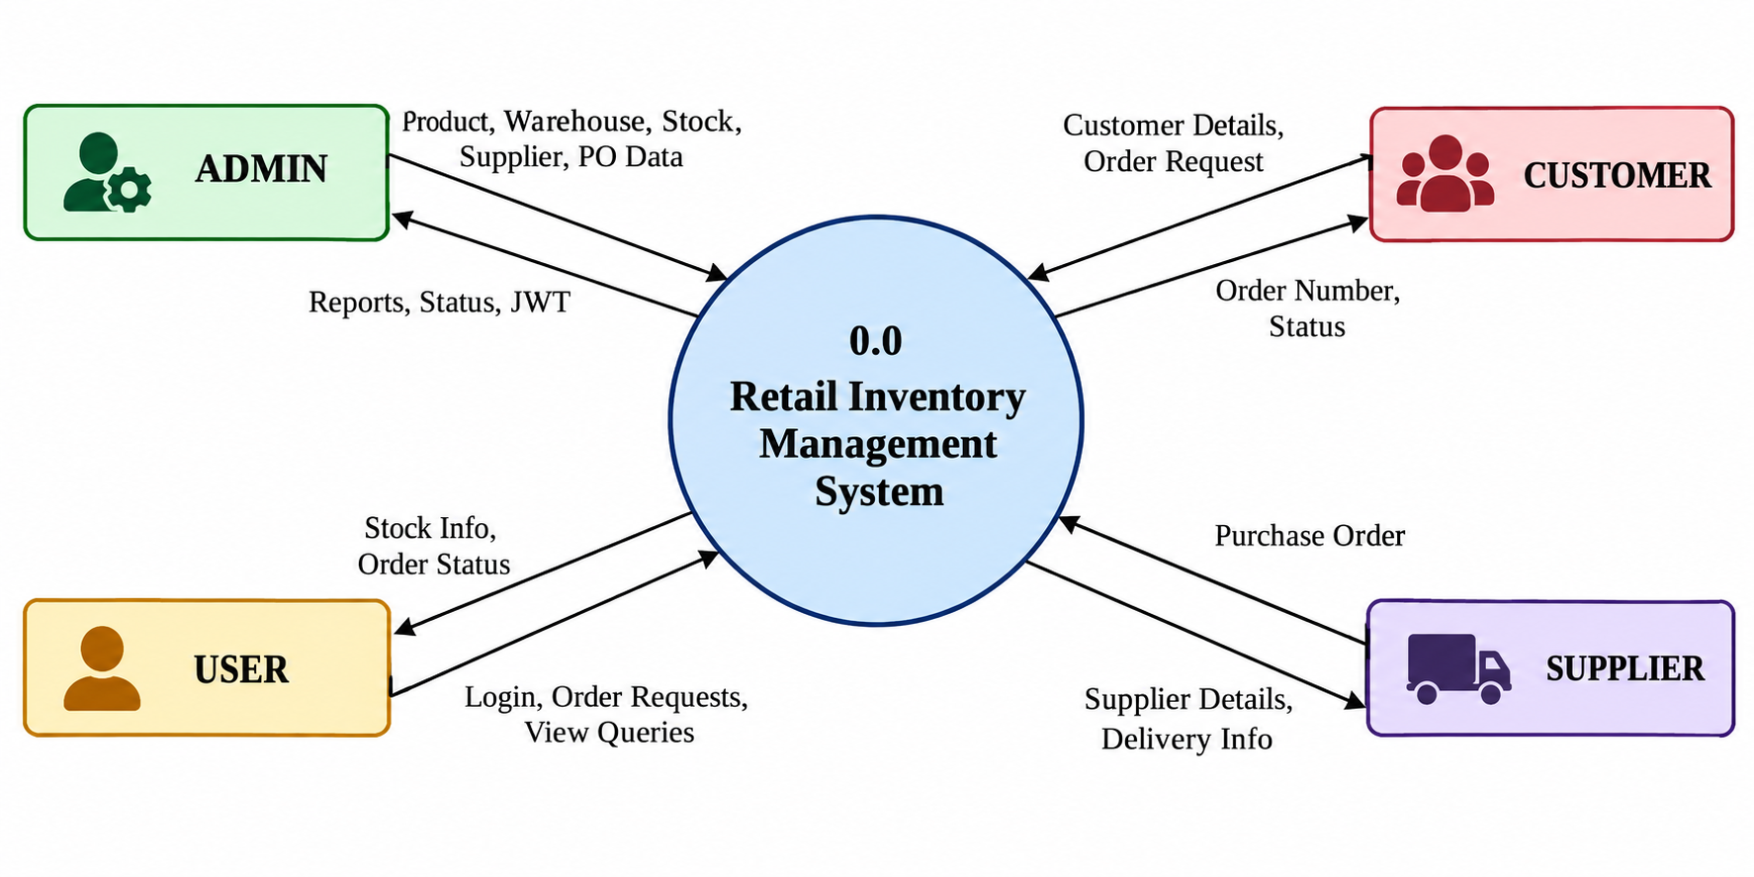
Figure 2.1: Context Level DFD (Level 0)
The key product functions are:
- User registration, authentication and role-based authorization
- Product catalog management (SKU, category, brand, price, status)
- Warehouse management (code, name, address, contact, capacity, status)
- Multi-warehouse inventory tracking (quantity, reserved quantity, reorder level)
- Customer management and order processing with order items and status tracking
- Supplier, purchase order and user management (ADMIN)
- Admin and User dashboards and list/form views for all modules
2.2 User Classes and Characteristics
RIMS accommodates two user classes with different access hierarchies:
User Role / Persona | Characteristics | Core Responsibilities & Rights
ADMIN | Store/inventory manager with system-level responsibility | Full access: products, warehouses, inventory, customers, orders, suppliers, purchase orders, user management and admin dashboard
USER | Operational staff with basic computer skills | Operational access to permitted functions (e.g., view products/inventory, manage customers, create/view orders, user dashboard)

The role access matrix for the system modules is given in Table 2.1.
Module | ADMIN | USER | Notes
Authentication | Yes | Yes | Public login and registration endpoints
Product Management | Full | View | Per configured permissions
Warehouse Management | Full | View | Per configured permissions
Inventory Management | Full | View | Per configured permissions
Customer Management | Full | Limited | Configurable
Order Management | Full | Limited | Create/view orders
Supplier Management | Full | No | ADMIN only (Spring Security)
Purchase Orders | Full | No | ADMIN only (Spring Security)
User Management | Full | No | ADMIN only (Spring Security)
Table 2.1: Role Access Matrix
2.3 Operating Environment
The application operates within the following software and hardware environments:
- Client Requirements: Any modern web browser (Chrome, Edge, Firefox) on Windows, Linux or macOS.
- Server Runtime Environment: Java 17+ runtime with Spring Boot; Maven for build; MySQL 8.x database server.
- Frontend Stack: Angular 22 with TypeScript, Tailwind CSS v4, Angular Router and HttpClient; Node.js/npm for build tooling.
2.4 Design and Implementation Constraints
- Backend Technology: Backend must use Java, Spring Boot, Spring Data JPA and Spring Security.
- Data Storage: Data must be persisted in a relational MySQL database with normalized tables.
- Communication Standard: All frontend-backend communication must use REST over HTTP(S) with JWT authentication.
- Academic Budget Constraint: The project must be developed using open-source or freely available tools (academic setting).
2.5 Assumptions and Dependencies
- Assumption: Users have network access to the server and a supported browser.
- Dependency: The MySQL server is available and correctly configured before the backend starts.
- Assumption: Supplier, purchase-order and user modules are ADMIN-only; other module permissions are configurable and will be finalized with the project guide.
3. System Features and Functional Requirements
Requirements are categorized by functional subsystem modules with unique requirement identifiers (FR-xx). Unless stated otherwise, the system shall provide the listed operations to authorized users.
3.1 Functional Requirements
Req ID | Requirement Description | Role | Priority
FR-01 | Users shall register and log in with email and password (the first registered account becomes ADMIN, later accounts USER); on successful login the system issues a JWT, and on failure returns an error. | All | High
FR-02 | The system shall reject requests to protected APIs that lack a valid JWT (access denied). | All | High
FR-03 | The system shall enforce ADMIN and USER roles on all secured operations. | All | High
FR-04 | The system shall allow adding, viewing, updating and deleting products with SKU, name, category, brand, price and status. | ADMIN | High
FR-05 | The system shall ensure each product SKU is unique and shall reject duplicates. | System | High
FR-06 | The system shall show product availability based on inventory records. | All | Medium
FR-07 | The system shall manage warehouses with code, name, address, contact details, capacity and status. | ADMIN | High
FR-08 | The system shall store inventory per product and warehouse with quantity, reserved quantity and reorder level. | ADMIN | High
FR-09 | The system shall provide product-wise and warehouse-wise inventory views. | All | High
FR-10 | The system shall manage customers with name, email, phone, address and location. | ADMIN/USER | Medium
FR-11 | The system shall create orders with an order number, customer, order items, total amount and shipping information. | ADMIN/USER | High
FR-12 | The system shall track order status: PENDING, CONFIRMED, PROCESSING, SHIPPED, DELIVERED, CANCELLED. | ADMIN/USER | High
FR-13 | The system shall manage suppliers with name, email, phone, address, contact person and status. | ADMIN | High
FR-14 | The system shall create purchase orders with PO number, supplier, products, quantity, cost, total amount, expected delivery date and status. | ADMIN | High
FR-15 | The system shall validate inputs (empty fields, negative quantities) and display clear error messages. | System | High
FR-16 | The system shall expose REST endpoints /api/auth, /api/products, /api/warehouses, /api/customers, /api/inventory, /api/orders, /api/suppliers, /api/purchase-orders and /api/users. | System | High
FR-17 | The system shall provide Admin and User dashboards with an overview of modules and navigation. | All | Medium
FR-18 | The system shall allow ADMIN to manage users and their roles (ADMIN/USER). | ADMIN | Medium

3.2 Use Case Summary
Use Case | Actor | Brief Flow
Login | ADMIN, USER | Enter credentials → validate → JWT generated → frontend stores token → access granted.
Manage Product | ADMIN | Open Products → add/edit/delete → validate SKU → save to database → list refreshed.
Update Inventory | ADMIN | Select product and warehouse → enter quantity/reorder level → save inventory record.
Place Order | ADMIN, USER | Select customer → add items → system computes total → order saved as PENDING.
Create Purchase Order | ADMIN | Select supplier → add products with quantity and cost → set delivery date → save PO.

3.3 Data Requirements
The database retail_inventory contains ten tables: product, warehouse, customer, inventory, orders, order_item, supplier, purchase_order, purchase_order_item and users.
Entity | Main Fields / Notes
Product | id, sku (unique, not null), name, category, brand, price, status
Warehouse | id, code, name, city/address, contact, capacity, status
Inventory | id, product (FK), warehouse (FK), quantity, reserved quantity, reorder level
Customer | id, name, email, phone, address
Order / OrderItem | id, orderNumber, customer (FK), totalAmount, status; item: order (FK), product (FK), quantity
Supplier | id, name, email, phone, contact person, status
PurchaseOrder / Item | id, number, supplier (FK), amount, expected delivery, status; item: product, quantity, cost
User | id, name, email, password (hashed), role (USER/ADMIN)
Table 3.1: Key Data Entities
Integrity rules: primary keys, foreign keys, unique constraints (e.g., SKU), not-null constraints, validation annotations and enum values (e.g., order status, role) shall be applied. Product, inventory, customer, order, supplier and purchase-order data are kept in separate tables (normalized) to avoid duplication.
3.4 Order and Purchase Order Status Values
An order moves through the following statuses: PENDING (created, awaiting confirmation), CONFIRMED (accepted), PROCESSING (items being prepared), SHIPPED (dispatched to the customer), DELIVERED (received by the customer) and CANCELLED. A purchase order uses PENDING (awaiting approval), APPROVED (approved), ORDERED (placed with supplier), RECEIVED (products received) and CANCELLED.
4. External Interface Requirements
4.1 User Interfaces (UI)
The interface is an Angular 22 web UI (standalone components) with Login and Registration pages, Admin and User dashboards, and pages for Products, Warehouses, Customers, Inventory, Orders, Suppliers and Purchase Orders. It uses reusable components: Layout, Navbar, Sidebar, icons, data tables, forms, status badges and error messages.
4.2 Hardware Interfaces
- Special Hardware: No special hardware is required.
- Client: Standard PC/laptop.
- Server: Adequate CPU, RAM and disk for MySQL.
4.3 Software Interfaces
- Backend Service: Spring Boot REST backend.
- Database Connector: MySQL via Spring Data JPA/JDBC.
- Frontend Client: Angular HttpClient for HTTP calls; an HTTP interceptor attaches the JWT as a Bearer token to protected requests.
- API Testing Tools: Postman / Thunder Client.
4.4 Communication Interfaces
- Web Traffic Protocol: HTTP/HTTPS with standard methods GET, POST, PUT and DELETE.
- Data Serialization: JSON payloads.
- Authorization: Bearer-token header (Authorization: Bearer <JWT>) for secured endpoints.
4.5 REST API Endpoints
Endpoint | Module | Operations
/api/auth | Authentication | POST (login, register)
/api/products | Product Management | GET, POST, PUT, DELETE
/api/warehouses | Warehouse Management | GET, POST, PUT, DELETE
/api/inventory | Inventory Management | GET, POST, PUT, DELETE
/api/customers | Customer Management | GET, POST, PUT, DELETE
/api/orders | Order Management | GET, POST, PUT, DELETE
/api/suppliers | Supplier Management | GET, POST, PUT, DELETE
/api/purchase-orders | Purchase Order Management | GET, POST, PUT, DELETE
/api/users | User Management (ADMIN) | GET, POST, PUT, DELETE
Table 4.1: REST API Endpoints
5. Non-Functional Requirements (NFRs)
Attribute | Requirement
Security (NFR-01) | All protected APIs shall require a valid JWT; passwords shall be stored in hashed form; role checks shall be enforced by the backend, not only the UI (Supplier, Purchase Order and User APIs require ADMIN).
Performance (NFR-02) | Normal CRUD operations should respond within about 2 seconds under typical load (target for a small-to-medium retail setup).
Reliability (NFR-03) | All data shall be stored persistently in MySQL; integrity shall be protected by primary/foreign keys and constraints.
Usability (NFR-04) | Consistent navigation, forms, tables and status badges; meaningful validation and error messages.
Maintainability (NFR-05) | Layered architecture (Controller, Service, Repository, Entity, Security) with separation of concerns.
Scalability (NFR-06) | Modular design shall allow new modules (e.g., analytics, notifications) without redesigning existing ones.
Portability (NFR-07) | Runs on any OS supporting Java, Node.js and MySQL; accessed through standard browsers.
Availability (NFR-08) | The system should be available during business hours; database backups should be possible using MySQL tools.

6. System Design and Analysis Models
6.1 System Architecture
RIMS follows a three-tier layered architecture. The JWT filter in the Security layer validates every protected request before it reaches the Controller.
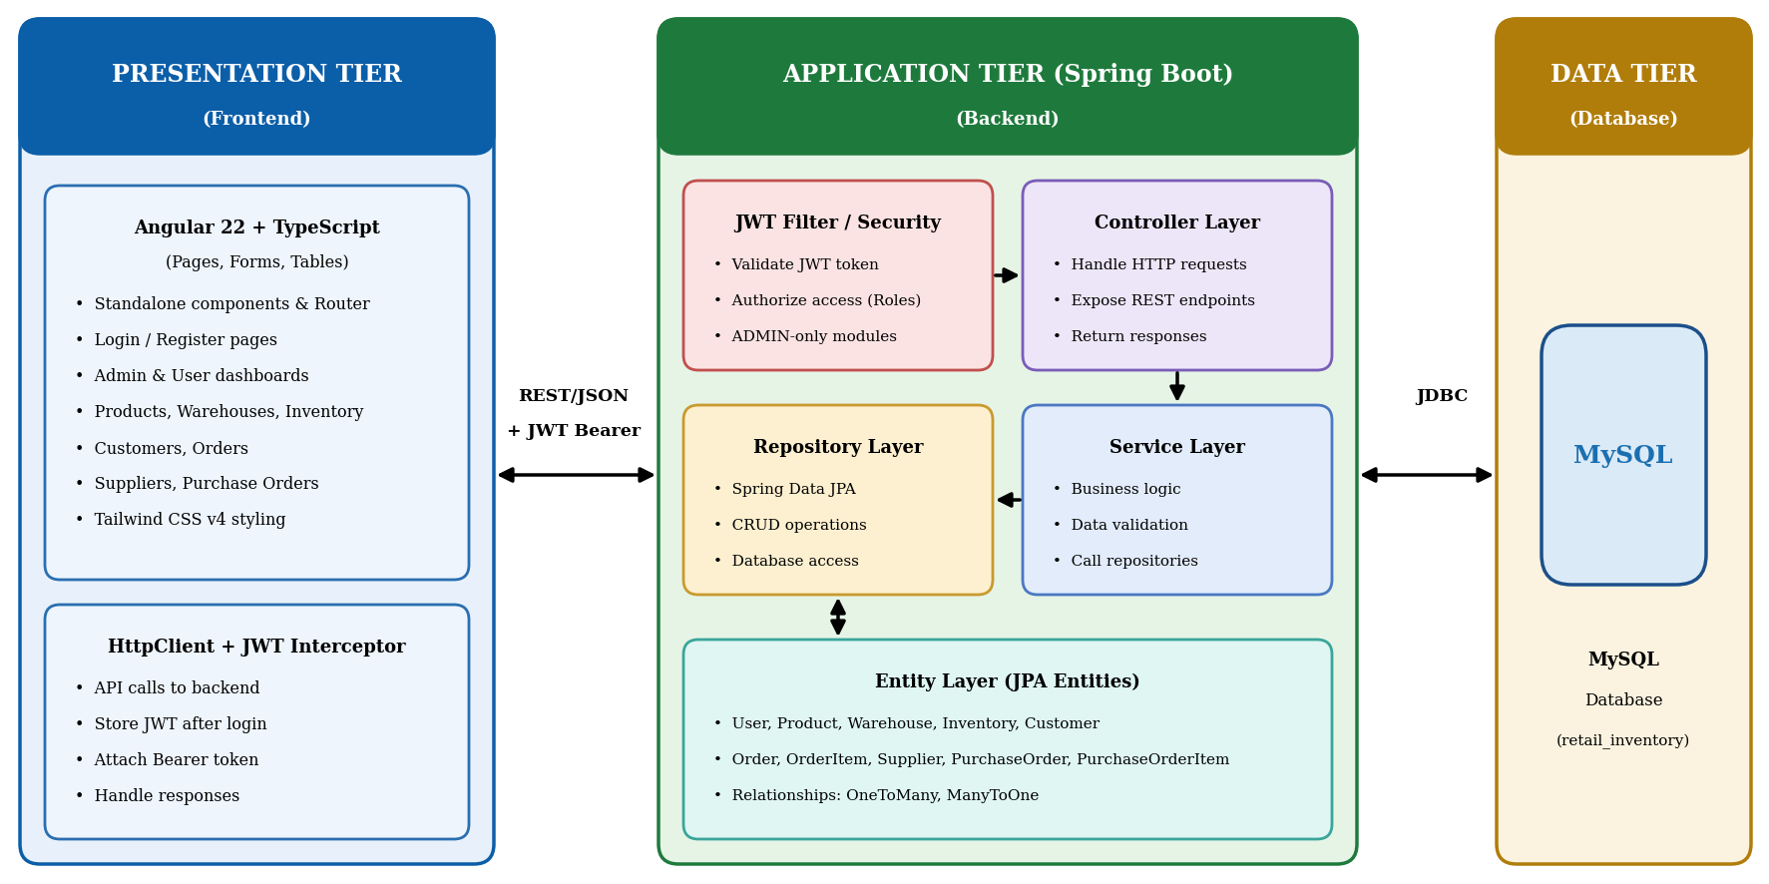

Figure 6.1: System Architecture
6.2 Data Flow Diagrams
The context-level DFD (Figure 2.1) shows the four external entities that interact with the system; the Level-1 DFD (Figure 6.2) breaks the system into five processes and four data stores.
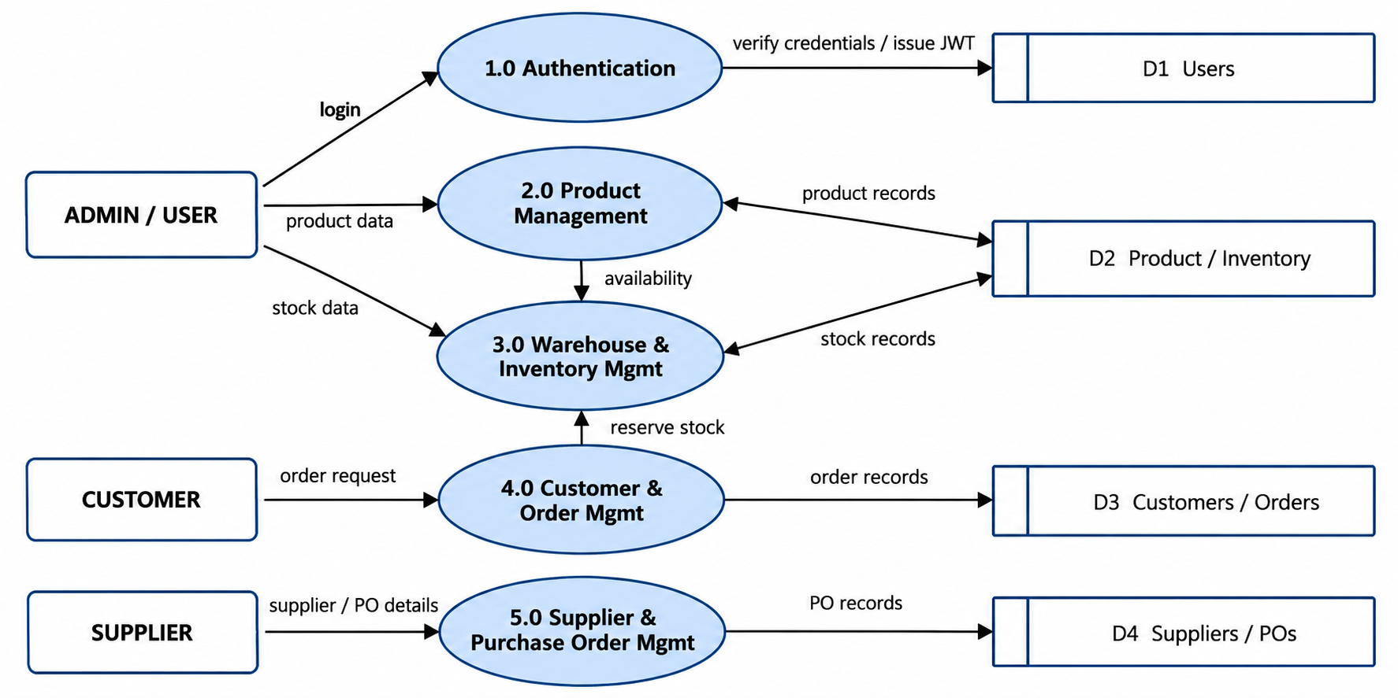

Figure 6.2: Level 1 DFD
6.3 Entity Relationship Diagram
The ER diagram shows the ten entities of the retail_inventory database. Foreign keys are shown in red and primary keys in bold.
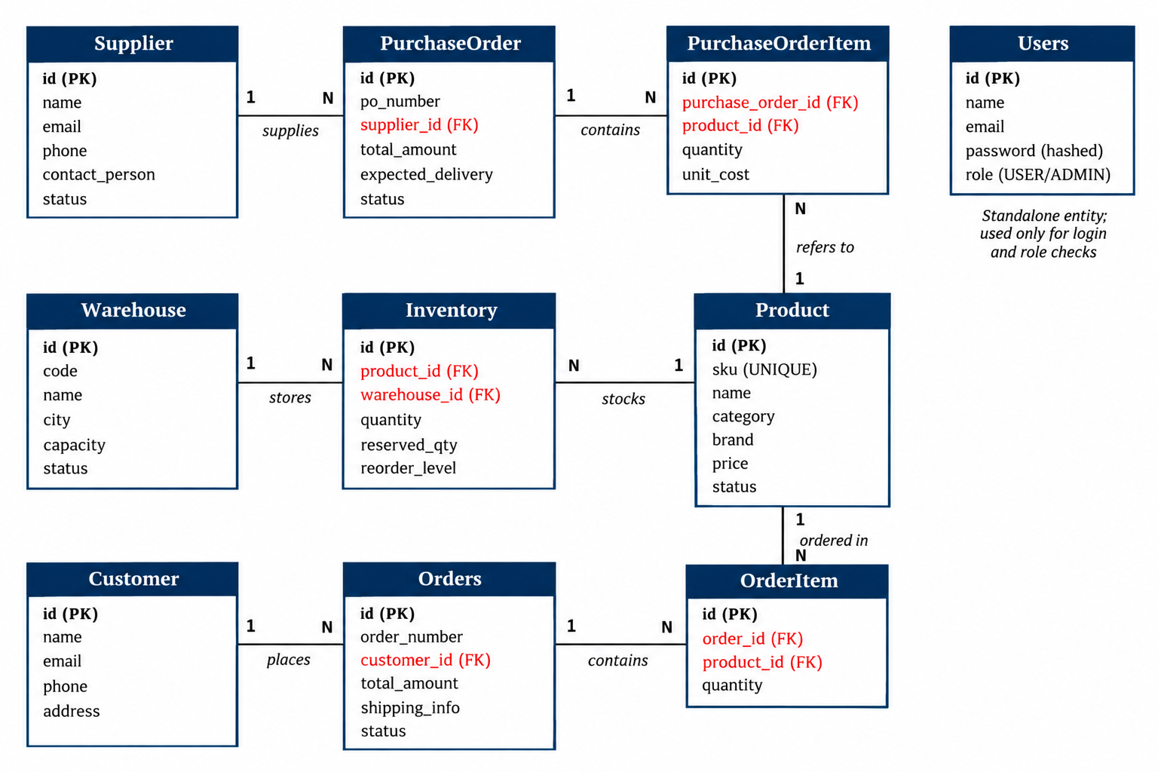

Figure 6.3: Entity Relationship Diagram
6.4 Authentication Flow
Register / Login → Validate Credentials → Generate JWT → Angular Frontend Stores Token → HTTP Interceptor Sends Bearer Token → JWT Filter Validates Token → Access Protected Resource. The first registered account is ADMIN; later accounts are USER. Authorization is enforced by the backend, not by any frontend setting.
7. Verification, Limitations and Future Scope
7.1 Verification and Acceptance
Requirements shall be verified through unit, integration, functional, REST API, validation, authentication, authorization and frontend testing. Sample acceptance tests are given below.
ID | Test Case | Expected Result | Requirement
TC-01 | Valid login | JWT generated | FR-01
TC-02 | Invalid login | Error returned | FR-01
TC-03 | Add product | Product created | FR-04
TC-04 | Update / delete product | Product updated / deleted | FR-04
TC-05 | Duplicate SKU | Request rejected | FR-05
TC-06 | Add warehouse | Warehouse created | FR-07
TC-07 | Add inventory record | Inventory created for product and warehouse | FR-08
TC-08 | Add customer | Customer created | FR-10
TC-09 | Create order with items | Order saved, status PENDING | FR-11, FR-12
TC-10 | Add supplier | Supplier created | FR-13
TC-11 | USER calls ADMIN-only API / no token | Access denied | FR-02, FR-03
TC-12 | Create purchase order | PO created | FR-14
TC-13 | Negative quantity / empty field | Validation error shown | FR-15
Table 7.1: Acceptance Test Cases
7.2 Limitations and Future Scope
Limitations: No barcode scanning, payment gateway, advanced analytics, mobile app or AI-based forecasting; notification functionality is limited. Future scope: Barcode/QR integration, automated low-stock alerts, email/SMS notifications, payment gateway, shipment tracking, cloud deployment, mobile application, demand prediction and inventory analytics.
8. Risks and Open Issues
8.1 Risks and Mitigation
Risk | Impact | Mitigation
Unauthorized API access | Data exposure | JWT validation and backend role checks
Incorrect stock entries | Wrong availability | Validation rules and constraints
Database unavailable | System downtime | Regular MySQL backups
Requirement changes | Schedule delay | Layered, modular design
Table 8.1: Risk Register
8.2 Open Issues
- Final USER-role permissions for non-ADMIN modules (Table 2.1) are to be confirmed with the project guide.
- Response-time target (NFR-02) is to be validated during testing.

