**OHLC Chart**

I start with drawing an OHLC (open/high/low/close) chart to get a sense of historical prices.

Below OHLC I draw Volume chart which shows number of stocks traded each day.

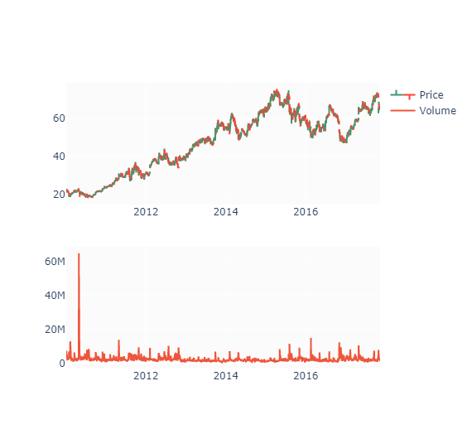

#### Decomposition

#### 

##### *Moving Averages*[*¶*](http://localhost:8888/notebooks/Github_Upload/XGBoost_for_stock_prediction/XGBoost_for_stock_prediction.ipynb#Moving-Averages)

I'm calculating few moving averages to be used as features: SMA5 , SMA10 , SMA15 , SMA30 and EMA9 .

#### 

#### Relative Strength Index

I'll add RSI indicator to predict whether a stock is overbought/oversold.

#### 

#### MACD

#### 

#### Here I split stock data frame into three subsets: training ( 70% ), validation ( 15% ) and test ( 15% ) sets. I calculated split indices and create three separate frames (train_df, valid_df, test_df). All three frames have been ploted in the chart below.

#### 

#### Calculate and visualize predictions

#### 