VARIABLES:
#Base vars
setwd("C:/MS Degree/MIS470/Data Sets")
ctaData = read.csv("CTA2_Data.csv", header = TRUE)
ctaCloseSampMean <- mean(ctaData$Close)
ctaCloseStdDev <- sd(ctaData$Close)
x <- 125
#Setting t.test confidence intervals
tTestClose_90 <- t.test(mu > x, ctaData$Close, conf.level = .9)
tTestClose_95 <- t.test(mu > x, ctaData$Close, conf.level = .95)
tTestClose_99 <- t.test(mu > x, ctaData$Close, conf.level = .99)
#Execution
tTestClose_90
tTestClose_95
tTestClose_99
ctaCloseSampMean
ctaData

RESULTS
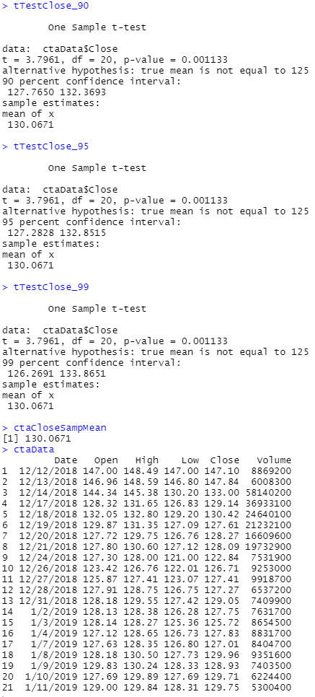

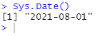

Hello Professor,
If you were observing CTA Option 2, you could note here that confidence intervals bounds are higher than $125. This, along with cursory review of the data, which has only one "Close" record above the value of $125, immediately suggests that you would reject a null hypothesis that the sample mean of "Close" is less than $125. This is proven by a p-value of .001133 at all confidence levels with a mu of 125.
As I am moving forward with CTA Option 1 - the results from the T-Tests for the confidence intervals 90, 95, and 99 show that as you increase your confidence interval, your upper and lower bounds also increase. This is because to artificially increase to the level of confidence within a statistical analysis, you are actually increasing the spread of what results you are willing to accept in order to for analysis estimate to be true. In other words, you are required to relax your requirements of the data related to your hypothesis.
Concerning advantages & disadvantages of the setting confidence intervals, you, as the researcher, are essentially able to select your own acceptance requirements for your data. As requirements for confidence are dependent on the topics at hand it is very beneficial to have the flexibility needed to find a sufficient margin for error (i.e., the margin of error for car sales is much greater than that of heart surgery).
However, the standard is a minimum confidence of 90% (suggested is .95) and chasing an hypothesis acceptance/rejection rate more inclusive than 90% may be an unnecessary trade off as the less confidence you have, the more likely it is that you have accepted a false hypothesis (Type II Error). Looking at our confidence intervals, 99% of the data will fall in between 126.2691 and 133.8651 based on our sample. We accept the alternative hypothesis, and this same analysis is true at a 95% confidence.
Apologies as I threw in some items from CTA 2 here as well. Let me know if you would prefer me stick strictly to 1 in the future.

Respectfully,
Austin J Brown

