Linear Regressions CTA 3 Option 1

Austin Brown
Colorado State University
MIS470: Data Science Foundations
Dr. Alin Tomoiaga
8/8/2021

This week’s assignment required is to review, apply, and interpret the methods around the development of Linear Regression Models. The work serves to introduce concepts of algebraic modeling, forecasting, and variable relationships alongside previous hypothesis testing. These models are used in a variety of professional and research settings to create and enhance new or currently existing descriptive and predictive models. At its core, the modeling process allows the analyst to establish the validity, type, and level of impact that any chosen variable may have on another.
Our goal and supporting datasets & reading for this week provided us a scenario in which we interpreted statistical objects relative to linear regressions (Pearson’s Correlation Coefficient, Coefficient of Determination, concept of Least Squares, etc). Steps provided by the supporting documentation guided us to a point in which we were able to develop a final linear model, f(x) = b0 + b1(x). The observed topic was the relationship between U.S. Quarterly Gross Domestic Product, later referred to as ‘x’, and U.S. Dollar – Euro Exchange Rates, later referred to as ‘y’, and the supporting data provided metrics between the time frame of Q1-2010 and Q3-2018.
Initial visualization of the data suggested that there may be at least a weak to moderate correlation between the two variables. Reviewing the graph, as the plots and the line moved downward from left to right in a loose line, it became further apparent that the nature of the relationship was inverse – as our x value increased, the y decreased. Next, we worked to validate our initial assumptions through a correlation and statistical summary test between our two variable arrays. R’s outputs here confirmed that the two variables shared a moderate level of negative correlation. The following are the general guidelines for interpreting Pearson’s Correlation Coefficient:
- r = ± 1: perfect linear and monotone relationship. The closer r is to 1 or –1, the stronger the relationship.
- r = 0: no linear or monotone relationship
- r < 0: negative, inverse relationship (high values of one variable tend to occur together with low values of the other variable)
- r > 0: positive relationship (high values of one variable tend to occur together with high values of the other variable)
A negative relationship is represented by a falling regression line (regression coefficient b < 0), a positive one by a rising regression line (b > 0) (Schneider, 2010).
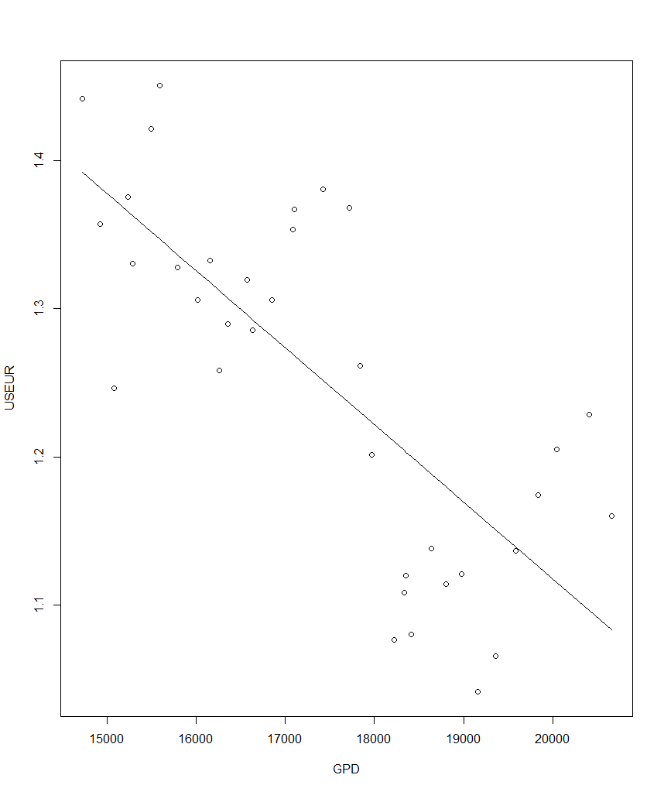
Figure 1 – Scatter plot with Line of Best Fit

By the end of our analysis we were able to confirm a moderate, negate correlation between the two variables that accounts for 56.5% (55.2% Adjusted) of variability within the model. That being said, the fit of the model is a good start but not great due to the amount of unaccounted error and the r only being moderately correlated. We ended this phase of the assignment through testing a null hypothesis that the coefficient of b1, or the slope of x, was statistically significant from 0 (i.e. H0: b1 = 0 ; H2: b2 =/ 0) at an alpha of .05. Our null hypothesis was rejected when a p-value of .000000193 was returned, denoted by R’s statistical summary Pr(>|t|) value of 1.93e-07 (.000000193).
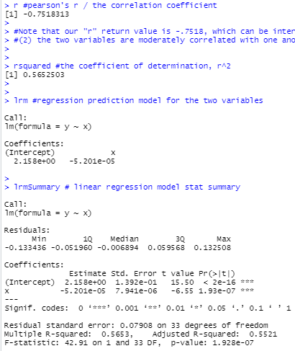
Figure 2 - Statistical Summary & Linear Model Fitness Attributes
The closing phase of our assignment was to write and demonstrate the final linear model based on the statistical summary. Based on the linear model b1 coefficient of -.00005201 and a y-intercept of 2.158, we arrived at a linear regression model of y = 2.158 + (-.00005201)x + e. This formula can be used by simply plugging in any desired value of x to get a corresponding y. For example, when applied and not accounting for the variance error within the model, a quick plugin in of 15,000 for GDP, x, returns a predicted Exchange Rate, y, of 1.37785. The only thing that needs to be kept in mind is that this is not accounting for all the variance within the data so the error within the model still needs to be accounted for.
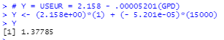
Figure 3 - Final Model Application

R Outputs

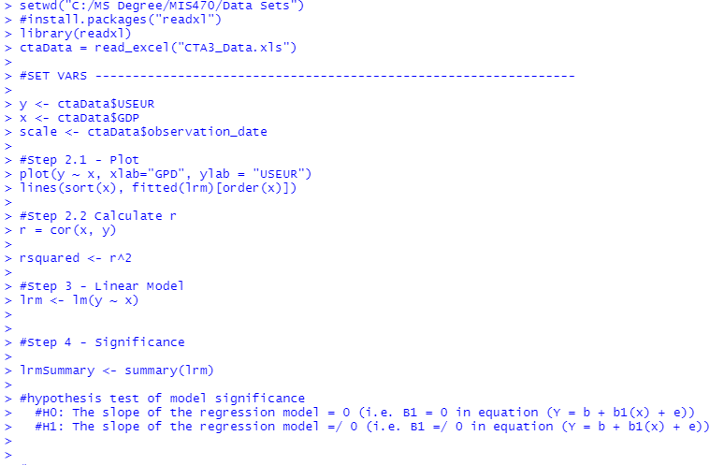
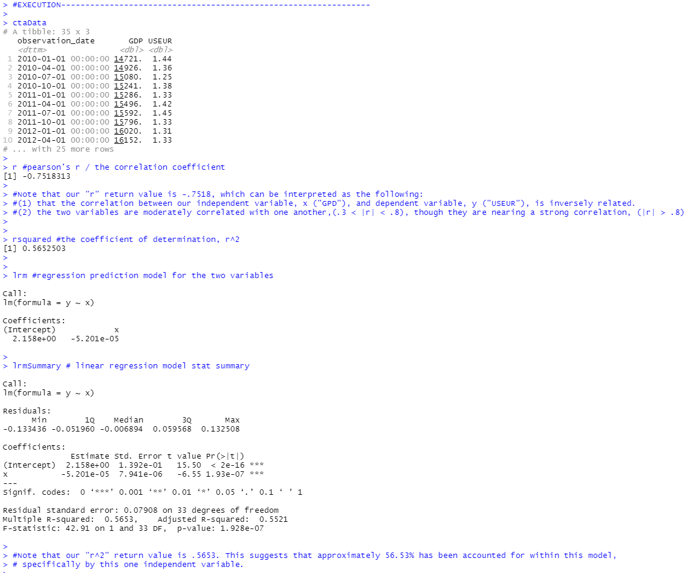
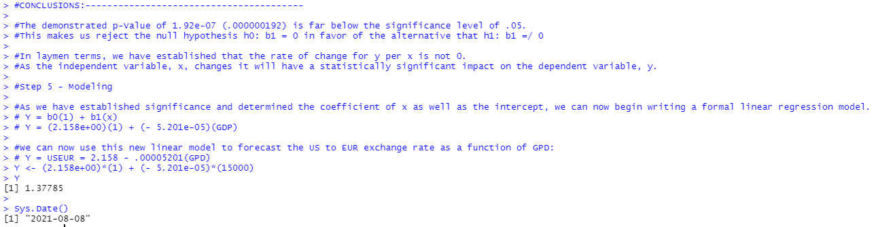
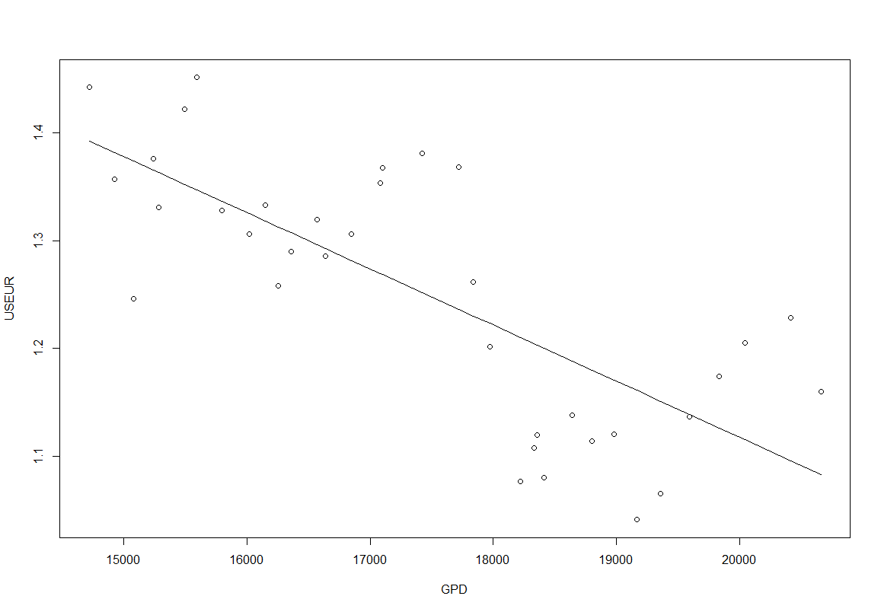

References

Berrier, J., Berrier, H., Chan, C., Nestler, S., Pardoe, I., Sturdivant, R., Vahid, F., Watts, K. (2018). Fundamentals of Data Analytics (R). ZyBook.
Schneider, A., Gerhard, H., Blettner, M. (2010). Linear Regression Analysis. Deutsches Arzteblatt International. https://www.ncbi.nlm.nih.gov/pmc/articles/PMC2992018/

