CTA4 – Option 1

Austin Brown
Colorado State University
MIS470: Data Science Foundations
Dr. Alin Tomoiaga
8/15/2021

For this assignment we were tasked with creating, testing and implementing a Logistic Regression Model for determining the probability of a vehicle having a manual or automatic transmission based on mileage. The dataset provided had multiple variables but the two that were of consequence to our task were the “MPG” of the vehicle as well as it’s binary identifier column for Automatic or Manual transmission, “AM”, where 1 = Manual and 0 = Automatic. Ultimately, the resulting model would allow a method of predicting and classifying the transmission of a car based on its Mileage. The steps taken for the creation and validation of the regression model are outlined through the rest of this document.

Cursory Analysis & Model Choice
Our initial step was to output a scatter plot and basic relationship analyses through RStudio to help us describe the relationship between the variables, provide visualization, and allow us to determine the proper regression model given the data.
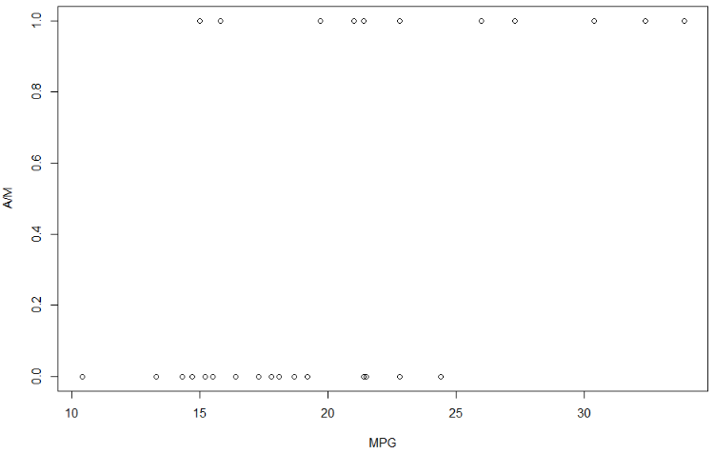

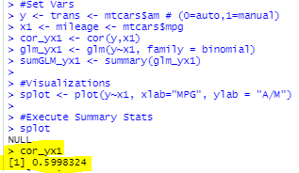

As we can see from the plot above, our dependent variable, AM, is split between to possible outcomes, 0 or 1. As there are only 2 possible outcomes for the classification, the variable itself can be described as binary in nature. This designation conflicts with the requirements of a linear regression model, where the dependent variable must be continuous in nature. Applying a linear regression model in this scenario would make it impossible to provide a line of best fit with any level of confidence or reduction in error as a simple line does not fit the data. Instead of the Linear Regression model we can decide to employ a Binary Logistic Regression model here, which primary use is to predict the probability of a binary event (dependent variable) based on inputs (independent variables). We also run a correlation test on the two variables to determine the strength of their relationship, which we observe as moderate & positive (i.e. as MPG increases, the likelihood of AM = 1 increases).

Fitting & Validating the Model

Our next step was to determine the Logistic Regression model that fit the data presented. This was done through Rstudio to return summary statistics, namely the intercept and x1 coefficient (slope).
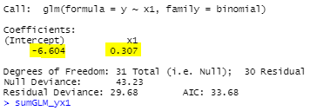
Taking the outputs provided by the glm() and summary() functions of R, we are able to fit the respective intercept and slope values, -6.604 and .307, to our data for use within the Logistic Regression model:
log( p(y=1) / 1-p(y=1) ) = (𝛽0 + 𝛽1 * X) = (e^(𝛽0+𝛽1*X) / (1 + e^(𝛽0+𝛽1*X))
After conduction a hypothesis test on the slope of the proposed model fit, where (H0: 𝛽1=0) and ( H1: 𝛽1≠0) with Alpha = .05, we returned a p-score of .00751. Being that the p-score fell below our decided alpha, we were able to reject the null hypothesis that there was no difference between a 𝛽 of 0 and a 𝛽 of .307. Simply put, we rejected the assumption that mileage has no impact on the prediction of the transmission type and instead opt for the alternative hypothesis that mileage is a statistically significant indicator of transmission type. At this point we move forward with a suitable & statistically significant estimate model as follows:
log(p(y=1) / 1-p(y=1)) = (𝛽0 + 𝛽1 * X) = (e^(-6.604 + .307 * X) / (1 + e^(-6.604 + .307 * X))
=
Probability (p) y is 1 (i.e. am is manual) = (e^(-6.604 + .307 * X) / (1 + e^(-6.604 + .307 * X))

Final validation and implementation of the model was completed by though the selection of an x1 (MPG) to produce an output from the model. Our number given was 16 MPG.
p = (e^(-6.604 + .307 * 16) / (1 + e^(-6.604 + .307 * 16))

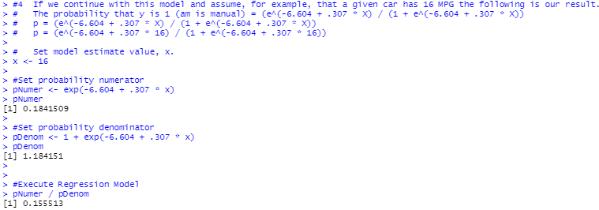
This model produced a probability output of .1555, or 15% chance that a vehicle with 16 MPG has an AM of 1. Alternatively, (1-p) = (1-.1555) can be used to describe how there is a .8445 or 84.45% chance that the vehicle in question has an AM of 0. Based on these outputs, the vehicle should be predicted as having an Automatic transmission.

R Inputs / Outputs

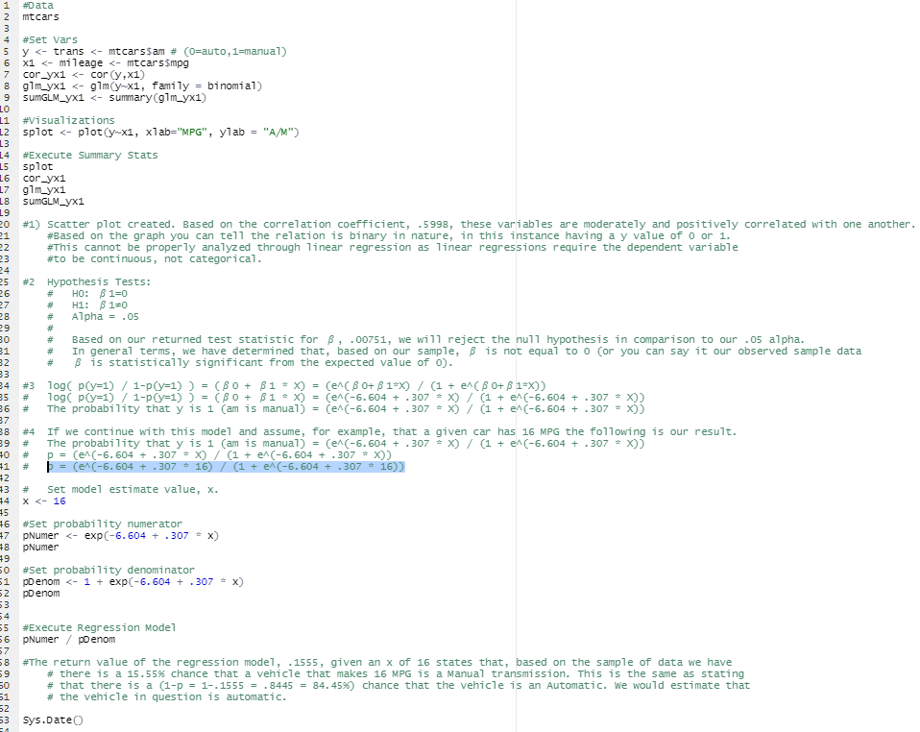
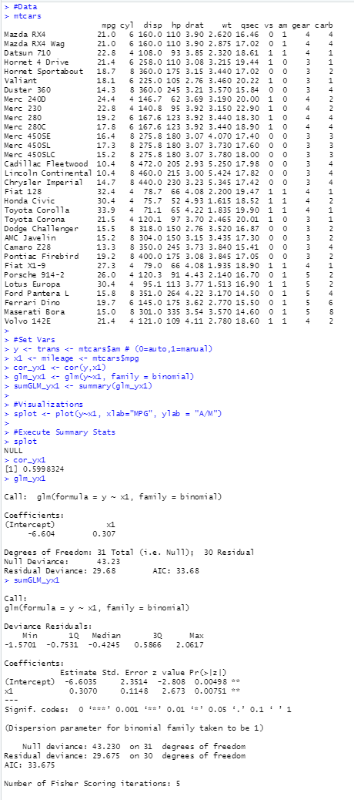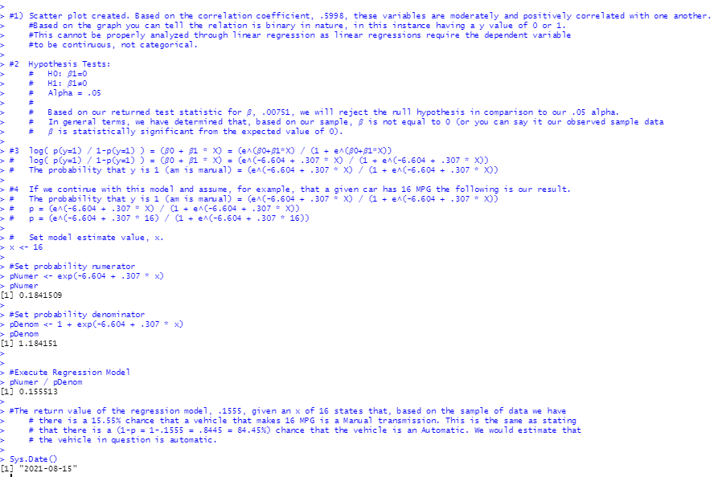
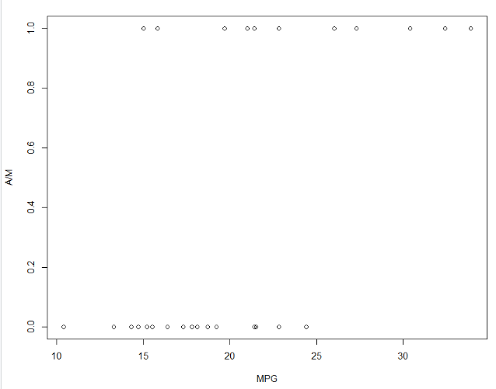

References

Berrier, J., Berrier, H., Chan, C., Nestler, S., Pardoe, I., Sturdivant, R., Vahid, F., Watts, K. (2018). Fundamentals of Data Analytics (R). ZyBook.
Peng, Joanne & Lee, Kuk & Ingersoll, Gary. (2002). An Introduction to Logistic Regression Analysis and Reporting. Journal of Educational Research. 96. 3-14. https://www.researchgate.net/publication/242579096_An_Introduction_to_Logistic_Regression_Analysis_and_Reporting

