Portfolio Project
Austin Brown
Colorado State University
MIS470: Data Science Foundations
Dr. Alin Tomoiaga
9/12/2021

Introduction

As a continuation of our previous Portfolio Milestone focused on Housing Data and price estimation, we have been asked to extend or previous linear regression efforts into a Multiple Regression across provided Test and Train datasets. Per previous efforts, we will be re-using and extending our prior analysis and R code in order to fully flesh out the task at hand. First off, there are a few assumptions and parameters I want to establish.
Firstly, for the purpose of this document we will omit the explanation on the technical setup/load of R, the necessary packages, and the base data sets (“testHousingData” and “trainHousingData”), instead jumping directly into the outlined task and analysis. Secondly, it is to be assumed that all R scripting is being run through the RStudio Integrated Development Environment (IDE). Third, we will not breakdown, in detail, the statistical methods and theories used within our functions. Though the knowledge and breakdown is useful in understanding exactly what and why something is being calculated, it is beyond the scope of this document and assignment given the page limitation and instruction. Finally, the data sets used are comprised of 24 variables, or columns, not including the Unique ID. Per the assignment goal of establishing a predictive model for Housing Prices we will be looking at one variable, “SalePrice”, as our dependent or output variable. SalePrice will furthermore be referenced as a function of x (f(x₁, x₂, x_{3,}…)) or simply denoted as “y”.

Distribution Summary

Our first step in developing our Multiple Regression Model is to revisit, observe, and compare summary statistics on our two base data sets, “testHousingData” and “trainHousingdata”. Viewing most relevant distribution summary statistics is easily done through R for each data set via the summary(), sd(), kurtosis(), and skewness() functions, running them for each dataset. We also use the hist() function in order to produce histograms for each data set, offering a basic visualization of the data.

Summary Statistics: Test - House Sale Price
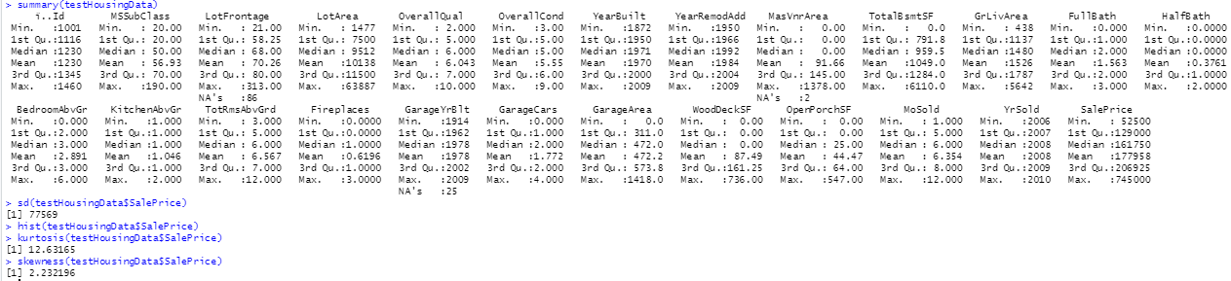

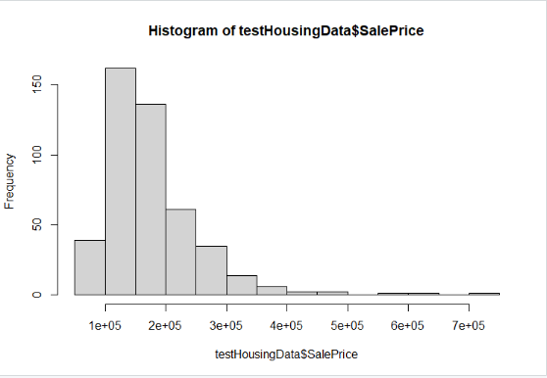
Mean = $177,958: On average, a house sells for $177,958.
Median = $161,750: Half the results in the array of sales price data are less than or equal to $161,750 and half are greater than or equal to $161,750.
Standard Deviation = $77,569: On average, the sale of a house deviates $77,569 from the mean value.
Minimum = $52,500: The minimum sale of a house was $52,500.
First Quartile = $129,000: 25% of house sale prices are less than or equal to $129,000.
Third Quartile = $206,925: 75% of house sale prices are greater than or equal to $206,925.
Maximum = $745,000: The maximum sale of a house was $745,000.
Kurtosis = 12.63: The Kurtosis of the distribution is 12.63.
Skewness = 2.23: The Skew of the distribution is 2.23.

Based on the above outputs, Austin (2021) asserted that the output of [test] housing sale price histogram reflects a positively, or right, skewed (median < mean or when skewness > 0) leptokurtic (kurtosis > 0) distribution of the sample data. This data is not normally distributed as the values are distributed asymmetrically around the mean, are positively skewed (2.2321 > 0) and display positive kurtosis (12.6317 > 0) (p. 2 – 3). You also can easily note that the largest volume of frequency in the data exists at a Sale Price of between $100,000 and $200,000.
The skewness displayed is positive, where the distribution is "biased towards higher values, such that mean of the distribution will exceed the median" (Calculate Skewness in R, 2021, Para. 2). As far as kurtosis goes, we can observe a leptokurtic, or fat-tailed distribution, where “extreme outcomes are more common than would be predicted by a standard normal distribution (Calculate Kurtosis in R, 2021, Para. 3). Austin (2021) concluded his assessment stating these observations are represented in the data and histogram based on the high frequency/concentration of observed sale prices at the median value relative to the rest of the distribution (p. 3)

Summary Statistics: Train – House Sale Price
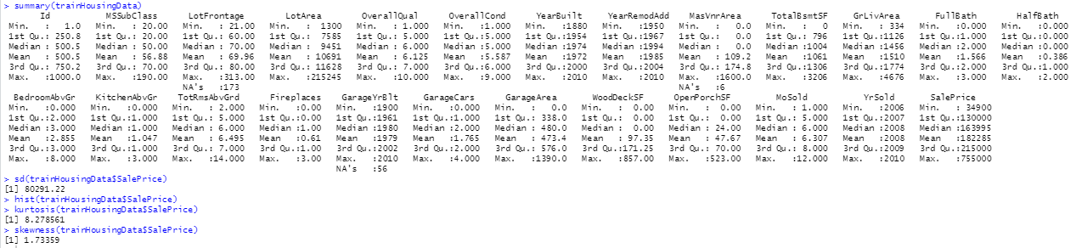

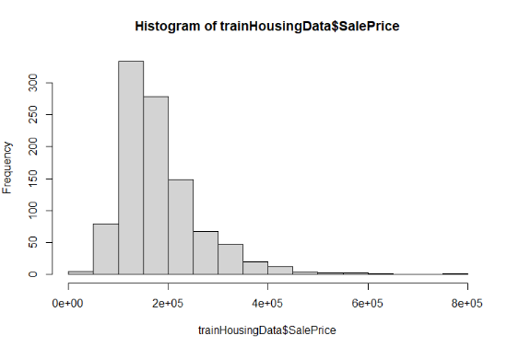
Repeating the same analysis as above for the training data set provides the following results.
Mean = $182,285: On average, a house sells for $182,285.
Median = $163,995: Half the results in the array of sales price data are less than or equal to $163,995 and half are greater than or equal to $163,995.
Standard Deviation = $80,291.22: On average, the sale of a house deviates $80,291.22 from the mean value.
Minimum = $34,900: The minimum sale of a house was $34,900.
First Quartile = $130,000: 25% of house sale prices are less than or equal to $130,000.
Third Quartile = $215,000: 75% of house sale prices are greater than or equal to $215,000.
Maximum = $755,000: The maximum sale of a house was $755,000.
Kurtosis = 8.28: The Kurtosis of the distribution is 8.28.
Skewness = 1.73: The Skew of the distribution is 1.73.

Summary outputs and the histogram clearly show that the distribution is not normal, being right skewed (Skew > 0 or median < mean) and leptokurtic (fat-tailed distribution, Kurtosis > 0). The highest observed frequency of data has shifted up slightly, but still resides between $100,000 and $200,000 for sales prices. When comparing these two explicit data sets we can clearly see that, though the sets are similar, they each have notable differences in their summary statistics. Overall, the test data set is smaller, more compact, and more concentrated sample with a narrower spread of values – resulting in relatively more extreme results due to the lower n. This is important to note, though summary statistics for test seem more normal as opposed to train based on smaller differences between ranges and differences, that is not the case due to its smaller sample size and noticeably larger skewness and kurtosis values.

Summary Statistics: Combined – House Sale Price

Combining our two data sets, we are able to look at the same summary statistics as in our previous sections. After combining the sets and removing duplicate IDs through the omission of Column 1 and applying the various functions specifically for “SalePrice”, R returns the following results and visualization.
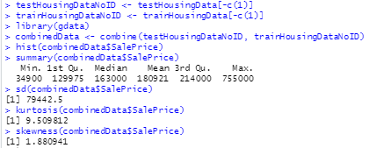
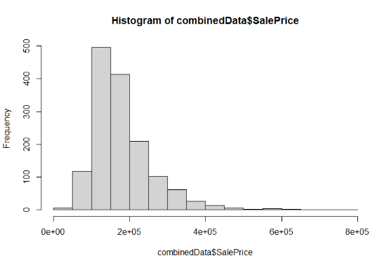
Mean = $180,921: On average, a house sells for $180,921.
Median = $163,000: Half the results in the array of sales price data are less than or equal to $163,000 and half are greater than or equal to $163,000.
Standard Deviation = $79,442.50: On average, the sale of a house deviates $79,442.50 from the mean value.
Minimum = $34,900: The minimum sale of a house was $34,900.
First Quartile = $129,975: 25% of house sale prices are less than or equal to $129,975.
Third Quartile = $214,000: 75% of house sale prices are greater than or equal to $214,000.
Maximum = $755,000: The maximum sale of a house was $755,000.
Kurtosis = 9.51: The Kurtosis of the distribution is 9.51.
Skewness = 1.88: The Skew of the distribution is 1.88.
Measure | Test | Train | Combined
Mean | $177,958 | $182,285 | $180,921
Median | $161,750 | $163,995 | $163,000
Standard Deviation | $77,569 | $80,291.22 | $79,442.50
Minimum | $52,500 | $34,900 | $34,900
1st Quart. | $129,000 | $130,000 | $129,975
3rd Quart. | $206,925 | $215,000 | $214,000
Maximum | $745,000 | $755,000 | $755,000
Kurtosis | 12.63 | 8.28 | 9.51
Skewness | 2.23 | 1.73 | 1.88
Row Count | 420 | 960 | 1380
Predictably, the merging of these two non-normal data sets results in another non-normal data set with sample weighed average differences in all summary statistics. Breaking down the difference between these three data sets you can easily pick apart the similarities and differences.

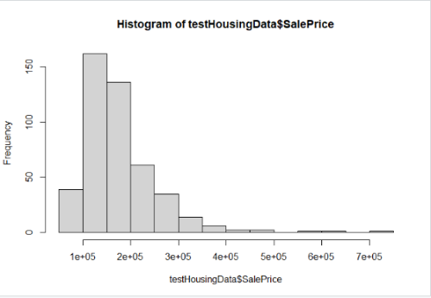

As you can see, the combined data outputs more closely reflect that of the train data set due to the difference in sample sizes. Due to the fact train has more than double the records of test, their combined weighted average will favor that of train. This weight effects all calculated values (Mean, Standard Deviation, Quartiles, Kurtosis, Skewness) while dimensional data favors the largest dimensions (Median, Minimum, Maximum).

Modeling & Hypothesis Testing

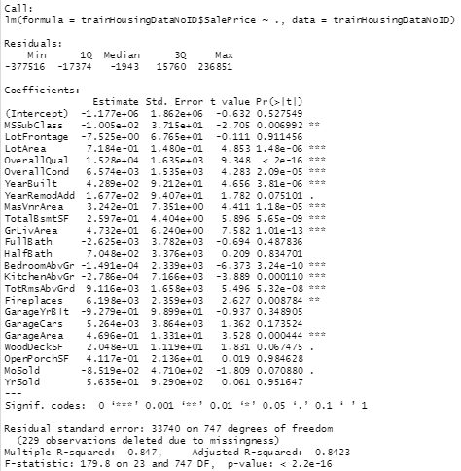
Using the training data set, we can construct the Multiple Regression Model that will be implemented alongside the combined dataset to predict Sale Price, y. This is done through establishing the model through R’s lm() (linear model) function in relation to the train dataset and calling it within a summary(), remembering to designate our train “SalePrice” variable as the desired output for the model. The resulting output gives us the all the coefficients and significance levels of every independent variable within the corresponding data set.

Each of these variables and their coefficient estimates have the potential to be used within the Multiple Regression Model based on their p-value. Our selection, in the case, will be made based on the general standard Alpha rate of .05 – in other words, we will reject the null hypothesis for any instance where the P-value is less than or equal to .05. Another way of looking at this is that we are comfortable with 5% chance or less of the designated predictor not being significant in the determination of y. As you can see, this particular output does a lot of work for us as you would normally be required to hypothesis test each variable coefficient, following correlation tests, to determine whether or not a particular variable was statistically significant in determining y (i.e. getting a p-value).
For example, we can construct a hypothesis test to see if the variable “LotArea” is significant in the model. This is done by setting the null hypothesis of LotArea’s coefficient, H_{0,} equal to 0. In other words, we assume that the standard is that LotArea‘s impact or slope on the model is 0. Our alternative hypothesis to the statement H₀ = 0 is that H₁ =/ 0, or that LotArea’s coefficient or slope is not 0.
H0: the slope of the regression equation is 0 (i.e. 𝛽₁ = 0)
H1: the slope of the regression equation is significantly different from 0 (i.e. 𝛽₁ =/ 0)

With the null and alternative hypothesis established, we can perform a t-test based on the expected, observed, and variance amounts to get a P-score – this test results in a P-score of .00000148. This P-score translates to a 0000015% chance that, based on the sample, LotArea’s slope is actually 0 while assuming it is not. The general result is as follows, due to the fact that our variables P-score falls under the maximum acceptable alpha error rate of 5%, as determined by us, we are able to reject the null hypothesis in favor of the alternative. By rejecting the null hypothesis, we are stating that LotArea does, in fact, have an impact on SalePrice and we can include it in our model.
Based on R’s outputs above, any variable listing an asterisk on the final column meets our P-score < .05 requirement. As such our Multiple Regression Model will be constructed of the following variables’ estimates, including the intercept if applicable. One item to note concerning the interpretation of significant variable coefficient estimates, negative values here denote an inverse relationship with the dependent and independent variable (if 𝛽 is negative, as x increases y decreases).
Independent Variables:
[MSSubClass, LotArea, OverallQual, OverallCond, YearBuilt, MasVnrArea, TotalBsmtSF, GrLivArea, BedroomAbvGr, KitchenAbvGr, TotRmsAbvGrd, Fireplaces, Garage Area]
Dependent Variable: [SalePrice]
Intercept: Not Statistically Significant, therefore omit.
Model Template: Y = Error + 𝛽₀ + 𝛽₁(X₁) + 𝛽₁(X₁) + 𝛽₁(X₁)…
Final Model:
SalePrice = f(x) = Y = Error + ((-100.5(MSSubClass)) + .7184(LotArea) + 15280(OverallQual) + 6574(OverallCond) + 428.9(YearBuilt) + 32.42(MasVnrArea) + 25.97(TotalBsmtSF) + 47.32(GrLivArea) + (-14910(BedroomAbvGr)) + (-27860(KitchenAbvGr)) + 9116(TotRmsAbvGrd) + 6198(Fireplaces) + 46.96(Garage Area))
Now that we need have constructed the model and validated the significance of the variables, we need to interpret theoretical estimate accuracy of the model by looking at the r^2 value. This was also provided in the output image above as the Multiple R-Squared (Adjusted R-Squared is similar but discounts insignificant variables), .847. This value can be interpreted as stating 84.7% of the variability of the variability of the dependent variable is explained by the variability of the independent variable (i.e. our model explains 84.7% of variation within the housing sale prices). Now that we have a significant and substantial theoretical model, we can employ it in any data set to test it.
Testing
In order to test the model we will use the provided Test data set, limited to the first 20 rows. After cleaning the data set of any null values and limiting it to the first 20 records, we can call the set within the predict() function to return a Y prediction based on the first 20 rows of data and the previously established model. It is now possible to easily compare predicted values to actual records in order to determine the accuracy of the model.
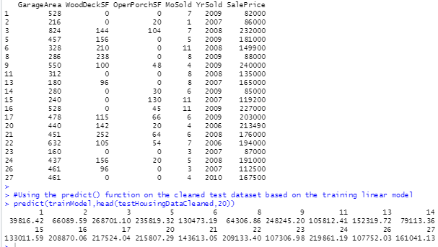

The suggested method of calculating the error between the test set and the model output is called the Mean Absolute Percentage Error. As noted by Khair (2017) “The Mean Absolute Percentage Error (MAPE) is calculated using the absolute error in each period divided by the observed values that are evident for that period. Then, averaging those fixed percentages. This approach is useful when the size or size of a prediction variable is significant in evaluating the accuracy of a prediction. MAPE indicates how much error in predicting compared with the real value” (pg. 2).
As our model variables are all highly significant and our R^2 is relatively high, the MAPE should be a good theoretical candidate for error analysis. When we run our MAPE calculation in R for our actual vs. predicted values, we get a return of MAPE = 15.04 or 15.04% error within the prediction case. This means that, on average, our predicted Y across all records was 15% off of the observed values. This value is theoretically accounted for in the situation where our percentage of (1-R^2) share no inter-correlation with any of our validated independent variables, though that is an interesting observation at best.
In reality, according to Swanson et al.(2011) in reference to the National Research Council, “any summary measure of error should meet five basic criteria — measurement validity, reliability, ease of interpretation, clarity of presentation, and support of statistical evaluation. MAPE meets most of these criteria, but its validity is questionable. As noted previously, the distribution of absolute percent errors is often asymmetrical and right skewed. As such, the MAPE is neither a resistant or robust summary measure because a few outliers can dominate it and the MAPE will not be close in value for many distributions Therefore, the MAPE can understate forecast accuracy, sometime dramatically. As such, it has tended to reinforce the perception of inaccurate forecasts” (pg. 8). Given the limitation of the MAPE and the fact that our data is not normal, I would be more interested in method such as the Median Absolute Error. Focusing on the median, given the observed data, should help to eliminate issues integral in mean and percentage calculations when dealing with heavily skewed data.
R Inputs/Outputs
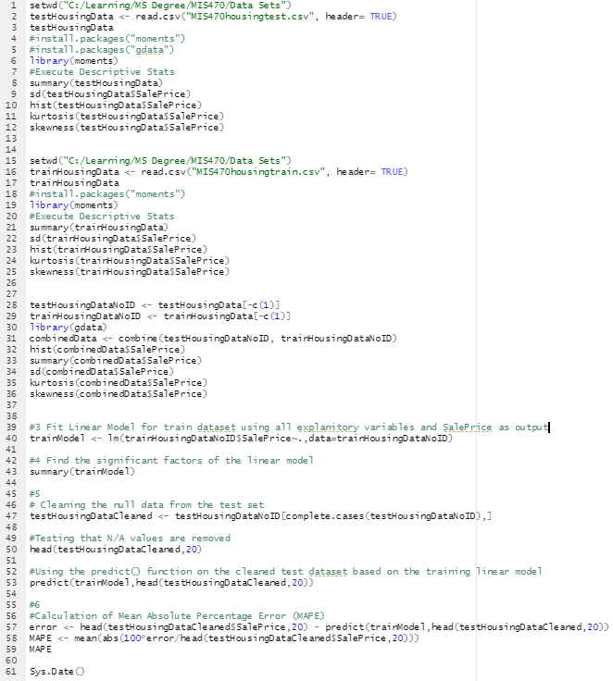

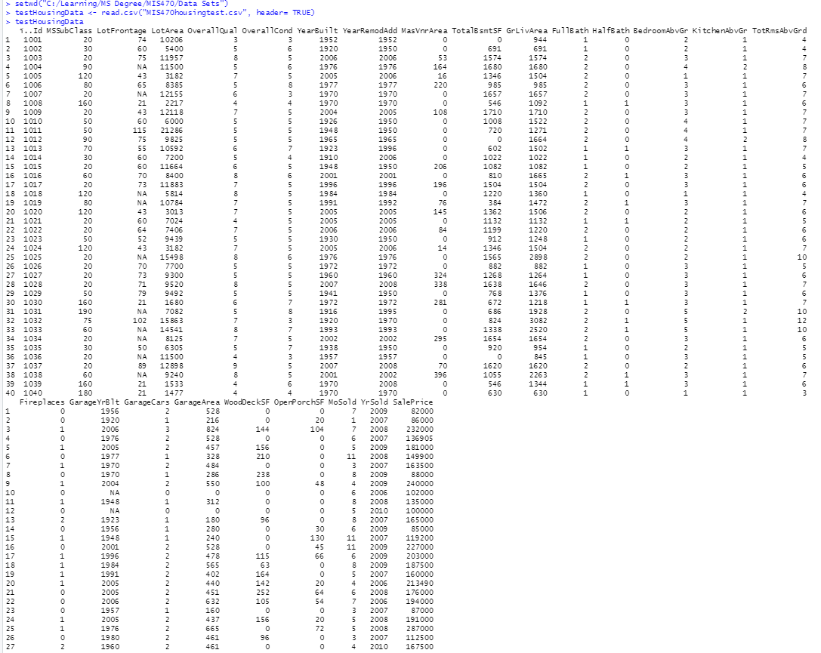
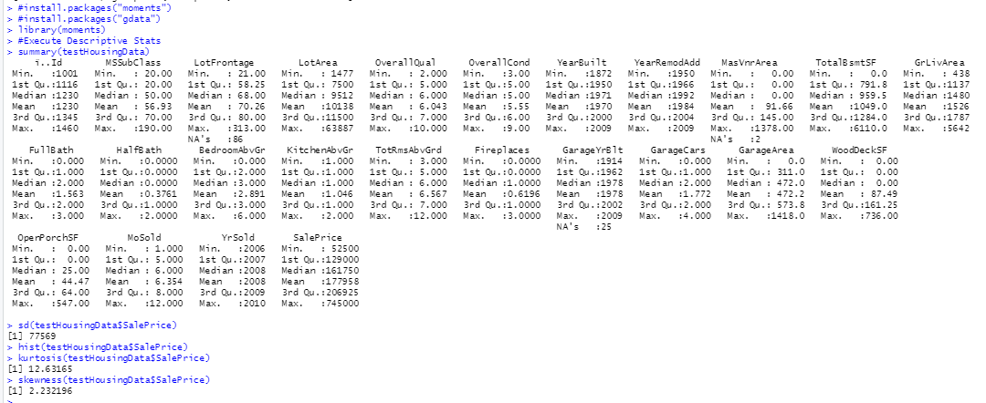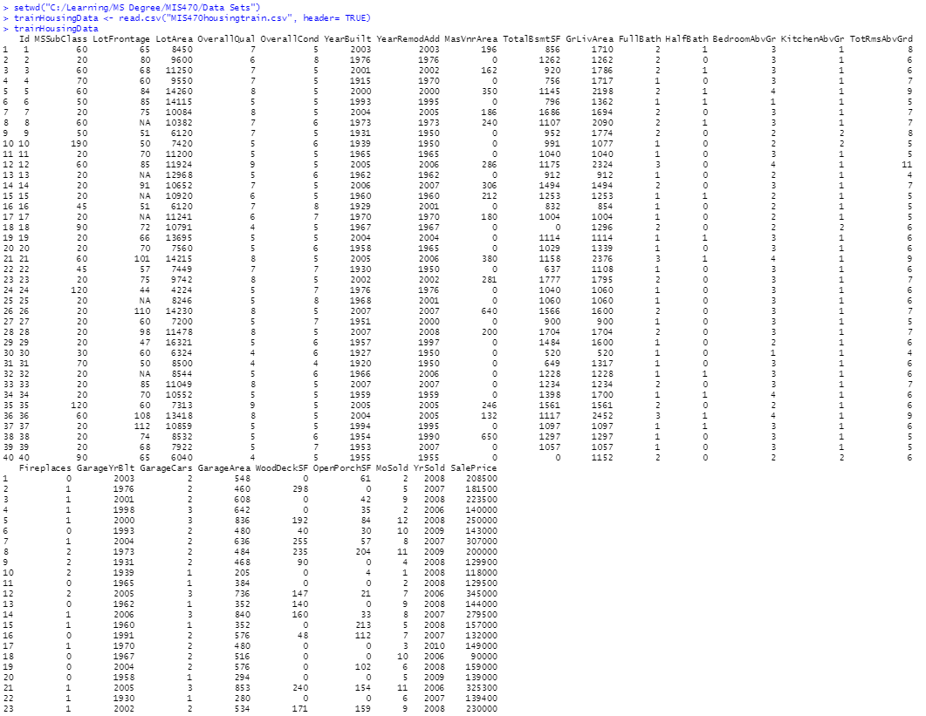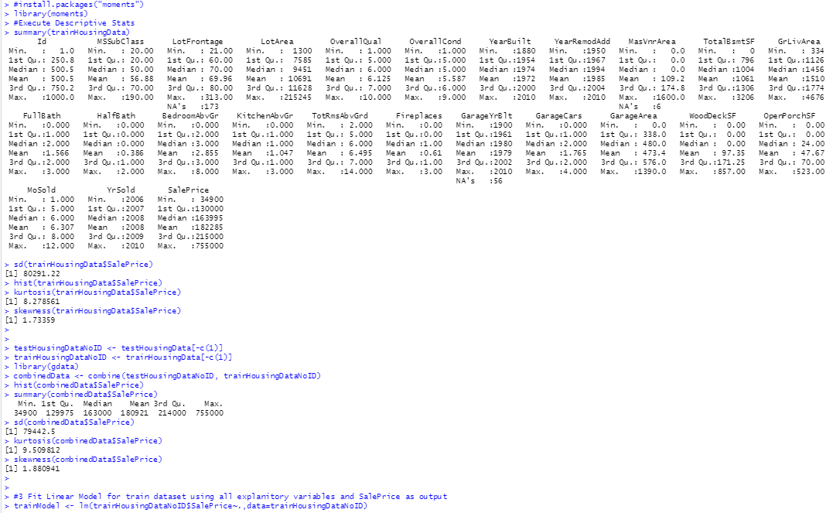
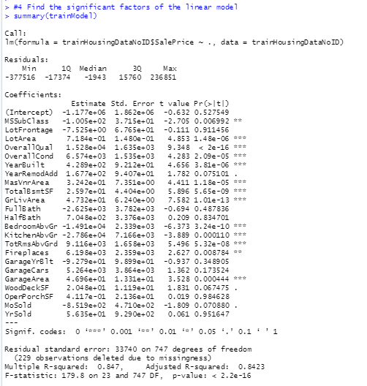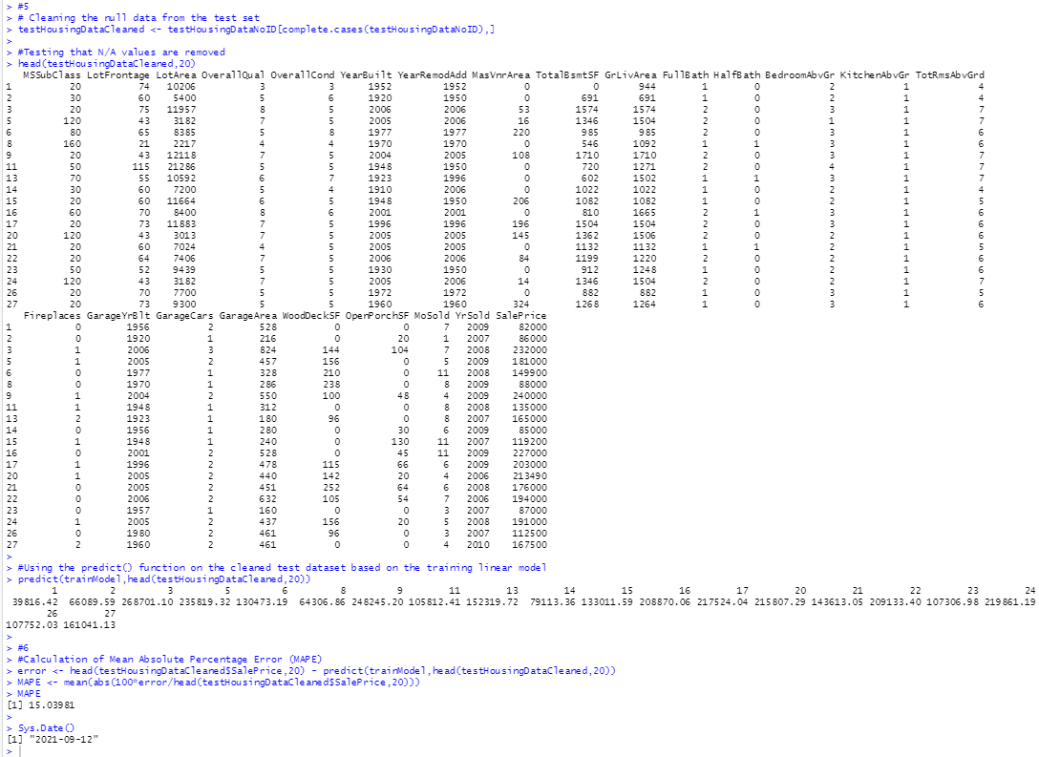
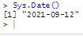
References
Brown, A. (2021). Portfolio Milestone – Option 1 [Unpublished manuscript]. Colorado State University – Global.
Calculate Kurtosis in R. (n.d.). ProgrammingR. https://www.programmingr.com/statistics/kurtosis/
Calculate Skewness in R. (n.d.). ProgrammingR. https://www.programmingr.com/statistics/skewness/
Khair, U., Fahmi, H., Al Hakim, S., Rahim, R. (2017). Forecasting Error Calculation with Mean Absolute Deviation and Mean Absolute Percentage Error. Journal of Physics: Conference Series, 1-7. doi :10.1088/1742-6596/930/1/012002
Swanson, D., Tayman, J., Bryan, T. (2011). Mape-R: A Rescaled Measure Of Accuracy For Cross-Sectional, Subnational Forecasts*. 1-36. https://paa2011.princeton.edu/papers/110062

