Portfolio Milestone – Option 1

Austin Brown
Colorado State University
MIS470: Data Science Foundations
Dr. Alin Tomoiaga
8/15/2021

For this assignment we took the supplied data for housing to analyze the descriptive statistics and histogram for sales prices within the dataset. The following items were my results:
Note: The csv link on the Portfolio Milestone Canvas page links to a housing testing csv as opposed to the housing training csv suggested by the labels given on the provided template as well as assignment text. I used the data set that was provided by the link, not the one suggested by the text that could be find within the Kaggle link.
Descriptive Statistics
Mean = $177,958: On average, a house sells for $177,958.
Median = $161,750: Half the results in the array of sales price data are less than or equal to $161,750 and half are greater than or equal to $161,750.
Standard Deviation = $77,569: On average, the sale of a house deviates $77,569 from the mean value.
Minimum = $52,500: The minimum sale of a house was $52,500.
First Quartile = $129,000: 25% of house sale prices are less than or equal to $129,000.
Third Quartile = $206,925: 75% of house sale prices are greater than or equal to $206,925.
Maximum = $745,000: The maximum sale of a house was $745,000.
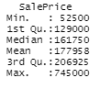
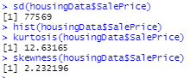

Graphical Analysis
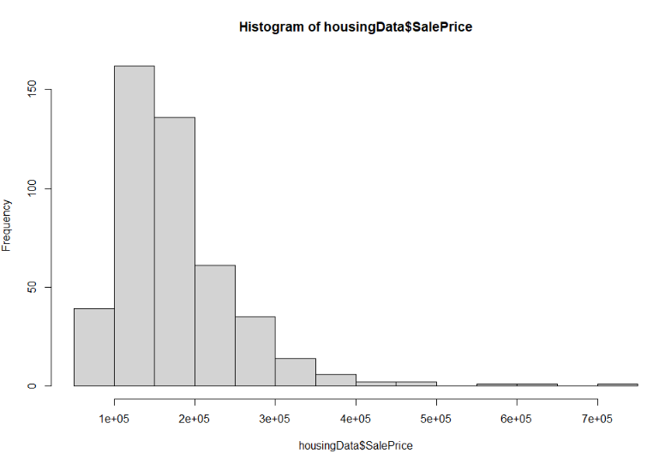
The output of housing sale price histogram reflects a positively, or right, skewed (median < mean or when skewness > 0) leptokurtic (kurtosis > 0) distribution of the sample data. This data is not normally distributed as the values are distributed asymmetrically around the mean, are positively skewed (2.2321 > 0) and display positive kurtosis (12.6317 > 0).
The skewness displayed is positive, where the distribution is "biased towards higher values, such that mean of the distribution will exceed the median" (Calculate Skewness in R, 2021, Para. 2). As far as kurtosis goes, we can observe a leptokurtic, or fat-tailed distribution, where “extreme outcomes are more common than would be predicted by a standard normal distribution (Calculate Kurtosis in R, 2021, Para. 3). You can see this represented in the data and histogram by looking at the high frequency/concentration of observed sale prices at the median value relative to the rest of the distribution (i.e. the center of the distribution is tall).

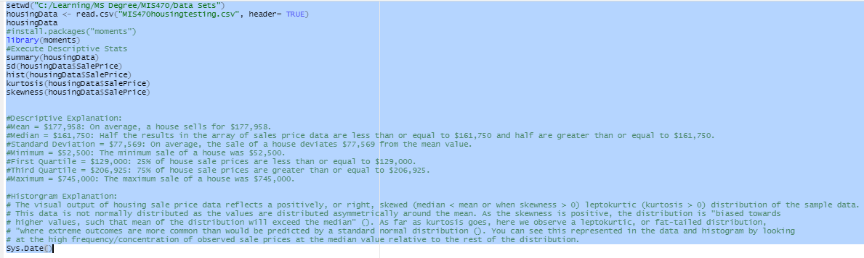
R Inputs / Outputs

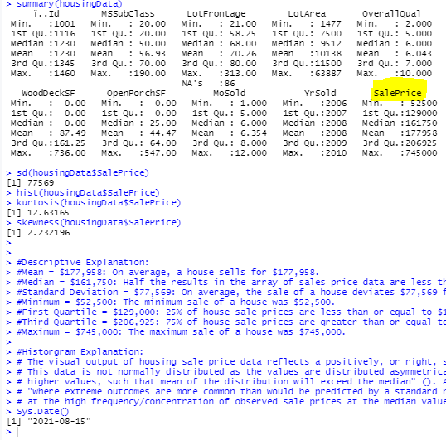

References

Calculate Kurtosis in R. (n.d.). ProgrammingR. https://www.programmingr.com/statistics/kurtosis/
Calculate Skewness in R. (n.d.). ProgrammingR. https://www.programmingr.com/statistics/skewness/

