**Hunchlab Mission Accuracy Map**

When I interned at Azavea, I built a script to assess the accuracy of Hunchlab’s generated police missions and produce a map like the one below. The gray boxes represent a Hunchlab mission, the green dots represent crimes that have been ‘captured’ by a mission, and yellow to red dots are uncaptured crimes colored in by distance to the closest mission. The below map was generated by running my script on Philadelphia’s patrol mission from Feb 11 to Feb 2 2018. The interactive html file is also available in the Drive folder.

**Figure 1: Assessing Hunchlab Patrol Accuracy in Philly**

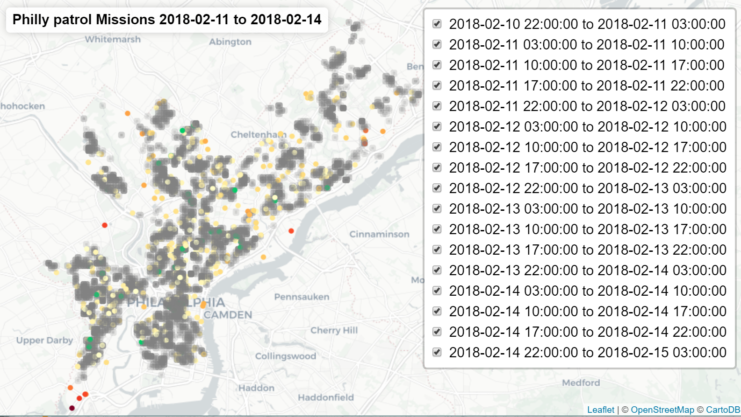 **Source:** Data provided from Hunchlab repository by Jeremy Heffner and pulled by Kenny Shepard in Feb 2018

**Notes:** Built with leaflet.js