test-options

# Heading 1

Cities First Paragraph

One Body text

## Heading 2

### Heading 3

1. Introduction
2. Current State of Affairs
3. Literature review
   1. VGI and Crowdsourcing
   2. Digital Divide and E-government
   3. 311 data
   4. Geostatistics
   5. Underreporting
   6. Useful Existing Tools
4. Future Directions
   1. Proposed Summer project
   2. Extensions
      * Adding aggregation to blockgroups
      * Predictive Models
      * Clustering algorithms

|  |  |  |
| --- | --- | --- |
| Variable | Mean | SD |
| Dependent variable |  |  |
| Median household value | 66287.73 | 60006.08 |
| Predictor |  |  |
| # Individuals living in poverty | 189.7709 | 164.3185 |
| % Bachelors degree or more | 16.08137 | 17.76956 |
| % Of vacant houses | 11.28853 | 9.628472 |
| % Of single house units | 9.226473 | 13.24925 |
| Median household income | 31541.76 | 16298.43 |

Cunningham, Christopher R. 2006–1AD. “House Price Uncertainty, Timing of Development, and Vacant Land Prices: Evidence for Real Options in Seattle.” *Journal of Urban Economics.* 59 (1). New York, Academic Press: 31.

Cunningham, Christopher R. 2006–1AD. “House Price Uncertainty, Timing of Development, and Vacant Land Prices: Evidence for Real Options in Seattle.” Journal of Urban Economics. 59 (1). New York, Academic Press: 31.

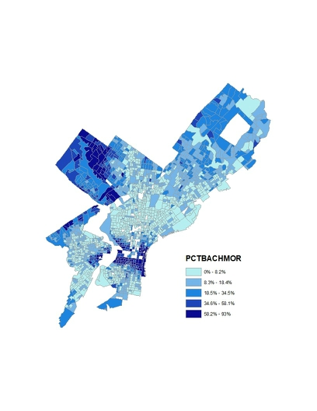

##### Heading 5