PENETRATION TESTING REPORT
FOOTPRINTING & NETWORK SCANNING PHASES
W2-PM-FINAL | CYBERSECURITY | NETWORKWALKS

Pentester Name  (Cybersecurity Professional) | Azhar Mansuri
Program/Batch | B082-Networkwalks
Date | 13 November 2026
Modules completed | W2-PM1 (Multiple Kali Tools & theHarvester)  W2-PM5 (Zenmap Scanning)
Client/Target | 1. Networkwalks (secured written permission already)  2. My own local LAN network  3. microsoft.com (passive OSINT with theHarvester only, public sources)
Permission secured from client? | Yes (Networkwalks and my own network). theHarvester queries were passive only.
Phases covered | Phase 1: Reconnaissance & Footprinting  Phase 2: Scanning & Network Discovery  Phase 3-5: In Progress

1. Liability Disclaimer
I have performed these activities only on the systems & devices where I had secured written permission or the devices/systems that I own myself. All these materials are for education and research purpose only. Do not use anything from here to break the law. The instructor, the authors and Networkwalks are not responsible for what you do with this knowledge. Every action you take is your own responsibility. Misuse can lead to criminal charges, heavy fines, loss of your job and a permanent record. In most countries unauthorised access is a crime even when nothing is damaged.

2. Introduction
This report covers footprinting the networkwalks.com domain using six Kali Linux tools and theHarvester (W2-PM1), and scanning my own local network with Zenmap, the graphical front end of Nmap (W2-PM5). One module covers the footprinting phase and the other covers the scanning phase, so together they show how an attacker moves from gathering public information to mapping live hosts on a network. It is the Week 2 part of my ongoing internship program at Networkwalks.
All commands were run in Kali Linux virtual machines (footprinting and OSINT) and on a Windows PC with Zenmap installed (scanning). Every step below includes the exact command used, the result I observed, and a screenshot as evidence in Section 8, with a short note on why the finding matters from an attacker's point of view.

3. Tools Used
The table below lists each tool used in this report and its purpose.
Tool | Purpose
Kali Linux & Windows | Operating systems used for reconnaissance and scanning activities
WHOIS | Find domain registration details (registrar, dates, name servers).
whatweb | Fingerprint web technologies (server, CMS, plugins, IP).
nslookup | Resolve the domain name to its IP address using DNS.
curl -I | Read the HTTP response headers of the website.
wafw00f | Detect whether a Web Application Firewall protects the site.
dnsrecon | Enumerate DNS records (SOA, NS, MX, A, TXT, SRV).
theHarvester | Collect public OSINT data (emails, hosts, IPs) from open sources.
Zenmap (Nmap GUI) | Scan the local subnet to find live hosts, IPs and MAC addresses.
Windows CMD (ipconfig) | Local IP address, subnet mask and gateway identification

4. Activities Performed

4.1 Footprinting & Reconnaissance

I performed reconnaissance against the networkwalks.com domain using six Kali Linux tools: WHOIS, WhatWeb, Nslookup, Curl, Wafw00f and DNSRecon. Each tool was used to collect a different type of information about the target.
First, I ran whois networkwalks.com to obtain public domain registration information. The domain is registered through GoDaddy.com, LLC. It was created on 6 November 2019, last updated on 12 November 2025 and expires on 6 November 2027. The name servers are NS6135.HOSTGATOR.COM and NS6136.HOSTGATOR.COM, which shows the site is hosted with HostGator. The domain has four client lock statuses (delete, renew, transfer and update prohibited) and DNSSEC is unsigned.
I then ran whatweb networkwalks.com to identify the technologies used by the website. The HTTP address returned a 301 redirect to HTTPS, and the HTTPS site returned 200 OK. WhatWeb identified Apache as the web server, WordPress 7.1.4 with WP Download Manager 3.3.76, jQuery 3.7.1 and Bootstrap. It also exposed the server IP 192.232.216.135 (United States), the contact email info@networkwalks.com, the page title Networkwalks Academy and a __wpdm_client cookie with the HttpOnly flag.
Using nslookup networkwalks.com (DNS server 8.8.8.8), I resolved the domain name to its IP address. The non-authoritative answer returned 192.232.216.135, which matches the IP address shown by WhatWeb.
I used curl -I https://networkwalks.com to inspect the HTTP response headers. The server replied HTTP/1.1 200 OK and identified itself as Apache. The Link header exposed the WordPress REST API endpoint /wp-json/, and headers such as X-nginx-cache: WordPress and X-Endurance-Cache-Level revealed caching details. The __wpdm_client cookie was set with the Secure and HttpOnly flags. I did not see Strict-Transport-Security, X-Frame-Options or Content-Security-Policy headers in this response.
Next, I ran wafw00f networkwalks.com (WAFW00F v2.4.2) to determine whether a Web Application Firewall was protecting the website. After 2 requests, the result identified ModSecurity (SpiderLabs).
Finally, I ran dnsrecon -d networkwalks.com to enumerate DNS records. The results showed the SOA and NS records (ns6135.hostgator.com at 50.87.144.87 and ns6136.hostgator.com at 192.232.216.131), both running BIND 9.16.23-RH; an MX record (mail.networkwalks.com at 192.232.216.135); an A record (192.232.216.135); two TXT records, including the SPF policy v=spf1 +a +mx +ip4:50.87.144.87 +include:websitewelcome.com ~all and a Google site-verification record; and eight SRV records for cPanel email autodiscovery on port 443. DNSRecon also reported an error because there was no answer to its DNSSEC query.

4.2 OSINT with theHarvester
I used theHarvester 4.11.1 to collect publicly available information (emails, hosts, IP addresses and names) about a domain from open sources. I used microsoft.com as a well-known public domain for this demonstration. The queries were passive: theHarvester only asked search engines and public data sources and did not scan or connect to the target's own servers.
In the first run I used theHarvester -d microsoft.com -l 1000 -b baidu, which searches the Baidu search engine with a limit of 1000 results. It finished with no IPs, no emails, no people and no hosts found.
In the second run I used theHarvester -d microsoft.com -l 50 -b all to query every supported source. Many sources failed with Missing API key messages (for example BeVigil, Bitbucket, BuiltWith, Brave Search, Censys, CriminalIP and Dehashed) because no API keys were configured in /etc/theHarvester/api-keys.yaml. This showed me that theHarvester returns limited results unless API keys are added for the sources that require them.

4.3 Network Scanning with Zenmap
For the final activity, I used Zenmap (the graphical interface of Nmap 7.991) to perform network discovery on my local network. The practical required me to identify my local IP address and subnet, discover live hosts, identify their IP and MAC addresses, and generate a network topology.
I first used the Windows ipconfig command. My active Wi-Fi adapter has the IPv4 address 10.225.224.134, subnet mask 255.255.255.0 and default gateway 10.225.224.18, so my local subnet is 10.225.224.0/24. The VMware adapters (VMnet1 192.168.47.1 and VMnet8 192.168.120.1) are virtual networks and were not scanned.
I entered 10.225.224.0/24 as the target in Zenmap and selected the Ping scan profile, which runs nmap -sn 10.225.224.0/24. The scan started on 13 November 2026 and checked 256 IP addresses in 9.46 seconds. It found 3 live hosts:
- 10.225.224.18 (default gateway), MAC address 9E:BD:11:26:74:1D
- 10.225.224.195 (another device on the network), MAC address 8E:25:7C:5C:92:A6
- 10.225.224.134 (my own Windows PC), EC-3A-56-33-0D-CA

Nmap could not match either MAC address to a manufacturer (shown as "Unknown"). Both addresses are locally administered, which usually means the devices use private (randomized) MAC addresses, as many modern phones do.
After completing the scan, I opened the Topology tab in Zenmap, enabled the legend and saved the network topology in PDF format (PM 1.pdf in the W2_Task_Networkwalks folder) as required by the practical task. Both screenshots are included in Section 8.

5. Risk Analysis / Impact
Based on the information collected during the footprinting and network scanning activities, I identified the following potential risks.
# | Risk / Finding | Evidence / Observation | Potential Impact | Risk Level
1 | Web technology information exposed | WhatWeb identified WordPress 7.1.4 and WP Download Manager 3.3.76 | Attackers may use exposed technology/version information to identify software requiring further security review | ● Medium
2 | Server IP address identifiable | Nslookup resolved the domain to 192.232.216.135 | Provides information about the network location of the web service | ● Low
3 | HTTP technical information exposed | Curl showed the Apache server, /wp-json/ REST API link and cache headers; no HSTS, X-Frame-Options or CSP header seen | May assist technology fingerprinting and further enumeration | ● Low
4 | WAF technology identifiable | Wafw00f identified ModSecurity (SpiderLabs) | Reveals information about the web application's security architecture | ● Low
5 | DNS infrastructure information exposed | DNSRecon listed NS, MX, SPF and SRV records, and BIND 9.16.23-RH on both name servers | DNS information can help build a broader infrastructure profile; software versions help targeted research | ● Medium
6 | DNSSEC not enabled | WHOIS showed DNSSEC "unsigned"; DNSRecon got no answer to its DNSSEC query | DNS answers cannot be cryptographically verified, which makes DNS spoofing easier in theory | ● Low
7 | Multiple live hosts visible on local network | Zenmap found 3 live hosts (2 MAC addresses) on 10.225.224.0/24 | Unknown or unauthorized devices may be present on a network | ● Low

Risk level key: ● Critical ● Medium ● Low
The risks above are observations from the footprinting and scanning exercises, not confirmed vulnerabilities.
The practical exercises primarily involved information gathering and host discovery. No exploitation or vulnerability validation was performed as part of this work.
Therefore, the presence of information such as a software version, IP address or DNS record does not by itself mean that the system is vulnerable. Further authorized security testing would be required to confirm any actual vulnerability.

6. Recommendations
Based on the observations from these activities, I recommend the following security improvements:
- Review publicly exposed technology information
Organizations should regularly review what information about their web technologies, CMS and plugins is publicly visible.
- Keep software updated
CMS platforms, plugins and other web technologies should be regularly updated and reviewed against current security advisories.
- Review HTTP headers
HTTP response headers should be reviewed to remove unnecessary technical information (server details, REST API links, cache headers) and to add security headers such as HSTS, X-Frame-Options and Content-Security-Policy where suitable.
- Review DNS records regularly
DNS records should be checked periodically to ensure that only required information and services are publicly exposed, and software version banners (for example BIND) should be hidden.
- Enable DNSSEC and review email authentication
Enable DNSSEC for the domain and consider tightening the SPF policy (currently ~all, soft fail) once all legitimate mail senders are listed.
- Properly configure and monitor the WAF
Keep the WAF (ModSecurity) enabled and tuned, since it already blocks naive attacks.
- Limit what OSINT tools can find
Review which emails, hosts and subdomains are publicly discoverable (for example with theHarvester) and remove anything that is not needed.
- Perform regular internal network discovery
Organizations should periodically scan their own networks to identify active devices.
- Investigate unknown devices
Any unexpected device discovered during network scanning should be investigated and verified.
- Maintain network documentation
Network topology and device information should be documented and updated regularly.
- Perform security testing with authorization
Reconnaissance and scanning should only be performed against systems and networks where appropriate authorization has been provided.

7. Conclusion
During Week 2 of my Cybersecurity & Ethical Hacking internship, I completed practical activities covering footprinting, reconnaissance, OSINT collection and network scanning.
In the footprinting activity, I used six Kali Linux tools to collect information about networkwalks.com. I learned how WHOIS can provide domain registration details, WhatWeb can identify web technologies, Nslookup can resolve domain names, Curl can inspect HTTP headers, Wafw00f can identify a WAF, and DNSRecon can enumerate DNS records. I also used theHarvester for passive OSINT and learned that many of its sources need API keys before they return results.
In the network scanning activity, I used Zenmap to identify my local network configuration (10.225.224.0/24), discovered three live hosts, collected their IP and MAC address information and saved a network topology.
The exercises showed me that information gathering is an important part of cybersecurity. Even before attempting to exploit a system, a security professional can learn a significant amount about an environment by carefully analyzing publicly available information and network responses.
I also learned that technical findings should be documented clearly. A good cybersecurity report should explain what was performed, what was discovered, what the observation means, what risk it may create, and what can be done to reduce that risk.
Finally, I learned that reconnaissance and scanning must always be performed within an authorized scope. These activities were completed as part of the assigned educational cybersecurity lab.

8. Evidences Collected

Figure 1: WHOIS lookup of networkwalks.com (whois networkwalks.com)
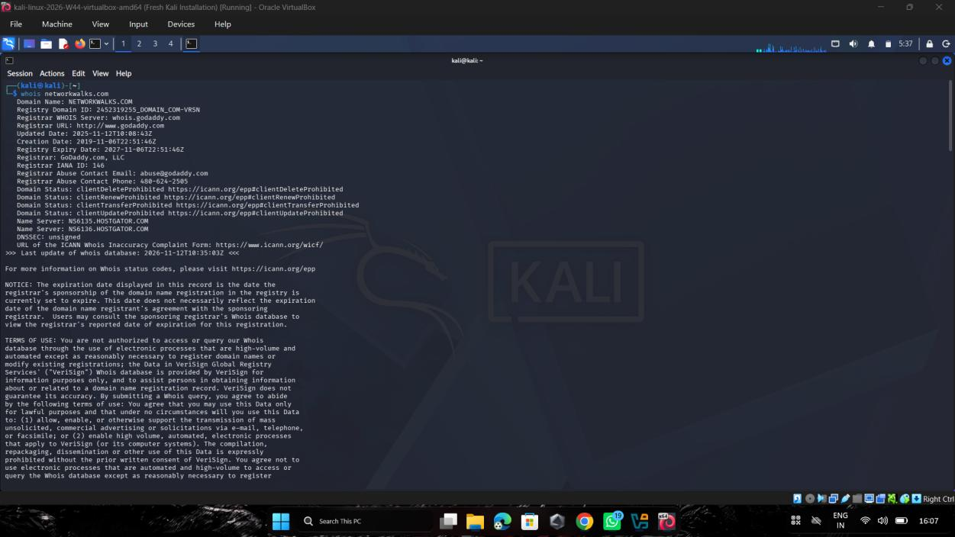
Figure 2: WhatWeb technology fingerprint (whatweb networkwalks.com)
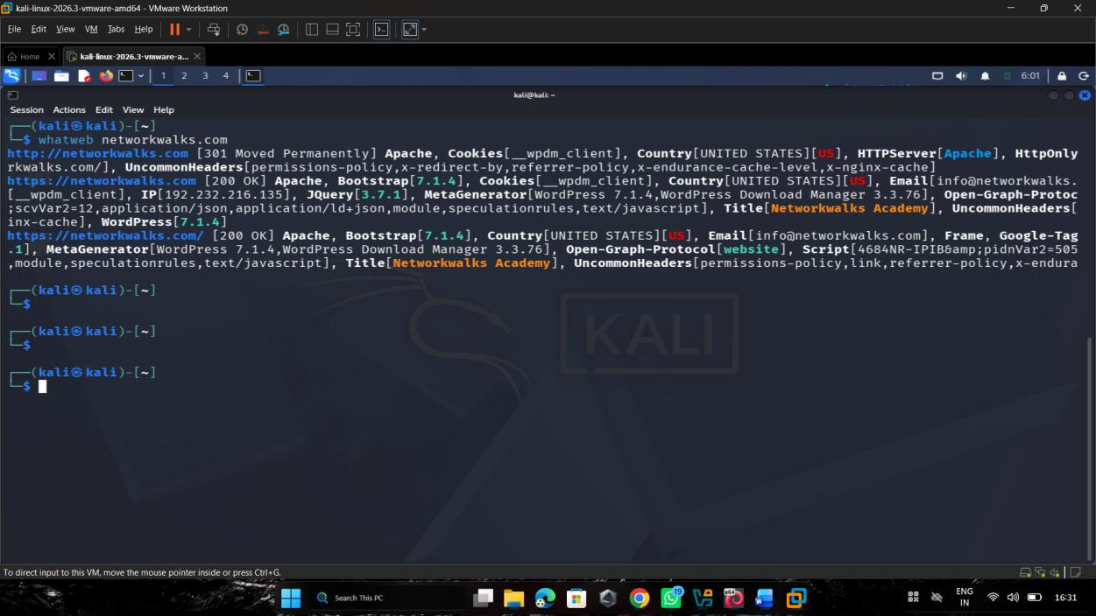
Figure 3: Nslookup IP resolution (nslookup networkwalks.com)
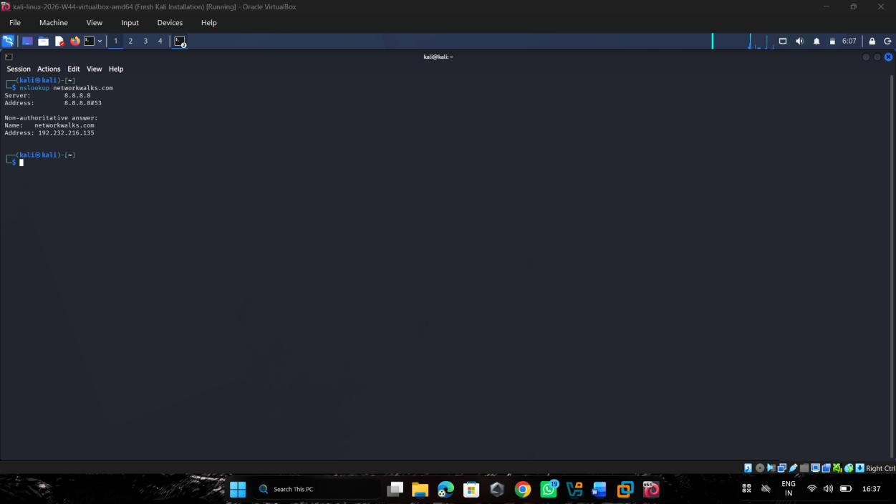
Figure 4: HTTP response headers (curl -I https://networkwalks.com)
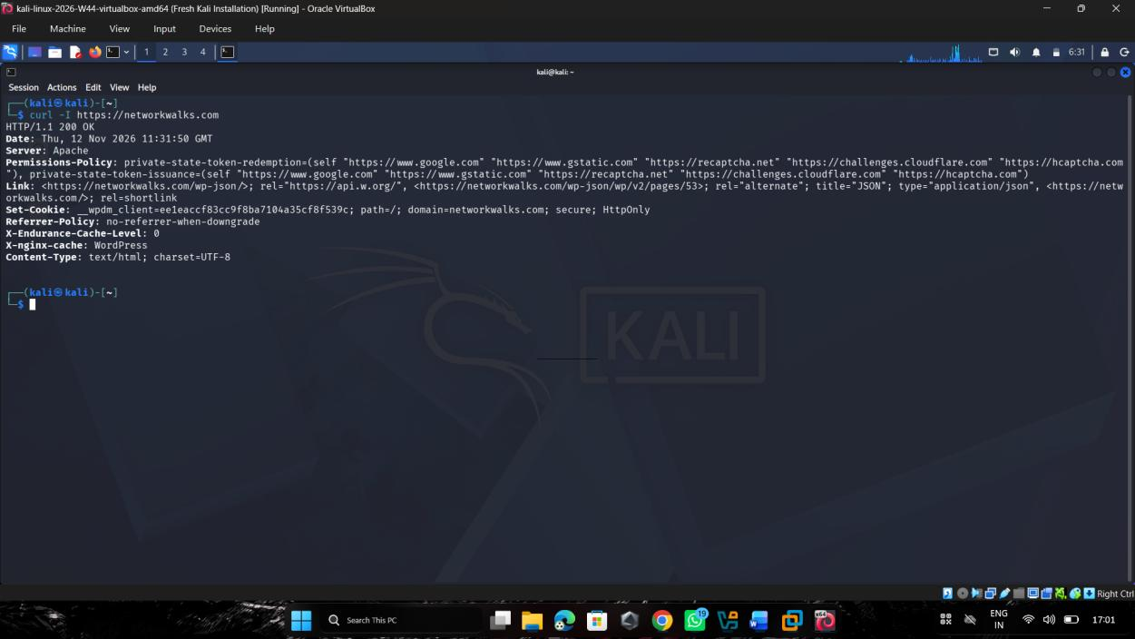
Figure 5: Wafw00f WAF detection (wafw00f networkwalks.com)
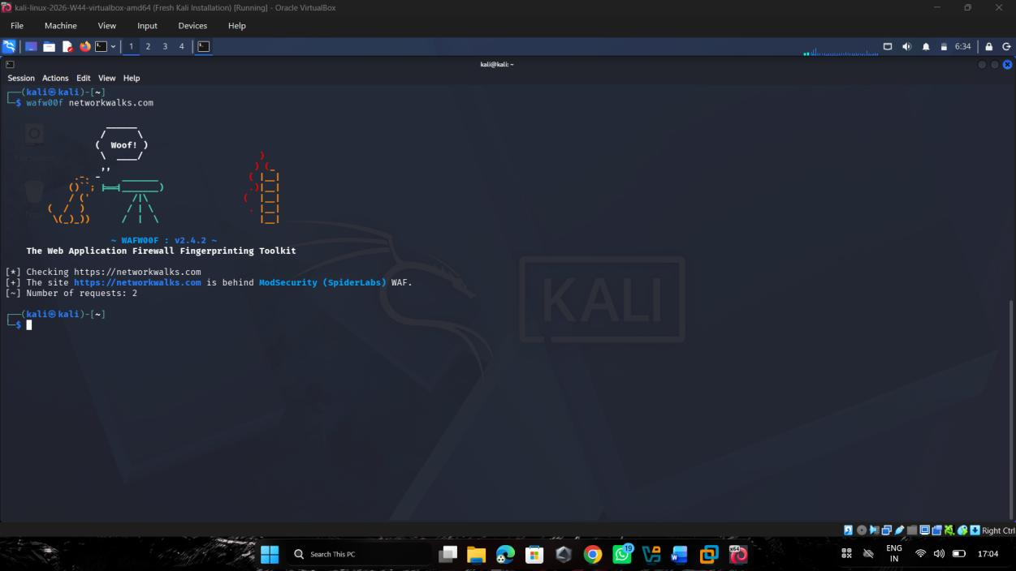
Figure 6: DNSRecon enumeration (dnsrecon -d networkwalks.com)
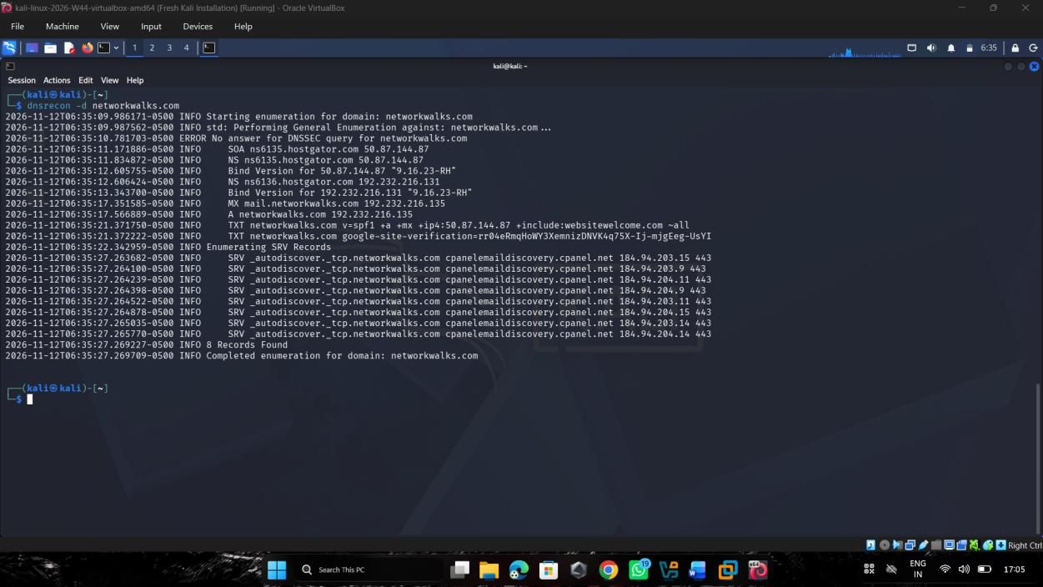
Figure 7: theHarvester run 1 (theHarvester -d microsoft.com -l 1000 -b baidu)
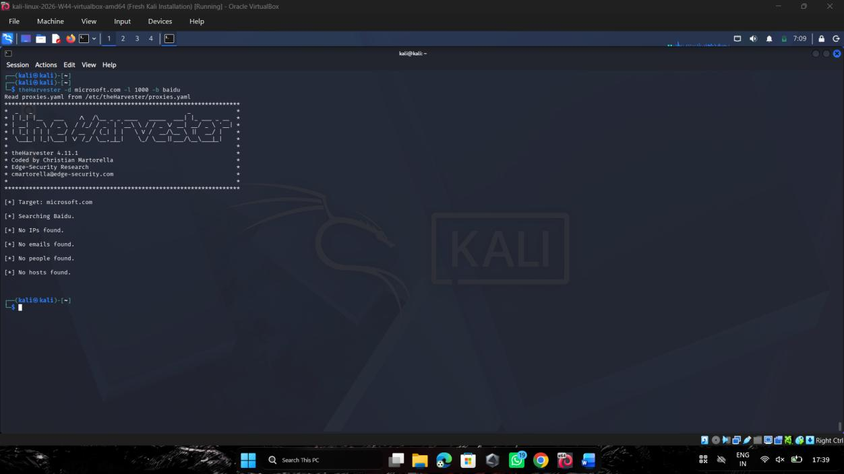
Figure 8: theHarvester run 2 (theHarvester -d microsoft.com -l 50 -b all)
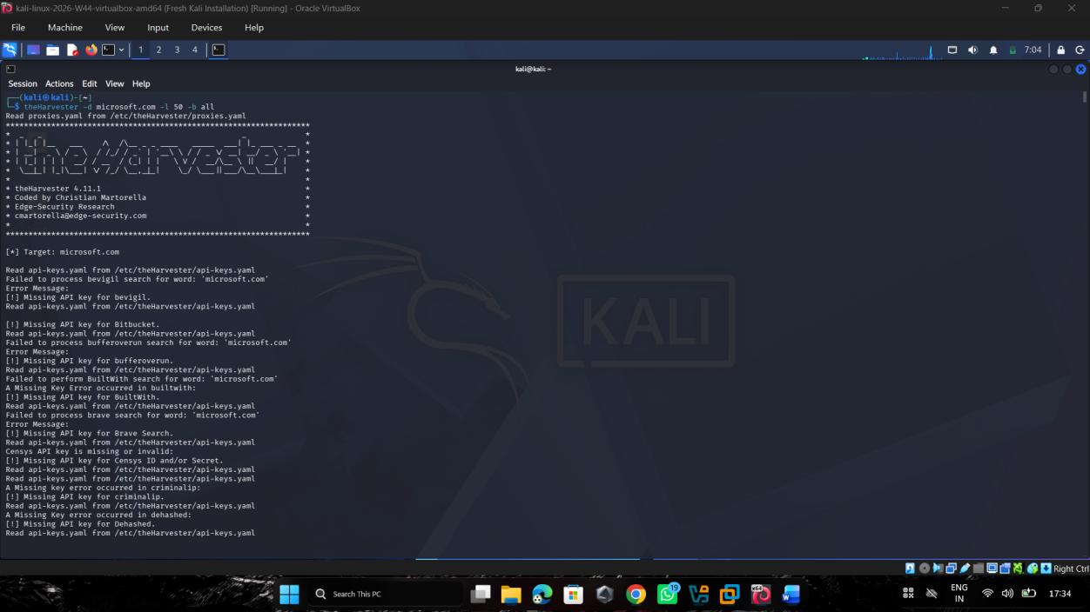
Figure 9: Local IP configuration (ipconfig)
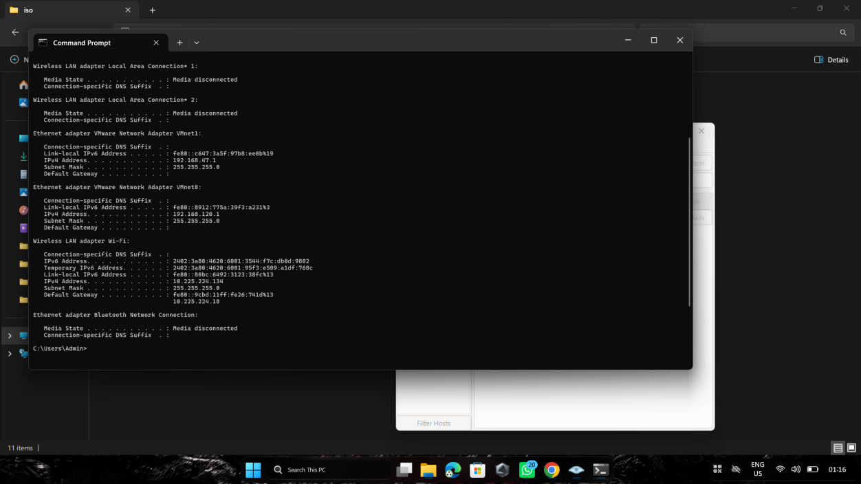
Figure 10: Zenmap Ping scan of 10.225.224.0/24 (nmap -sn 10.225.224.0/24)
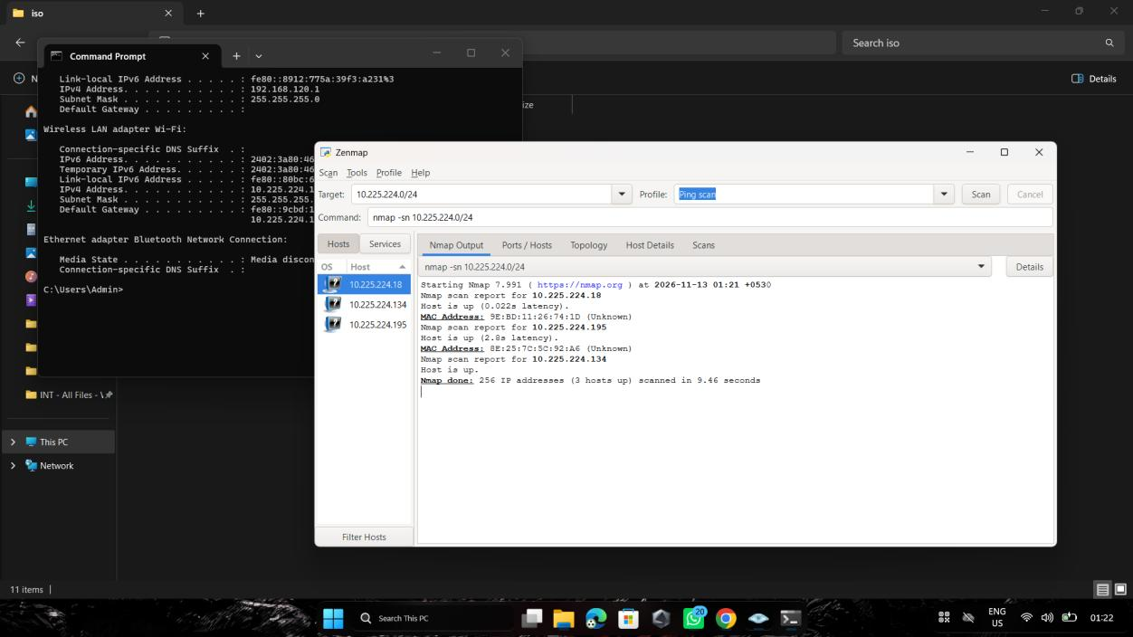
Figure 11: Network topology saved as PDF (PM 1.pdf)
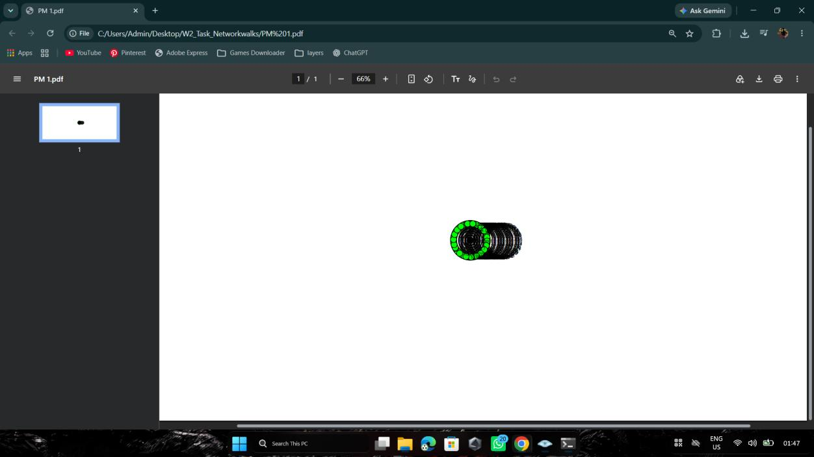
Figure 12: Zenmap Topology tab
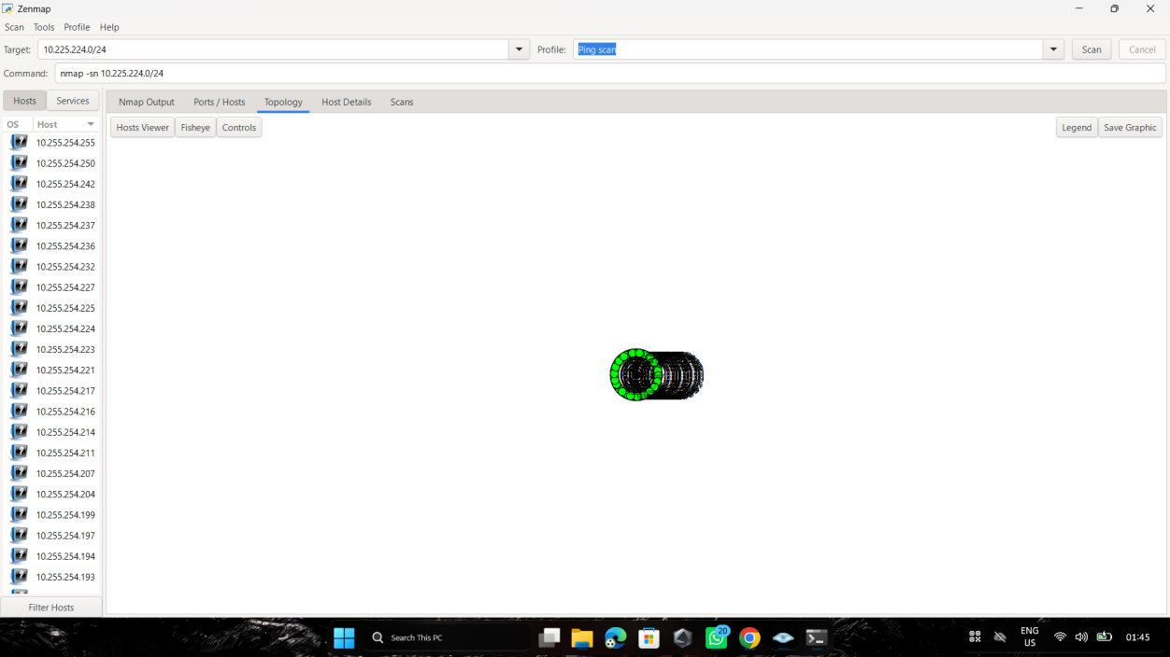
-End-

👤 Author
Azhar Mansuri
Cybersecurity Professional B082

📌 Project Information
Program Name: Cybersecurity program at Networkwalks | Week: 02 | Repository: GitHub

