Problem:
Launch 3 instance 1 master and 2 worker node (test and prod) Insall ansible in master and connect it to worker node
Write Yamal file such that is should install Jenkins,jave and docker in master node and docker and java in both worker
And deploy simple application on using Jenkins freestyle project , first on test node and if it is success then on prod

Solution
- Launch and configure 3 instances
- Install ansible in master node using command
- Create ssh key and connect to both the nodes by using commad
ansible all -m ping
- Write a yaml to install Jenkins ,java and docker on master and docker and java worker nodes
---
- hosts: localhost # use localhost to install packages where ansible is installed
become: yes
tasks:
- name: install java
script: jenkins.sh
- name: instal docker
command: sudo apt install docker.io -y

- hosts: test
become: yes
tasks:
- name: install docker
command: sudo apt install docker.io -y
- name: install java
command: sudo apt install openjdk-17-jre -y
- hosts: prod
become: yes
tasks:
- name: install docker
command: sudo apt install docker.io -y
- name: install java
command: sudo apt install openjdk-17-jre -y

run command
ansible-playbook main.yaml

- Check the worker node packages installed or not
- Copy the public Ip of master node browse publicIp:8080 for Jenkins
- Now on master node clone a git repo with a simple docker file
https://github.com/pnyn96/capstone-1.git
- After cloning it delete the repo
- Create a new public repo
- Create a new branch test
git branch test
git checkout test
git remote add origin <new git repo>
git push origin test ## push the code into test branch not the main branch

- Now open Jenkins
- Create node so that particular will job run the worker node if the push comes from the particular branch
manage Jenkinsnodecreate node
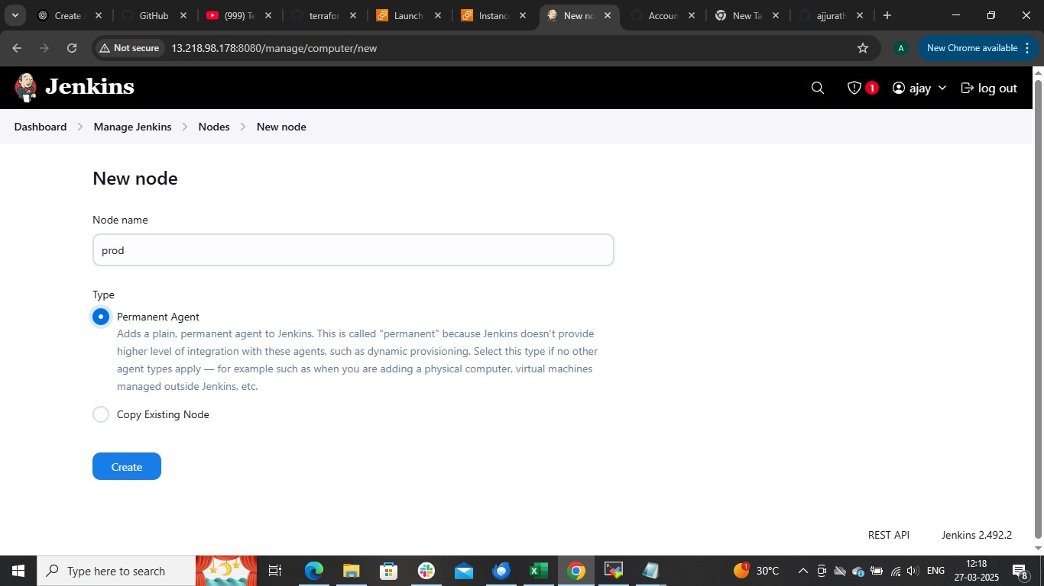

- In root directory mention /home/ubuntu/jenmkins ( it will create Jenkins home directory in slave node)
- 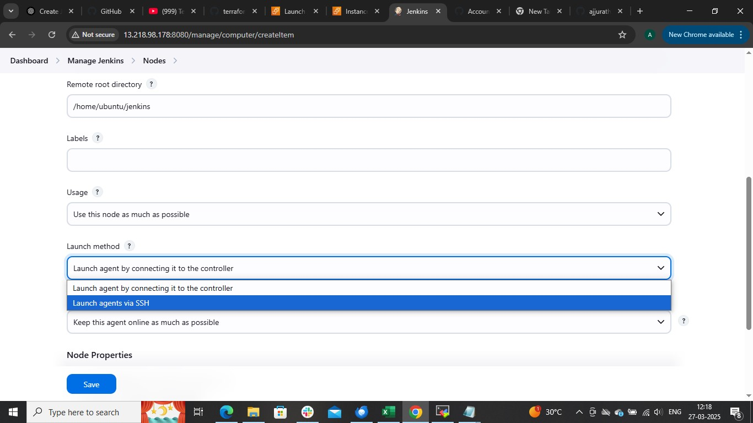
launch methodlaunch agent via ssh
host put private Ip of slave node add Jenkins crediantials
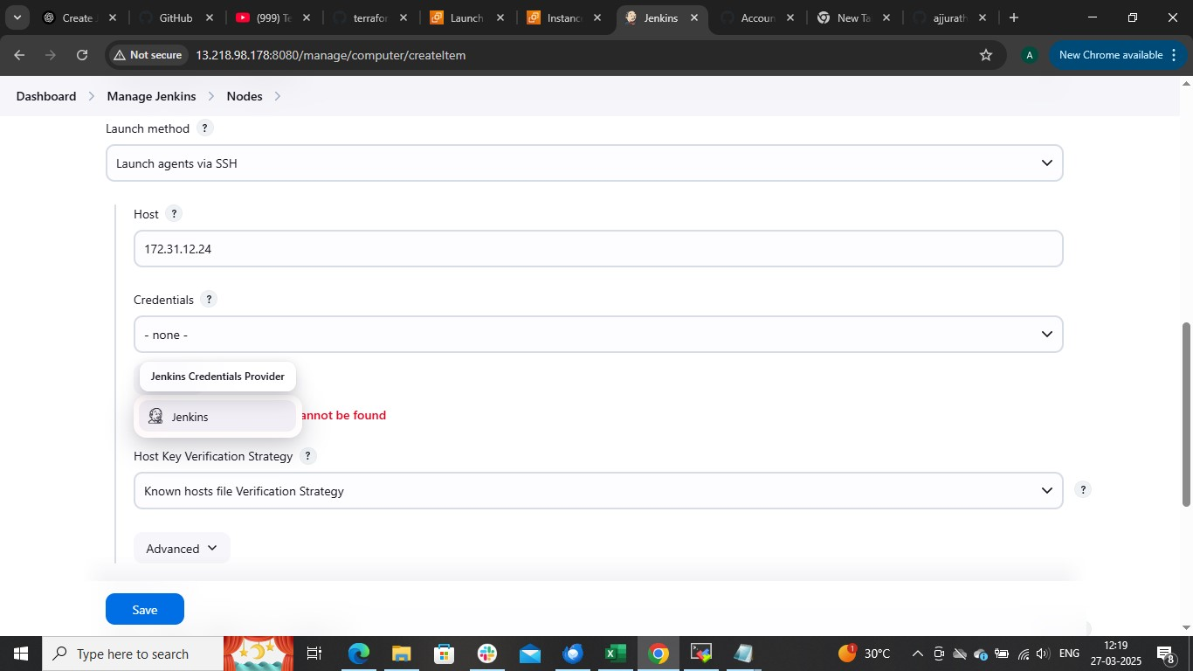

ssh username with private key
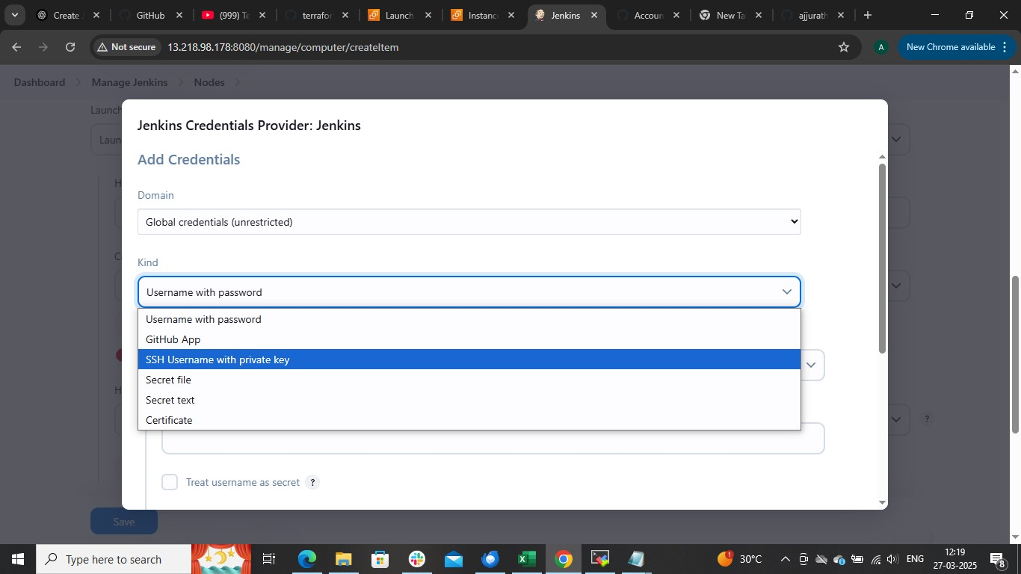

Put username as ubuntu
and copy .pem file key of that slave node and paste
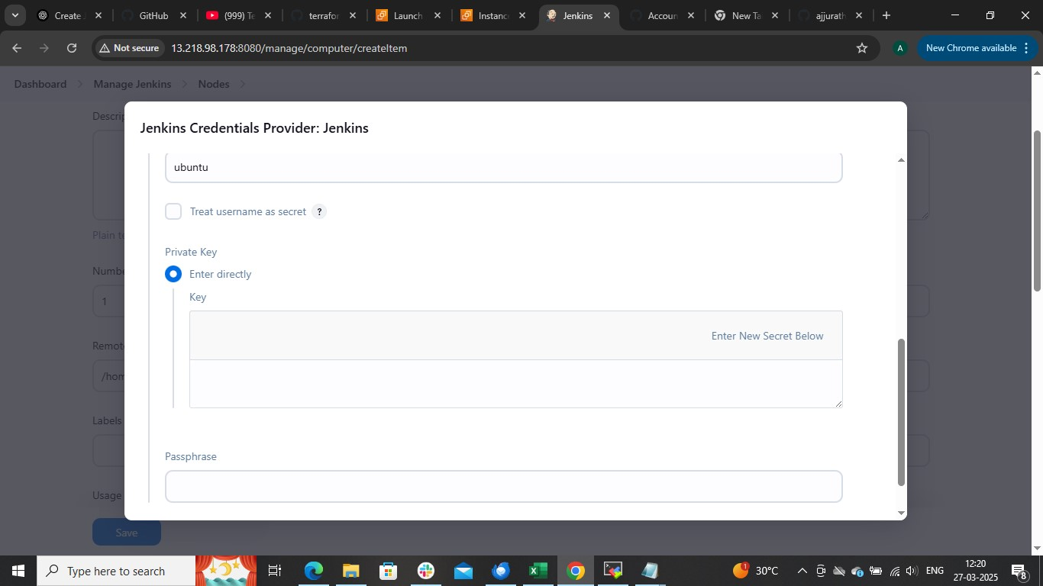
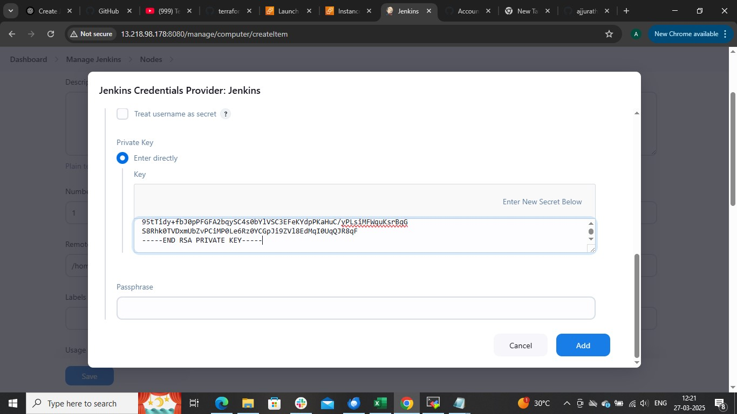

Choose that credentials
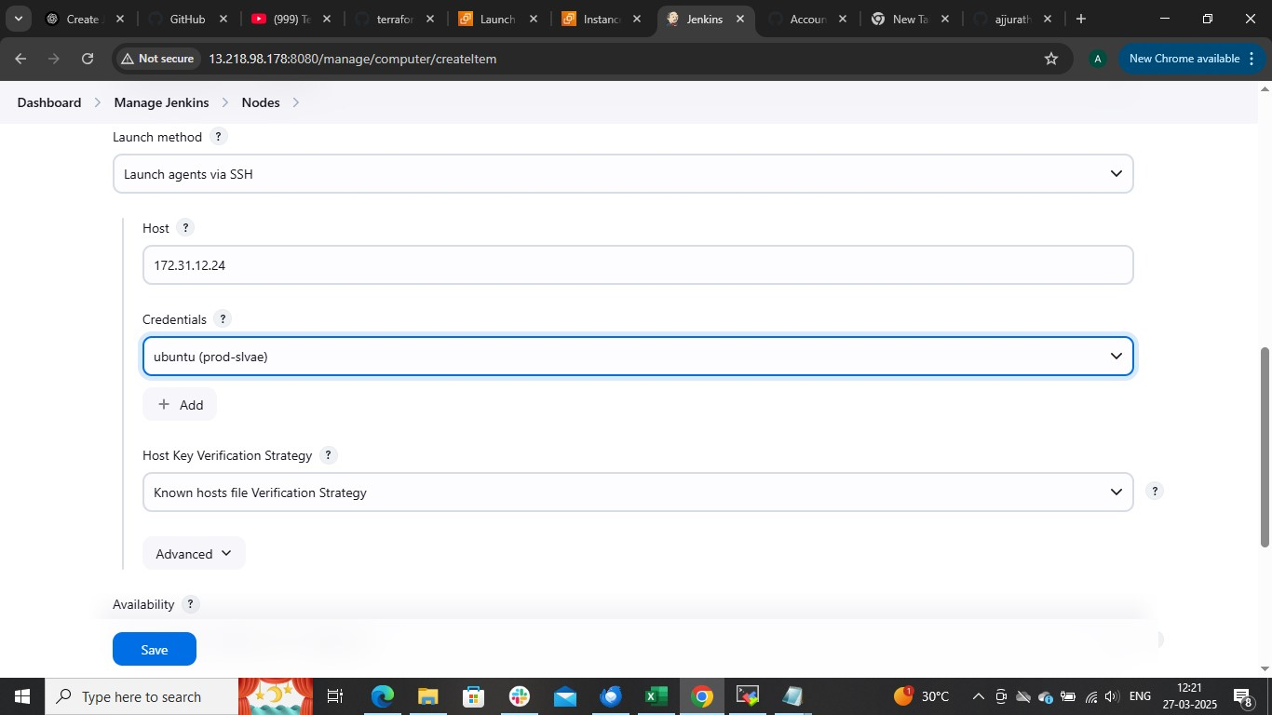

no verifying verification stratergy
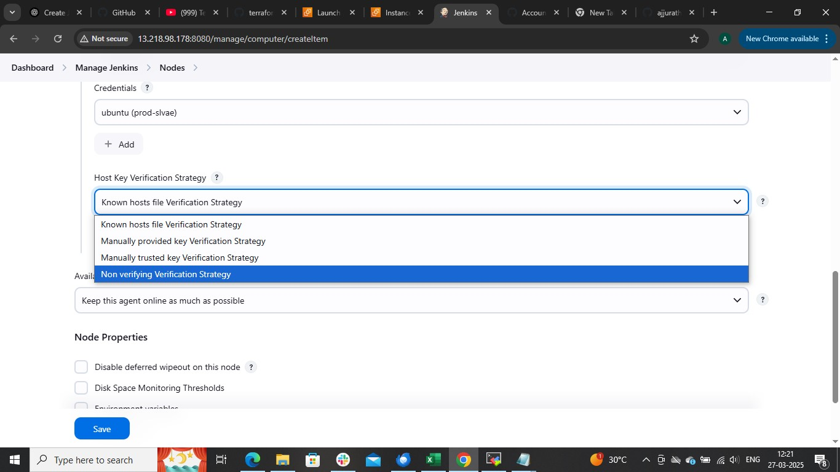

save that’s it you will get slave node ,create as many as slave nodes you want

After doing this create A freestyle job
restrict where this can be run ( test-slave) ==this will allows to run job only on test-slave
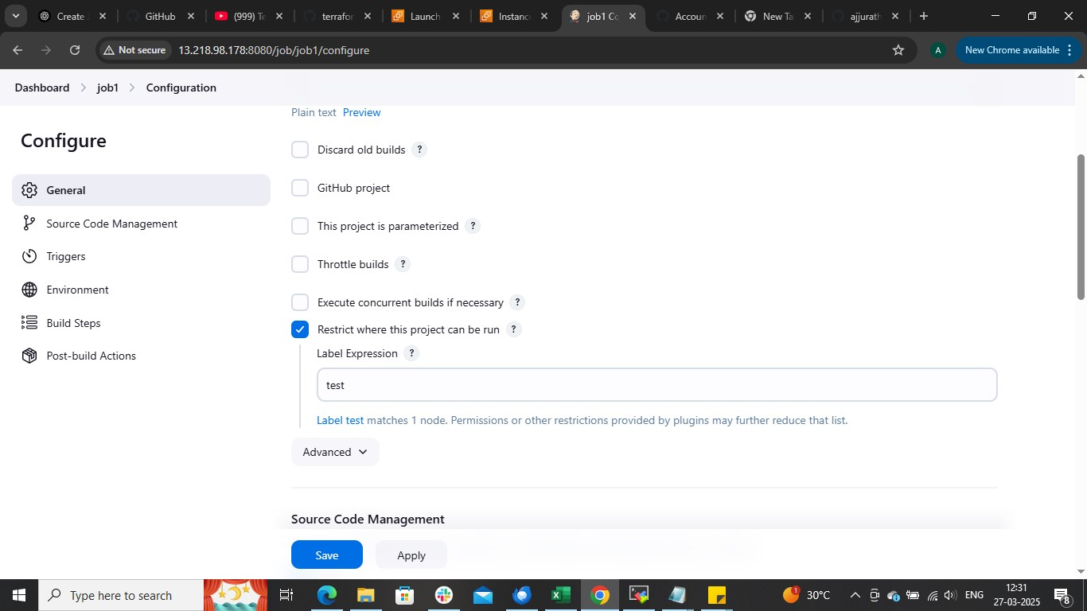
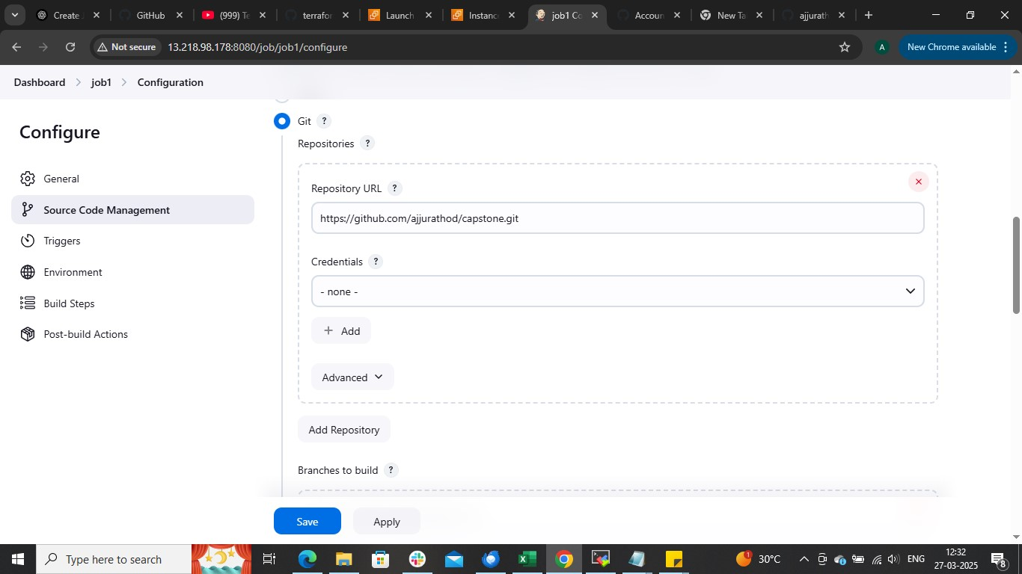

== hear mention the branch from to which we pushed code (for to run test node we should not push code from master branch use different branch to push the code like below this)
- After cloning it delete the repo
- Create a new public repo
- Create a new branch test
git branch test
git checkout test
git remote add origin <new git repo>
git push origin test ## push the code into test branch not the main branch

Hear I have develop branch from which I pushed my code
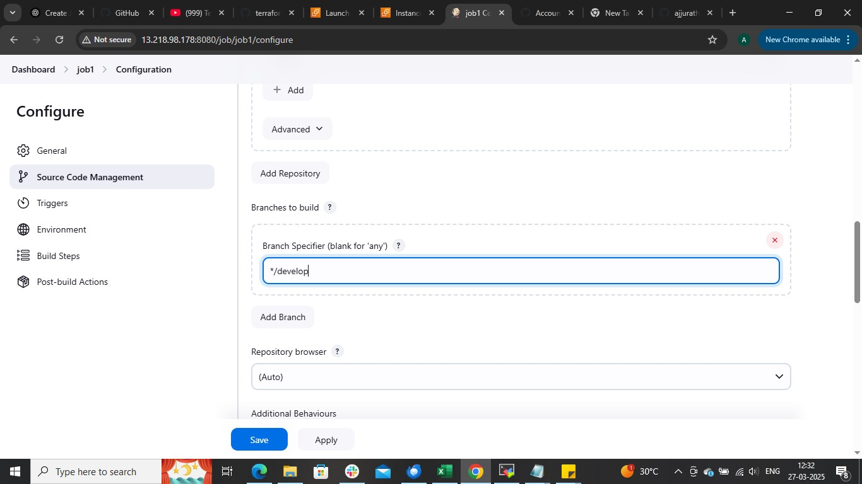

build step execute shell to build docker image and run container on the the slave node we configure
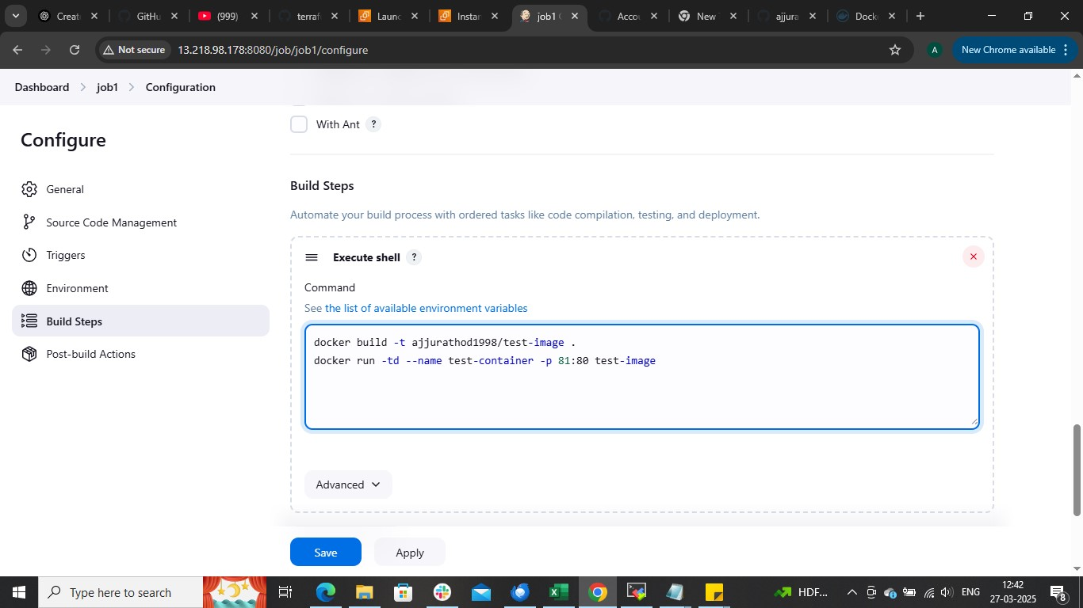

applysave

Now copy the public Ip of the working node along with container port browse it \

Publicip:81
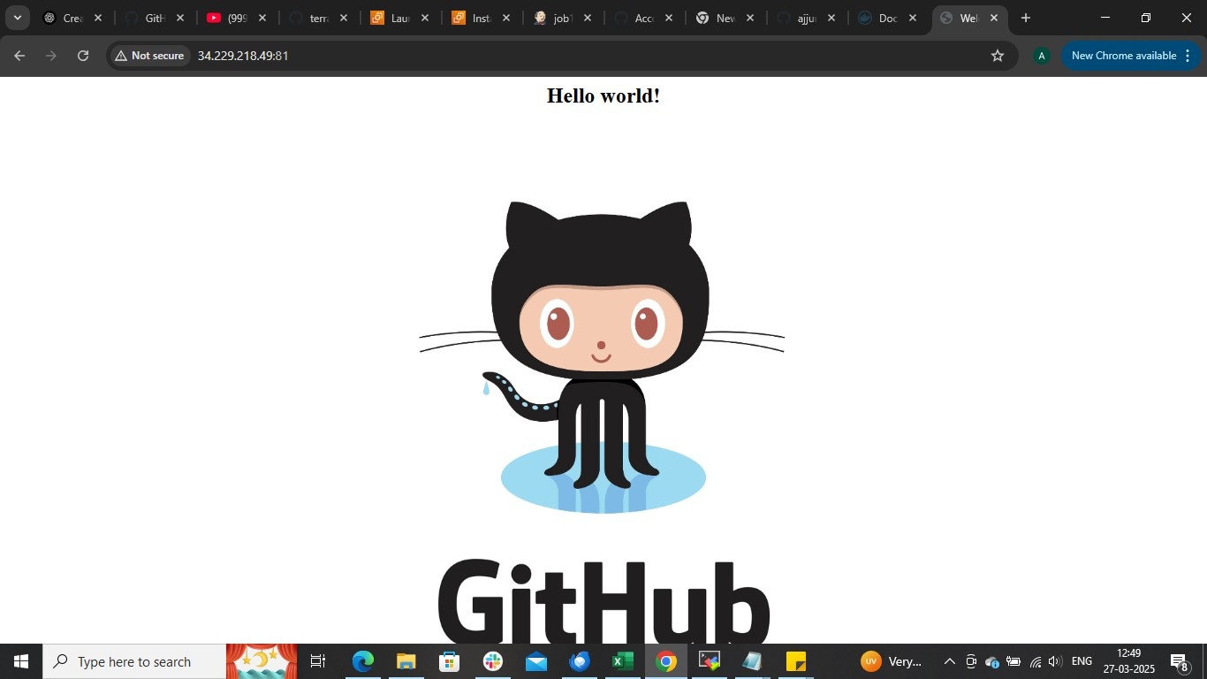

Now do same for prod server (hear we push code from main branch of git to mian branch of git repo beacuase we already did test our application on test-slave node )

