To create Runner in GitHub-action
Steps
- Create instance and allow ports 80,443 and 22
- Create a git repo

On gitrepo
settingactionrunnernew runnerliunx and copy the paste the given commands in instance
Makes sure to not use SUDO
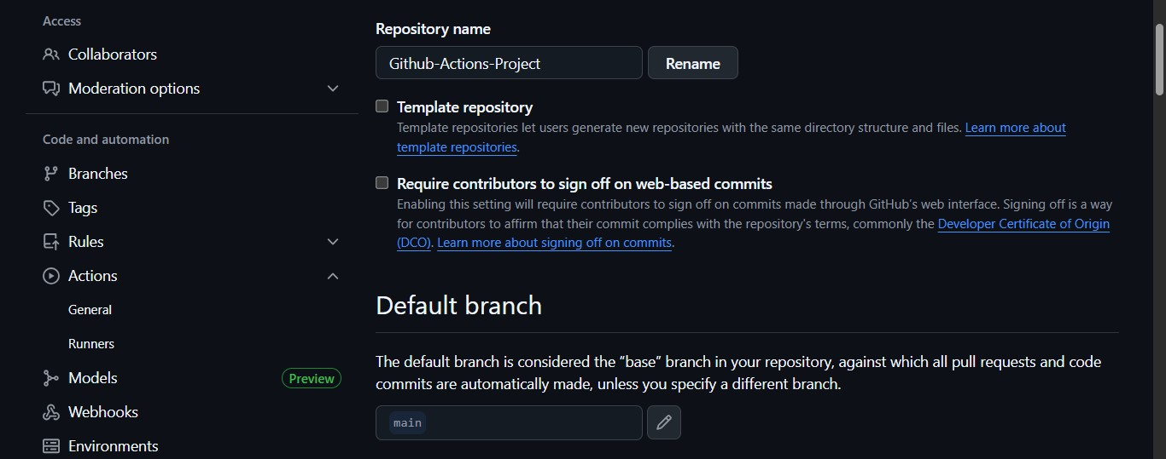

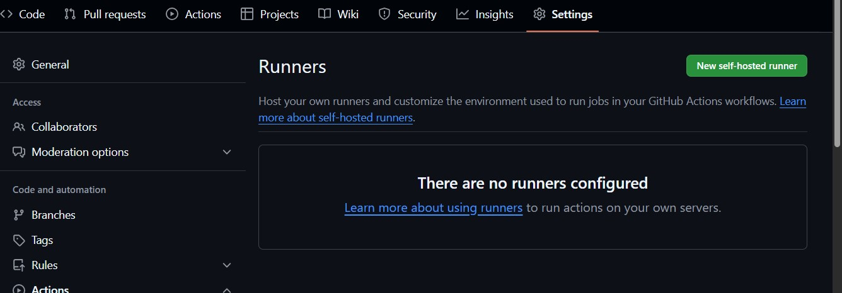

Ruuner group is default enter
Runner name runner 1
Label self-hosted
Work folder is defaultenter
