Revert back to the previous version of code
I have commited 2 commits and I want go back to 1st or previous commit
Previous version
Imagine you realized the mistake immediately and you haven't pushed to GitHub yet. You want to pretend that "Bad" commit never happened.
Create a file calc.sh
x= a+b

now add into stage
git add calc.sh # to add only one file

commit it
git commit calc.sh -m "my first commit"

to see the commit histroy
git log or git log --oneline

now open file calc.sh
x = a+b
y = A-b

add file
git add calc.sh

commit
git commit calc.sh -m "my second commit"

git log

u will get 2 commit histroy ID first and second

now u want previous one version ( first )

git reset --hard <first commit id>

and now open
cat calc.sh
x= a+b

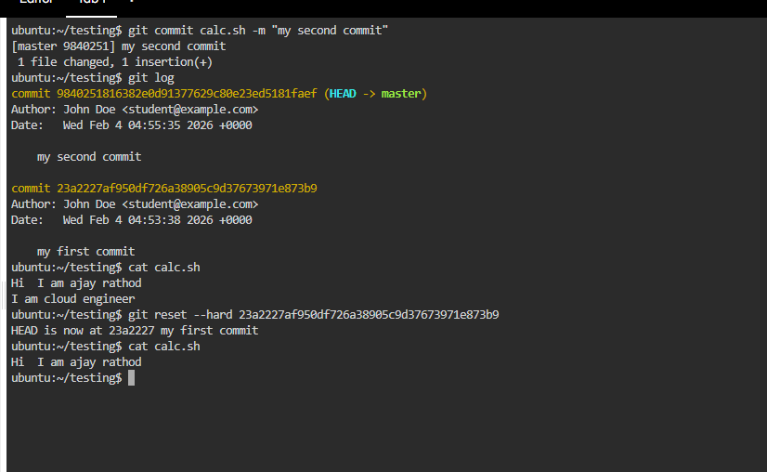

If we pushed the code to github then to revert back previous version and un-do the current commit we have do

git revert commit-id

You commited one file and you came to knew that u have commited wrong file , now you want to let know other that this is worng commit so that others will not use this

git revert <commit-id>

Now, run the revert. This does not delete the old commit; it creates a new commit one that deletes the file.
Files gets deleted
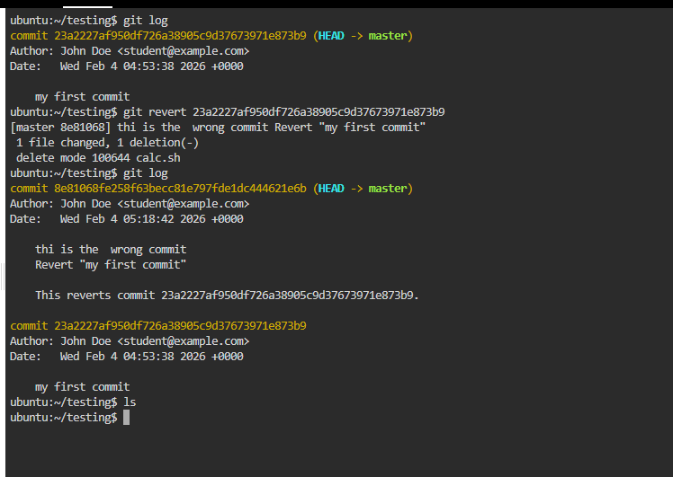

What exactly git init command do ??
When we run git init command , it will initialize the current working directory to local repository
And create a hidden .git folder which contains all the metadata that are required for git to keep the track of version, commits, branches and history

Key things inside .git:
- objects/ → stores all commits, files, and snapshots (compressed)
- refs/ → pointers to branches and tags( to track branched and tags)
- HEAD → points to the current branch (usually main or master)
Head tells where you are right now
- config → repository-specific Git configuration
- hooks/ → scripts triggered on Git events (pre-commit, post-commit, etc.)
prevents developers ( someone) to push secretes accidently into remote repo by running pre-commit scripts

ways to clone the git repo onto local repository
HTTPS and SSH
HTTPS is most commann and easier way to clone the repo where we need access_token to clone repo
where as SSH is most secure way where we need public-key to clone the repo
To generate public key
On ubuntu run the commad
ssh-keygen

enter,enter and u will get key generated in .ssh folder

cd .ssh

open the public key folder and copy the enter key

go to git repo settingssh and keygennew ssh key and paste the key add

now do git clone it will not ask for password

The Situation: You were trying to be fancy with commands and accidentally deleted a branch that had 2 days of work on it. You haven't pushed it to GitHub yet. It feels like the code is gone forever.

How to get back the deleted branch
Lets say you have created a feature (delete branch) from main branch and you work on the code from feature (delete branch) and added and commited the file but did not pushed to remote repo or merged the changes into main branch and you accendtily deleted the feature (delete branch)
how you will you restore the feature (delete branch)
Git: Git tracks every move you make, even on deleted branches.
Run command to see al the records of branch
git reflog

git reflog records every single time the HEAD (your current position) moves—whether you switched branches, committed, or even deleted something.

The Setup (Creating the Work)
First, we need to create some work and then "accidentally" destroy it.
- Create a new branch:
git checkout -b secret-feature

- Create a file with "valuable" code:
echo "This took me 10 hours to write" > work.txt

- Commit it:
git add work.txt git commit -m "Add very important work"

- Go back to main:
git checkout main

- The Disaster (Delete the branch):
git branch -D secret-feature

(The -D force-deletes it even though it wasn't merged. It's now "gone" from your branch list)
Now, your code is missing. If you type git branch, secret-feature is gone. Here is how we use the flight recorder.
1. Run the Reflog
Type:
git reflog

2. Identify the Commit
You will see a list that looks like this (newest at the top):
4a5b6c7 (HEAD -> main) HEAD@{0}: checkout: moving from secret-feature to main
a1b2c3d HEAD@{1}: commit: Add very important work

- The Hash: a1b2c3d (Your actual code ID).
- The Pointer: HEAD@{1} (Where you were one step ago).

Part 1: Finishing the Reflog Recovery
If you found your hash (e.g., a1b2c3d) in the reflog, here is how you bring the dead back to life:
The Command:
git checkout -b recovered-feature a1b2c3d

What this does: It tells Git, "Create a new branch called recovered-feature and start it exactly at the moment that commit a1b2c3d existed." Just like that, your "deleted" work is back.

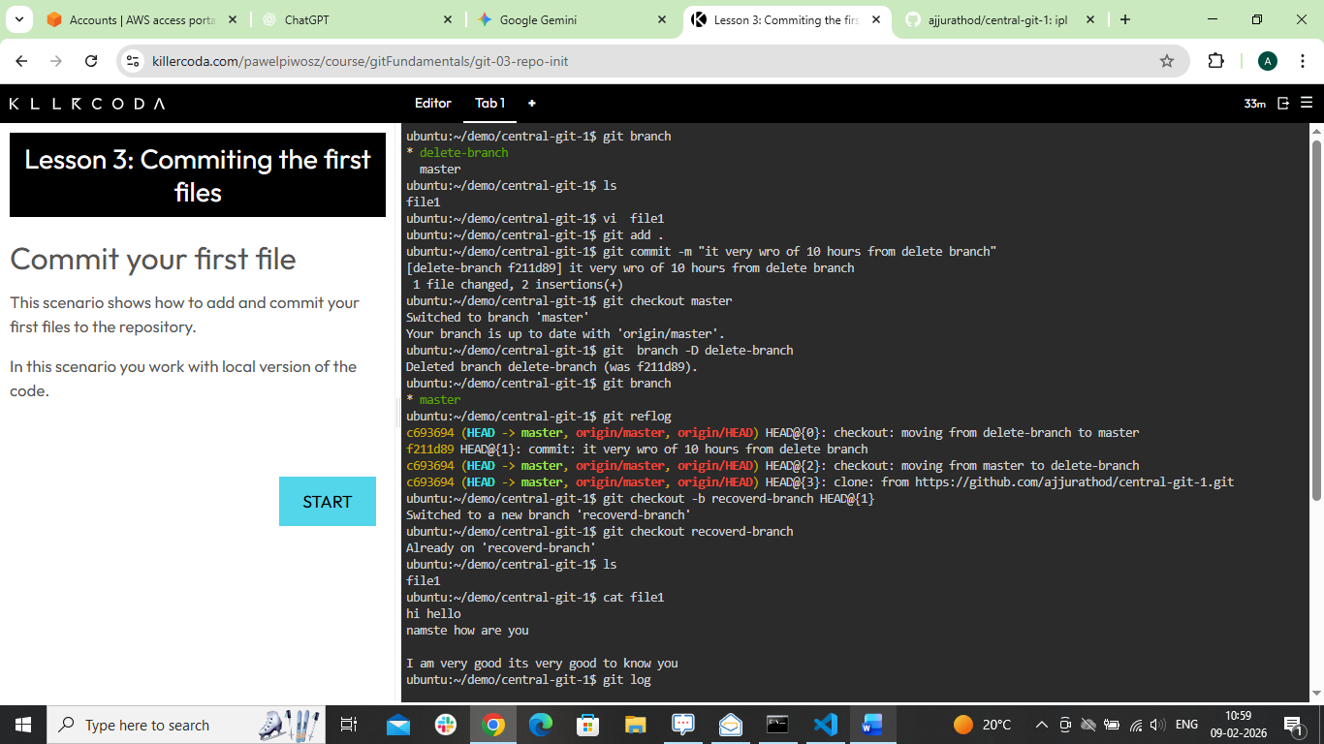

To recover the files
We added file into staging area ( not commited) and then mistakenly deleted that file from our local
how to recover that file
Run the command
git restore < deleted-file-name>

