KUBERNETES
TASK 1: EXPLORE K8s
- Kubernetes is an opensource container orchestration platform designed to automate the deployment, scaling and management of containerized applications.
Key features of Kubernetes:
- Automated deployment and scaling
- Load balancing and service discovery
- Self-healing
- Declarative configuration
- Automated rollouts and rollbacks
Master Node Components
- API Server: Exposes Kubernetes API
- Controller manager: Ensures the desired state of system by handling controllers
- Scheduler: Assigns workload to nodes based on resource availability
- Etcd: A distributed key value store to store the cluster wide secrets.
Worker Node Components
- Kubelet : Manager containers on a node.
- Kube-Proxy: Manages networking for a pod on a node.
- Container Runtime: Software that runs containers.

Objects:
- Pods: A small unit of Kubernetes which contains one or several containers inside.
- Services: Distributes the traffic among healthy pods.
- Deployment: It is used to create set of pods and also manages the rollout and rollback updates for the pods.
- Replica Sets: It will ensure that the stable set of pods are running in Kubernetes cluster.
TASK 2: Create a kubeadm cluster ( 1 master and 1 worker node).
STEP 1: Launch two t2.medium ubuntu based EC2 instance namely Master node and worker node and install kubernetes (on both nodes) by the following steps and commands.
##Update the system's package list and install necessary things:
- sudo apt-get update
- sudo apt install apt-transport-https curl -y

## Install containerd
- curl -fsSL https://download.docker.com/linux/ubuntu/gpg | sudo gpg --dearmor -o /etc/apt/keyrings/docker.gpg
- echo "deb [arch=$(dpkg --print-architecture) signed-by=/etc/apt/keyrings/docker.gpg] https://download.docker.com/linux/ubuntu $(lsb_release -cs) stable" | sudo tee /etc/apt/sources.list.d/docker.list > /dev/null
- sudo apt-get update
- sudo apt-get install containerd.io -y
## Create containerd configuration
- sudo mkdir -p /etc/containerd
- sudo containerd config default | sudo tee /etc/containerd/config.toml
- sudo sed -i -e 's/SystemdCgroup = false/SystemdCgroup = true/g' /etc/containerd/config.toml
- sudo systemctl restart containerd
## Install Kubernetes
- curl -fsSL https://pkgs.k8s.io/core:/stable:/v1.30/deb/Release.key | sudo gpg --dearmor -o /etc/apt/keyrings/kubernetes-apt-keyring.gpg
- echo 'deb [signed-by=/etc/apt/keyrings/kubernetes-apt-keyring.gpg] https://pkgs.k8s.io/core:/stable:/v1.30/deb/ /' | sudo tee /etc/apt/sources.list.d/kubernetes.list
- sudo apt-get update
- sudo apt-get install -y kubelet kubeadm kubectl
- sudo apt-mark hold kubelet kubeadm kubectl
- sudo systemctl enable --now kubelet

## Disable swap
- sudo swapoff -a
- sudo modprobe br_netfilter
- sudo sysctl -w net.ipv4.ip_forward=1
STEP 2: Execute the following steps only on Master Node.
- sudo kubeadm init --pod-network-cidr=10.244.0.0/16

- mkdir -p $HOME/.kube
- sudo cp -i /etc/kubernetes/admin.conf $HOME/.kube/config
- sudo chown $(id -u):$(id -g) $HOME/.kube/config
#Network plugin
- kubectl apply -f https://github.com/flannel-io/flannel/releases/latest/download/kube-flannel.yml
STEP 3: Execute the following steps only on Worker Node.
- sudo kubeadm reset pre-flight checks
- sudo su
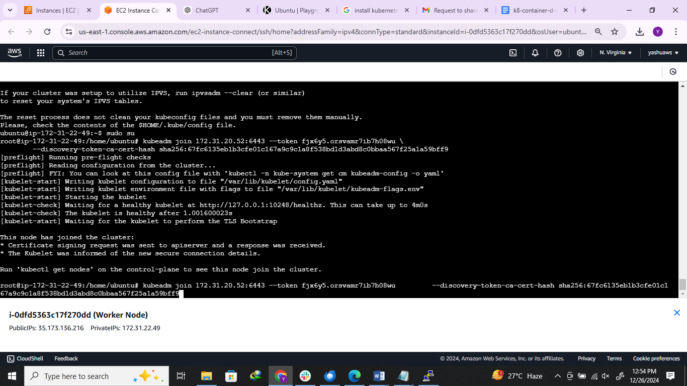

STEP 4: Verify Cluster Connection on Master Node
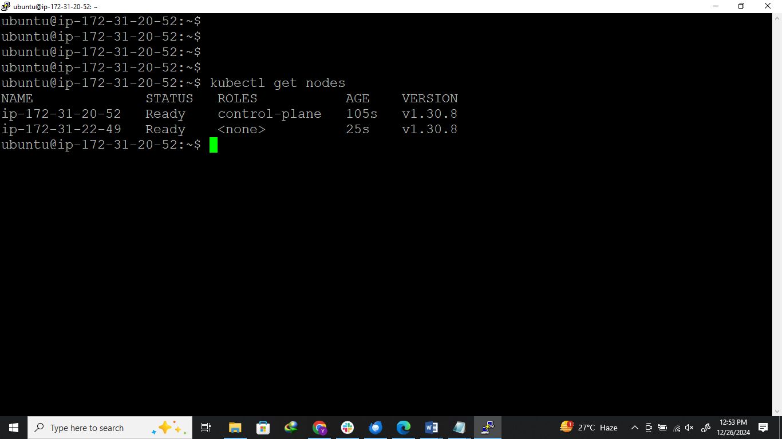

TASK 3: Explore Helm chart
- Helm chart is a popular package manager for Kubernetes
- It simplifies the deployment and management of applications on Kubernetes by providing a structured way to define, install, and upgrade Kubernetes applications.
Key concepts of Helm chart
- Chart.yaml: Metadata about the chart, such as name, version, and description.
- values.yaml: Default configuration values for the chart.
- Templates directory: A directory containing Kubernetes manifest templates.
- Charts directory: A directory for dependencies.
Advantages of using Helm chart
- Simplifies Kubernetes Management
- Reusability
- Dependency Management
- Version Control
Common Commands
- helm list: List Installed Releases
- helm uninstall <release-name> : Uninstall a release
- helm create <chart name> : Creates chart
TASK 4: Deploy the sample application in the kubeadm cluster through helm chats.
STEP 1: After installing helm chart follow the below command to deploy the sample nginx application in Kubeadm cluster through Helm chart.
COMMANDS:
- helm repo add bitnami https://charts.bitnami.com/bitnami
- helm repo update
- helm install my-nginx bitnami/nginx
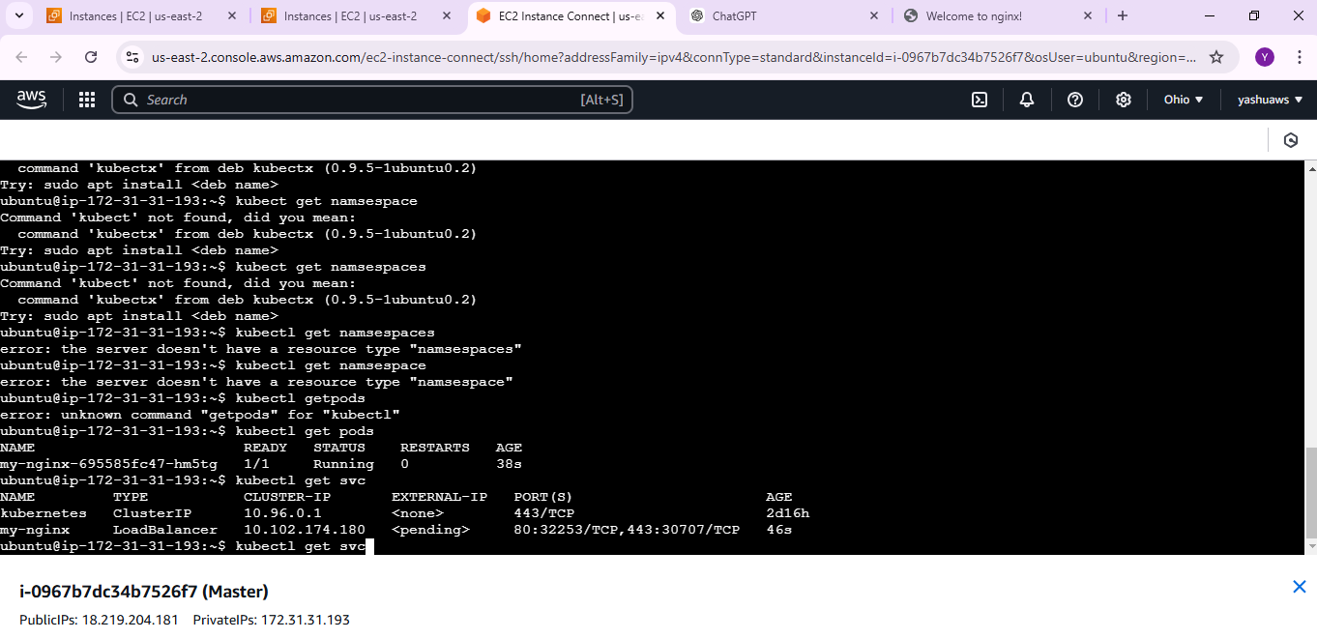

STEP 2: By using the Public IP of EC2 instance and port number we will be able to access the default nginx application page.
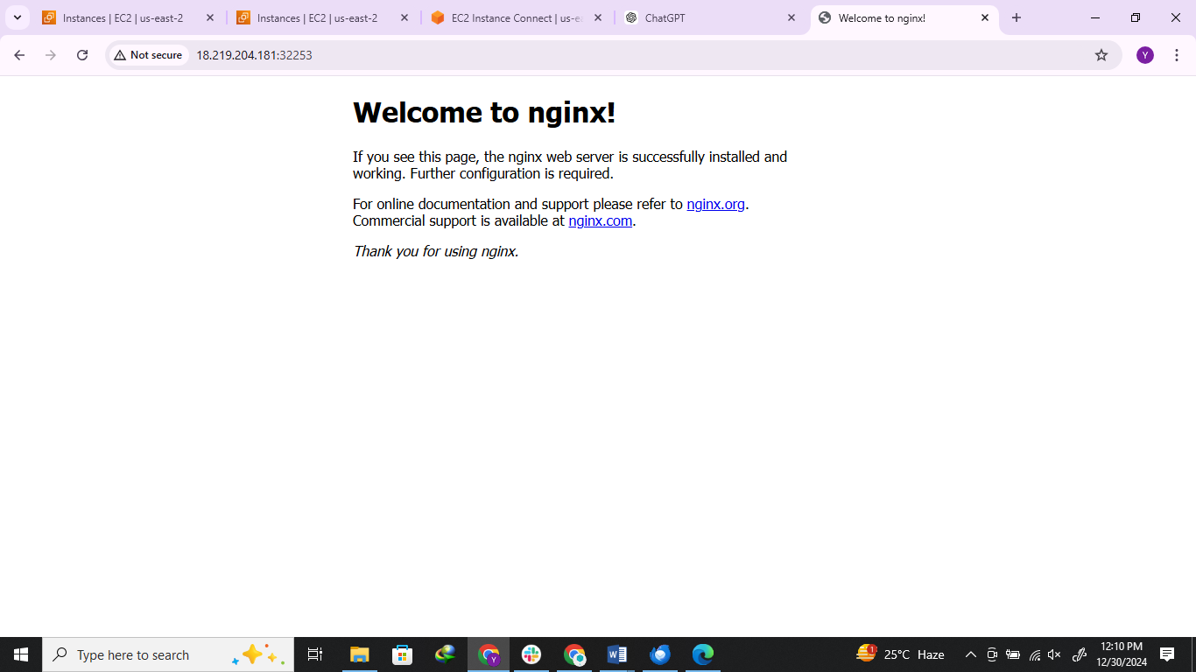

TASK 5: Monitor the kubeadm cluster through Grafana and create an alert if cluster goes down.
STEP 1: By using the following commands install the Kube Prometheus stack on the Master node .
COMMANDS:
- Kubectl create namespace prometheus
- helm install stable prometheus-community/kube-prometheus-stack --version 48.3.1 -n rometheus
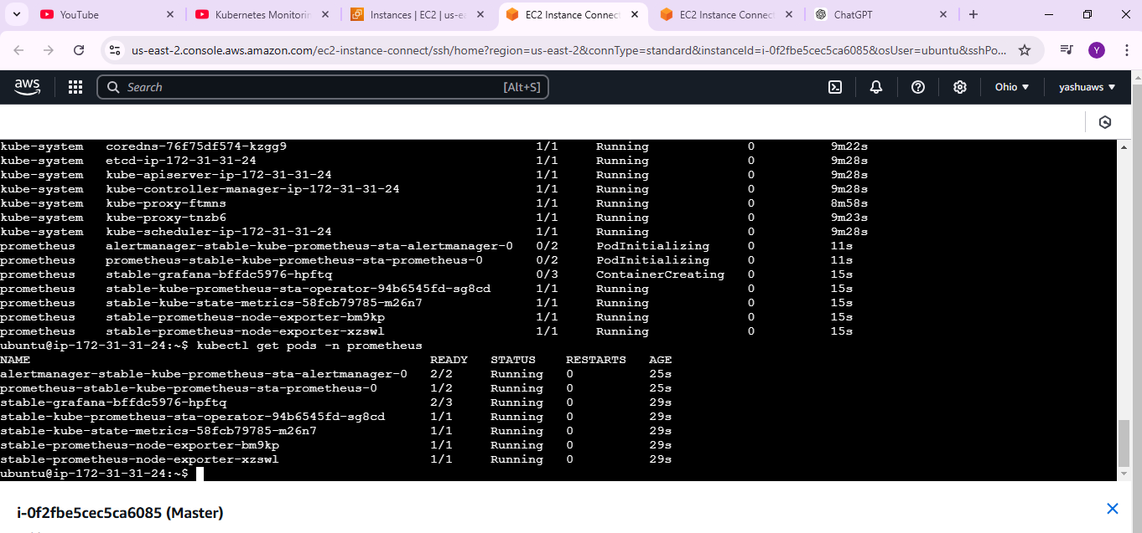

STEP 2: Edit the Service by using the following commands and change the service type with Nodeport to access Grafana on our browser.
COMMANDS:
- kubectl edit svc stable-grafana -n Prometheus
- kubectl edit svc stable-kube-prometheus-sta-prometheus -n prometheus
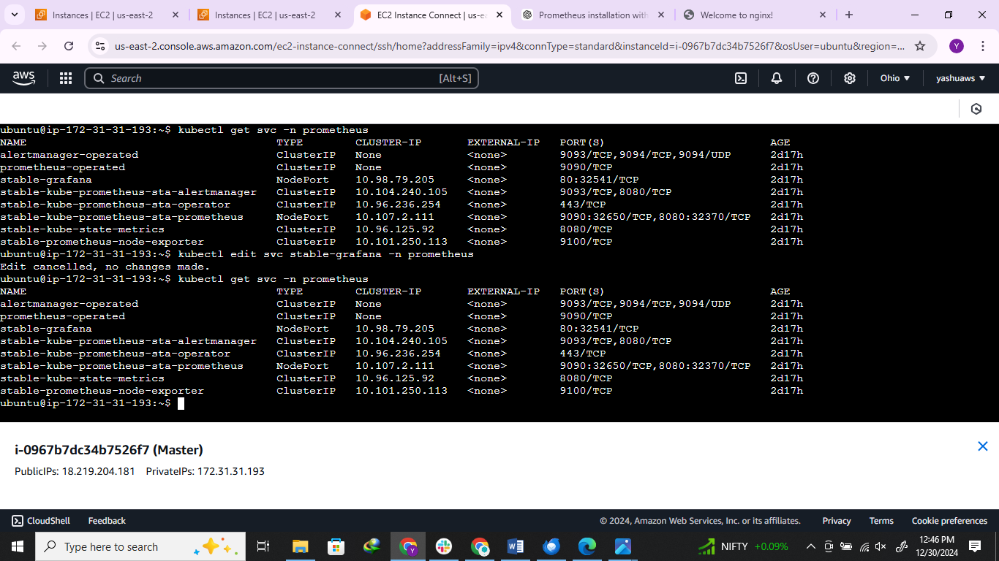

STEP 3: Click on Add data source and select Prometheus and add Prometheus URL to integrate it with Grafana.
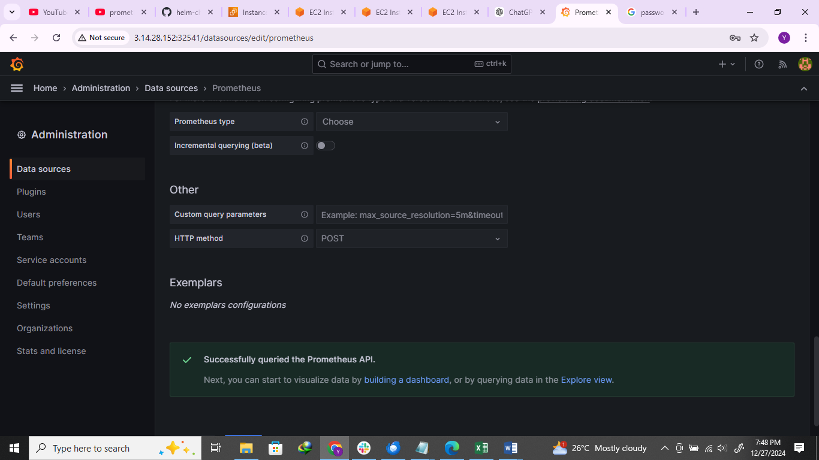

STEP 4: Now we can see the dashboard which is monitoring the Kubernetes cluster.
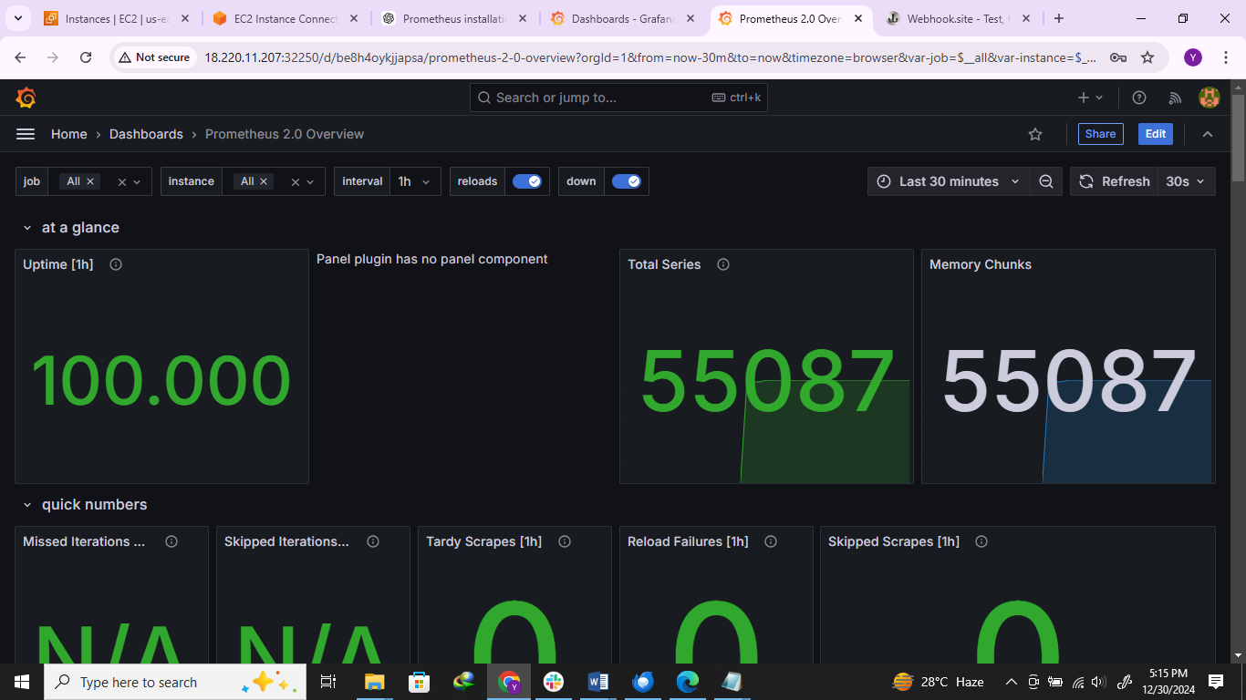

STEP 5: Create an Alert for the Kubernetes cluster creating a contact point as Webhook by adding Webhook URL from Webhook. Site and we can see the alert for the same.
