Terraform
1: To create a single vpc, public subnet, route table and internet gate-way
Create key-pair in aws console and mention the same name in script so that we can use it to access instance
provider "aws" {
region = "us-east-1"
}

resource "aws_vpc" "my-vpc" {
cidr_block = "10.0.0.0/16"

tags = {
Name = "my_vpc"
}
}

resource "aws_subnet" "public_subnet" {
vpc_id = aws_vpc.my-vpc.id
cidr_block = "10.0.1.0/24"

tags = {
Name = "public_subnet"
}
}

resource "aws_internet_gateway" "IG" {
vpc_id = aws_vpc.my-vpc.id

tags = {
Name = "IG"
}
}

resource "aws_route_table" "public_RT" {
vpc_id = aws_vpc.my-vpc.id

route {
cidr_block = "0.0.0.0/0"
gateway_id = aws_internet_gateway.IG.id
}

tags = {
Name = "public_RT"
}
}

resource "aws_route_table_association" "association" {
subnet_id = aws_subnet.public_subnet.id
route_table_id = aws_route_table.public_RT.id
}

resource "aws_security_group" "webSg" {
name = "webSg"
vpc_id = aws_vpc.my-vpc.id

ingress {
description = "HTTP from VPC"
from_port = 80
to_port = 80
protocol = "tcp"
cidr_blocks = ["0.0.0.0/0"]
}
ingress {
description = "SSH"
from_port = 22
to_port = 22
protocol = "tcp"
cidr_blocks = ["0.0.0.0/0"]
}

egress {
from_port = 0
to_port = 0
protocol = "-1"
cidr_blocks = ["0.0.0.0/0"]
}

tags = {
Name = "Web-sg"
}
}

resource "aws_instance" "ajay-terra1"{
ami = "ami-0f9de6e2d2f067fca"
instance_type = "t2.micro"
key_name = "terraform1234"
vpc_security_group_ids = [aws_security_group.webSg.id]
subnet_id = aws_subnet.public_subnet.id
associate_public_ip_address = true
# user_data = file("C:/Terraform/1.sh")
tags = {
Name = "ajay-terra1"
}
}

Run this command
terraform init
terraform plan
terraform apply

It will create vpc with a public instance

2 : To create a vpc , public-sunbet , Internet gateway and route table and connect to the instance and install package like docker by using provisioners
- In this we are creating key-pair resource to let terraform to connect with instance directly
- Use private-key and public-key location

provider "aws" {
region = "us-east-1"
}

resource "aws_key_pair" "example" {
key_name = "terraform1234" # Replace with your desired key name it will create new key-pair
public_key = file("C:/Users/Cjp/.ssh/id_rsa.pub") # location of your public key, required to connect the instance
# Replace with the path to your public key file
}

resource "aws_vpc" "my-vpc" {
cidr_block = "10.0.0.0/16"

tags = {
Name = "my_vpc"
}
}

resource "aws_subnet" "public_subnet" {
vpc_id = aws_vpc.my-vpc.id
cidr_block = "10.0.1.0/24"

tags = {
Name = "public_subnet"
}
}

resource "aws_internet_gateway" "IG" {
vpc_id = aws_vpc.my-vpc.id

tags = {
Name = "IG"
}
}

resource "aws_route_table" "public_RT" {
vpc_id = aws_vpc.my-vpc.id

route {
cidr_block = "0.0.0.0/0"
gateway_id = aws_internet_gateway.IG.id
}

tags = {
Name = "public_RT"
}
}

resource "aws_route_table_association" "association" {
subnet_id = aws_subnet.public_subnet.id
route_table_id = aws_route_table.public_RT.id
}

resource "aws_security_group" "webSg" {
name = "webSg"
vpc_id = aws_vpc.my-vpc.id

ingress {
description = "HTTP from VPC"
from_port = 80
to_port = 80
protocol = "tcp"
cidr_blocks = ["0.0.0.0/0"]
}
ingress {
description = "SSH"
from_port = 22
to_port = 22
protocol = "tcp"
cidr_blocks = ["0.0.0.0/0"]
}

egress {
from_port = 0
to_port = 0
protocol = "-1"
cidr_blocks = ["0.0.0.0/0"]
}

tags = {
Name = "Web-sg"
}
}

resource "aws_instance" "ajay-terra1"{
ami = "ami-0f9de6e2d2f067fca"
instance_type = "t2.micro"
key_name = "terraform1234"
vpc_security_group_ids = [aws_security_group.webSg.id]
subnet_id = aws_subnet.public_subnet.id
associate_public_ip_address = true
# user_data = file("C:/Terraform/1.sh")
tags = {
Name = "ajay-terra1"
}

connection {
type = "ssh"
user = "ubuntu"
private_key = file("C:/Users/Cjp/.ssh/id_rsa") # use this when you are on windows
host = self.public_ip # or use this ~/.ssh/id_rsa on linux
}

provisioner "remote-exec" {
inline = [
"sudo apt update -y",

"sudo apt install docker.io -y",
"sudo docker --version"
]

}

}

terraform init
terraform plan
terraform apply

run this command and now launch the instance and run
docker –version to see the docker is installed or not
3: To create single vpc, public and private subnet, internet gateway , nat gateway ,elastic ip , public and private instance

create a key-pair so that we use it access the application
provider "aws" {
region = "us-east-1"

}

resource "aws_vpc" "my-vpc1" {
cidr_block = "10.0.0.0/16"
tags = {
Name = "my-vpc1"
}
}

resource "aws_subnet" "public-subnet" {
vpc_id = aws_vpc.my-vpc1.id
cidr_block = "10.0.0.0/24"
map_public_ip_on_launch = true
tags = {
Name = "public-subnet"
}
}

resource "aws_subnet" "private-subnet" {
vpc_id = aws_vpc.my-vpc1.id
cidr_block = "10.0.1.0/24"

tags = {
Name = "private-subnet"
}
}

resource "aws_internet_gateway" "IG" {
vpc_id = aws_vpc.my-vpc1.id

tags = {
Name = "IG"
}
}

resource "aws_eip" "nat_eip" {
domain = "vpc"

}

resource "aws_nat_gateway" "NG" {
allocation_id = aws_eip.nat_eip.id
subnet_id = aws_subnet.public-subnet.id

tags = {
Name = "NG"
}

# To ensure proper ordering, it is recommended to add an explicit dependency
# on the Internet Gateway for the VPC.
depends_on = [aws_internet_gateway.IG]
}

resource "aws_route_table" "public-RT" {
vpc_id = aws_vpc.my-vpc1.id

route {
cidr_block = "0.0.0.0/0"
gateway_id = aws_internet_gateway.IG.id
}

tags = {
Name = "public-RT"
}
}

resource "aws_route_table_association" "public-asso" {
subnet_id = aws_subnet.public-subnet.id
route_table_id = aws_route_table.public-RT.id
}

resource "aws_route_table" "private-RT" {
vpc_id = aws_vpc.my-vpc1.id

route {
cidr_block = "0.0.0.0/0"
gateway_id = aws_nat_gateway.NG.id
}

tags = {
Name = "private-RT"
}
}

resource "aws_route_table_association" "private-asso" {
subnet_id = aws_subnet.private-subnet.id
route_table_id = aws_route_table.private-RT.id
}

resource "aws_security_group" "WebSg" {
name = "WebSg"
vpc_id = aws_vpc.my-vpc1.id

ingress {
description = "port ssh"
protocol = "tcp"
self = true
from_port = 22
to_port = 22
cidr_blocks = ["0.0.0.0/0"]
}
ingress {
description = "port HTTP"
protocol = "tcp"
self = true
from_port = 80
to_port = 80
cidr_blocks = ["0.0.0.0/0"]
}
ingress {
description = "port HTTPS"
protocol = "tcp"
self = true
from_port = 443
to_port = 443
cidr_blocks = ["0.0.0.0/0"]
}

egress {
from_port = 0
to_port = 0
protocol = "-1"
cidr_blocks = ["0.0.0.0/0"]
}
}

resource "aws_instance" "public-instance" {
ami = "ami-0f9de6e2d2f067fca"
instance_type = "t2.micro"
key_name = "terraform"
subnet_id = aws_subnet.public-subnet.id
vpc_security_group_ids = [aws_security_group.WebSg.id]
associate_public_ip_address = true

tags = {
Name = "public-instance"
}
}

resource "aws_instance" "private-instance" {
ami = "ami-0f9de6e2d2f067fca"
instance_type = "t2.micro"
key_name = "terraform"
vpc_security_group_ids = [aws_security_group.WebSg.id]
subnet_id = aws_subnet.private-subnet.id

tags = {
Name = "private-instance"
}
}

4: To create single vpc, public and private subnet, internet gateway , nat gateway ,elastic ip , public and private instance and connect to private instance and install docker in it from terraform
- Create key_pair
provider "aws" {
region = "us-east-1"

}

resource "aws_key_pair" "ajay-key_name" {
key_name = "ajay123"
public_key = file("C:/Users/Cjp/.ssh/id_rsa.pub")

}

resource "aws_vpc" "my-vpc1" {
cidr_block = "10.0.0.0/16"
tags = {
Name = "my-vpc1"
}
}

resource "aws_subnet" "public-subnet" {
vpc_id = aws_vpc.my-vpc1.id
cidr_block = "10.0.0.0/24"
map_public_ip_on_launch = true
tags = {
Name = "public-subnet"
}
}

resource "aws_subnet" "private-subnet" {
vpc_id = aws_vpc.my-vpc1.id
cidr_block = "10.0.1.0/24"

tags = {
Name = "private-subnet"
}
}

resource "aws_internet_gateway" "IG" {
vpc_id = aws_vpc.my-vpc1.id

tags = {
Name = "IG"
}
}

resource "aws_eip" "nat_eip" {
domain = "vpc"

}

resource "aws_nat_gateway" "NG" {
allocation_id = aws_eip.nat_eip.id
subnet_id = aws_subnet.public-subnet.id

tags = {
Name = "NG"
}

# To ensure proper ordering, it is recommended to add an explicit dependency
# on the Internet Gateway for the VPC.
depends_on = [aws_internet_gateway.IG]
}

resource "aws_route_table" "public-RT" {
vpc_id = aws_vpc.my-vpc1.id

route {
cidr_block = "0.0.0.0/0"
gateway_id = aws_internet_gateway.IG.id
}

tags = {
Name = "public-RT"
}
}

resource "aws_route_table_association" "public-asso" {
subnet_id = aws_subnet.public-subnet.id
route_table_id = aws_route_table.public-RT.id
}

resource "aws_route_table" "private-RT" {
vpc_id = aws_vpc.my-vpc1.id

route {
cidr_block = "0.0.0.0/0"
gateway_id = aws_nat_gateway.NG.id
}

tags = {
Name = "private-RT"
}
}

resource "aws_route_table_association" "private-asso" {
subnet_id = aws_subnet.private-subnet.id
route_table_id = aws_route_table.private-RT.id
}

resource "aws_security_group" "WebSg1" {
name = "WebSg1"
vpc_id = aws_vpc.my-vpc1.id

ingress {
description = "port ssh"
protocol = "tcp"
self = true
from_port = 22
to_port = 22
cidr_blocks = ["0.0.0.0/0"]
}
ingress {
description = "port HTTP"
protocol = "tcp"
self = true
from_port = 80
to_port = 80
cidr_blocks = ["0.0.0.0/0"]
}
ingress {
description = "port HTTPS"
protocol = "tcp"
self = true
from_port = 443
to_port = 443
cidr_blocks = ["0.0.0.0/0"]
}

egress {
from_port = 0
to_port = 0
protocol = "-1"
cidr_blocks = ["0.0.0.0/0"]
}
}

resource "aws_instance" "public-instance1" {
ami = "ami-0f9de6e2d2f067fca"
instance_type = "t2.micro"
key_name = "ajay123"
subnet_id = aws_subnet.public-subnet.id
vpc_security_group_ids = [aws_security_group.WebSg1.id]
associate_public_ip_address = true

tags = {
Name = "public-instance1"
}
}

resource "aws_instance" "private-instance1" {
ami = "ami-0f9de6e2d2f067fca"
instance_type = "t2.micro"
key_name = "terraform"
vpc_security_group_ids = [aws_security_group.WebSg1.id]
subnet_id = aws_subnet.private-subnet.id

connection {
type = "ssh"
user = "ubuntu"
private_key = file("C:/Users/Cjp/.ssh/id_rsa")
host = self.private_ip
bastion_host = aws_instance.public-instance1.public_ip
bastion_user = "ubuntu"

}
provisioner "remote-exec" {
inline = [
"sudo apt update -y",
"sudo apt install docker.io -y"

]

}

tags = {
Name = "private-instance1"
}
}

- Using self in terraform block
If we are in resource block then to call particular attributes of the resource, we use SELF.
Example
Resource “aws_ec2_instance” “” my-instance”{
ami = “ami-0.12444588”
key = “mu-key”
type = “t2-micro”
connection {
type = “ssh”
user = “ubuntu”
host = self.public_ip # we are using self to get the public ip of EC2 inside its resource block
}
}

For the same scenario, to call ip from outside the resource block
we use
Type of resource.resource_name.attribute( public_ip)
aws_ec2_instance.my-instance.public_ip

- Provisioners
Provisioners allows us to execute commands/action during the resource creation or destruction
3 types
File , Locan and remote provisioners

- Statefile
Statefile is a heart of terraform , which stores the information of the infrastructure created by terraform

What happens if there is no statefile or statefile is deleted
lets say u already created ec2 instaacnce through terraform , and now there is no terraform statefile or it was deleted accidently
and we added any new updates to ec2 like tags then ran terraform apply ,
terraform first see statefile , if no statefile is present then terraform will create one more ec2 instance with updated tags

Statefile stores everything like information of resource and sensitive information too….
Whoever has access to infrastructure of terraform code they have access to statefile which put the risk of sensitive information….
For this purpose we user remote backend
we store our statefile in s3 bucket ad remote backend
so we strore the statefile in s3 then we can put block public access or bucker or iam policies for least priviledge access

We our remote backend is s3 ,
we pushed our terraform code into git repository , and some other devops enginerr is forked it and updated changes in terraform code then applied changes and merged back to the repo
then no need to push ( merge) statefile because our statefile will get automatically updated as we are using s3 for remote backend

If our statefile is in local or git repo the along with changes we have push statefile too…

Real word scenario : explaniation workflow…..
We were a group of 3 – 4 devops enginner where we had git repository to host terraform infrastructure code ( which allows us to create aws resources)
we used s3 bucket as remote backend to store statefile instead of storing it in git repo …..
If any devops enginner wants to update the terraform infrastructure code then , they can simply clone the repository updated the code then applied with terraform apply and request pull request ( PR)
and some one devops team will accept the pull request . and code will updated and statefile too…..

Commnd to see the terraform state file
terraform show

State lock
with dynamo db
what is terraform state lock with dynanodb
Lets form group of 4 – 5 engineer more than one engineer try to run terraform apply at same time
then terraform will get confused which one to apply first
so we use statelock with dynamo db then only one person can able to run terraform apply ( whoever run first )then others have to wait till the apply command executes then othes can run apply
see if devops enginner 1 run terraform apply then terraform lock the state file allows him create resource while others have to wait till process gets complete

In an organization
If we working on terraform then for every environment ( dev, stage, prod) there will a separate account for each environmemt
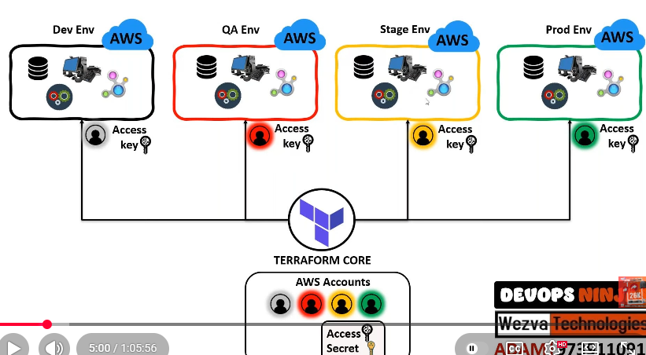

Version control
terraform IaC will be hosted on Git repositiory
once code is hosted on repo , code will be on default main/master branch
Scenario :
In group of 4 – 5 people want to update or work on IaC code then use Git branching strategy
create dev/state/ or any branch clone repo and update the code , test the code like terraform apply once the everthing is working fine then delete thw resources
create a pull request senior will review the code then accept the pull request

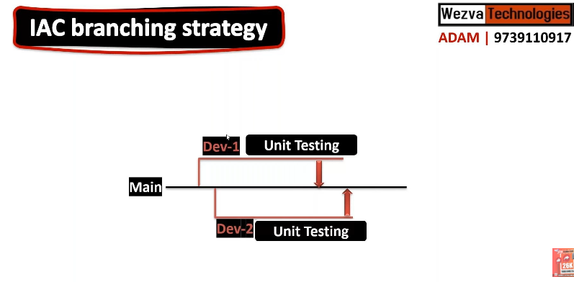

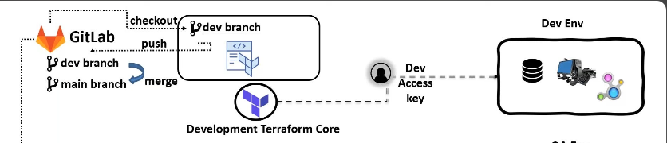

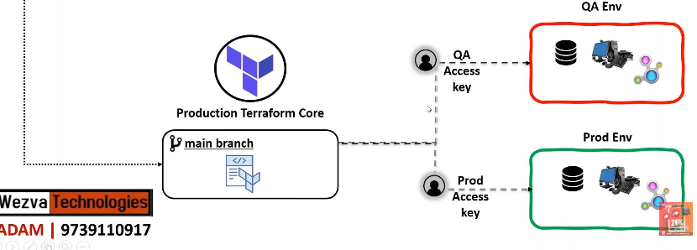

How to do Scan vulnarabilities of terraform code ( how to secur terraform code )
ANS : By static code analysis
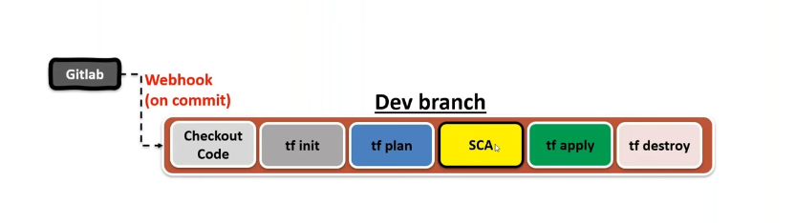
Using the static code analysis we can scan the vulnarabilities in IaC and make sure the code follows standard procedure …
For static code anyalsis we use CHECKOV
What is Checkov?
Checkov is open-source static code analysis tool which is used to scan the infrastructure as code IaC file to detect
- Vulnarabilities
- Best practices
In cloud projects, infrastructure is written as code:
- Terraform
- CloudFormation
- Kubernetes YAML
- Helm charts
- Dockerfiles
If infrastructure has mistakes like:
- Public S3 buckets
- Open security groups
- Unencrypted databases
Then attackers can exploit them.
Checkov helps prevent this early.

To install the checkov
pip install checkov

to scan the terraform folder
checkov -d .
Exmple
resource "aws_s3_bucket" "mybucket" {
bucket = "ajay-demo-bucket"
acl = "public-read"
}

Run checkov -d .
Output
Check: CKV_AWS_20: "S3 Bucket should not be public"
FAILED for resource: aws_s3_bucket.mybucket
File: main.tf:1-5
Guideline: Ensure S3 buckets are private

Scenario :
After junior enginerr updated and test the code in dev branch he wil create pull request and once pull request is created then senior engineer will verify the the code
for that he will github action once PR is created it will trigger a pipeline , run the code and if
it is good then senior enginner will the accept the code
The Hierarchy: One Codebase, Multiple States
In a professional setup, you have one Git repository but three separate state files.
The Code: Everyone shares the same .tf files.
The State: Each environment (Dev, Stage, Prod) has its own dedicated state file in S3.
Why separate them?
If Junior A runs an apply in Dev, it should never touch the Prod state file. If they shared a state file, Junior A would accidentally overwrite the Production settings with Development settings.

2. Where does the information store?
Terraform knows where to store information based on your Backend Configuration.
If the Junior Engineer is in the dev environment (or workspace) and runs terraform apply:
Terraform looks at the Dev State File in S3.
It compares the code to the Dev infrastructure.
It updates only the Dev infrastructure.
The information is stored only in the Dev state file.
The Prod state file remains untouched and "frozen" until the Senior Engineer runs Terraform against the Prod backend.

3. The Workflow (Step-by-Step Example)
Let’s look at the "Life of a Change" from Junior to Senior.
Step 1: Junior Engineer (Dev Environment)
Junior A wants to add an S3 bucket.
Action: They create a new branch feature-s3-bucket.
Command: terraform workspace select dev then terraform apply.
Result: A bucket is created in the AWS Dev Account. The Dev State File is updated.
Testing: Junior A confirms the bucket works.
Step 2: The Merge (Git)
Action: Junior A opens a Pull Request (PR) to merge their code into the main branch.
Review: The Senior Engineer reviews the code. They aren't looking at state files; they are looking at the logic.
Merge: Once approved, the code is merged into main.
Step 3: Senior Engineer (Prod Environment)
Now the code for the new bucket exists in the main branch, but the bucket does not exist in Production yet.
Action: The Senior Engineer (or an automated CI/CD tool like GitHub Actions) switches context.
Command: terraform workspace select prod then terraform apply.
Result: Terraform reads the Prod State File. It sees that the code wants a bucket, but the Prod State says "I don't have one."
Final Update: Terraform creates the bucket in the AWS Production Account and updates the Prod State File.

Question: You need to update an EC2 instance’s AMI ID without downtime. Terraform wants to destroy and recreate the instance. How do you avoid downtime?
Answer:
Use create_before_destroy lifecycle
Use Create Before Destroy in lifecycle rules:
resource "aws_instance" "example" {
ami = var.ami_id
instance_type = "t3.micro"

lifecycle {
create_before_destroy = true
}

This ensures the new instance is created before the old one is deleted.

Question: Your team is using Terraform with remote state in S3. A team member’s Terraform run failed, leaving the state locked. How do you resolve this issue?
use
terraform force-unlock <LOCK_ID>

A teammate ran Terraform apply But the run failed (network issue, crash, interruption). Terraform left the state in LOCKED mode.
Now others get:
Error: Error acquiring the state lock

Lock Info:
ID: 1234abcd...
Operation: OperationTypeApply
Who: user@laptop
Version: 1.6.0

Note the lockid and run the below command
Note the lock ID and run the command
terraform force-unlock 1234abcd-5678

Scenario: Avoiding Resource Recreation in Terraform
Question: You updated an EC2 instance type, but Terraform wants to destroy and recreate it instead of modifying it in-place. How do you prevent this?
- Use the ignore_changes lifecycle rule to keep the existing resource:
resource "aws_instance" "example" {
ami = "ami-123456"
instance_type = "t2.micro"

lifecycle {
ignore_changes = [instance_type]
}
}

What ignore_changes Actually Does
ignore_changes works only on attributes inside the resource
It is used when you want Terraform to ignore changes in attributes like:
- tags updated manually
- autoscaling changes
- AMI drift
- user_data changes

Scenario 2: The "State Migration" (Changing Backends)
The Problem: Your team started by storing state files locally on their laptops (bad practice). Now you have 5 developers, and you need to move the state to an S3 Bucket so everyone can share it.
The Question: If you simply copy the terraform.tfstate file to S3 manually, everything will break. What is the "Terraform way" to move state from a laptop to the cloud safely?
The Solution:
- Configure Backend: Add the backend "s3" { ... } block to your code.
- The Migration Command: Run terraform init.
- The Handshake: Terraform will detect that you have a local state file and a new remote configuration. It will ask: "Do you want to copy existing state to the new backend?"
- Confirm: Type yes. Terraform will upload the state and, importantly, update its internal "lineage" to ensure the move is tracked.

Scenario: The "Renaming Nightmare" (Refactoring)
The Problem: In your code, you named a resource resource "aws_instance" "server_1". Your boss wants you to rename it to resource "aws_instance" "web_production" to follow company standards.
The Question: If you just change the name in the code and run terraform apply, Terraform will Destroy the existing server and Create a brand new one because it thinks "server_1" is gone and "web_production" is new. How do you rename a resource in code without causing a deletion?
Solution:
Use the command line to rename it in the state file:
terraform state mv aws_instance.server_1 aws_instance.web_production

This tells Terraform:
“Same EC2 instance, just a new name.”
And terraform plan in output u will get no changes because no destroy, no recreate just a name change
This works for modules too
terraform state mv \
module.ec2.aws_instance.server_1 \
module.ec2.aws_instance.web_production

Scenario : The "Ghost" Resource (Manual Deletion)
The Situation: A developer manually deleted a Load Balancer in the AWS Console because they thought it was unused. However, your Terraform code still contains that Load Balancer.
The Problem: When you run terraform plan, Terraform sees the resource in the state file but can't find it in AWS. It will try to re-create it. But if that Load Balancer had specific DNS records or dependencies pointing to its old ID, your infrastructure is now "broken."

The Solution: You must tell Terraform to forget about the deleted resource so you can start fresh or clean up your code without errors.
- Identify: Find the resource address (e.g., aws_lb.ext_lb).
- State Surgery: Run
terraform state rm aws_lb.ext_lb.

  - What this does: It removes the metadata from terraform.tfstate but touches nothing in the real world.
- Clean up: Remove the code from your .tf file and run terraform plan. It should now show "No changes."
If u do not remove the cod block from .tf file, then again when u run terraform apply command , again it will try to re create it .

Scenario 3: The "Tainted" Resource
The Situation: You run terraform apply to create a VM. The VM is created successfully in AWS, but the provisioner script (the bash script that runs inside the VM to install Nginx) fails halfway through.
- The Problem: The VM exists, but it's "broken" (it doesn't have Nginx). Terraform knows the creation failed.
- The Challenge: If you run terraform apply again, Terraform normally says "No changes" because the VM exists. But you need a working VM.
- The Senior Question: How do you tell Terraform to "throw away this specific VM and try again" without destroying the whole environment?
Use the -replace flag:
terraform apply -replace="aws_instance.web"

This is safer because it doesn't modify the state file until you actually run the apply.
Terraform will:
- Destroy VM
- Create new VM
- Run provisioner again

Provisioners are NOT idempotent.
Terraform does not track what happened inside the VM.
Terraform only knows:
EC2 instance exists → done.

Terraform runs provisioners only when:
- Resource is being created
- Resource is being replaced
So second apply does not run provisioner again.

What are some best practices to manage terraform state file?
- Remote Storage: Store the state file remotely (e.g., AWS S3) for safety, collaboration and version control.
- State Locking: Enable state locking to prevent conflicts in concurrent operations.
- Access Controls: Limit access to the state file to authorized users and services.
- Automated Backups: Set up automated backups to prevent data loss.
- Environment Separation: Maintain separate state files for each environment or utilize Terraform workspaces to manage multiple state files.

Your infrastructure contains database passwords and other sensitive information. How can you manage secrets and sensitive data in Terraform
Ans
Mark Variables as sensitive = true
when you are definig a variable which holds secrets always add sensitive= true
variable "db_password" {
type = string
sensitive = true
}

What does this sensitive= true do ??
it prevents sensitive information from getting printed/displayed on termical of terraform or ci/cd
But
It does not encrypt the value in the state file. Secrets are still plain text in terraform.tfstate.
any one who has the access the can easily see the secrets
this is where protection at remote backend/ storage level come to picture
Since the state file will contain the secrets (Terraform needs them to compare changes), you must protect the S3 bucket where the state lives:
- Encryption at Rest: Enable AES-256 or KMS encryption on the S3 bucket.
- Restrict Access: Use IAM policies to ensure only the Senior Engineer and the CI/CD runner can access the bucket.

