**Not able to install Ta-Lib. I have used pip install, conda install but no success**

Steps to install Ta-Lib

To install Ta-Lib on Windows PC

Step 1: Identify the Python version and windows system architecture on our computer. You can find the version installed in your system by simply writing **python –version** in your command prompt.

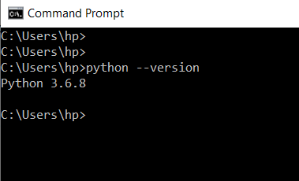

For the windows architecture, simply right-click on your “computer” icon and click properties and the system will display the details.

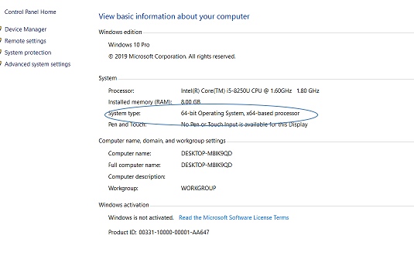

Step 2: We cannot directly use the “pip install” command when it comes to installing Ta-lib. Thus, we will first install the “whl” file which can be found from on this link:

<https://www.lfd.uci.edu/~gohlke/pythonlibs/#ta-lib>

The website is a useful resource foe a lot of Python extensions.

You can scroll down to the section where we fill find the relevant links, as shown:

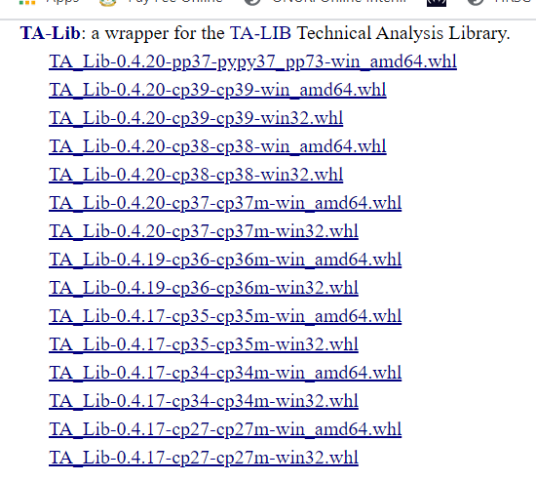

Download the file keeping in mind the python version, and the operating system.

By default, the “whl” file gets download in the “Downloads” folder. Move it to the working environment.

Step 3: Open command prompt and use the pip install command with the file name of the downloaded file.

Example-

**pip install TA_Lib-0.4.17-cp36-cp36m-win_amd64.whl**

**The following message will show up-**

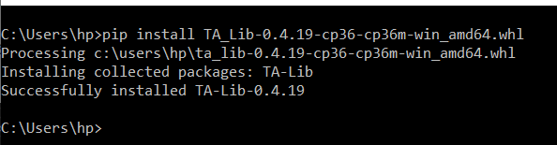

**We have finished installing the Ta-Lib Python Library.**

**We can check it by writing in the command, “ import talib” and press Enter.**

**If there’s no error, then it means the python Ta-Lib library has been successfully installed on your computer.**