Below is the link for the GitHub file:

<https://github.com/nh303/future-returns>

Below is the link for the explanation:

https://kapwi.ng/c/PFuXeRBc

Problem Statement 1:

Data & Features:

Import the data set and give summary statistics of that data.

Compute transformations like- log min returns, 5min_volatility, and 30min_volatility

Results:

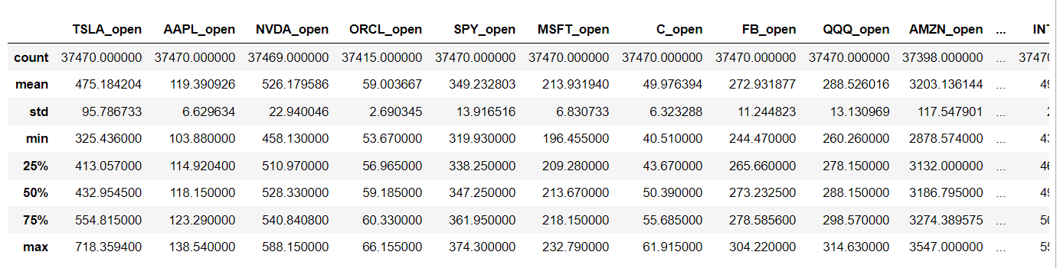

Problem Statement 2:

Back test & Performance Stats:

Build a rolling lookback regression model with regressors (- 5min_past_volatility, 30min__pastvolatility, previous 1min returns, and previous 2min returns), and regressand (-

Next day return).

Results:

Model: Rolling Lookback Linear Regression

Test_size=0.2

Accuracy of the model: 50.77%

Net PnL: 25.801311

R2_score: 0.034306492750382334

R-squared: 0.041

F-statistic: 10.37

Sharpe ratio: 14.6075

(Measure of risk-adjusted return)

Max DD: -0.004721

Q. Reason why this model does not perform well.

And: This model does not perform well because candles open price (instead of candles close price) is taken into consideration. Current candle open is constant.