**Machine Learning For Trading**

WHAT is Machine Learning?

Machine Learning is the practice of using algorithms to parse data, learn from it, and make a prediction about something. It is a branch of artificial intelligence based on the idea that systems can learn from data, identify patterns and make decisions with minimal human intervention.

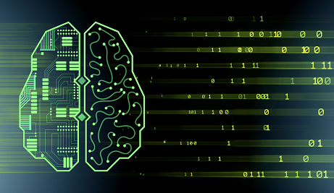

We human learn new things by performing tasks, and improve ourselves with experience.

Just like us, an ordinary system with machine learning can perform tasks, learns, predicts, compute complex problems, and helps people in necessary decisions. They learn from previous computations to produce reliable, repeatable decisions and results..

WHY Machine Learning?

Today we are revolving around DATA. To get meaningful information from this data and to learn, we need systems to churn the data and provide us beneficial results. Data is powerful and in order to use it, Machine Learning has added another way to reach it. Machine Learning uses an iterative approach to learn from data, the learning can be easily automated.

WHAT’s required to create good Machine Learning systems?

* Data preparation capabilities
* Algorithms – basic and advanced
* Automation and iterative process
* Scalability
* Ensemble modeling

HOW does Machine Learning works?

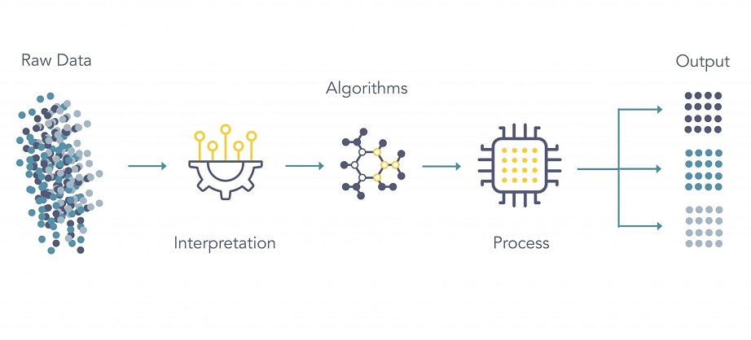

Machine Learning algorithms use the patterns contained in the training data to perform classification and future predictions. When any new input is introduced to the ML model, it applies its learned patterns over the new data to make future predictions.

* Gather past data in any form suitable for processing. The better the quality of data, the more suitable it will be for modeling.
* Data Processing-The data collected is in the raw form and needs to be pre-processed.
* Divide the input data into training, cross-validation, and test sets.
* Building models with suitable algorithms and techniques on the training sets.
* Testing our conceptualized model with data which was not fed to the model at the time of training and evaluating its performance using metrics.

HOW to split data in Machine Learning?

* Training Data: The part of the data we use to train our model. This is the part which the model sees and learns form.
* Validation Data: The part of data which is used to do a frequent evaluation of model, fit on training dataset along with improving involved hyper parameters. It plays part when the model is actually training.
* Testing Data: When our model is trained, testing data provides the unbiased evaluation. When we feed in the inputs of testing data, our model will predict some values. After prediction, we can evaluate our model by comparing it with actual output data.

WHAT are the types of Machine Learning?

TYPES of Machine Learning

Machine Learning can be classified into following three types:

* Supervised Learning
* Unsupervised Learning
* Reinforcement Learning

SUPERVISED LEARNING-

Supervised Learning is a learning function that maps an input to an output. Machine learns from training data. In Supervised Learning, the dataset of our model is **labeled** examples, such as an input where the desired output is known. The learning algorithms receive a set of inputs along with the corresponding correct outputs, and the algorithm learns by comparing its actual output with correct outputs to find errors. It then modifies the model accordingly. Supervised Learning is used in applications where historical data predicts future events.

Example- It can anticipate when credit card transactions are likely to be fraudulent or which insurance customer is likely to file a claim.

Supervised learning is classified into Classification and Regression

Types:

1. Regression
2. Logistic Regression
3. Classification
4. Naïve Bayes Classifiers
5. K-NN
6. Decision Trees
7. Support Vector Machine

UNSUPERVISED LEARNING-

Unsupervised Learning allows the model to figure out the patterns itself. The system is unknown about the answer. The algorithm identifies the patterns and learns them. No training data is required. The goal is to explore the data and find some structure within. They group them into clusters based on their density. It deals with **unlabeled data**. It is used against data that has no historical labels. It works well on transactional data.

Example-It can identify segments of customers with similar attributes who can then be treated similarly in marketing campaigns. It can also find the main attributes that separate customer segments from each other. These algorithms are also used to segment text topics, recommend items and identify data outliers.

Types:

**Clustering**-

1. Overlapping
2. Exclusive
3. Agglomerative
4. Probabilistic

**Clustering Types**-

1. Hierarchical clustering
2. K-means clustering

REINFORCEMENT LEARNING-

Reinforcement Learning is used for robotics, gaming, and navigation. With reinforcement learning, the algorithm discovers trial and error which actions yield the greatest rewards. Machine learns on its own. The aim of Reinforcement Learning is to learn the best policy.

Example-Gaming

Applications of Machine Learning

* Machine Learning for Algorithmic Trading
* High-frequency Trading
* Machine Learning to find patterns in the data
* Machine Learning for Sentiment Analysis
* Predicting Real-world Data and Assessing Risks
* Use of Chabot’s in Trading
* Using robo advisors for Automated Advisory

Problem Statement-

Predict future price of Apple stock using machine learning.

Here, is the link to the python code for the above problem statement.

https://github.com/nh303/predict-future-sock-price