Avishek Kumar

2/16/2023

Course: Foundations of Programming: Python

Assignment 05

## Lists & Dictionaries

Introduction:

In this course, I was tasked to generate a python script using List & dictionaries by defining functions, lists, attributes & strings. I was also able to define loops, strings & tuples for input data using list of choices all while looping data input into files.

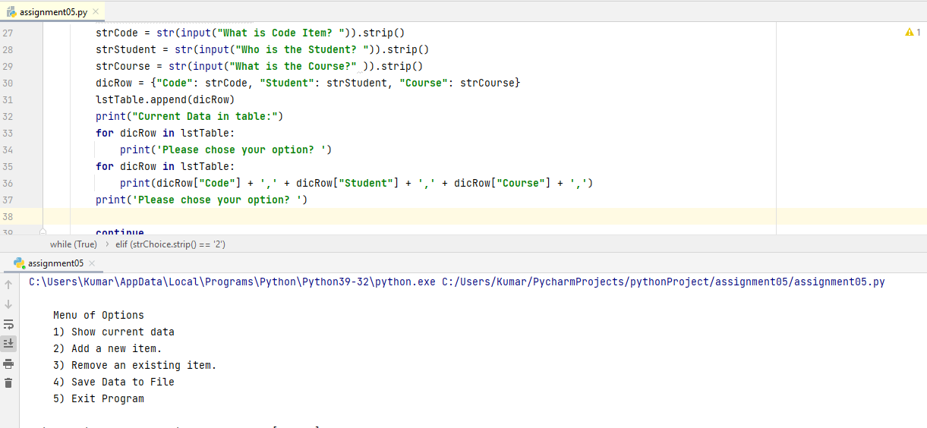

Topic 1: Declare Variables, Functions, strings

In the first task assignment, I was able to generate python script to declare Variables which were “lstTable” this variable included a file which included lists of data that would allow me to store data into the file using input functions. By defining the variables, strings, functions into list of rows defined into a dictionary, I was able to load data into a file. This file was scripted to include list of rows which included attributes. In order to complete this first task, I defined a dictionary to collect data into file into 3 different list of rows.

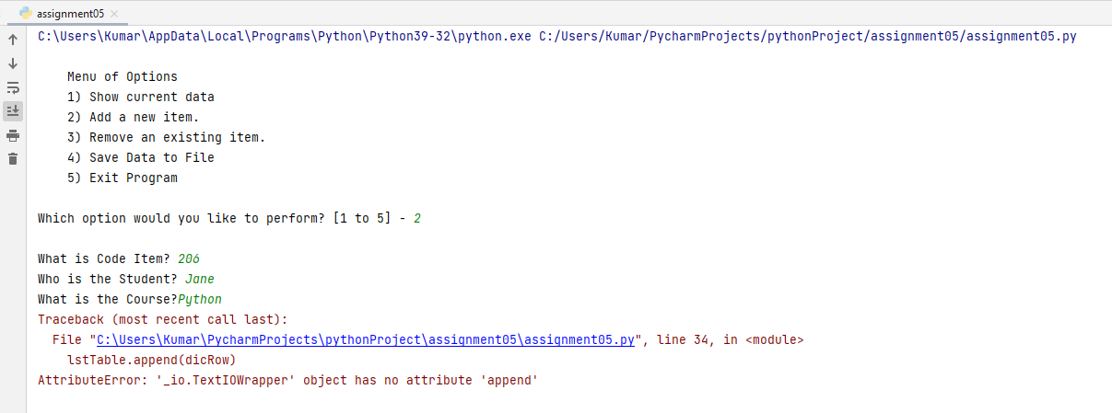

Topic 2: List Menu of Options for data input

In the second set of task assignment, I was able to define variable which was to list a menu of options with the input function to display back to the user for data collection. I was able to define a string for the input function to collect data from the user which would display the data collected from the list of menu options.

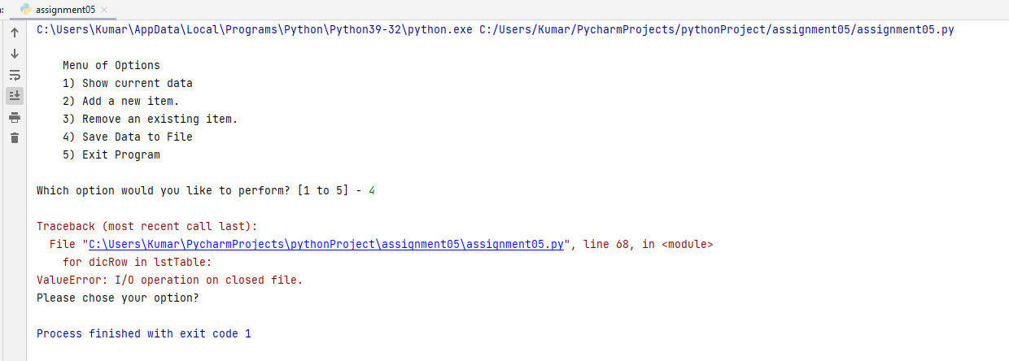

Topic 3: Define variable, Strings, lists & dictionaries

In the third set of scripts, I was able to define a the second set of menu options was to chose Items to be stored into the txt file. I was able to define 3 different sets of strings which were Code, Student, Course; which allows the input function of these 3 strings of data to collect data and store into the text file in its associated rows. These rows included the string of attributes to be collected and stored in the file. In order to successfully complete this section of the script, I defined list stored into dictionaries and define loops for how the data gets collected and stored within the row. The script that I generated also allowed me to add and remove data collected using the input functions to be manipulated for data addition and data removal from the lists defined as dictionaries.

Topic 4: Collect data, Save data, Store Data

In this section of the assignment, I was able to save data collected from previous sections of the script and store into a file. I was able to complete the script by generating a “for” loop to manipulate data stored in the text file. This script included the “print” function to display the list of tuples defined by the dictionary which were “Code”, “Student”, and “Course”. This code included using the list of menu options to save data to the file which was collected and stored as a dictionary. The list was defined as rows within a table of the text file, upon choosing the menu option, I was able to collect data and save into the text file. Boolean characters were also used with the “if” loop statement to confirm if the user in fact permitted the save to data file.

Summary

In this course, I was able to generate a python script to define lists of data to be stored into dictionary. I was able to utilize functions, variables, strings, attributes, tuples and Boolean characters to structure the script to collect data, display data, process the data, as well as save the data to text file. In this course I was able to use the proved documentation to verify the script was successful in processing the data, collecting the data and saving the data as well. Upon running all my scripts, I believe the code structure was broken despite my effort to generate properly working script.

I don’t know what I’m doing wrong. I’m not ready for this course.