AI EXP : HW3 : Linear Regression

Alex Lamarche

**Problem 1: Setting up the functions**

1.A - Scripts included or check the GitHub link here : <https://github.com/ajl3545/AI_HW3>

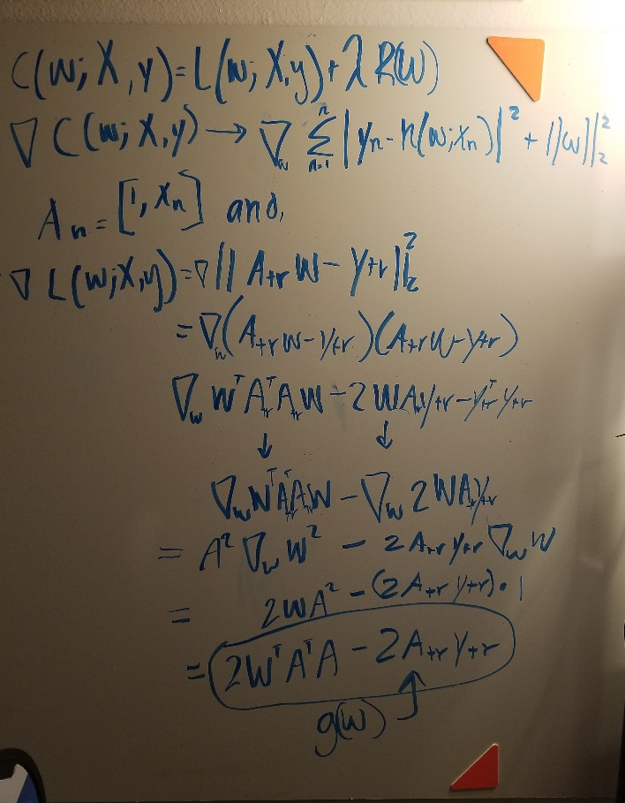1.B – Derivation of g(w) the gradient function

1.C Derivation of g(Wopt) the gradient function whose value is: g(w) = 0

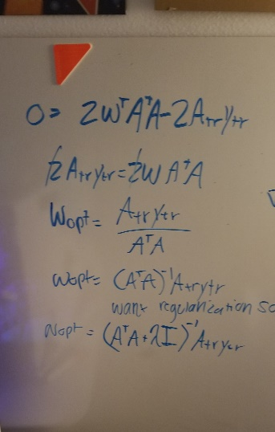

1.D – Gradient Algorithm presentation and effects of α and τ:

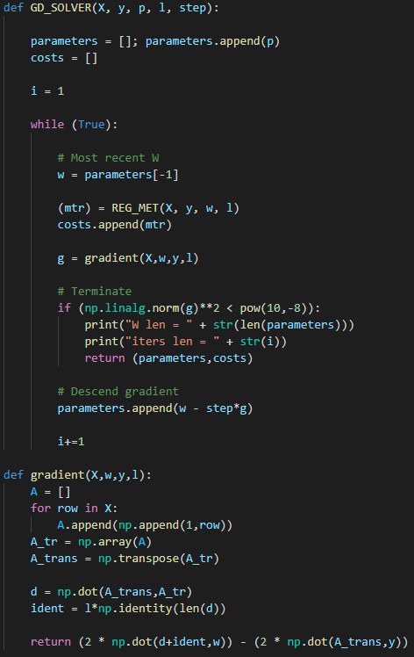*Discussion –* α represents the *step* that must be taken towards the minimal value of the computed gradient. Each of the w values changes with the gradient descent iterations - towards an optimal set of parameters. By subtracting the previous set of w parameters by the current gradient “direction,” computed by gradient(W,x,y,z), the algorithm gets closer to a solution that minimizes the cost function. Step is a multiplier that is used to get closer to the minimum of the gradient function. Increasing the step could lead to overfitting and would overshoot on the gradient.

τ, a threshold per se, is used to compute how close the parameters get us to an optimal regression line. First, we step towards the minimum, then we check how close we are. τ ensures that we are close to the minimal value. If the summation of the squares of the parameters (the cost at that parameter iteration) is lower than τ, then that means the most recent w parameters have- as closely as possible and within reason – calculated a minimal cost.

*ignore the print statements*

**Problem 2 – Linear Regression (true function is affine)**

2.A <https://github.com/ajl3545/AI_HW3/blob/main/problem2.py> or check out included file

2.B – Present the results of CF_SOLVER on training and testing data and show MSE for each:

Training data:



Testing data:



The Results: barely a difference, with the Wopt values nearly being the same. The testing data however, had more data and took less time to run. The training data took nearly 10x more iterations to come up with a result.

(cont.)

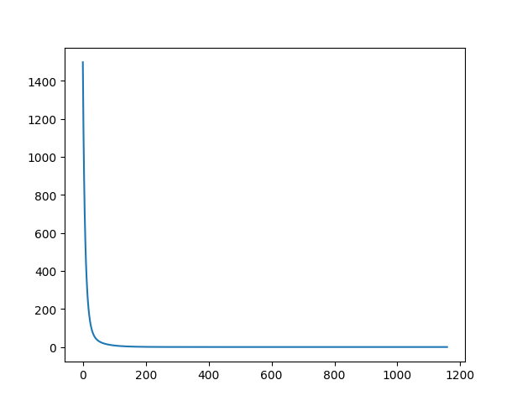2.C – **Figure 1**. Regression objective(y) versus GD iteration (x). As the iteration progresses along the x axis, the cost metric reduces – which is expected since we want the cost to be minimal.

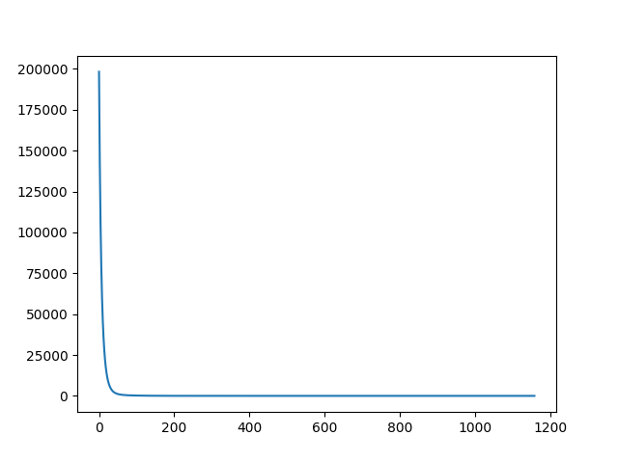2.D – **Figure 2.** Euclidean norm (y) versus the iteration (x). Total # of iterations = 1158 on training data:

2.E – **Figure 3.** The metric lines (black) for both testing and training overlap since they are so small. Plotted are the MSE values for training (blue), testing, (red), and the benchmark MSE values (black) calculated by CF_SOLVER. Both MSE’s converge close enough to the benchmarks to consider calculation successful.

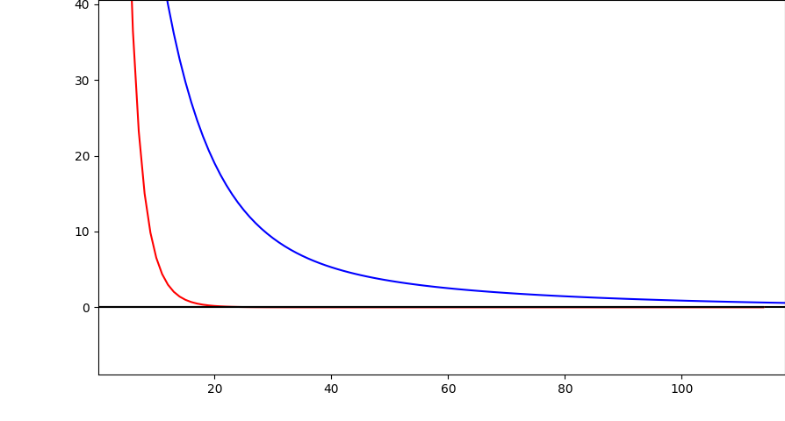

2.F – The benchmarks were meaningful since they predict a successful linear regression. Since the benchmark values aim to be at zero, the MSE lines must align with the benchmark as the iterations grow along the X axis. The MSE’s are both aligning with the benchmark.

2.G – **Figure 4.** There isn’t even 10 lines in the testing data to compare with… I still managed to run the plots. It seems that when the dataset is lower, more iterations are needed to converge to a minimum. Less data means more effort to calculate a relationship between variables. When there is more data, the linear relationship becomes more evident more quickly:

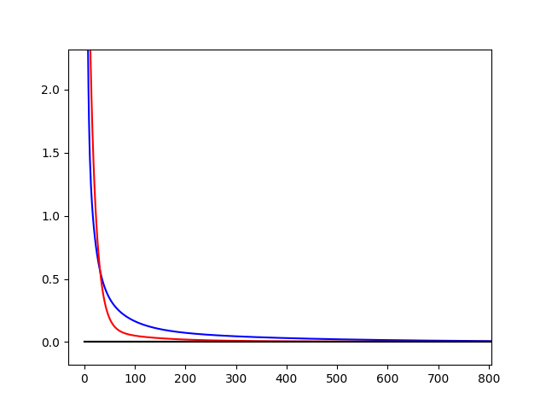

(cont.)

2.H – **Figure 5.** With lambda = 2. There were nearly 5k iterations on the training data and over 20k iterations on the testing data. I assume that with a large enough lambda, the data overfits or overshoots? The benchmark data is out of whack and doesn’t represent a proper value at all. Affecting the regularization skews the accuracy:

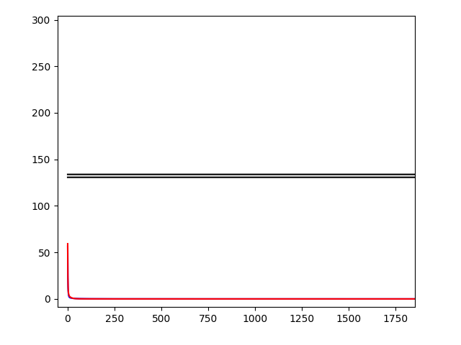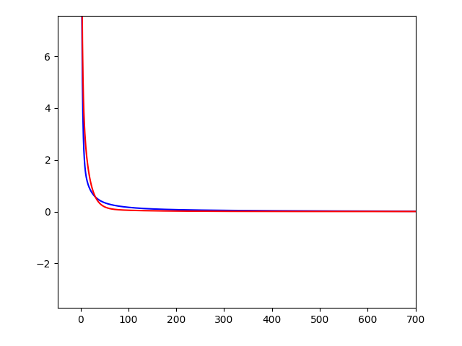

**Problem 3 - Linear Regression (true function is affine + noise)**

*All of the following graphs

Red: l=0

Green: l=0.1

Blue: l=1

3.A – Check out the GitHub link : <https://github.com/ajl3545/AI_HW3/blob/main/problem3.py> or see attached files problem3.py.

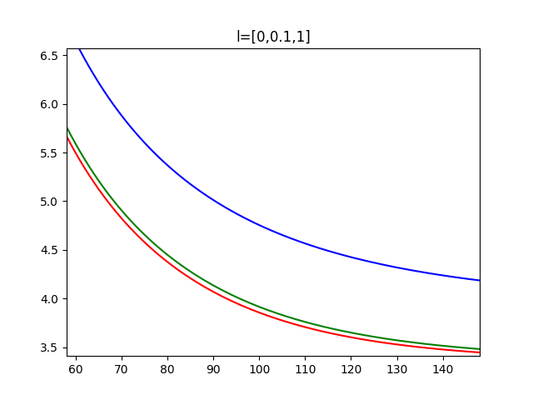3.B – **Figure 6-7** For l = [0,0.1,1] in the training data:

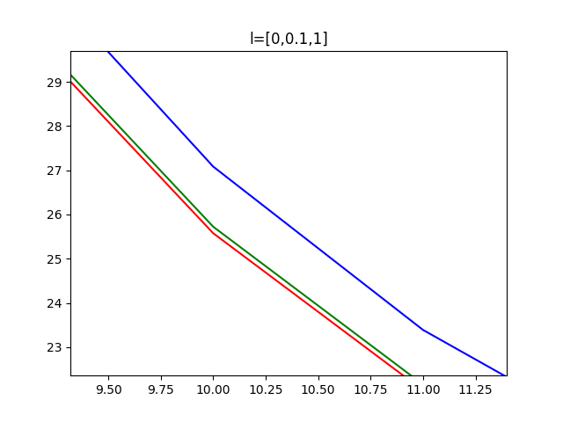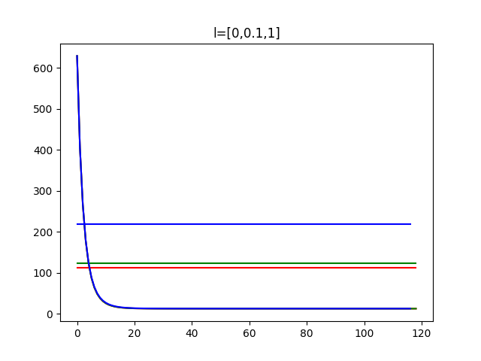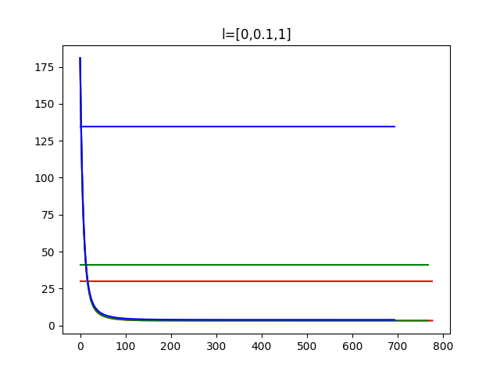test:

3.C – **Figure 8.** For fewer data. Not sure I did this correctly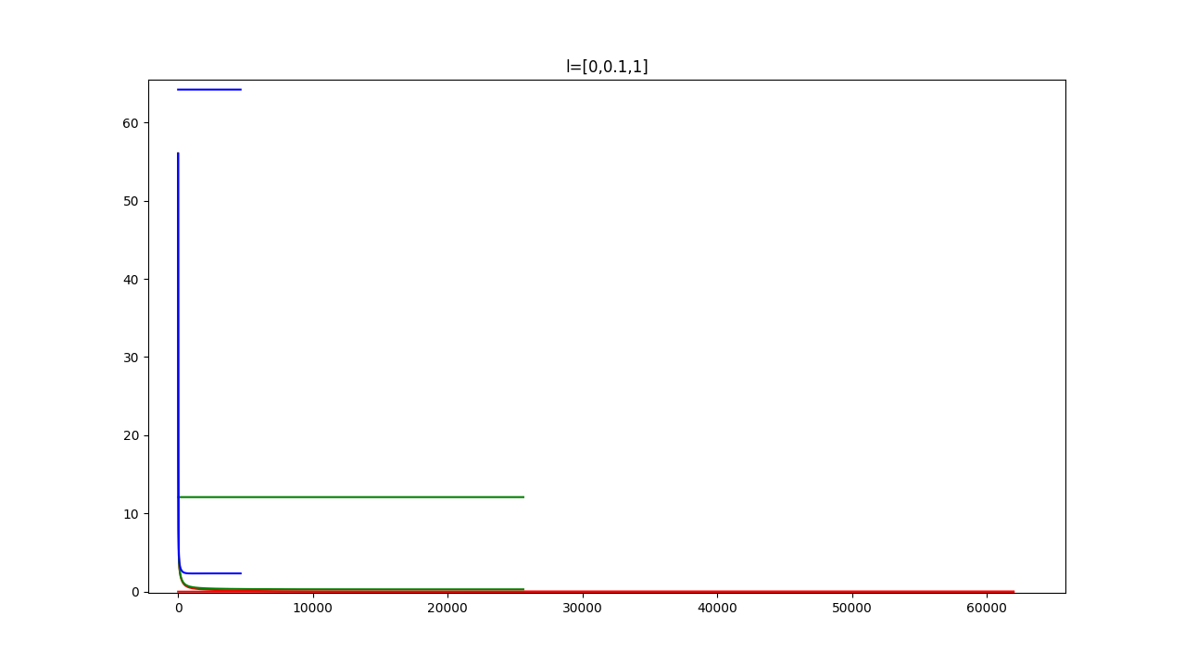

I don’t know what the remaining questions for problem 3 are asking…

I tried my best. I still need to understand the concepts clearly. I can’t even zoom into the graphs properly at this point.

DATA

The following is a MSE converging on 0 error over the course of several GD iterations given a random set of parameters and training data from clean data and lambda=0 and step = 0.01:

CF_SOLVER DATA START

Wopt =

[0.9999999999999989, 2.0000000000000018, 2.999999999999999, 4.0, 4.999999999999999, 5.0, 3.999999999999999, 2.9999999999999996, 1.9999999999999998, 1.0000000000000022]

Scientific notation. These values are nearly 0 (pretty much zero)

Opt Cost (mtr) = 3.3695454009416875e-28

Opt MSE = 3.7439393343796526e-29

CF_SOLVER DATA END

GD_SOLVER DATA START

W len = 111

iters len = 111

MSE 0 = 166.4035357461

MSE 1 = 32.2847049312

MSE 2 = 11.4500481246

MSE 3 = 6.0198087551

MSE 4 = 3.9534427416

MSE 5 = 2.8626801898

MSE 6 = 2.1549692721

MSE 7 = 1.6486129376

MSE 8 = 1.2711225328

MSE 9 = 0.9846285416

MSE 10 = 0.7652286020

MSE 11 = 0.5962770496

MSE 12 = 0.4656485482

MSE 13 = 0.3643217362

MSE 14 = 0.2855073769

MSE 15 = 0.2240578514

MSE 16 = 0.1760480677

MSE 17 = 0.1384709846

MSE 18 = 0.1090134325

MSE 19 = 0.0858895519

MSE 20 = 0.0677161522

MSE 21 = 0.0534188664

MSE 22 = 0.0421610999

MSE 23 = 0.0332899662

MSE 24 = 0.0262949577

MSE 25 = 0.0207762204

MSE 26 = 0.0164201081

MSE 27 = 0.0129802817

MSE 28 = 0.0102630512

MSE 29 = 0.0081159775

MSE 30 = 0.0064189887

MSE 31 = 0.0050774403

MSE 32 = 0.0040166850

MSE 33 = 0.0031778171

MSE 34 = 0.0025143317

MSE 35 = 0.0019895003

MSE 36 = 0.0015743059

MSE 37 = 0.0012458175

MSE 38 = 0.0009859092

MSE 39 = 0.0007802506

MSE 40 = 0.0006175097

MSE 41 = 0.0004887245

MSE 42 = 0.0003868063

MSE 43 = 0.0003061475

MSE 44 = 0.0002423117

MSE 45 = 0.0001917891

MSE 46 = 0.0001518022

MSE 47 = 0.0001201534

MSE 48 = 0.0000951038

MSE 49 = 0.0000752771

MSE 50 = 0.0000595840

MSE 51 = 0.0000471628

MSE 52 = 0.0000373311

MSE 53 = 0.0000295490

MSE 54 = 0.0000233893

MSE 55 = 0.0000185137

MSE 56 = 0.0000146544

MSE 57 = 0.0000115997

MSE 58 = 0.0000091817

MSE 59 = 0.0000072678

MSE 60 = 0.0000057528

MSE 61 = 0.0000045537

MSE 62 = 0.0000036045

MSE 63 = 0.0000028531

MSE 64 = 0.0000022584

MSE 65 = 0.0000017876

MSE 66 = 0.0000014150

MSE 67 = 0.0000011201

MSE 68 = 0.0000008866

MSE 69 = 0.0000007018

MSE 70 = 0.0000005555

MSE 71 = 0.0000004397

MSE 72 = 0.0000003481

MSE 73 = 0.0000002755

MSE 74 = 0.0000002181

MSE 75 = 0.0000001726

MSE 76 = 0.0000001366

MSE 77 = 0.0000001082

MSE 78 = 0.0000000856

MSE 79 = 0.0000000678

MSE 80 = 0.0000000536

MSE 81 = 0.0000000425

MSE 82 = 0.0000000336

MSE 83 = 0.0000000266

MSE 84 = 0.0000000211

MSE 85 = 0.0000000167

MSE 86 = 0.0000000132

MSE 87 = 0.0000000104

MSE 88 = 0.0000000083

MSE 89 = 0.0000000065

MSE 90 = 0.0000000052

MSE 91 = 0.0000000041

MSE 92 = 0.0000000032

MSE 93 = 0.0000000026

MSE 94 = 0.0000000020

MSE 95 = 0.0000000016

MSE 96 = 0.0000000013

MSE 97 = 0.0000000010

MSE 98 = 0.0000000008

MSE 99 = 0.0000000006

MSE 100 = 0.0000000005

MSE 101 = 0.0000000004

MSE 102 = 0.0000000003

MSE 103 = 0.0000000002

MSE 104 = 0.0000000002

MSE 105 = 0.0000000002

MSE 106 = 0.0000000001

MSE 107 = 0.0000000001

MSE 108 = 0.0000000001

MSE 109 = 0.0000000001

MSE 110 = 0.0000000000

GD_SOLVER DATA END

GRAPH on NEXT PAGE

