Error Handling in Qlikview

## Introduction:

Error handling is one of the most important—and overlooked—topics for programmers, regardless of the language used. In general, an exception is handled (resolved) by saving the current state of execution in a predefined place and switching the execution to a specific subroutine known as an exception handler.

There are variables in Qlikview to determine what action is to be taken by QlikView when an error is encountered during script execution. Lets explain this concept with an example.

### Explanation:

The Error variables in qlikview are

1. ErrorMode
2. ScriptError
3. ScriptErrorDetails
4. ScriptErrorCount
5. ScriptErrorList

**ErrorMode:**

Values assigning to this variable will decide what action to be taken by qlikview when an error is encountered.

**Set ErrorMode=0 🡪** Will ignore the failure and continue script execution.

**Set ErrorMode= 1 🡪**Will halt the script execution when an error is encountered and prompt user for action.

**Set ErrorMode= 2 🡪**Will display an "Execution of script failed..." error message immediately on failure, without prompting the user for action

**ScriptError:**

This variable will return the error code of the last executed script statement. Each error code has corresponding meaning.

**Error code:**

1🡪No Error. 4🡪General ODBC Error. 7🡪General HTML Error 10🡪 Table Not Found.

2🡪General Error. 5🡪General OLEDB Error. 8🡪 File Not Found. 11🡪Field Not Found.

3🡪 Syntax Error. 6🡪General XML Error. 9🡪 Database Not Found 12🡪File Has Wrong Format

**ScriptErrorDetails:** Returns detailed description of the error.

**ScriptErrorCount:** Returns total number of statements that have caused error.

**ScriptErrorList**: It will contain concatenated list of all script errors that have occurred during script execution.

Example:

Writing an Qlikview script to show how this error variable works. Lets load an file that doesn’t exist in the mentioned location.

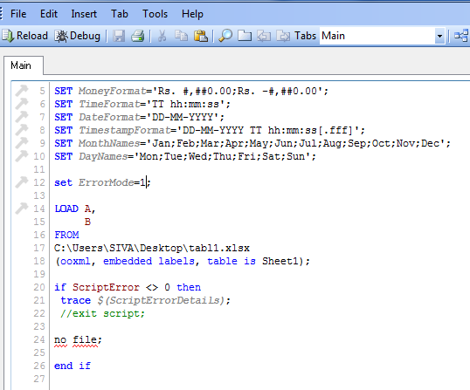

Now, run the QVW file to test this process. It will throw the error as shown below.

