

**CEN 308 SOFTWARE ENGINEERING**

PROJECT DOCUMENTATION

CARSHARING

Prepared by:

**Adi Hadžiomerović**

**Ajla Šišić**

Proposed to:

**Nermina Durmić, Assist. Prof. Dr.**

**Aldin Kovačević, Teaching Assistant**

June 24th, 2022

TABLE OF CONTENTS

**Contents**

1. Introduction 3

1.1. About the Project 3

1.2. Project Functionalities and Screenshots. 3

2. Project Structure 6

2.1. Technologies 6

2.2. Database Entities 6

2.3. Architectural Pattern 7

2.4. Design Patterns 7

3. Conclusion 7

# 1. Introduction

## 1.1. About the Project

Carsharing is a globally popular car renting service allowing its subscribers easiest methods of private car renting. Users choose which category describes their need based on the vehicles size, capacity, cost and availability. Our products, which are the vehicles we rent, are deployed around the city area and available to other subscribers as soon as the car is parked on a valid parking location by previous subscriber that used that particular vehicle. We monitor the battery and charge the vehicles if necessary, as we would only use electric vehicles, and maintenance requirements in case the vehicle needs any. Similar to nextbike and BeeBee Scooters, there would be a map displaying locations of available vehicles that would also include their type, cost and current battery status

However, taking into consideration that this is a mobile app, we decided to create a website for administration purposes, such as listings, statistics, communication and etc.

The application is hosted on Heroku at: <https://carsharingse.herokuapp.com/>

## 1.2. Project Functionalities and Screenshots.

* Vehicle listing (CRUD)
* User registration and validation
* Commenting/Communication
* Task scheduling
* Order history
* Support ticket system

**Screenshots:**

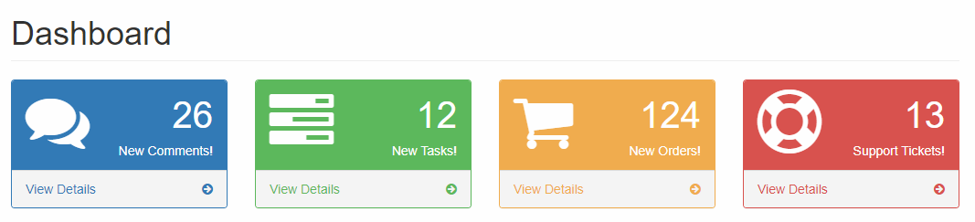

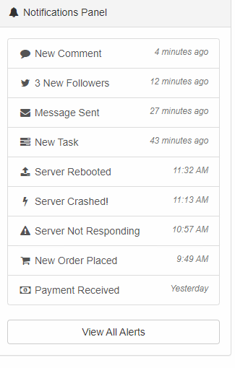

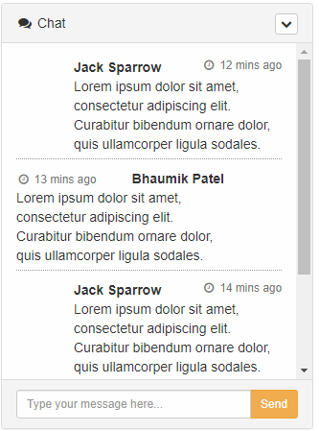

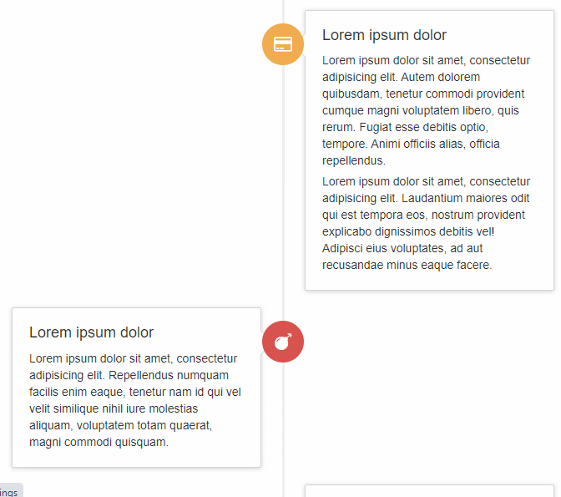

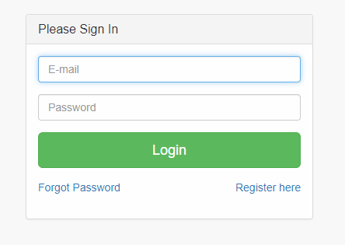

# 2. Project Structure

## 2.1. Technologies

The technologies used for our website are: HTML, CSS, Bootstrap, PHP and the data is being stored and read from a MySQL database. There are some JavaScript assets that were input as well. The code was written in Visual Studio Code, endpoints tested with Postman and database communication through SQLyog.

We were cautious throughout the development phase and we took extra care to have all coding standards we mentioned in the lectures and labs. Our style can be related to PSR-1, as during coding we followed the standards of the mentioned PHP Standard Recommendation which includes naming conventions, file and folder organization, commenting, classes and functions, and tests.

## 2.2. Database Entities

List of database entities:

* Accounts
* Locations
* Payments
* Rentaldetails
* Users
* Vehicles

## 2.3. Architectural Pattern

The architectural pattern used for the development is the layered pattern. We decided to use the mentioned pattern since we decided to create a fullstack web app which required many functions, services and entities. Our core backend files would be the ones found in the ../api directory while the subfolders within it are higher levels of the layer that use the lower-level services and functions.

One of the most used layers/folders throughout the project is probably the vendor file that contains FlightPHP, Autoload composers, JWT, Swagger PHP and etc.

## 2.4. Design Patterns

* Builder pattern: used in the backend, in the file *../api/config.php* – since it’s a web app for multiple users and multiple intentions, we established the database connection through this file and built a SMTP connection.
* Decorator pattern: used for the frontend, in the file *../assets/css and ../assets/fonts* – we implemented bootstrap for an easier and adaptive design.

# 3. Conclusion

Overall, we are happy with how the website look, the simplistic design of it seemed like a good choice. However, our time management was poor due to the updated independencies that caused some issues which we discovered just before the deadline.

Nevertheless, we would like to improve our PHP knowledge further through similar projects and tasks as we believe practical examination is the best method of learning and widening your skills when it comes to backend development.