**Abstract**

Pyrolysis of methane is carried out at 1 atm pressure, in the presence of Sodium catalyst at 973 K temperature. Partial pressure of methane and argon gases is 0.45 atm, and for sodium it is 0.45 atm. Based upon the reaction kinetics and mechanisms, a data of concentration of CH4 vs time is plotted.

**Sensitivity Analysis using Degree of Reaction Control**

A method of sensitivity analysis, called Degree of Reaction Control (DRC) is used

here to determine the rate-limiting steps from the number of reaction steps.

Following is the equation to calculate DRC:

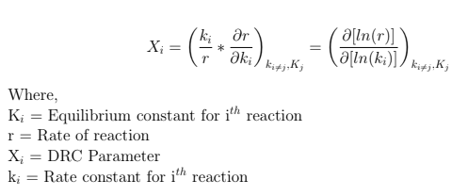

**Rate Equation**

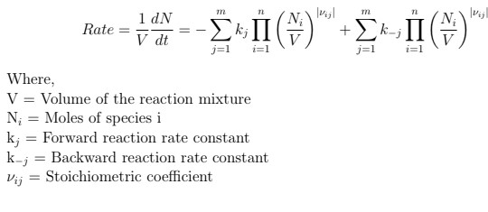

**Result Plot**

