**MATLAB For Scientists**

**HW6**

**Instructions**

* Complete each question below in an **individual** script or function. Each individual script should be named according to: HW#Q#_script.m, or HW#Q#_fun.m where <#> indicates the corresponding HW number or question. These are the scripts that will be considered for grading.
* Submit all files (**including** the provided data, but **excluding** any tables/files that are saved as a result of the HW question) as a compressed .zip folder with the name **<HW#_YourCodeName.zip>.**
* Each script **must** run entirely through without error. If you did not finish part of a question, comment it out so it runs.
* Suppress all intermediate outputs other than your answer to the question; only the answer should display on the command line.
* Absolutely no hard coding beyond the minimum specified.
* **All plotting should now conform to our guidelines of publication quality figures**
* **Everything must be commented. Uncommented codes get zero credit!**

**Problems**

**Question 1**

Diff can be used to solve for critical values of x (e.g., where f’(x)=0). Use this approach to plot f(x) as a function of x, and on the same plot, overlay square (‘s’) markers at each critical point. Choose any x vector that generates a smooth function f(x) between the ranges of 0 and 4.

Hint: sign(m), where m is any vector or matrix, outputs a matrix of the same size as m, with 1 where m > 0, -1 where m < 0, and 0 otherwise.

$$f\left(x\right)=5\cos\left(10x\right)+x^{3}-2x^{2}-6x+10$$

**Question 2**

Relative luminescence units (RLU) is a commonly used reporter that is linearly correlated with intracellular ATP on the log-log scale, meaning that of both measurements are log-transformed, they will exhibit a strong linear relationship. HW6Q2_atpRLU.xlsx contains three replicates of RLU measurements at the same 6 concentrations of ATP. ATP vs. Using this data, write a script that does the following:

* Log-transforms the data
* Uses a for loop to (1) generate a figure with 1x3 subplots such that each individual subplot contains a scatterplot of ATP vs. one replicate of RLU along with the corresponding line of best fit in black, and (2) collects in a single matrix the correlation coefficient, and the fitted parameters, for each replicate
* Displays the equation for the relationship between log-ATP and log-RLU using the average of the collected parameters

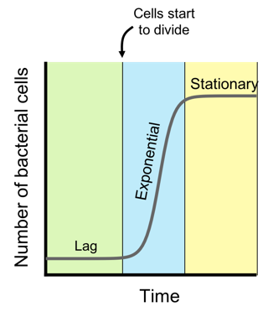

Figure 1: Growth curve of bacterial population over time

**Question 3**

Bacteria go through three phases of growth (Figure 1): lag, exponential, and stationary. The bacterial growth rate corresponds to the rate of expansion during exponential phase. Accurately extracting this quantity from growth curve data is critical to automate new antibiotic discovery. HW6Q3_single.mat has a time vector and a data vector of cell density over time. Using this data, write a script that does the following:

* 1. Fits cell density over time using lsqcurvefit for both the Logistic and Gompertz equations below. Here, l is the time lag (where blue region begins in Figure 1), A is the maximum density (#cells at stationary phase), and mm is growth rate (typically == 0.5).
  2. Plots each fit on the same figure as the data using different colors for the fits
  3. 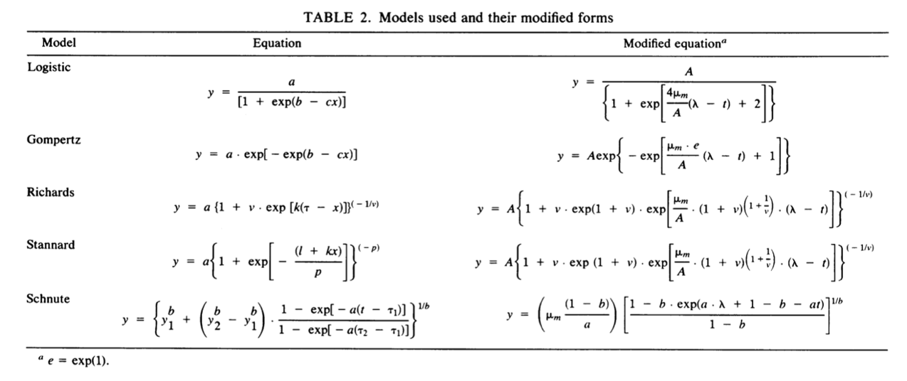Reports the growth rate from each method.

**Question 4**

These growth rates are used to determine an organism’s sensitivity to a drug, such as an antibiotic, or chemotherapeutic. Specifically, growth inhibition as a function of a drug concentration creates a characteristic dose response curve from which an IC50 value can be obtained (Figure 2). The IC50 value corresponds to the drug concentration at which the growth rate is exactly inhibited by half, and the equation for obtaining the IC50 is the following:

$$μ=\frac{μ_{Max}IC_{50}^{n}}{{\left[Drug\right]}^{n}+IC_{50}^{n}}$$

Recently, we tested the drug sensitivity of a clinical multi-drug resistant bacterial isolate to a new antibiotic Telithromycin currently in clinical trials. The file HW6Q4.mat contains a vector time, cell density in a matrix called ydata, and a vector called drugCon, consisting of 8 drug concentrations in g/mL. ydata is organized such that the rows correspond to time, and every three columns is a set of replicates at a single concentration (e.g., the first three columns of data correspond to growth at drugCon(1), the next three correspond to drugCon(2), etc.). Write a script that does the following:

Figure 2: Growth inhibition dose response

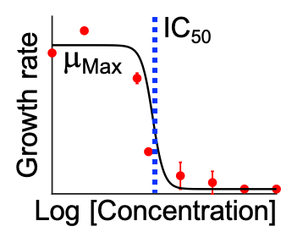

* Uses either equation from (Q3) to determine the growth rate for each column in ydata, and then calculates the growth rate average and standard deviation for each set of 3 replicates
* Generates a scatter plot where the y-axis is the average growth rate from the three replicates, and the x-axis is drug concentration, as shown in figure (2), including error bars representing the standard deviation of the replicates
* Fits average growth rates and drug concentrations using the dose response equation above, to obtain mfit, and plots it as a black sigmoidal curve
* Displays the calculated IC50 concentration as a complete sentence

Notes:

1. The x-scale is on a log-transformed axis; this does not change the fitting procedure, but does help visualize the fit. Use log scale in your final figure.
2. Any growth rate calculated to be negative is an artifact of fitting and can be set equal to zero
3. Your initial guess = [2, 4, 0.5] for mm, n, and IC50, respectively.