X. Complete System Framework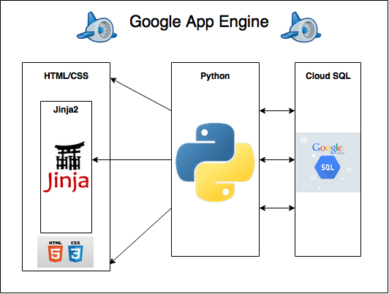

This figure depicts the complete framework of the system that we used to build Moogle. The central and most important piece of the framework is Google App Engine (GAE). GAE provided us with all the necessary tools to build a robust and scalable web store and also allowed us to run the our web application on top of Google’s stable infrastructure. Every element of the website was built within the GAE environment.

The command center of our application lies within the Python code contained in moogle.py. This Python code handles all of the users’ requests, serves the appropriate HTML files, and maps all of the URLs to their respective handlers. This is also where we communicate with our MySQL database in the form of Google’s Cloud SQL. This database is another feature provided by GAE in which all of the information that our application uses in our database is stored within the cloud and can be obtained by any application that is authorized access to it. Within the Python code we are also able to send variables and data to the Jinja2 template engine so that they can be used and rendered within the HTML and displayed on the site’s front end.