**Bamazon – screenshots**

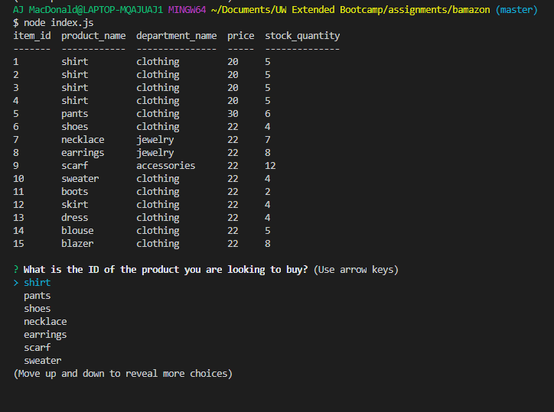

Using arrow keys, I navigated to ‘scarf.’ I am prompted to enter the desired quantity:

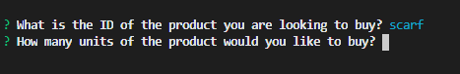

I am currently running into an error:

