**Liribot Screenshots**

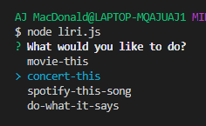 Menu of options so that user can navigate to which action they’d like to take.

Movie-this option is functioning as it should.

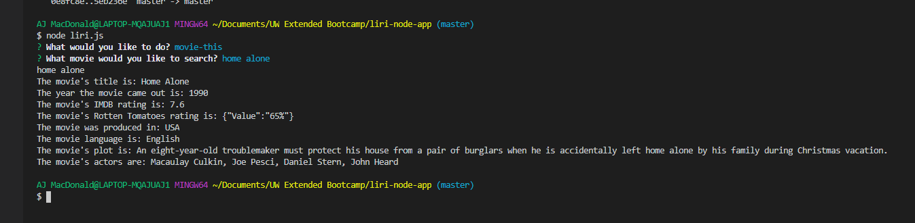

Bands in town/concert-this:

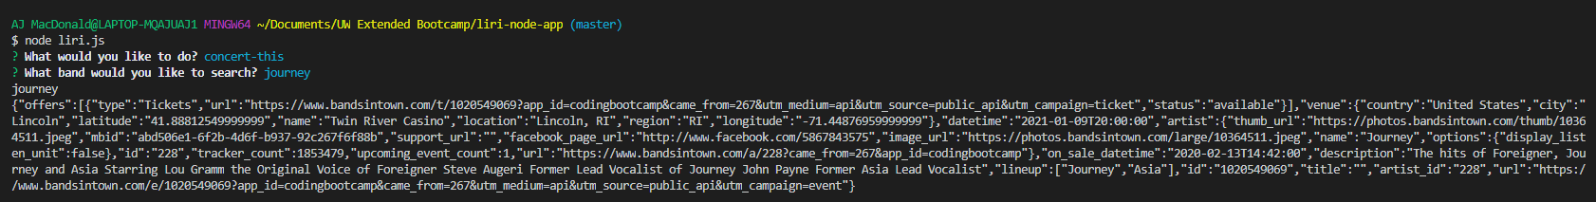

Spotify search keeps returning “undefined,” so going to take a look at that.

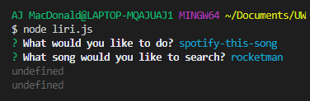

Do what it says currently returns nothing.  
