| Characteristic | N = 77 |
| --- | --- |
| **Age of First Use** |  |
| Mean (SD) [Minimum-Maximum] | 23.3 (5.2) [15.0-42.0] |
| **Alcohol Use Disorder** |  |
| At risk | 58 (75%) |
| Not at risk | 19 (25%) |
| **Frequency of Use at Peak** |  |
| 1 to 2 times per month | 31 (40%) |
| Weekly | 33 (43%) |
| Daily | 13 (17%) |
| **Last Meth Use** |  |
| Years | 10 (13%) |
| Months | 13 (17%) |
| Weeks | 33 (43%) |
| Days | 21 (27%) |
| **Mode of Use** |  |
| Snorting | 1 (1.3%) |
| Oral | 5 (6.5%) |
| Smoking | 13 (17%) |
| Injection | 58 (75%) |
| **Other Illicit Drug Use** | 73 (95%) |
| **Substance Dependence Severity** |  |
| MUD | 69 (90%) |
| Recreational | 8 (10%) |

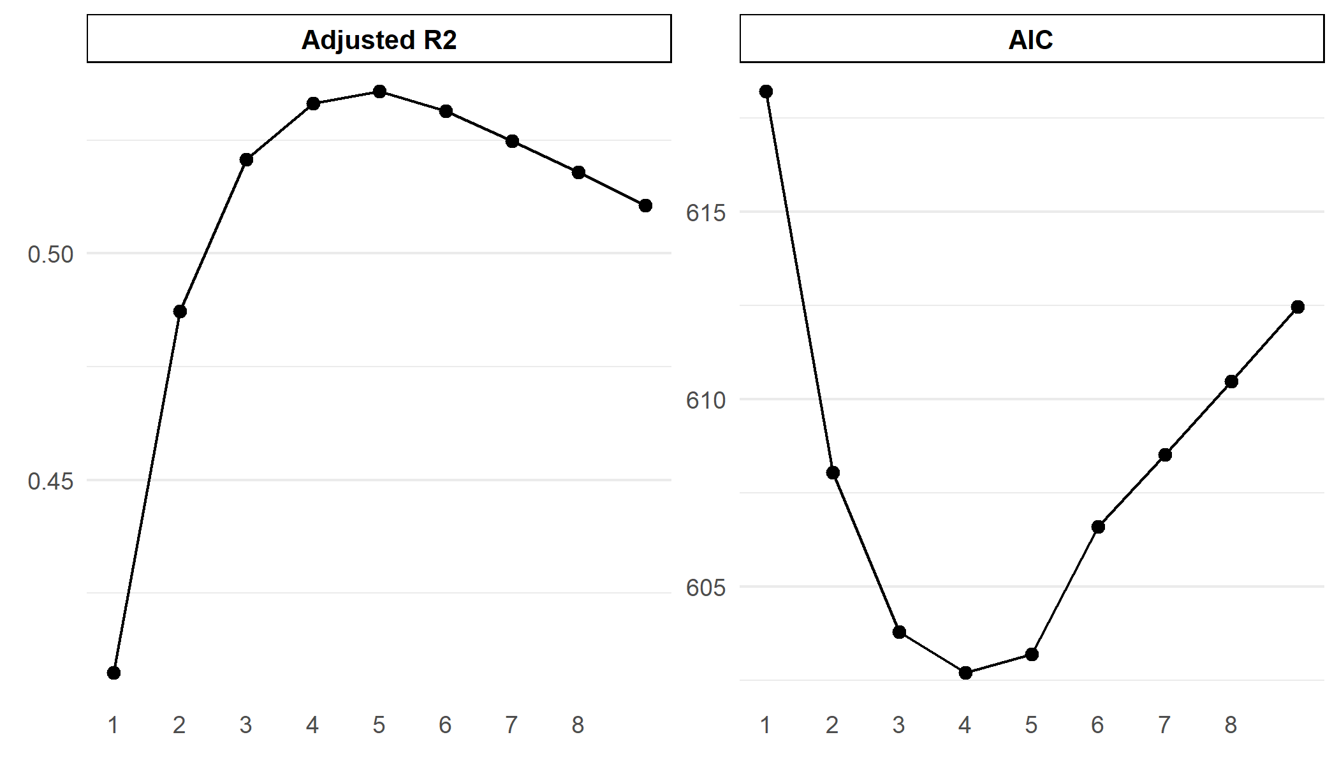

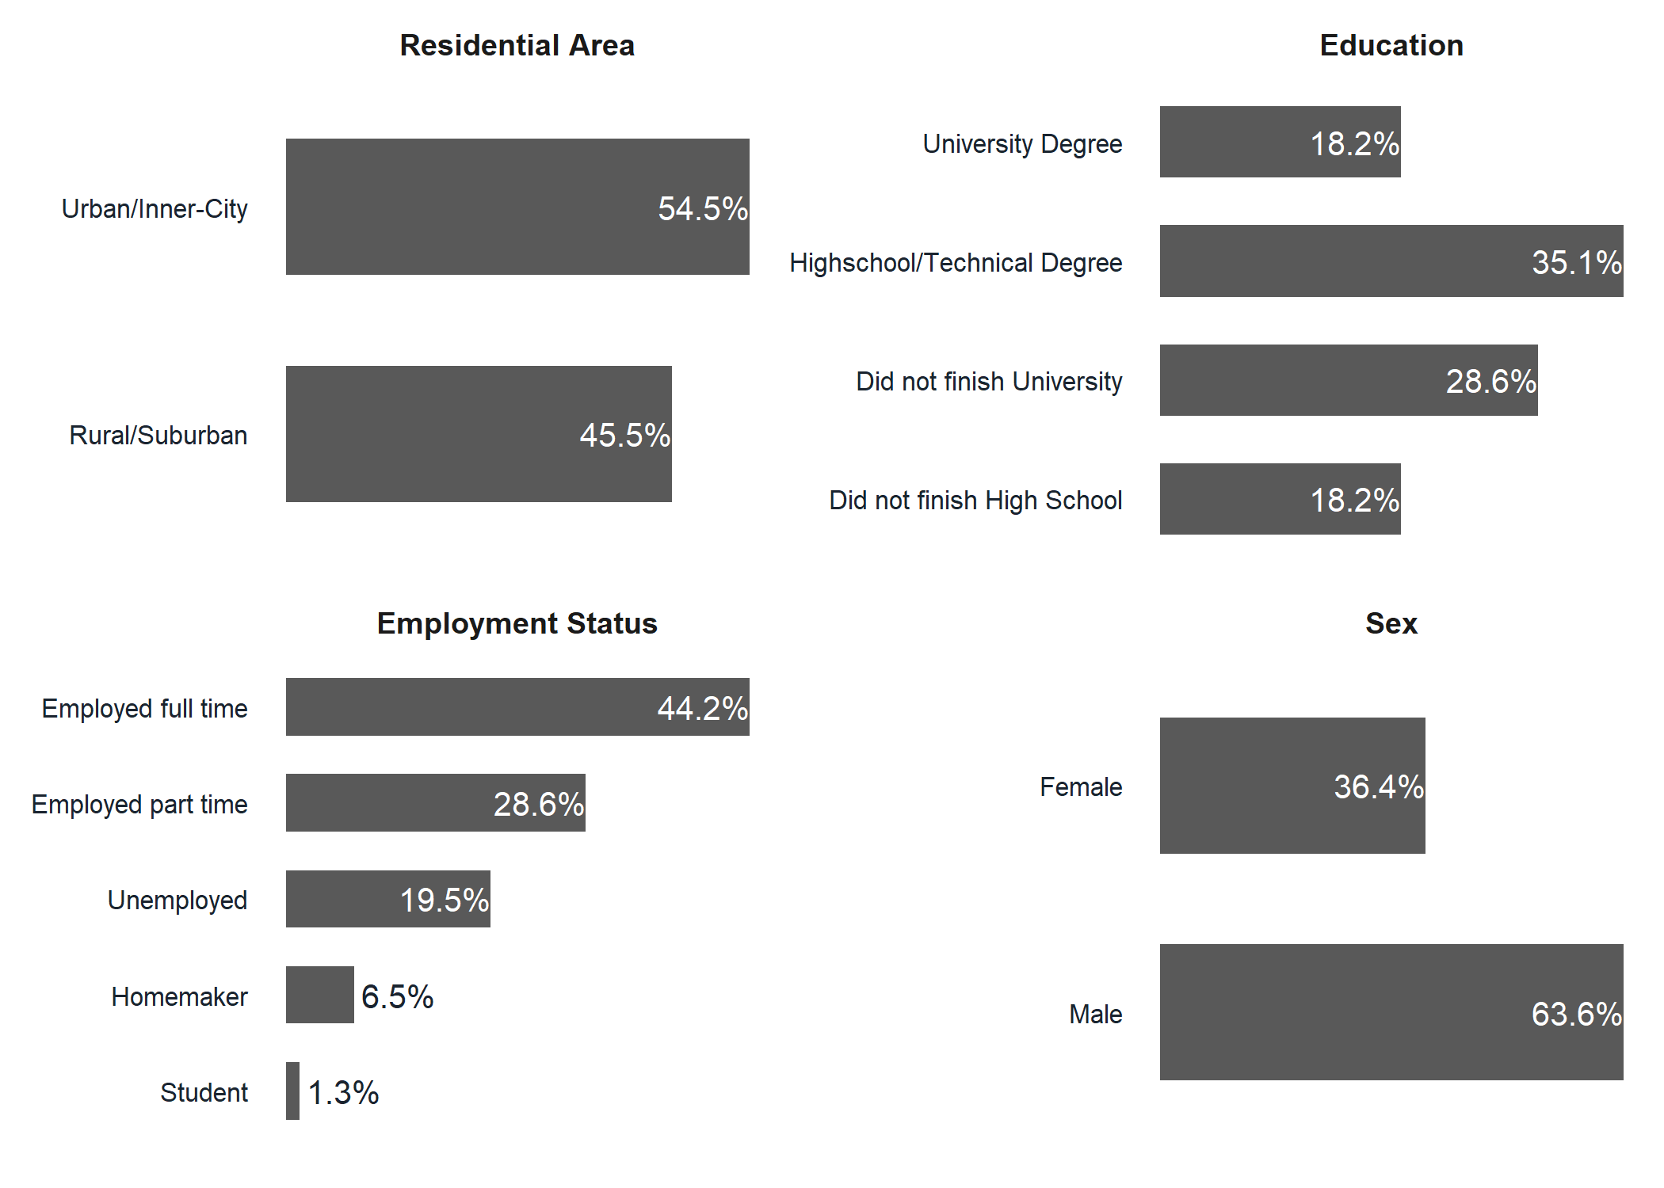

| N | Predictors | R2 | Adj R2 | AIC |
| --- | --- | --- | --- | --- |
| 1 | Trait Anger | 0.42 | 0.41 | 618.21 |
| 2 | Alcohol Use State Anger | 0.50 | 0.49 | 608.05 |
| 3 | Alcohol Use Trait Anger State Anger | 0.54 | 0.52 | 603.79 |
| 4 | Alcohol Use Methamphetamine Dependence Trait Anger State Anger | 0.56 | 0.53 | 602.71 |
| 5 | Residential Area Alcohol Use Methamphetamine Dependence Trait Anger State Anger | 0.57 | 0.54 | 603.21 |
| 6 | Education Residential Area Alcohol Use Methamphetamine Dependence Trait Anger State Anger | 0.58 | 0.53 | 606.60 |
| 7 | Age Education Residential Area Alcohol Use Methamphetamine Dependence Trait Anger State Anger | 0.58 | 0.52 | 608.53 |
| 8 | Age Sex Education Residential Area Alcohol Use Methamphetamine Dependence Trait Anger State Anger | 0.58 | 0.52 | 610.49 |
| 9 | Age Sex Education Residential Area Alcohol Use Methamphetamine Dependence Psychological Distress Trait Anger State Anger | 0.58 | 0.51 | 612.46 |

| **term** | **Estimate** | **CI** | **Partial** | **F2** | **p** |
| --- | --- | --- | --- | --- | --- |
| (Intercept) | 19.76 | 8.17-31.35 |  |  | 0.001 |
| trait.total | 0.92 | 0.23-1.62 | 0.30 | 0.04 | 0.01 |
| state.total | 0.47 | 0.11-0.84 | 0.29 | 0.04 | 0.012 |
| sds.total | 1 | -0.16-2.16 | 0.20 | 0.04 | 0.09 |
| audit.total | 1.58 | 0.47-2.69 | 0.32 | 0.09 | 0.006 |
|  |  |  |  |  |  |
| F | 22.7 |  |  |  |  |
| df | (4, 72) |  |  |  |  |
| p | 0 |  |  |  |  |
| R2 | 0.56 |  |  |  |  |
| Adj R2 | 0.53 |  |  |  |  |
| AIC | 602.71 |  |  |  |  |