Regression Assumptions

Aaron

$$DDDI_{i}=β_{0}+β_{1}attitude_risk+β_{2}attitude_sanction+β_{3}attitude_peer+e_{i}$$

## Assumptions

### Linearity

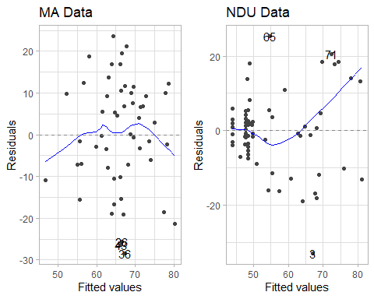

### Normality

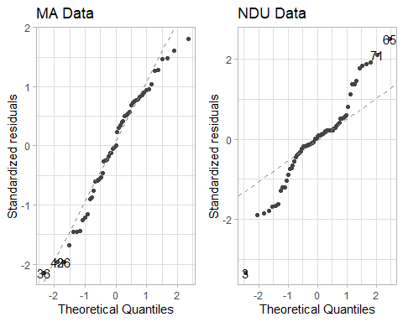

### Equal Variance

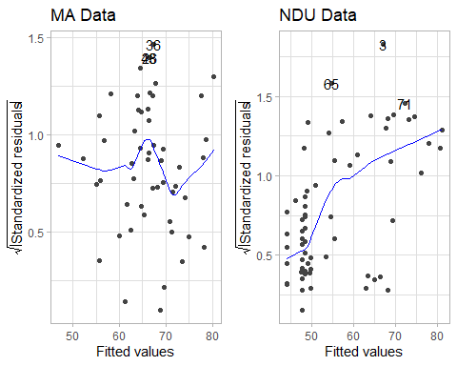

### Multicolinearity

Multicolinearity (MA Data)

| **var** | **VIF** | **TOL** |
| --- | --- | --- |
| DUID Risk | 2.23 | 0.45 |
| DUID Sanction | 2.04 | 0.49 |
| DUID Peer | 1.37 | 0.73 |

Multicolinearity (NDU Data)

| **var** | **VIF** | **TOL** |
| --- | --- | --- |
| DUID Risk | 1.60 | 0.62 |
| DUID Sanction | 2.41 | 0.41 |
| DUID Peer | 2.13 | 0.47 |