For the CASE competition, I tried implementing two quantitative strategies on the quantopian quantitative algorithmic trading platform and divided my portfolio asset allocation equally across the two strategies. A brief summary of each strategy is presented below:

1. **Exponential Regression on Momentum**

This strategy looked at momentum as an alpha factor and attempted to get linear coefficients for the log of the asset price as a time series. The function returns the annualized slope (multiplied by the r^2 value to incorporate a confidence metric in the result). The strategy quantifies momentum in such a way over two windows: 60 and 90 days (leaving out the last 5 days), averages their momentum scores, and ranks them accordingly to choose the top 10 with the highest momentum score. The back test is summarized below:

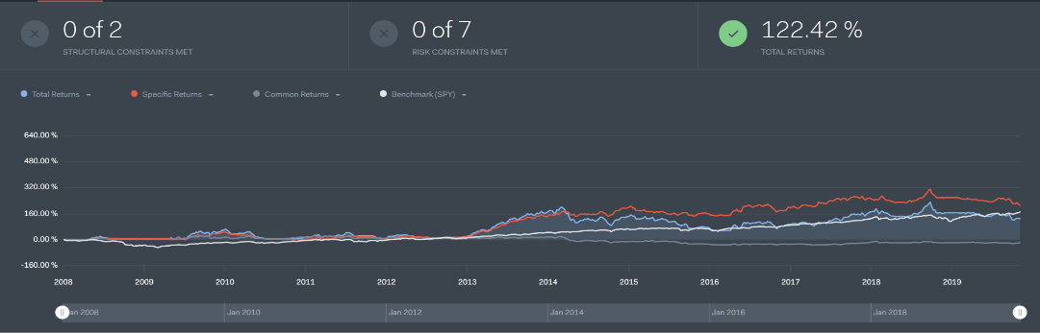

A drawback of this strategy is that it attempts to identify trends in market by looking at momentum, and therefore market exposure is high. In fact, over the course of this back test, Beta to SPY500 was found to be 1.15, with a Sharpe ratio of 0.38.

1. **Momentum Crossover with News Analytics**

This strategy is again structured as a long-hold-sell strategy by quantifying momentum. However, in this strategy, rather than using an exponential regression slope, asset momentum is quantified more naively, via using moving average signals for different window lengths. Upon crossover of these signals, a buy/sell signal is generated. However, there are two more factors used in this strategy: The CBOE VIX index and financial news data from Sentdex. The buy signal is generated when there is a short-term trend spotted by the moving average windows, and the VIX close value is below a certain threshold (to prevent buying assets in a market with high expected volatility). The other factor at play here is from Sentdex news analytics. Sentdex provides sentiment analytics (using NLP) on financial data for various companies. These analytics are used (in conjunction with downward momentum trends) to trigger a sell signal for equities that have a strong negative sentiment from recent news publications. A back test for this strategy can be seen below:

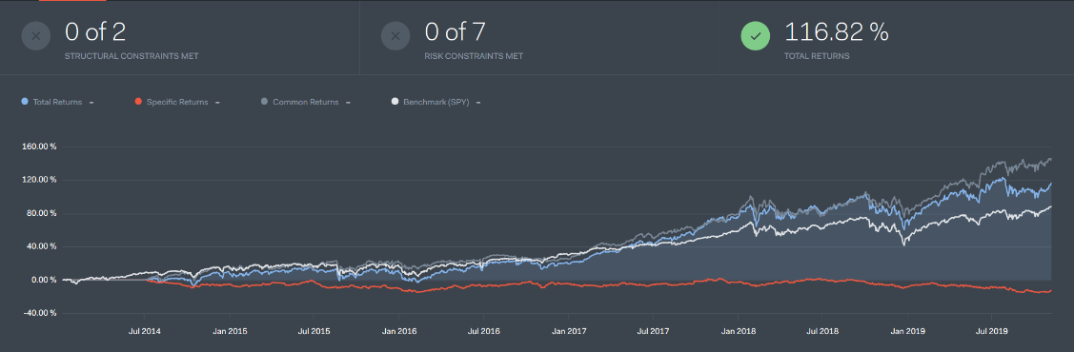

Again, the major drawback here is the high market exposure with a Beta to SPY500 of around 1.1 in the back test shown above. The Sharpe Ratio is more promising though, at a value of 1.11.