Buying over MA

* 1. File: indicator/overma.xlsx
  2. legend: lower2, upper5 means ma2 is under ma5
  3. **asset domain**: **MIXED results.** **Strategy depends on individual stock.**  In Chinese Market, buying stocks with ma2 < ma240 is better than ma2>ma240. But it is in general not very significant. This finding matches trend2 finding that past winners are likely future losers. Hence buying ma2 >ma240 is already at peak, the cycle will start reverse. Exception here is ma20.

|  |  |  |  |  |  |  |
| --- | --- | --- | --- | --- | --- | --- |
|  | **close2_over** | **close5_over** | **close10_over** | **close20_over** | **close60_over** | **close240_over** |
| **close2** |  | 1.00076 | 1.001026 | 1.000674 | 1.00134 | 1.001961 |
| **close5** | 1.001496 |  | 1.001231 | 1.0009 | 1.001512 | 1.001882 |
| **close10** | 1.001324 | 1.001126 |  | 1.000894 | 1.00151 | 1.001775 |
| **close20** | 1.001725 | 1.001451 | 1.001433 |  | 1.001634 | 1.001613 |
| **close60** | 1.0009 | 1.000702 | 1.000689 | 1.000601 |  | 1.001117 |
| **close240** | 1.000242 | 1.000373 | 1.000662 | 1.000844 | 1.00152 |  |

* 1. **date domain**: **buying WITH the trend is better**. More significant than asset domain.

|  |  |  |  |  |  |  |
| --- | --- | --- | --- | --- | --- | --- |
|  | **closer2_over** | **closer5_over** | **closer10_over** | **closer20_over** | **closer60_over** | **closer240_over** |
| **close2** |  | 0.999202 | 0.999695 | 0.999193 | 1.000021 | 1.000016 |
| **close5** | 1.003408 |  | 1.000624 | 1.000053 | 1.000507 | 1.00001 |
| **close10** | 1.002973 | 1.002206 |  | 0.999915 | 1.000509 | 0.999784 |
| **close20** | 1.003485 | 1.002756 | 1.00292 |  | 1.000982 | 0.999961 |
| **close60** | 1.00275 | 1.002334 | 1.002339 | 1.00195 |  | 1.000574 |
| **close240** | 1.002692 | 1.002685 | 1.002858 | 1.002709 | 1.002193 |  |

Buying MA crossover

* 1. general logic: If the trade is a sinoid wave, then trend strategy is better than when buying at ma cross over. Anticipating turnover points is really important.

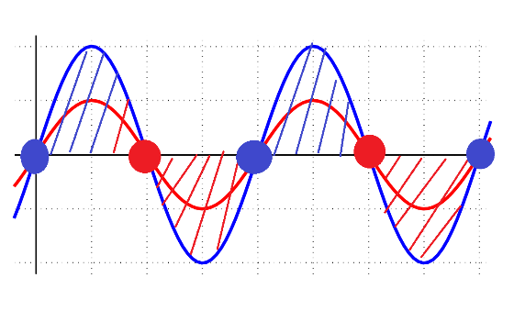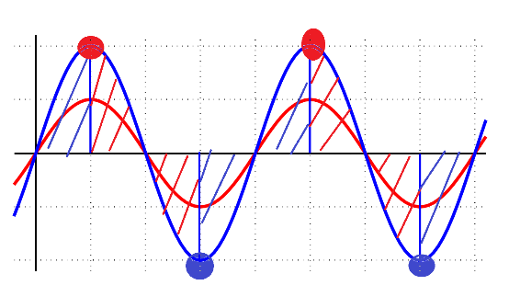

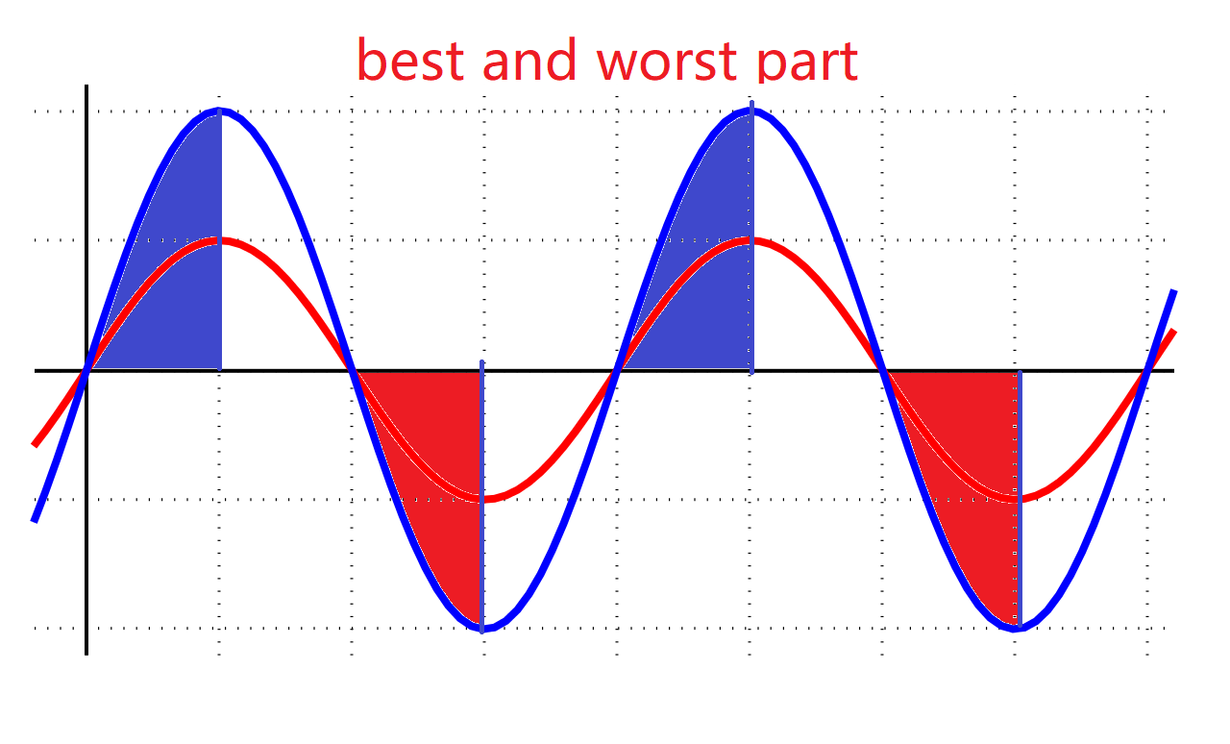

* 1. legend: upper2_cross1_lower5 means close2 was under close5 and now crosses close5 to become higher. upper2_cross-1_lower5 means close2 was above close5 and now crosses close5 to become lower. Basically ignore upper and lower keyword since they are misleading.
  2. **asset domain**: **buying WITH the trend is better**. For fgain2, pgain2 is the most significant indicator. Crossma is more significant for asset than overma.

|  |  |  |  |  |  |  |
| --- | --- | --- | --- | --- | --- | --- |
|  | **close2_cross1** | **close5_cross1** | **close10_cross1** | **close20_cross1** | **close60_cross1** | **close240_cross1** |
| **close2** |  | 1.000851 | 1.000921 | 0.998965 | 0.99786 | 0.999217 |
| **close5** | 1.003653 |  | 1.000883 | 0.999101 | 0.998287 | 1.002512 |
| **close10** | 1.002388 | 0.999586 |  | 0.999598 | 0.999394 | 1.002828 |
| **close20** | 1.003469 | 1.00135 | 1.001898 |  | 1.001123 | 1.000971 |
| **close60** | 1.002656 | 1.000605 | 1.001753 | 1.00251 |  | 1.002519 |
| **close240** | 1.003769 | 1.001778 | 1.001633 | 1.002356 | 1.000773 |  |

|  |  |  |  |  |  |  |
| --- | --- | --- | --- | --- | --- | --- |
|  | **close2_cross-1** | **close5_cross-1** | **close10_cross-1** | **close20_cross-1** | **close60_cross-1** | **close240_cross-1** |
| **close2** |  | 1.003751 | 1.002372 | 1.003563 | 1.002698 | 1.003933 |
| **close5** | 1.000858 |  | 0.999564 | 1.001453 | 1.000603 | 1.001928 |
| **close10** | 1.000964 | 1.000903 |  | 1.002006 | 1.001819 | 1.001795 |
| **close20** | 0.998969 | 0.999029 | 0.999591 |  | 1.002651 | 1.002234 |
| **close60** | 0.997788 | 0.998229 | 0.999537 | 1.001348 |  | 1.000316 |
| **close240** | 0.9989 | 1.002211 | 1.002662 | 1.000667 | 1.002271 |  |

* 1. **date domain**: **the result is no very significant. In general: Buy WITH TREND. Small freq over big freq is good, big freq over small freq is bad. Consistent with overma date finding.** The absolute value does not differ much from overma mean. For fgain2 Crossma date is almost same a overma date.

|  |  |  |  |  |  |  |
| --- | --- | --- | --- | --- | --- | --- |
|  | **close2_cross1** | **close5_cross1** | **close10_cross1** | **close20_cross1** | **close60_cross1** | **close240_cross1** |
| **close2** |  | 0.9983 | 0.999102 | 0.996396 | 0.994199 | 1.002652 |
| **close5** | 1.003422 |  | 0.997955 | 0.998407 | 0.997854 | 1.016089 |
| **close10** | 1.002647 | 1.000139 |  | 0.998891 | 0.993049 | 0.990335 |
| **close20** | 1.005105 | 1.003326 | 0.99768 |  | 1.006798 | 0.991309 |
| **close60** | 1.002675 | 1.002062 | 1.006694 | 1.002813 |  | 1.008152 |
| **close240** | 1.00447 | 1.000322 | 1.001555 | 1.004392 | 1.013447 |  |

|  |  |  |  |  |  |  |
| --- | --- | --- | --- | --- | --- | --- |
|  | **close2_cross-1** | **close5_cross-1** | **close10_cross-1** | **close20_cross-1** | **close60_cross-1** | **close240_cross-1** |
| **close2** |  | 1.003482 | 1.002647 | 1.005105 | 1.002778 | 1.002642 |
| **close5** | 0.9983 |  | 1.000139 | 1.003326 | 1.002189 | 1.000322 |
| **close10** | 0.999085 | 0.99793 |  | 0.99768 | 1.006947 | 0.997033 |
| **close20** | 0.996406 | 0.998436 | 0.998928 |  | 1.003021 | 0.999757 |
| **close60** | 0.994199 | 0.997854 | 0.993049 | 1.006798 |  | 1.008407 |
| **close240** | 1.002652 | 1.013864 | 0.990335 | 0.991309 | 1.008152 |  |

Increase Limit: todo probability dist characteristic before 涨停(tor, etc)

1.1 legend: day1 means 1 day after. Day-1 means 1 day before.

* 1. **asset domain:** After 涨停，the future gain will not be good. Fgain for the next n days range from near 0 to bad.

|  |  |  |  |  |  |  |  |  |  |  |  |  |
| --- | --- | --- | --- | --- | --- | --- | --- | --- | --- | --- | --- | --- |
|  | **pgain2** | **pgain5** | **pgain10** | **pgain20** | **pgain60** | **pgain240** | **fgain2** | **fgain5** | **fgain10** | **fgain20** | **fgain60** | **fgain240** |
| **days1** | 1.120722 | 1.140146 | 1.136393 | 1.136532 | 1.208348 | 1.616039 | 0.999561 | 1.001766 | 0.995699 | 0.994471 | 0.978619 | 0.977409 |
| **days2** | 1.020207 | 1.140236 | 1.13606 | 1.134455 | 1.20694 | 1.616235 | 1.000226 | 1.001524 | 0.993347 | 0.995257 | 0.978931 | 0.977445 |
| **days3** | 0.99953 | 1.138407 | 1.134067 | 1.132895 | 1.203719 | 1.612301 | 1.000047 | 1.005503 | 0.99448 | 0.996077 | 0.982018 | 0.97948 |
| **days5** | 0.999996 | 1.019472 | 1.137109 | 1.131321 | 1.198814 | 1.610562 | 1.001576 | 0.996334 | 0.992071 | 0.994353 | 0.981675 | 0.981635 |
| **days10** | 0.99107 | 0.995781 | 1.015266 | 1.126755 | 1.185914 | 1.593504 | 0.997436 | 0.995858 | 0.995937 | 0.985608 | 0.990629 | 0.989469 |
| **days-1** | 1.017296 | 1.015154 | 1.011259 | 1.017463 | 1.080286 | 1.43998 | 1.120944 | 1.123263 | 1.126834 | 1.117979 | 1.097833 | 1.094596 |
| **days-2** | 1.000977 | 0.997828 | 0.997646 | 1.002052 | 1.063415 | 1.416624 | 1.117323 | 1.139631 | 1.147702 | 1.135141 | 1.112946 | 1.10992 |
| **days-3** | 0.998965 | 0.998015 | 0.999622 | 1.001108 | 1.062768 | 1.418111 | 1.017608 | 1.141429 | 1.145007 | 1.136439 | 1.111697 | 1.109409 |
| **days-5** | 0.996233 | 0.995549 | 0.994911 | 0.998348 | 1.066097 | 1.423784 | 0.999085 | 1.119484 | 1.142498 | 1.137187 | 1.108469 | 1.104975 |
| **days-10** | 0.998023 | 0.997158 | 0.99745 | 1.013155 | 1.08889 | 1.456483 | 0.997668 | 0.996742 | 1.121961 | 1.143947 | 1.113375 | 1.09779 |



|  |  |  |  |  |  |  |  |  |  |  |  |  |
| --- | --- | --- | --- | --- | --- | --- | --- | --- | --- | --- | --- | --- |
|  | **pgain2** | **pgain5** | **pgain10** | **pgain20** | **pgain60** | **pgain240** | **fgain2** | **fgain5** | **fgain10** | **fgain20** | **fgain60** | **fgain240** |
| **days1** | 0.88782 | 0.85825 | 0.8472 | 0.8529 | 0.9227 | 1.36451 | 0.9978 | 0.99873 | 1.01921 | 1.02527 | 1.06029 | 1.09136 |
| **days2** | 0.98381 | 0.86294 | 0.84855 | 0.84862 | 0.91686 | 1.36103 | 1.00045 | 1.00325 | 1.01919 | 1.03135 | 1.06437 | 1.09762 |
| **days3** | 0.99784 | 0.86772 | 0.84884 | 0.85155 | 0.91457 | 1.35097 | 0.99818 | 1.00717 | 1.01555 | 1.04109 | 1.06484 | 1.09844 |
| **days5** | 0.99831 | 0.98231 | 0.85162 | 0.8528 | 0.9018 | 1.32931 | 1.00485 | 1.02205 | 1.02934 | 1.05251 | 1.07633 | 1.10239 |
| **days10** | 1.01332 | 1.02152 | 1.00202 | 0.85752 | 0.89989 | 1.33923 | 0.99911 | 1.00757 | 1.00996 | 1.03226 | 1.05669 | 1.08342 |
| **days-1** | 0.97261 | 0.95622 | 0.96503 | 0.96325 | 1.05034 | 1.54469 | 0.88754 | 0.8866 | 0.89478 | 0.91045 | 0.93291 | 0.96573 |
| **days-2** | 0.98606 | 0.97617 | 0.98833 | 0.97998 | 1.08005 | 1.5875 | 0.88227 | 0.86674 | 0.87245 | 0.8885 | 0.9107 | 0.9442 |
| **days-3** | 0.98689 | 0.97973 | 0.99575 | 0.98876 | 1.09322 | 1.60358 | 0.97261 | 0.86241 | 0.86365 | 0.88026 | 0.90278 | 0.93498 |
| **days-5** | 0.99474 | 0.99191 | 1.00723 | 1.01364 | 1.12408 | 1.63863 | 0.98712 | 0.86724 | 0.85051 | 0.87062 | 0.89357 | 0.9264 |
| **days-10** | 1.0138 | 1.01312 | 1.01293 | 1.04568 | 1.17699 | 1.70091 | 0.999 | 0.99232 | 0.86268 | 0.85705 | 0.88334 | 0.91375 |

Decrease Limit

* 1. **asset domain:** After 跌停，5-10 days return will be very significantly good. Days before 跌停，it is usually small negative return -3 to -2.

Auto-Correlation: pgain and fgain

* 1. **asset domain:** The pearson are very low. All under 0.05 or -0.05 which makes the pearson coefficient useless and almost near random.
  2. **Date domain**: The personal coefficient are low except for pgain240 and fgain240 which is at around -0.11 and pgain60 and fgain60 which is at 0.10. The rest is under 0.05 and can be rejected to use.

1.3 Conclusion: Naïve auto correlation on price does not yield any useful result.

Probability Distribution of categorized stock price

* 1. ts_code/asset domain: pgain category -10_-8, -8_-6…6_8,8_10 are used to show probability of future category. The problem is that it is difficult to calculate all the cases. Even if it is possible, the result are very broad and applies to all stocks. Hence, the individual predictability of this result on any asset is very weak. The asset is dominated by its own stuff and

2.2 date domain: same too complicated and not useful.

* 1. Conclusion: Assign probability to price to difficult and too broad. Not very useful