For pct_chg != pct_chg

* 1. Close1 to close2 aka standard
  2. Open1 to open2 aka 投机

Actually almost no difference with close1_close2 pct_chg

* 1. Open1 to close1 aka trade

Almost 50% 50% win and lose

* 1. Close1 to open2 aka non trade

The gap mostly opens on the previous day close. 33% same as previous close, 33% higher and 33% lower than previous close.

Buying over MA

* 1. File: indicator/overma.xlsx
  2. legend: lower2, upper5 means ma2 is under ma5
  3. **asset domain**: **MIXED results.** **Strategy depends on individual stock.**  In Chinese Market, buying stocks with ma2 < ma240 is better than ma2>ma240. But it is in general not very significant. This finding matches trend2 finding that past winners are likely future losers. Hence buying ma2 >ma240 is already at peak, the cycle will start reverse. Exception here is ma20.

|  |  |  |  |  |  |  |
| --- | --- | --- | --- | --- | --- | --- |
|  | **close2_over** | **close5_over** | **close10_over** | **close20_over** | **close60_over** | **close240_over** |
| **close2** |  | 1.00076 | 1.001026 | 1.000674 | 1.00134 | 1.001961 |
| **close5** | 1.001496 |  | 1.001231 | 1.0009 | 1.001512 | 1.001882 |
| **close10** | 1.001324 | 1.001126 |  | 1.000894 | 1.00151 | 1.001775 |
| **close20** | 1.001725 | 1.001451 | 1.001433 |  | 1.001634 | 1.001613 |
| **close60** | 1.0009 | 1.000702 | 1.000689 | 1.000601 |  | 1.001117 |
| **close240** | 1.000242 | 1.000373 | 1.000662 | 1.000844 | 1.00152 |  |

* 1. **date domain**: **buying WITH the trend is better**. More significant than asset domain.

|  |  |  |  |  |  |  |
| --- | --- | --- | --- | --- | --- | --- |
|  | **closer2_over** | **closer5_over** | **closer10_over** | **closer20_over** | **closer60_over** | **closer240_over** |
| **close2** |  | 0.999202 | 0.999695 | 0.999193 | 1.000021 | 1.000016 |
| **close5** | 1.003408 |  | 1.000624 | 1.000053 | 1.000507 | 1.00001 |
| **close10** | 1.002973 | 1.002206 |  | 0.999915 | 1.000509 | 0.999784 |
| **close20** | 1.003485 | 1.002756 | 1.00292 |  | 1.000982 | 0.999961 |
| **close60** | 1.00275 | 1.002334 | 1.002339 | 1.00195 |  | 1.000574 |
| **close240** | 1.002692 | 1.002685 | 1.002858 | 1.002709 | 1.002193 |  |

Buying MA crossover

* 1. general logic: If the trade is a sinoid wave, then trend strategy is better than when buying at ma cross over. Anticipating turnover points is really important.

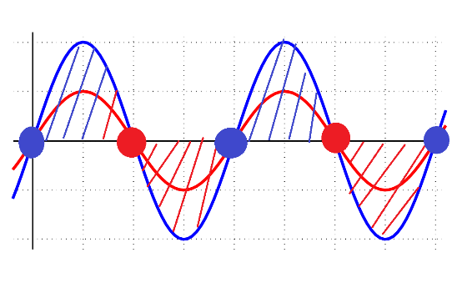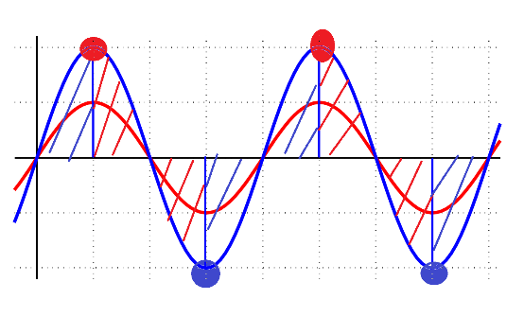

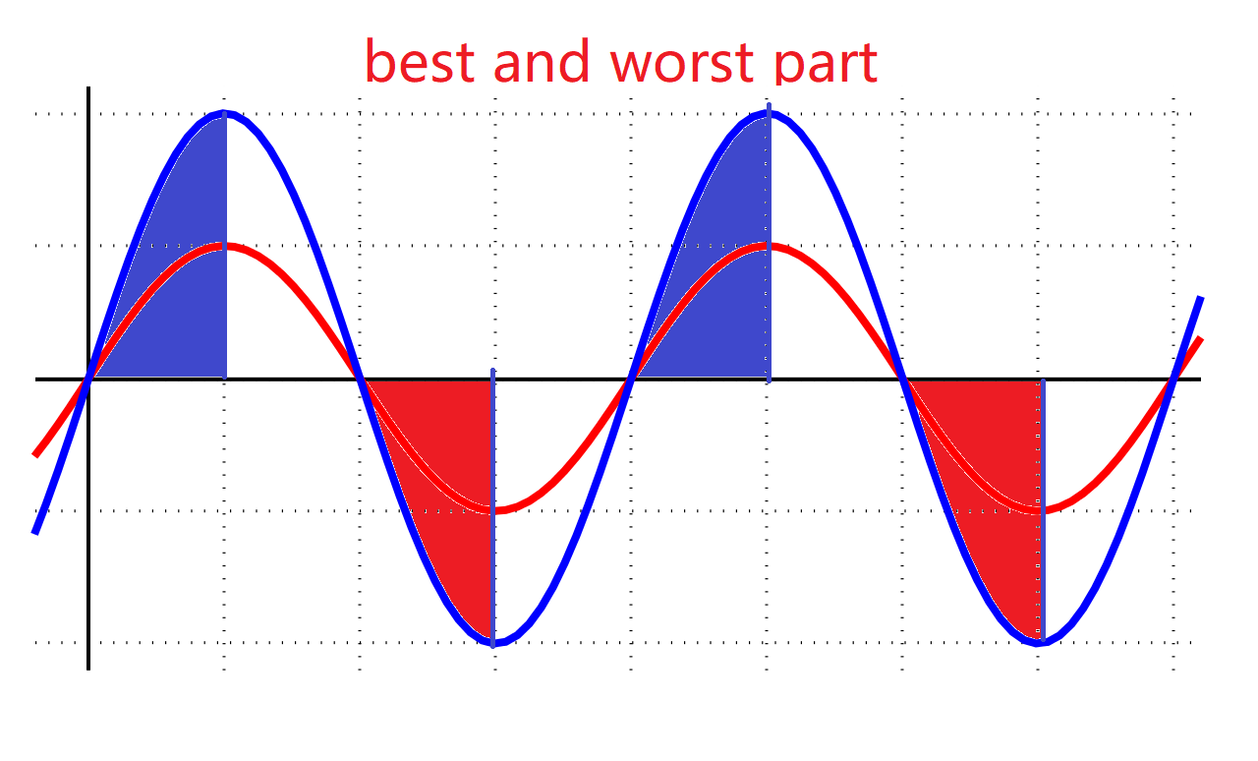

* 1. legend: upper2_cross1_lower5 means close2 was under close5 and now crosses close5 to become higher. upper2_cross-1_lower5 means close2 was above close5 and now crosses close5 to become lower. Basically ignore upper and lower keyword since they are misleading.
  2. **asset domain**: **buying WITH the trend is better**. For fgain2, pgain2 is the most significant indicator. Crossma is more significant for asset than overma.

|  |  |  |  |  |  |  |
| --- | --- | --- | --- | --- | --- | --- |
|  | **close2_cross1** | **close5_cross1** | **close10_cross1** | **close20_cross1** | **close60_cross1** | **close240_cross1** |
| **close2** |  | 1.000851 | 1.000921 | 0.998965 | 0.99786 | 0.999217 |
| **close5** | 1.003653 |  | 1.000883 | 0.999101 | 0.998287 | 1.002512 |
| **close10** | 1.002388 | 0.999586 |  | 0.999598 | 0.999394 | 1.002828 |
| **close20** | 1.003469 | 1.00135 | 1.001898 |  | 1.001123 | 1.000971 |
| **close60** | 1.002656 | 1.000605 | 1.001753 | 1.00251 |  | 1.002519 |
| **close240** | 1.003769 | 1.001778 | 1.001633 | 1.002356 | 1.000773 |  |

|  |  |  |  |  |  |  |
| --- | --- | --- | --- | --- | --- | --- |
|  | **close2_cross-1** | **close5_cross-1** | **close10_cross-1** | **close20_cross-1** | **close60_cross-1** | **close240_cross-1** |
| **close2** |  | 1.003751 | 1.002372 | 1.003563 | 1.002698 | 1.003933 |
| **close5** | 1.000858 |  | 0.999564 | 1.001453 | 1.000603 | 1.001928 |
| **close10** | 1.000964 | 1.000903 |  | 1.002006 | 1.001819 | 1.001795 |
| **close20** | 0.998969 | 0.999029 | 0.999591 |  | 1.002651 | 1.002234 |
| **close60** | 0.997788 | 0.998229 | 0.999537 | 1.001348 |  | 1.000316 |
| **close240** | 0.9989 | 1.002211 | 1.002662 | 1.000667 | 1.002271 |  |

* 1. **date domain**: **the result is no very significant. In general: Buy WITH TREND. Small freq over big freq is good, big freq over small freq is bad. Consistent with overma date finding.** The absolute value does not differ much from overma mean. For fgain2 Crossma date is almost same a overma date.

|  |  |  |  |  |  |  |
| --- | --- | --- | --- | --- | --- | --- |
|  | **close2_cross1** | **close5_cross1** | **close10_cross1** | **close20_cross1** | **close60_cross1** | **close240_cross1** |
| **close2** |  | 0.9983 | 0.999102 | 0.996396 | 0.994199 | 1.002652 |
| **close5** | 1.003422 |  | 0.997955 | 0.998407 | 0.997854 | 1.016089 |
| **close10** | 1.002647 | 1.000139 |  | 0.998891 | 0.993049 | 0.990335 |
| **close20** | 1.005105 | 1.003326 | 0.99768 |  | 1.006798 | 0.991309 |
| **close60** | 1.002675 | 1.002062 | 1.006694 | 1.002813 |  | 1.008152 |
| **close240** | 1.00447 | 1.000322 | 1.001555 | 1.004392 | 1.013447 |  |

|  |  |  |  |  |  |  |
| --- | --- | --- | --- | --- | --- | --- |
|  | **close2_cross-1** | **close5_cross-1** | **close10_cross-1** | **close20_cross-1** | **close60_cross-1** | **close240_cross-1** |
| **close2** |  | 1.003482 | 1.002647 | 1.005105 | 1.002778 | 1.002642 |
| **close5** | 0.9983 |  | 1.000139 | 1.003326 | 1.002189 | 1.000322 |
| **close10** | 0.999085 | 0.99793 |  | 0.99768 | 1.006947 | 0.997033 |
| **close20** | 0.996406 | 0.998436 | 0.998928 |  | 1.003021 | 0.999757 |
| **close60** | 0.994199 | 0.997854 | 0.993049 | 1.006798 |  | 1.008407 |
| **close240** | 1.002652 | 1.013864 | 0.990335 | 0.991309 | 1.008152 |  |

Increase Limit: todo probability dist characteristic before 涨停(tor, etc)

1.1 legend: day1 means 1 day after. Day-1 means 1 day before.

* 1. **asset domain:** After 涨停，the future gain will not be good. Fgain for the next n days range from near 0 to bad.

|  |  |  |  |  |  |  |  |  |  |  |  |  |
| --- | --- | --- | --- | --- | --- | --- | --- | --- | --- | --- | --- | --- |
|  | **pgain2** | **pgain5** | **pgain10** | **pgain20** | **pgain60** | **pgain240** | **fgain2** | **fgain5** | **fgain10** | **fgain20** | **fgain60** | **fgain240** |
| **days1** | 1.120722 | 1.140146 | 1.136393 | 1.136532 | 1.208348 | 1.616039 | 0.999561 | 1.001766 | 0.995699 | 0.994471 | 0.978619 | 0.977409 |
| **days2** | 1.020207 | 1.140236 | 1.13606 | 1.134455 | 1.20694 | 1.616235 | 1.000226 | 1.001524 | 0.993347 | 0.995257 | 0.978931 | 0.977445 |
| **days3** | 0.99953 | 1.138407 | 1.134067 | 1.132895 | 1.203719 | 1.612301 | 1.000047 | 1.005503 | 0.99448 | 0.996077 | 0.982018 | 0.97948 |
| **days5** | 0.999996 | 1.019472 | 1.137109 | 1.131321 | 1.198814 | 1.610562 | 1.001576 | 0.996334 | 0.992071 | 0.994353 | 0.981675 | 0.981635 |
| **days10** | 0.99107 | 0.995781 | 1.015266 | 1.126755 | 1.185914 | 1.593504 | 0.997436 | 0.995858 | 0.995937 | 0.985608 | 0.990629 | 0.989469 |
| **days-1** | 1.017296 | 1.015154 | 1.011259 | 1.017463 | 1.080286 | 1.43998 | 1.120944 | 1.123263 | 1.126834 | 1.117979 | 1.097833 | 1.094596 |
| **days-2** | 1.000977 | 0.997828 | 0.997646 | 1.002052 | 1.063415 | 1.416624 | 1.117323 | 1.139631 | 1.147702 | 1.135141 | 1.112946 | 1.10992 |
| **days-3** | 0.998965 | 0.998015 | 0.999622 | 1.001108 | 1.062768 | 1.418111 | 1.017608 | 1.141429 | 1.145007 | 1.136439 | 1.111697 | 1.109409 |
| **days-5** | 0.996233 | 0.995549 | 0.994911 | 0.998348 | 1.066097 | 1.423784 | 0.999085 | 1.119484 | 1.142498 | 1.137187 | 1.108469 | 1.104975 |
| **days-10** | 0.998023 | 0.997158 | 0.99745 | 1.013155 | 1.08889 | 1.456483 | 0.997668 | 0.996742 | 1.121961 | 1.143947 | 1.113375 | 1.09779 |



|  |  |  |  |  |  |  |  |  |  |  |  |  |
| --- | --- | --- | --- | --- | --- | --- | --- | --- | --- | --- | --- | --- |
|  | **pgain2** | **pgain5** | **pgain10** | **pgain20** | **pgain60** | **pgain240** | **fgain2** | **fgain5** | **fgain10** | **fgain20** | **fgain60** | **fgain240** |
| **days1** | 0.88782 | 0.85825 | 0.8472 | 0.8529 | 0.9227 | 1.36451 | 0.9978 | 0.99873 | 1.01921 | 1.02527 | 1.06029 | 1.09136 |
| **days2** | 0.98381 | 0.86294 | 0.84855 | 0.84862 | 0.91686 | 1.36103 | 1.00045 | 1.00325 | 1.01919 | 1.03135 | 1.06437 | 1.09762 |
| **days3** | 0.99784 | 0.86772 | 0.84884 | 0.85155 | 0.91457 | 1.35097 | 0.99818 | 1.00717 | 1.01555 | 1.04109 | 1.06484 | 1.09844 |
| **days5** | 0.99831 | 0.98231 | 0.85162 | 0.8528 | 0.9018 | 1.32931 | 1.00485 | 1.02205 | 1.02934 | 1.05251 | 1.07633 | 1.10239 |
| **days10** | 1.01332 | 1.02152 | 1.00202 | 0.85752 | 0.89989 | 1.33923 | 0.99911 | 1.00757 | 1.00996 | 1.03226 | 1.05669 | 1.08342 |
| **days-1** | 0.97261 | 0.95622 | 0.96503 | 0.96325 | 1.05034 | 1.54469 | 0.88754 | 0.8866 | 0.89478 | 0.91045 | 0.93291 | 0.96573 |
| **days-2** | 0.98606 | 0.97617 | 0.98833 | 0.97998 | 1.08005 | 1.5875 | 0.88227 | 0.86674 | 0.87245 | 0.8885 | 0.9107 | 0.9442 |
| **days-3** | 0.98689 | 0.97973 | 0.99575 | 0.98876 | 1.09322 | 1.60358 | 0.97261 | 0.86241 | 0.86365 | 0.88026 | 0.90278 | 0.93498 |
| **days-5** | 0.99474 | 0.99191 | 1.00723 | 1.01364 | 1.12408 | 1.63863 | 0.98712 | 0.86724 | 0.85051 | 0.87062 | 0.89357 | 0.9264 |
| **days-10** | 1.0138 | 1.01312 | 1.01293 | 1.04568 | 1.17699 | 1.70091 | 0.999 | 0.99232 | 0.86268 | 0.85705 | 0.88334 | 0.91375 |

Decrease Limit

* 1. **asset domain:** After 跌停，5-10 days return will be very significantly good. Days before 跌停，it is usually small negative return -3 to -2.

Auto-Correlation: pgain and fgain

* 1. **asset domain:** The pearson are very low. All under 0.05 or -0.05 which makes the pearson coefficient useless and almost near random.
  2. **Date domain**: The personal coefficient are low except for pgain240 and fgain240 which is at around -0.11 and pgain60 and fgain60 which is at 0.10. The rest is under 0.05 and can be rejected to use.

1.3 Conclusion: Naïve auto correlation on price does not yield any useful result.

Probability Distribution of categorized stock price

* 1. ts_code/asset domain: pgain category -10_-8, -8_-6…6_8,8_10 are used to show probability of future category. The problem is that it is difficult to calculate all the cases. Even if it is possible, the result are very broad and applies to all stocks. Hence, the individual predictability of this result on any asset is very weak. The asset is dominated by its own stuff and

2.2 date domain: same too complicated and not useful.

* 1. Conclusion: Assign probability to price to difficult and too broad. Not very useful

Methods to find the right turning points.

1. Crossma
2. Overma
3. Absolute value too high or too low
4. Distant between high and low freq too big
5. Smoothing
   1. double RSI
   2. tripple RSI
   3. high pass filter
   4. low pass filter
   5. John ehlers
6. Absolute RSI

6.1. It seems that rsi240 under 50 is better than above 50. This is because the mean reverse are more likely to happen. Same for rsi500 is better if it is under 50.

6.2 rsi10,7,20 ,5 is better if it is abv 50

6.3 RSI120, 80,60, is better if it is under 50

越大，越要低于RSI 50. 越小越要高于RSI50

RSI3 RSI2 are too shot to give any accurate answer.

1. The higher distance between two ma/RSI the better. If they are too close, like ma5+ma10, then their usage is very small because too similar. Better one would be ma3+ma12 Ma10+ma260 etc
2. In general. All rsi shows higher future gain if less than 30 in long and short run. E.g. ma3+ma120 both less than 30 % of their past normal value. Which translates to at 1/3 lowest half year ma and 1/3 lowest 3 day rsi.
3. In general, the price abv ma buy strategy is very very insignificant because the spread is very small. So buy and sell decision based on if price is over ma, is very bad. This is logical since ma and charts are very common. Useful information are in places where normal people cant access.

IDEAL score involves:

1. Cyclic pattern (rsi low is buy, rsi high is sell)
2. Trend pattern (rsi)
3. Resistance pattern (knows where are support and resistance). Possible ressitance. Trend, Ma, polynom. Horizontal lines. Golden cross(crossma, overcross and under cross)
4. Beta
5. Other Technical Analysis like boll
6. Fundamentals
7. Group
8. Maybe every stock needs a tailored version of all general finding. E.g. the general stock rsi is good at 70, bad at 30. Each stocks needs to be specifically adjusted from the past data.
9. Maybe rescue trend2 by assign probabilistic model to guess the next turning point type. Then we can always assume the right trade until next turning point.
10. Define different class of signals. Crossover, overma, resistance, cycle, go with or without trend. Volatility, fundamentals. Each one class gives one distinct score. They must be distinct, otherwise their score are overlapped and hence not very useful. Like maby semantic source, newspaper source, keyword search source is also required. All kind of different channel is required

KAMA TEST:

SUMMARY:

1. Buy price UNDER SMA610. ABV KAMA233 under EMA377
2. Whenever Stock price is under 144/620 KAMA, the next 3 days, the price will drop 8 pct in mean and the std is 0.11 which is very small. In other words, when ever this happens, the next 3 days the stock will almost certain drop 8 pct。
3. This also applies for (price abve 337KAMA, the next 5 day will drop)
4. Buy above ma 233 or 年线, the next year is good. This has high significance using KAMA in general. This is especially good for创业板stoocks. Buying above 233 has a low STD. But some stocks are not good to buy above ma223 which is very strange.
5. Buying above 610ma will give bad next 610 return. In other words, if this 610 was good, next 610 will be bad. And the standard deviation is very small which means that it is very certain.
6. Buying abve 377 will have good future 377 days return. This standard deviation is also small which means that one should always buy when price is above 377.
7. Buying under 144 半年 ma is bad. The next half year will also be bad. Buy above 半年is better.
8. The small freqs are very insignificant
9. But buying under 610ma has high STd. which means that it is not certain that the stock will become bad in next 610 periods
10. **Summary, buy under 610ma and above 233**
11. **Note: KAMA is better than SMA at identifying buy opportunities for 233 by filtering out noise.**
12. **Industries with higher overma underma spread are industries that are more volatile and less volatile.**
13. **When under 610ma, all stocks drop down in future 610 periods with less exceptions. Which means std is low. But when price is above 610 ma, std is high. So only couple stocks go up**
14. **It basically depends on which indicator can first find signal when long term market is going to turn. That indicator will be most usefule since short term market trend does not work on any indicator anyway.**

**Visual Expression of problems**

1. **Signal classifier to 1 buy 0 sell:**

**Good classifier = Occurence x Mean return x standard deviation**

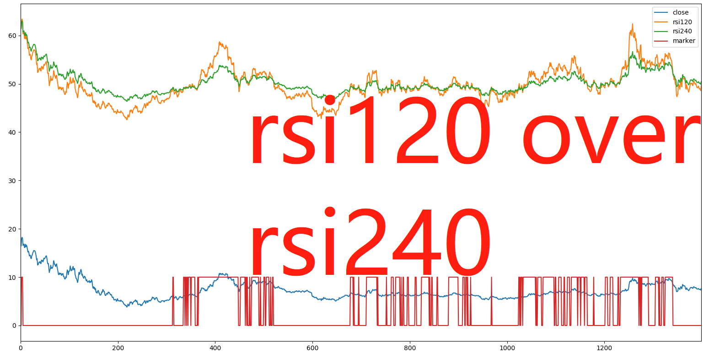

1. **Problem: useless in cycle mode.**
2. **Problem: long lag in trend mode**

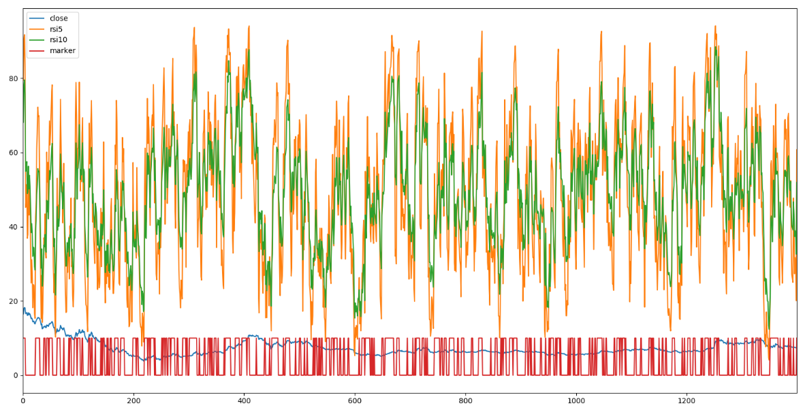

**Even more useless rsi5 over rsi10. Too many noise and wrong signals.**

**Dominant cylces by counting high and lows between**

1. **FFT is basically useless because the sample data is non periodic, non stationary, and sample period would be adaptive.**