a

BUSINESS PROPOSAL

for

EMV-COMPLIANT CARD ISSUANCE SOLUTION

for the consideration of

Attn: Mr. Som Ratana
Retail Products Manager

Personal Banking

No. 20FE-E0, Kramoun Sar
Phnom Penh, Cambodia
Tel: (855) 23-999-000

Submitted by
“YOUR TRUSTED PARTNER
IN
BUSINESS-BUILDING TOOLS”



Hengbao International Pte Ltd.
300 Beach Road #34-06, The Concourse, Singapore 199555

PROPRIETARY NOTICE

The information contained in this document is confidential and may also be proprietary and trade secret. Without prior notice written approval from Hengbao International, Ltd no part of this document may be reproduced or transmitted in any form or by any means, including but not limited to electronic, mechanical, photocopying or recording or stored in any retrieval system or whatever nature. Use of any copyright notice does not imply unrestricted public access to any part of this document. Hengbao International, Ltd trade names used in this document are trademarks of Hengbao International, Ltd. Other trademarks are acknowledged as the property of their rightful owners.

DOCUMENT CONTROL

Proposal Reference: JTRB/HBI/19022020/1.2

Version | Date of Release | Author | Authorized by | Changes
1.3 | 17rd April 2020 | David Tang  Business Development Director, HBI | Andrew Teh  Managing Director, HBI | Document Creation

This document is strictly confidential and must be reserved to an internal use only. All rights reserved.

For further information please contact:

David Tang
Business Development Director
Financial Cards & Payment System

Hengbao International Pte Ltd
300 Beach Road #34-06, The Concourse
Singapore 199555
Tel: +65 6298 8348
HP: +65 9645 9649
E-Mail: davidtang@hengbao.com

Table of Contents
SECTION 1  INTRODUCTION |  | 1.1 Executive Summary  1.2 Scope of Proposal
SECTION 2  EMV COMPLIANT CARD ISSUANCE SOLUTION |  | 2.1 System Description  2.2 System Architecture  2.3 Proposed Software Component  2.3.1 PersoMaster Software  2.3.1.1 Data Preparation Module  2.3.1.2 Key Master / Key Partner Module  2.3.1.3 Card Issuance Module  2.3.1.4 Card Program for M/Chip & VSDC Card  2.4 Proposed Hardware Component  2.4.1 SafeNet Protect Server HSM  2.4.2 PC for New EMV Application
SECTION 3  PROJECT MANAGEMENT & PROFESSIONAL SERVICES |  | 3.1 SOW for Project Management  3.1.1 Installation of Core EMV Infrastructure  3.1.2 Installation & Testing of Card Programs  3.1.3 Customer’s Requirements  3.1.4 Target Hardware  3.1.5 Risk and Assumptions  3.1.6 Schedules of Deliverables
SECTION 4  COMMERCIAL OFFER  CARD ISSUANCE SOLUTION  & HARDWARE EMBOSS MACHINE |  | 4.1.1 Price of EMV Compliant CIS  4.1.2 Software License and Maintenance  4.1.3 CIS Terms and Conditions  4.2.1 Emboss Machine Hardware Description  4.2.2 Emboss Machine Terms and Conditions

SECTION
1

INTRODUCTION

“YOUR TRUSTED PARTNER
IN
BUSINESS-BUILDING TOOLS”

INTRODUCTION

The purpose of this document is to provide an EMV Smart Card Personalization Solution to issue personalized and certified EMV banking cards for JTrust Royal Bank. This document contains the details of the proposed architecture, the software and hardware components as well as the commercial offer.

We believe that our offer is a very competitive package in terms of pricing, professional services and project management for the EMV Compliant Smart Card Issuance Solution. Much effort has been done to ensure that the system is scalable for future higher card issuance and at minimum financial cost to JTrust Royal Bank. Furthermore, we are pleased to provide a complimentary one day EMV Technical Workshop at your premise at no additional cost to the Bank.

Once again, we thank you for this opportunity to be of service to JTrust Royal Bank and we look forward to working with you in the near future.

Best Regards,

David Tang
Business Development Director
Financial Cards & Payment System
19th Feb 2020
  - Executive Summary

Hengbao International (HBI) proposes an EMV Compliant Smart Card Issuance Solution to enable the use of the card personalization system to personalize EMV Cards. The system can be used for issuance of any other Payment Schemes i.e. Visa, MasterCard, Union Pay, American Express cards etc. in the near future.

  - scope of proposal

Based on the understanding of JTrust Royal Bank’s business needs as stated earlier, the document details the scope of works, consultancy services and list the options available as well as HBI’s commercial offer in order to implement this project.

The proposal is divided into several sections: -

Section 2 Proposed EMV-Compliant Card Issuance System

In this section, a Card Issuance System has been proposed; a system based on integration of PersoMaster and a Desktop embossing machine.

Section 3 EMV Project Management and Professional Service

In this section, the project implementation plan is briefly described. This will cover the whole area of implementation plan including the installation of EMV infrastructure, system component, target hardware and the issuing of EMV test card.

Section 4 Card Issuance Solution & Emboss Machine Commercial Offer

In this section, we describe the EMV Card Issuance Solution’s commercial offer for all the options with the terms and conditions.

SECTION
2

EMV-compliant

card issuance solution
“YOUR TRUSTED PARTNER
IN
BUSINESS-BUILDING TOOLS”

2.1 System description

In this section, HBI provides a solution for JTrust Royal Bank to issue an EMV cards using EMV-Compliant Card Issuance System. The proposed system requires an integration of PersoMaster System with an emboss machine that will be used for personalizing the EMV cards.

PersoMaster is divided into three software modules; Data Preparation, Key Master/ Key Partner and Card Issue. The Data Preparation Module is used to process the embossing data provided by Issuer CMS and produce an EMV data. During data preparation process, the keys and certificates will be calculated by the system. This requires utilization of SafeNet’s Hardware Security Module (HSM). In the next process, the chip personalization process is performed by Card Issue module. Once again the HSM will be accessed by the system in order to inject the RSA, Triple DES Keys and Certificates inside the chip.

Lastly the machine control software is used to control the machine parameter setting and emboss the cards.

2.2 System architecture

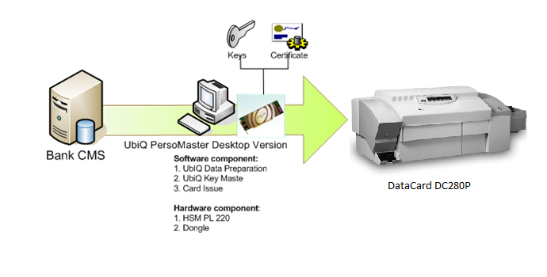
EMV Emboss Machine

2.3 proposed software component

The proposed software component to issue an EMV card will be as follow:

- PersoMaster EMV Personalization Software

- Data Preparation Module
- Key Master/ Key Partner Module
- Card Issue Module

2.3.1 perso master software

PersoMaster is a suite of smart card personalization software applications that significantly simplifies the process of personalizing single and multiple application smart cards. It takes a “lifecycle” approach to personalizing cards, which includes:

- Planning, selecting and validating card program components.
- Preparing data and generating security keys prior to production personalization.
- Producing cards in a time-sensitive and secure environment.
- Enables to design a complete issuing system using components that meet issuer specific requirements.
- Future smart card programs can be supported with minimal modifications.
- A single personalization system provides foundation to meet the needs of all current and future smart card programs.

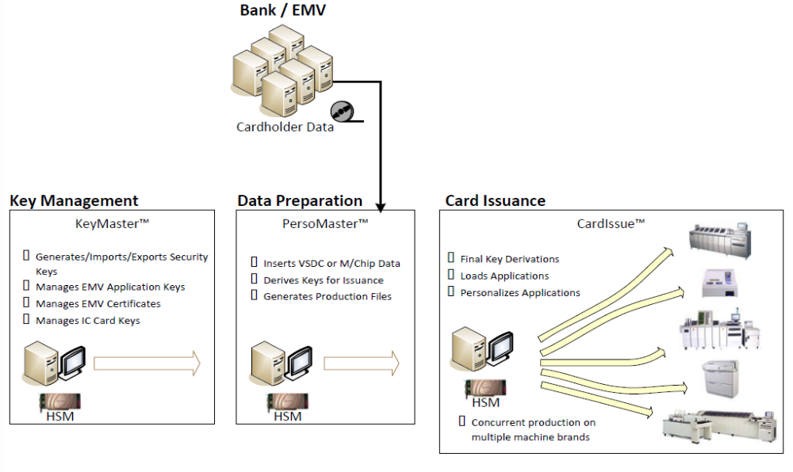

PersoMaster suite provides the solution to plan and implement each stage of the card personalization lifecycle and minimizes the risk of costly errors. It includes three application modules:

- Data PreparationTM Module: Provides personalization process tools to manage the preparation of the data and generation of security keys prior to production personalization.

- Key MasterTM/ Key PartnerTM Module: A universal key management system that can be configured support any card configuration designed the Card PlanTM module.

- Card IssueTM Module: A highly flexible personalization application that can support numerous smart card programs without requiring the issuer to write customized software. In addition, it includes the ability to interface with libraries of personalization devices, HSM and chip operating systems.

2.3.1.1 data preparation module

Data Preparation module offers a solution for the next generation of smart card data preparation requirements. The production of smart cards in a multi-application and multi-platform environment which requires software to combine a variety of input components to produce complex production data records, required to issue large volumes of smart cards daily. These data records contain text data, graphics data, and magnetic encoding data as well as personalized smart card application data that includes coded parameters and encrypted keys to be programmed into the smart chip. The standard emboss data file typically comes from a host system, and is combined with smart card data (i.e. EMV) to produce this production data output.

Data Preparation module is world leading smart cards data preparation software capable of processing multiple files in parallel. These files can include a wide variety of EMV (e.g VSDC, M/Chip or CUP) and other applications for various card platforms. To achieve maximum performance multiple HSM’s can be supported simultaneously. Data Preparation module can accommodate many different file formats and standards from many different CMS’s and SCM’s. These include CMS, SCMS and other proprietary system which are integrated into our data preparation system.

2.3.1.2 key master / key partner module

Key Master/ Key Partner module is a universal key management application designed so that it can be configured to support most smart card application through key profiles. The primary functions are to create, import /export, transfer, store and protect cryptographic keys and certificates. It supports issuer public key certificates for Visa, MasterCard and UnionPay International. Key Master/ Key Partner utilize a HSM for the performance of a spectrum of symmetric and asymmetric cryptographic operations, as well as a securing the key vault repository for keys, certificates and other sensitive information.

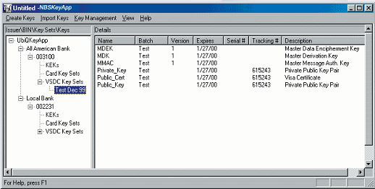

The input to the Key Master/ Key Partner module, for the purpose of creating all the keys and certificates for a Card Program is a key profile. Once the keys and certificates have been created and stored in the key vault, they are accessible to Data Preparation Module directly (if both applications are present on the same computer) or via secure transfer of the key vault contents (if the two applications are remote from one another).

The Key Master/ Key Partner and Data Preparation System are two distinct self-sending modules, that can be utilize the same HSM and key vault in the same computer, or they can be placed in separate computers and at separates locations. This allows one location to manage the keys while other locations simply use the keys in production. The second location has no need to manage the keys, only use them. This architecture is vital to providing support for centralized key management without forcing the installation of a data preparation system at each location.

2.3.1.3 card issuance module

Card Issue Module is the industry leader in supporting various card personalization equipment types. It runs as a compliment to Data Preparation Module and has been used in the issuance of millions of multi-application smart cards all over the world. It runs on a computer attached to a card personalization device and manages the smart card personalization process. By using Card Issue Module, multiple personalization devices from different manufacturers can be supported simultaneously and run in parallel.

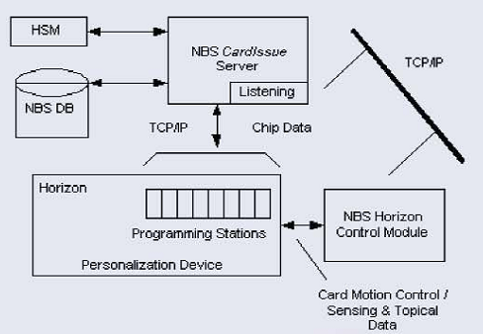

Advantages of Card Issue module includes:

- Supports multiple personalization devices from different manufacturers
- Supports a Smart Production process (Intelligent file format)
- When adding support for new applications no updates to Card Issue System or the personalization equipment are required most of the time
- Card Issue System can be configured to support remote issuance
- Support multiple audit/return files. Each application that is personalized can have its own unique audit file that can be returned to a host system. Card Issuance System has no limit on the number of audit files that can be produces for each production run.
2.3.1.4 card program for EMV global platform card

Card program is a personalization script to personalize EMV compliant application. The card program will be developed and customized to perform this processes.

With support from HBI, JTrust Royal Bank has to provide a detailed list of the EMV tag settings. This data information is required to be communicated to HBI for integration into the card program and must be received at least 4 weeks before installation of a new production card program.

2.4 proposed hardware component

This section describes the hardware system component to implement the EMV Compliant Card Issuance System. This includes:

          - SafeNet Protect Server HSM

          - PC for EMV Applications

          - Embosser Machine for Card Personalization (to be advised at a later date)

The EMV Personalization Software need to be equipped with the following hardware:

Item | Hardware Requirements | Descriptions
1 | Hardware Security Module (HSM) Safenet Protect Server Gold PL-25  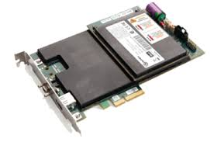 | HSM used to store EMV keys and Issuer certificate:  - It comes together with the Persomaster PC set and we will help issuer to configure the HSM and integrate with the Persomaster software  - We also will assist Issuer custodian to perform the key injection exercise
2 | PC (without monitor)  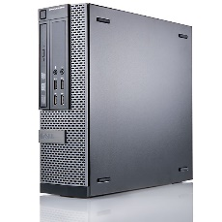 | Data Preparation PC: Used for installation of all PersoMaster modules (Data Preparation, Key Master and Card Issue). The Desktop PersoMaster software will be shipped together with PC (without monitor) as follows:  - 2nd Generation Intel® Core™ i5-2400 Processor (3.10GHz,6MB)  - 2 GB DDR3 SDRAM 1333MHz  - 500GB SATA 7200 RPM Hard Drives  - Tower Like PC with Open PCI Slot for SafeNet Protect Server Gold PL25 HSM  - LAN Ethernet Adapter  - Windows 7 / 10 Operating System

SECTION
3

project management & professional services

3.1 SCOPE OF WORK FOR PROJECT MANAGEMENT AND PROFESSIONAL SERVICES

There are a number of specific components to all EMV implementations which warrant description and attention. We have listed the primary components and associated responsibilities which are part of our implementation below. As part of this offer we are proposing part of our consulting services which will assist in guiding you though the deployment process and ensuring that UPI’s approved practices, including PCI-DSS compliance, are complied with throughout the end-to-end production cycle.

This project focuses on bringing you online with our EMV Solution for the Card Issuers. This project requires the following activities be completed on site:

3.1.1 INSTALLATION OF CORE EMV INFRASTRUCTURE HARDWARE AND SOFTWARE

Installation of PersoMaster application on a production class server PC is done at a central office site. This includes one Server class Intel hardware, Monitor, HSM and Dongle. This also includes the delivery of one Card Program (EMV). If you need another card program, there will be added costs which are mentioned as optional.

Note: Card programs typically require a minimum of 3-4 weeks advance notification.

3.1.2 INSTALLATION & TESTING OF CARD PROGRAMS

- Demo Card Program: As indicated above a ‘test’ card program will be implemented to confirm printer connectivity and operation of the implementation for UPI card scheme. It also can be used for gaining Visa or MasterCard certification.

- Input Files and Data Conversion Map: The standard process is for the bank to provide us with their standard magnetic stripe production file. We plan to enable the bank to continue using this file format. However, as part of the data preparation process we convert it to a smart card compliant format using a data conversion map. We will supply one data conversion map for each card program installed.

- EMV Parameters: The EMV setting will be configured and provided by Bank for this Card Program.

- HBI will test the following card program:

- One card program; to personalize EMV application based on Global Platform OS Card

- The following information needs to be validated by end user.
- Card Program Issuer: ______________________________
- Card Program BIN: ________________________________
- Card Program Name: ______________________________
- New Version Name: _______________________________

3.1.3 CUSTOMERS’ REQUIREMENTS

Customer must provide:

  - Sample input file
  - Customer will provide the necessary communication environment (LAN, Internet)

3.1.4 Target Hardware

- Any EMV certified emboss desktop machine, preferable to be one of any of these international established brands – DataCard, NBS, Matica, CIM.

3.1.5 Risk & Assumptions

  - The correct key value for the new key is added to the KeyMaster module.

  - HBI does not confirm that the card functions end-to-end. It is the Bank’s responsibility to perform the requisite end-to-end test which ensures terminal and point by point operation.

  - All required resources (system administrator, project manager etc.) will be available during the onsite infrastructure implementation.

  - A card program version will be defined in PersoMaster™.

  - Input files need to be provided to HBI at time of that input file format can be implemented, but it requires a few weeks of work.

3.1.6 Schedule of Deliverables

A specific timeline and project schedule will be provided by our Project Manager following the initial kick off meeting.

“YOUR TRUSTED PARTNER
IN
BUSINESS-BUILDING TOOLS”

SECTION
4

commercial offer

EMV COMPLIANT CARD ISSUANCE SYSTEM

and

EMV Card embosser hardware

“YOUR TRUSTED PARTNER
IN
BUSINESS-BUILDING TOOLS”

4.1 EMV Compliant Card Issuance System

4.1.1 System Detailed Description

Item | Description | Qty | Price (USD) | Total (USD)
1 | PersoMaster EMV Card Issuance System- Desktop Version  - Data Preparation Module  - Key Master/ Key Partner Module  - Card Issue Module  - Dongle and one year license & maintenance support | L/S | 53,500.00 | 53,500.00
2 | EMV-Compliant Card Program  - One EMV Card Program (UranusMVP-UPI) | L/S | 53,500.00 | 53,500.00
3 | SafeNet Protect Server Gold HSM PL-25  - PCI Card HSM Module  - The PersoMaster™ suite interfaces to the SafeNet HSMs using the PKCS #11 interface and proprietary SafeNet extensions. These cryptographic modules have been certified under FIPS 140-1 Security level 3.  - Cryptography Algorithms  - Symmetric - AES, DES, 3DES, CAST-128, RC2, RC4, SEED, plus others on request; Modes supported include ECB, CBC, OFB64, CFB-8 (BCF)  - Asymmetric - RSA (up to 4096 bits), DSA, ECDSA (up to 512 bits) Diffie Hellman (DH)  - Product dimension  - 231mm x 18.7mm x 105.5mm or 9.1” x 0.73” x 4.15” (w/h/d) | L/S | 53,500.00 | 53,500.00
4 | SmartSys Machine Control Software  - Software to control desktop embossing machine and to be integrate with Card Issue module during data personalization process. | L/S | 53,500.00 | 53,500.00
5 | Desktop PC  The PC specification as follow:  - 2nd Generation Intel® Core™ Processor  - 2 GB DDR3 SDRAM 1333MHz  - 500GB SATA 7200 RPM Hard Drives  - Tower Like PC with Open PCI Slot for PL 220 HSM  - CD ROM Drive  - LAN Ethernet Adapter  - Windows 7 Operating System | L/S | 53,500.00 | 53,500.00
6 | Project Management & Professional Services  - Installation & Commissioning of EMV-Compliant PersoMaster System  - End user training  - Implementation Project Management  - Analysis and Finalization of Bank Requirement  - Infrastructure Hardware and Software  - EMV System Configuration and Testing  - EMV Certificate Request  - Live BIN Configuration and Testing  - Pilot Production and User Training  - Initial support during 3 months warranty period | 1 | 4,500 | 4,500
7 | Additional Card Program (Optional)  - One EMV Card Program for Visa / MasterCard / JCB / Amex | 1 | 14,500.00 | 14,500.00
8 | Setup Fee for Additional BIN (Optional)  - EMV Certificate Generation and Request from Payment Association  - BIN Configuration and Testing for White Card Approval by Scheme Owner  - Live BIN Configuration and Testing  - Pilot Production and User Training | 1 | 5,500.00 | 5,500.00
9 |  | 1 | 9,500 | 9,500
  Card Issue Extension Module (Optional)
  Upgrade of Card Issue Extension Module to allow EMV Card Personalization on Two Desktop Machine Concurrently.
  With this extension module upgrade, the customer will be able to personalize EMV cards on 2 different desktop embossing machines concurrently using a single license.
10 | Back-Up System (Optional)  PersoMaster EMV Card Issuance System- Desktop Version  - Data Preparation Module  - Key Master/ Key Partner Module  - Card Issue Module  SafeNet Protect Server Gold HSM PL-25  - PCI Card HSM Module  - The PersoMaster™ suite interfaces to the SafeNet HSMs using the PKCS #11 interface and proprietary SafeNet extensions. These cryptographic modules have been certified under FIPS 140-1 Security level 3.  - Cryptography Algorithms  - Symmetric - AES, DES, 3DES, CAST-128, RC2, RC4, SEED, plus others on request; Modes supported include ECB, CBC, OFB64, CFB-8 (BCF)  - Asymmetric - RSA (up to 4096 bits), DSA, ECDSA (up to 512 bits) Diffie Hellman (DH)  - Product dimension  - 231mm x 18.7mm x 105.5mm or 9.1” x 0.73” x 4.15” (w/h/d)  SmartSys Machine Control Software  - Software to control desktop embossing machine and to be integrate with Card Issue module during data personalization process.  Desktop PC  The PC specification as follow:  - 2nd Generation Intel® Core™ Processor  - 2 GB DDR3 SDRAM 1333MHz  - 500GB SATA 7200 RPM Hard Drives  - Tower Like PC with Open PCI Slot for PL 220 HSM  - CD ROM Drive  - LAN Ethernet Adapter  - Windows 7 Operating System | 1 | 31,000.00 | 31,000.00

5.1 Card Printers System & Consumerables

5.1.1 ADVANTAGE M8 CARD EMBOSSER - Thermal / Embosser Card Printer

Item | Description | Qty | Unit Price  (USD) | Total Price (USD)
1 | NBS Advantage M8 Desktop Card Embosser  - 6 Cassette (6 Input Hopper)  - Magnetic Stripe Encoder  - Contact Smart Card - USB connection PCSC coupler  - Embosser with 54 characters with variety of emboss fonts (max 80 character including indent)  - Color tipper  - Color (Dye-sublimation) and mono (Thermal transfer) printing - dual side  - Rear Indent Mechanism  - Mastercard Rear Indent Character (require approval  - Smartsys Tabletop Machine Control Software | 1 | 21,800.00 | 21,800.00
2 | On-site Installation & Training | 1 | Included | Included

5.1.2 ADVANTAGE M8 CARD EMBOSSER - Thermal / Embosser Card Printer (Optional BackUp Unit)

Item | Description | Qty | Unit Price  (USD) | Total Price (USD)
1 | NBS Advantage M8 Desktop Card Embosser  - 6 Cassette (6 Input Hopper)  - Magnetic Stripe Encoder  - Contact Smart Card - USB connection PCSC coupler  - Embosser with 54 characters with variety of emboss fonts (max 80 character including indent)  - Color tipper  - Color (Dye-sublimation) and mono (Thermal transfer) printing - dual side  - Rear Indent Mechanism  - Mastercard Rear Indent Character (require approval  - Smartsys Tabletop Machine Control Software | 1 | 22,000.00 | 22,000.00
2 | On-site Installation & Training | 1 | Included | Included

5.1.2. ADVANTAGE LC-400 GEN II - Laser Engraver Card Printer

Item | Description | Qty | Unit Price  (USD) | Total Price (USD)
1 | NBS Advantage LC-400 Generation 2 Desktop Laser Engraver  - 10W Laser  - Dual Sided  - Magnetic Stripe Encoder  - Contact Smart Card  - Smartsys Tabletop Machine Control Software | 1 | 64,000.00 | 64,000.00
2 | On-site Installation & Training | 1 | Included | Included

5.1.3 Consumables for 5,000 Cards

Item | Description | Qty | Unit Price  (USD) | Total Price (USD)
1 | Black Indent Ribbon #16391-01  - Length: 300 feet  - Color: Black | 1 | 9.50 | 9.50
2 | Silver Tipping Foil #16390-01  -Length: 500 ft  -Color: Silver | 1 | 15.00 | 15.00
3 | YMCKO Color Ribbon #66200740  -Length: 200 prints/roll  -Color: YMCKO | 1 | 110.00 | 110.00
4 | White Mono Ribbon #61123113  -Length: 1000 prints/roll  -Color: White | 1 | 90.00 | 90.00
5 | Cleaning Roller #61100931 | 1 | 45.00 | 45.00
6 | Cleaning Cards 100’s #61100915 | 1 | 112.00 | 112.00

4.1.2 EMV Technical Workshop Session

Item | Description | Qty | Price (USD) | Total (USD)
1 | One day EMV Technical Workshop at bank premise | 1 | F.O.C | F.O.C

4.1.3 Annual Software License & Maintenance Support (Payable at Year 2)

Item | Description | Qty | Price (USD) | Total (USD)
1 | Annual Software License | 1 | 9,000.00 | 9,000.00
2 | Card Issue Extension Module License | 1 | 6,000.00 | 6,000.00

4.1.4 Terms and Conditions

Price | All prices quoted INCLUDE freight  All prices quoted EXCLUDE any sales or government tax.  All prices quoted EXCLUDE travelling and accommodation cost
Standard Reimbursement Charges for Professional Services and Maintenance Support | Hotel Accommodation  Flight tickets between sites i.e. Kuala Lumpur & Cambodia, Thailand, Laos  Local transportation and airport transfer  Out of pocket expenses
Out of Pocket Expenses (Per Diem) | Per Diem: US50.00 per day  Accommodation, Flights, Airport Transfer: Based on actual claim
Warranty | Hardware  - HSM: 1 year against manufacturing defects  Software  - PersoMaster software solution is warranted for 1 year from installation. During this time, NBS will make sure all of our software deliverables are integrated with the specified devices.
Payment | - 50% upon issuance of PO  - Remaining to paid prior to delivery
Time schedule | - Card Program: 8 ~ 10 weeks  - PersoMaster System: 4 ~ 6 weeks  - Machine: 6~8 weeks  - Other Hardware: 10 ~ 12 weeks
Validity | - This proposal is valid up within 3 months from the date of issue.

End of Proposal

